VTPBiS

Refresher TRAINING:

Workbook

Date: __________________

School: _____________________________________________

Team Members: ____________________________________________________
________________________________________________________________________________________________________

Activity #1: Team Structure, Norms & Roles, and Routines

Conducting Leadership Team Meetings Self-Assessment
(Adapted from Sugai & Todd, 10-22-03)

This Self-Assessment has been developed to facilitate the preparation, conducting, and evaluation of leadership team meetings. As a team, place and “X” in the appropriate box.

 | STATUS:
PREPARING: | In Place | Partially In Place | Not In Place | N/A
Review agreements/tasks from previous minutes
Identify/review/develop agenda items
Invite/remind/prepare participants
Prepare/review materials
Check/confirm logistics (e.g., room, location, time)
Data Analyst prepares data for meeting (e.g. Academic & Behavior)
BEGINNING:
Acknowledge/introduce participants
Review purpose
Review/assign roles
Rotate meeting role responsibilities (e.g. facilitator, time keeper)
Review/modify agenda items (e.g., discussion, decision, information)
Assign # of minutes for each agenda item
Set/review meeting rules/routines (Routines below)

CONDUCTING:
Follow agenda items
Stay within timelines
Follow/review rules/routines
Restate/review/remind of purpose/outcomes
Use the TIPS model to review data and problem solve
CONCLUDING: | In Place | Partially In Place | Not In Place | N/A
Review purpose
Review/summarize agreements/products/assignments
Review/evaluate extent to which agenda items addressed
Review new agenda items
Review compliance with rules/routines
Acknowledge/reinforce participation/actions/outcomes
Indicate next meeting date/time/place
Share workload among team members
FOLLOW-UP:
Distribute minutes to team and other stakeholders
Complete agreements/products/assignments
Contact/remind participants
Prepare for next agenda
Share data and successes with staff
Other Notes/Observations:

Routines for Conducting Effective and Efficient Meetings

- How are decisions made?
- How are problems/conflicts/disagreements resolved/processed?
- How are roles/responsibilities (e.g., leadership/facilitation, recording minutes, reporting) assigned and conducted?
- How is participation encouraged/reinforced?

Team Profile and Meeting Schedule – UNIVERSAL

Universal/School-Wide Leadership Team Roster
School Name: Grades:

Town/City: Supervisory Union:

Team Norms:

Team Member Name Building Role Team Member Role

Dates and Times of Monthly Meetings:

Team Profile and Meeting Schedule – TARGETED/INTENSIVE

Targeted and/or Intensive Team Roster
School Name: Grades:

Town/City: Supervisory Union:

Team Norms:

Implementation Team – Systems Level

Team Member Name Building Role Team Member Role

Dates and Times of Monthly Meetings:

Individual Student Level Team

Team Member Name Building Role Team Member Role

Dates and Times of Weekly Meetings:

Working Smarter Team Matrix

Team/Committee/Initiative  Related to School Climate | Purpose | Outcome | Target  Group | Staff  Involved | What School Action Plan Goal does it address?

Activity #2: Statement of Purpose, 3-5 Expectations & Teaching Behavior Expectations

What is your statement of purpose for PBIS in your school?

What are the stated behavioral expectations in your school?
1.

2.

3.

4.

5.
For Examples: http://www.pbisvermont.org/resources/schools/universal-examples
Teaching Matrix

Rule/ Expectation | Routine/Setting
For Examples: http://www.pbisvermont.org/resources/schools/universal-examples
Developing Lesson Plans

Lesson Plan Template: 1

Universal Expectation: ________________________________

Name of the Skill/Setting: _____________________________
Purpose of the lesson/why it is important:
1.
2.

Teaching examples:
1.
2.
3.

Kid activities/modeling/role-plays:
1.
2.
3.

Follow-up reinforcement Activities:
1.
2.

For Examples: http://www.pbisvermont.org/resources/schools/universal-examples

Adapted from the Illinois PBIS Network Training Manual, October 2006

Lesson Plan Template: 2

Social Skill Lesson Plan Activity
Lesson Focus:
Demonstrating _________________ (expectation) in the _________________ (setting).

Teaching Objective:
Following instruction, students will demonstrate _________________ (expectation) in the _________________ (setting) by_________________________________(describe behaviors) across __ out of __ sampled opportunities (criteria).

Teaching Examples:
Positive Examples | Negative Examples

Lesson Materials:

Lesson Activities:
Model:

Lead:

Test:

Follow-up Activities:
Strategies to prompt:

Procedures to reinforce:

Procedures to correct behavioral errors:

Procedures to monitor/supervise:

Procedures to collect and evaluate student data:

Developing Lesson Plans and Schedule for Teaching

Schedule for Teaching Behavior Expectations

Date: | Lesson Taught: | Who’s Teaching: | Where: | Grades Involved:

Activity #3: Acknowledging Behavior, Discouraging Problem Behavior and Procedures for Record Keeping and Decision Making

Plan for Encouraging School-wide Expected Behaviors for Students and Staff

 | Name of reward | Criteria for obtaining reward | Process for delivering reward  (What, When, By Whom, How Often, How Many, Where)
School-wide formal recognitions
School-wide “quick” acknowledgements
Classroom reward system
Individual student reward system
Staff reward system
Sustainability: What is the procedure to inform new staff/students of the various reward systems.

Guidelines for developing your procedures for encouraging expectations:

- Easy and quick form of acknowledgement (e.g. object, event) for all staff members to use
- Considerate of strategies/procedures that already exist
- Contextually appropriate name for acknowledgements
- Back- or follow-up acknowledgements.
- Schedule for daily, weekly, monthly, quarterly feedback to students and staff.
- Use by all staff (e.g. office, supervisors, bus drivers).
- Schedule for initial introduction of acknowledgements and for orientation to new faculty, staff and students.
- Schedule for regular boosters or re-implementation of acknowledgements.
- Included in school publications (handbooks, newsletters).
- Instruction and practice pairing acknowledgements with positive social behaviors.

Developing a Shared Understanding of Minors and Majors

MINOR BEHAVIORS: | MAJOR BEHAVIORS:

T-Chart of Behavior: Defining Minors vs. Major
For Example definitions of Major & Minor Behavior visit:
http://www.uvm.edu/cdci/best/pbswebsite/SWISReferralCategoryDefinitions2014.doc

Procedures for Discouraging Problem Behavior
General Procedure for Dealing with Problem Behaviors
Observe problem
behavior
Problem solve
Determine
consequence
Follow procedure
documented
File necessary
documentation
Send
referral to
office
File necessary
documentation
Determine
consequence
Follow
through with
consequences
Problem solve
Follow
documented
procedure
Write referral &
Escort student to office
Follow up
with student
within a
week
Is
behavior
major?
Does
student
have 3?
NO
YES
NO
YES
Find a place to talk with student(s)
Ensure safety

Insert Procedural Flow Chart here:
General Procedure for Dealing with Problem Behaviors

Yes
No
Is behavior major?
Does student have 3?
For Examples: http://www.pbisvermont.org/resources/schools/universal-examples

No
Yes
EXAMPLE A:
Office Discipline Referral Form (ODR)

Office Referral Form

Name: ____________________________ Location
Date: _____________ Time: ________  Playground  Library
Teacher: __________________________  Cafeteria  Bathroom
Grade: K 1 2 3 4 5 6 7 8  Hallway  Arrival/Dismissal
Referring Staff: _____________________  Classroom  Other ________
Minor Problem Behavior | Major Problem Behavior |  | Perceived Motivation
- Inappropriate language  - Physical contact  - Defiance  - Disruption  - Dress Code  - Property misuse  - Tardy  - Electronic Violation  - Other ______________ | - Abusive language  - Fighting  - Physical aggression  - Defiance/Disrespect  - Harassment  - Bullying  - Dress Code  - Inappropriate Display Aff.  - Electronic Violation  - Lying/ Cheating  - Skipping class  - Other _______________ |  | - Obtain peer attention  - Obtain adult attention  - Obtain items/activities  - Avoid Peer(s)  - Avoid Adult  - Avoid task or activity  - Don’t know  - Other ________________
Action Taken
- Loss of privilege  - Time in office  - Conference with student  - Parent Contact |  | - Individualized instruction  - In-school suspension (____hours/ days)  - Out of school suspension (_____ days)  - Other ________________

Others involved in incident:  None  Peers  Staff  Teacher  Substitute
 Unknown  Other
Other comments: _________________________________________________________________

 I need to talk to the student(s) teacher  I need to talk to the administrator

Parent Signature: _____________________________ Date: __________________
All minors are filed with classroom teacher. Three minors equal a major. All majors require administrator consequence, parent contact, and signature.
EXAMPLE B: CIRS Compatible ODR Form
SWIS/CIRS OFFICE DISCIPLINE REFERRAL FORM

Complete the following information. This Office Discipline Referral form includes CIRS reportable information marked by a bold C. If a CIRS box is checked complete the CIRS reporting process or forward this referral to the person responsible for reporting that information.

Student Name: _____________________________ Referring Staff: ______________________________ Grade: _____________

Date: _____________ Time of Incident: ___________________ Student on an IEP (Yes or No): ____________

LOCATION:

Classroom Cafeteria Bus loading zone Other____________
Playground Bathroom/Restroom Parking lot
Commons/common area Gym On bus
Hallway/breezeway Library Special event/assembly/field trip

PROBLEM BEHAVIORS (check the most intrusive)

MINOR: MAJOR: (C = CIRS reportable incident)

Inappropriate lang. Abusive lang./inapprop. Lang Skip class/truancy Property damage C
Physical contact Fighting/physical aggression Forgery/theft Bomb threat C
Defiance/disrespect/non-compliance Defiance/disrespect/ Dress code violation Arson C
Property misuse insubordination/non-compliant Lying/cheating Weapons C
Other________________________ Bullying C Tobacco C Violent crime C
Harassment C Alcohol/drugs C
Disruption Combustibles
Hazing C Vandalism

PERCEIVED MOTIVATION:

Obtain peer attention Avoid tasks/activities Don’t know
Obtain adult attention Avoid peer(s) Other______________________________________________
Obtain items/activities Avoid adult(s)

OTHERS INVOLVED:

None Peers Teacher Substitute Other staff Unknown Other_______________

ADMINISTRATIVE DECISION:

Time in office/out of class Detention For Majors Only
Loss of privilege Parent contact In-school suspension C
Conference with student Individualized instruction Out-of-school suspension
Other_________________________ or expulsion C

COMMENTS:

FOLLOW-UP COMMENTS:

Activity #4: Inventory of Targeted Interventions

Intervention System Support or Practice | Function of Behavior |  |  |  | Purpose/Goal | Staff Involved | Referral  Criteria | Evidence of Effectiveness (Does practice achieve anticipated outcomes? Is there data?)

Example: Inventory of Targeted Supports
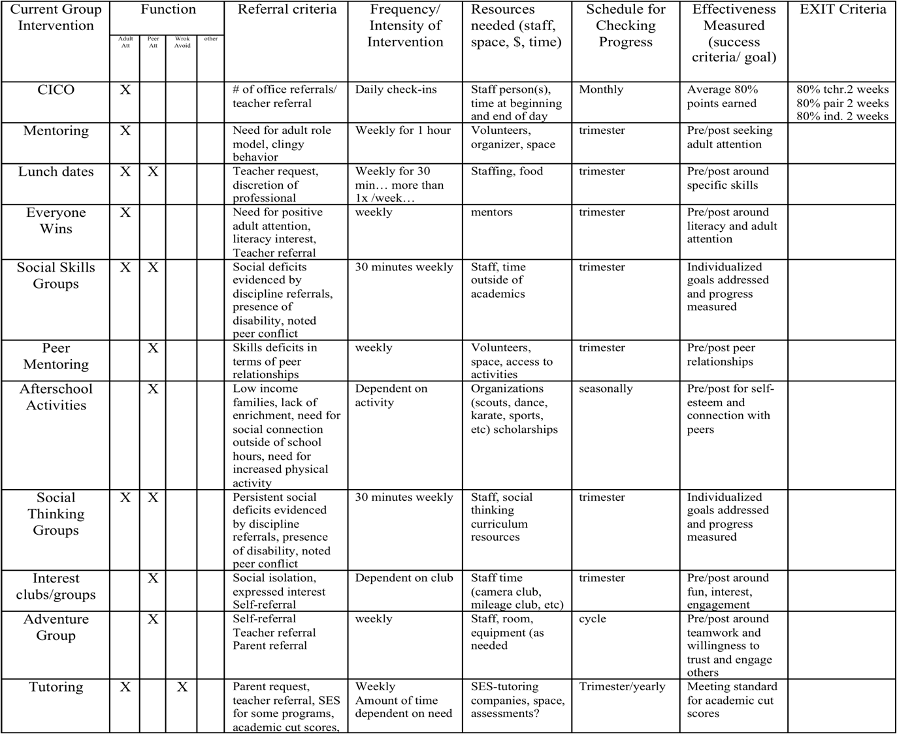
Activity #5:

Benchmarks of Quality (BoQ) TEAM SUMMARY

School_____________________________________ Date_____________________ Benchmarks Score___________

Areas of Strength
Critical Element | Description of Areas of Strength

Areas in Need of Development
Critical Element | Description of Areas in Need of Development

Other Action Items:
Critical Element | Description of Action Items

SAS Summary: Analyzing and Prioritizing the Results

For each system area, follow the steps as outlined below | Overall Perception
For each system area, follow the steps as outlined below | School-wide | Non-classroom | Classroom | Individual Student
1. Use SAS Total Score Report rate overall perspective of PBIS implementation & circle High, Med. or Low | High  Med  Low | High  Med  Low | High  Med  Low | High  Med  Low
2. Using SAS Individual Items Report to list three major strengths | a.  b.  c. | a.  b.  c. | a.  b.  c. | a.  b.  c.
3. Using the SAS Individual Item Report to list three major areas in need of development.  4. For each system, circle one priority area for focusing development activities | a  b.  c. | a.  b  c | a.  b.  c. | Targeted group or  Individual interventions  a.  b.  c.
5. Circle or define activities for this/next year’s focus to support area selected for development | a. Organize a team  b. Define/teach school rules  c. Define consequence systems for appropriate & inappropriate behavior  d. Define a measurement system linked to school improvement goal  e. Establish communication cycles with other school teams  f. Develop implementation plan | a. Define/teach routines  b. Supervisor booster training & feedback sessions  c. Data management  d. Maintain team & communication cycle with other school teams  e. Develop implementation plan | a. Define/teach routines/ link with school wide rules  b. Classroom staff boosters & feedback sessions for creating effective strategies/materials  c. Data management  d. Maintain team & communication cycle with other school teams  e. Develop implementation plan | a. Process for referral & support plan design, implementation & monitoring  b. Plan to develop & use FBA to support skills  c. Data management  d. Maintain team & communication cycle with other school teams  e. Develop implementation plan

Activity #6:
What is the precise nature of our problem (define, clarify, confirm/disconfirm inferences)?

Question: | Fill in the information below:
What problem behaviors are occurring?
When are problem behaviors occurring?
Where are problem behaviors occurring?
Who is engaging in problem behaviors?
Why do problem behaviors keep happening?

What are the actual elements of our plan?

Precise Problem Statement:

Prevention: Remove/alter “trigger” for problem behavior
Teaching: Define, instruct & model expected behavior
Reward: Expected/alternative behavior when it occurs; prompt as necessary
Extinction: Increase acknowledgement of presence of desired behavior
Corrective Consequence: Use non-rewarding/non-reinforcing responses when problem behavior occurs
Data Collection: Indicate how you know when you have a solution

Activity #7:
STATUS:  In place  Partially in place  Not in place | TASK | PRIORITY:  High  Medium  Low
 | Climate
 | 1. There is a process for assessing how welcomed, valued, and satisfied parents are in and with the school.
 | 2. There is a plan for addressing ways to help families feel welcomed and valued.
 | 3. There is a plan for training all staff to work collaboratively and respectfully with families.
 | 4. Plans for addressing ways to help families feel welcomed and valued address diverse families including those with students in the universal, targeted and intensive levels of PBIS.
 | Parent Involvement in Learning Activities at Home
 | 5. There is a process for assessing parents’ opinions about their own involvement in learning activities at home.
 | 6. There is a plan or set of activities for helping families to support their child’s learning at home.
 | 7. The plan includes activities for helping diverse families, including those with students in the universal, targeted and intensive levels of PBIS, support their child’s learning.
 | Communication with Parents/Families
 | 8. There is a process for assessing parents’ opinions about how well schools communicate with them.
 | 9. There is a plan for communicating with families in varied and helpful ways.

Family Engagement Checklist (Muscott & Mann, 2004)
School:_________________________________________ Team:__________________Date:___________

10. The plan includes activities for communicating with diverse families, including those with students in the universal, targeted and intensive levels of PBIS, about important school/home matters including discipline.

Parent/Family Involvement at School (Volunteering, Assisting)

11. There is a process for assessing parents’ opinions about how they can support schools through their involvement at school.

12. There is a plan for how parents can be involved in supporting learning at school through volunteering and assisting.

13. The plan for parental involvement in school activities addresses how diverse families, including those with students in the universal, targeted and intensive levels of PBIS, can participate.

Parent/Family Involvement in Decision-Making

14. There is a process for assessing parents’ opinions about the extent to which they are encouraged to participate in decision-making committees and activities (e.g., leadership teams).

15. There is a plan for encouraging and supporting parent participation in decision-making committees and activities.

16. The plan for parental participation in decision-making committees and activities addresses how diverse families, including those with students in the universal, targeted and intensive levels of PBIS, can participate.

17. There is a process for assessing parents’ opinions about the extent to which they can provide input to school personnel about matters of importance including discipline that is taken seriously.

18. There is a plan for gathering and incorporating parents’ input about matters of importance including discipline that is taken seriously.

19. The plan for gathering and incorporating parents’ input about matters of importance including discipline addresses how diverse families, including those with students in the universal, targeted and intensive levels of PBIS, can be heard.

Activity #8:

VTPBiS Annual Implementation Plan/Roll out

School: __________________________________ Date: ____________________
 | Task to be addressed? | To-Do List | Persons Responsible | Follow-Up or Completion Date
Implementation Plan | - Develop, schedule and deliver plans to teach staff the discipline and data system | 1.  2.  3.
Implementation Plan | - Develop, schedule and deliver plans to teach staff the lesson plans for teaching students | 1.  2.  3.
Implementation Plan | - Develop, schedule and deliver plans for teaching students expectations/rules/rewards | 1.  2.  3.
Implementation Plan | - Booster sessions for students and staff are planned, scheduled, and delivered | 1.  2.  3.
Implementation Plan | - Schedule for rewards/incentives for the year is planned | 1.  2.  3.
Implementation Plan | - Plans for orienting incoming staff and students are developed and implemented | 1.  2.  3.
Implementation Plan | - Plans for involving families/community are developed & implemented | 1.  2.  3.

Planning Staff Roll-out

Staff PBIS Roll-Out

Date:

Time:

Location:

Materials Required (check or list all that apply):

Agenda ____ Handouts ____ Other _____________________________________

Technology Supports LCD ____ TV/DVD/VIDEO _____ Screen ______ Easel ______ Chart Paper ______ Markers ______ Other _______

Presenters: __________________ ; ___________________ ; ____________________ ;

______________________ ; ________________________; ______________________

Activities (attach work sheets, if needed) Amount of Time

1. ____________

2. ____________

3. ____________

4. ____________

Evaluation/ Feedback Method (check all that apply)

Survey _____ Process Activity _____ Interview ______ Other ____________________________

Planning Student Roll-out

Student PBIS Roll-Out

Date:

Time:

Location:

Materials Required (check or list all that apply):

Agenda ____ Handouts ____ Other _____________________________________

Technology Supports LCD ____ TV/DVD/VIDEO _____ Screen ______ Easel ______ Chart Paper ______ Markers ______ Other _______

Presenters: __________________ ; ___________________ ; ____________________ ;

______________________ ; ________________________; ______________________

Activities (attach work sheets, if needed) Amount of Time

1. ____________

2. ____________

3. ____________

4. ____________

Evaluation/ Feedback Method (check all that apply)

Survey _____ Process Activity _____ Interview ______ Other ________________________________

Planning VTPBiS Roll-out for Families

Family and Community PBIS Roll-Out

Date:

Time:

Location:

Materials Required (check or list all that apply):

Agenda ____ Handouts ____ Other _____________________________________

Technology Supports LCD ____ TV/DVD/VIDEO _____ Screen ______ Easel ______ Chart Paper ______ Markers ______ Other _______

Presenters: __________________ ; ___________________ ; ____________________ ;

______________________ ; ________________________; ______________________

Activities (attach work sheets, if needed) Amount of Time

1. ____________

2. ____________

3. ____________

4. ____________

Evaluation/ Feedback Method (check all that apply)

Survey _____ Process Activity _____ Interview ______ Other _______________________
NOTES:

