

**Student Affairs Committee**

Minutes

427a Waterman

May 10, 2018

8:30-10:00

**Present** Kenneth Allen (CNHS), Jamie Benson (SGA), Thomas Chittenden (GSB), Dan DeSanto (LIB), William Louisos (CEMS), Omar Oyarzabal (EXT), Cathy Paris (FS President), Jennifer Prue (CESS), Martin Thaler (CAS), Nancy Welch (CAS)

**Absent** Zail Berry (COM), Mia Hockett (LCOM), Trish O’Kane (RSENR), Stephen Pintauro (CALS)

**Guests** Veronika Carter, Naima Denis, Sarah Warrington

Co-Chair Jennifer Prue called the meeting to order at 8:32 in Waterman 427a.

**Minutes.** The minutes of April 12, 2018 were approved as written.

**SAC Operating Procedures.** The SAC reviewed and approved the SAC Operating Procedures. The committee will revisit the procedures at the September 2018 meeting. They will make changes at that time if it is so needed.

**Faculty Senate Student Affairs Committee (SAC)**

**Operating & Voting Procedures**

**SAC Responsibilities & Membership (Source: Faculty Senate By-Laws)**

**7.1.5.3 Student Affairs Committee. This committee shall have responsibility for matters relating to student affairs, their effect on the educational process, and the academic climate of the University, including items referred to in Sections 1.1d, 1.2e, 1.2f, 1.4, and 1.5. It shall recommend policy with respect to honors programs, remedial programs, athletics, discipline, health service, placement, housing, student activities, etc. It shall include among its duties in-depth and ongoing review of University admissions and financial aid policies, including their relation to projected enrollments. This committee shall establish policy in matters related to general admissions standards and prerequisites, as referred to in Section 1.1d, and shall review, recommend and participate in formulation of admissions procedures. The committee shall establish a continuing liaison with student government groups and with all appropriate administrative and academic offices.**

**7.1.2.1 Elected Members.**

a. Number. Except as described below, standing committees and standing subcommittees shall be composed of at least one member from each of the major academic units (the Colleges of Arts and Sciences, Agriculture and Life Sciences, Education and Social Services, Engineering and Mathematics, and Medicine; the College of Nursing and Health Sciences, Business Administration, and Natural Resources; and the Officers of Extension, and of the Libraries. A unit with more than 200 full-time eligible faculty members may elect one additional member to each standing committee and standing subcommittee.

b. Eligibility. Any eligible faculty member may stand for election by his/her college or school to serve on a standing committee except as otherwise stated in these Bylaws.

c. Term. Members of the standing committees shall be elected for three years or as otherwise stated in these Bylaws, starting on July 1. Terms shall be staggered so that approximately one-third of the standing committee members shall be elected each year.

d. Election. The election of standing committee members shall be the responsibility of the individual college and school faculties. Elections shall be held no later than April of each year and shall be conducted by secret ballot distributed to all eligible faculty members of the college/school. An opportunity must be provided for all eligible faculty members to volunteer to run for election to Senate standing committees. The Faculty Senate shall supervise the elections of Senate Standing Committees; concerns regarding election irregularities must be communicated to the Senate President by May 1.

e. Vacancies. If a standing committee member vacates his/her seat the vacancy shall be filled by a special election within the unit from which s/he was elected. The term of a member under these circumstances shall commence immediately and shall normally be for the unexpired term of the regularly elected member. If a standing committee member is granted leave for one year or less a replacement shall be elected by a special election within the unit from which s/he was elected to take the absent standing committee member’s seat for the period of the leave.

f. Attendance. A standing committee member absent from three committee meetings in a calendar year in the absence of mitigating circumstances will be considered to have vacated his/her seat.

g. Members of the Senate. A standing committee member may also serve as an Elected Senator. Standing committee members are members of the Senate without vote if not also an Elected Senator.

**7.1.3 General Duties of Standing Committees.**

1. They shall recommend policy and changes in policy in their areas of responsibility to the Faculty Senate. They may initiate action on matters clearly within their province and request that they be placed on the agenda of the Senate meeting by the Executive Council.
2. They shall receive and consider policy proposals in their areas of responsibility from the Faculty Senate, the administration, student bodies, etc., and present their recommendations to the Faculty Senate for action.
3. They shall consider budgetary implications for policies in their areas of responsibility and make appropriate recommendations to the Faculty Senate and the administration regarding University priorities.
4. They shall annually review sections of the Officers' Handbook pertaining to their areas of concern and make recommendations for revision.
5. They shall consult with and provide advice to the administration, student groups, etc., in their areas of responsibility when requested to do so. Policy proposals generated as a result of these consultations shall be presented to the Faculty Senate for consideration and action.
6. They shall keep records of their activities and present reports at least once a year to the Faculty Senate.
7. They shall maintain close liaison with appropriate committees and groups established by the individual academic units, the student governing bodies, the Staff Council, and other University constituencies.
8. They shall meet frequently in order to promptly and responsively discharge their duties to the Senate, the faculty, and the University as a whole.

**Committee Procedures**

**Meetings (Dates, Times, Location)**

* The SAC has a standing meeting time scheduled on Thursdays from 8:30 - 10:00 AM. On occasion the length of the meeting time may be extended if required to meet deadlines. Elected members should have a schedule that allows for regular attendance at meetings on Thursday mornings at the designated time.
* Agenda items for each meeting are determined by the Chair/Co-Chair. These agenda items are identified from the following sources:
  + Committee members
  + SGA requests or resolutions.
  + Faculty Senate Leadership (President, Vice President, Executive Council..) requests.
  + Administration requests
* Agenda item priorities are determined by the committee during the May meeting and regularly during the ‘Other Business’ end of meeting discussion.
* It is the responsibility of the SAC Chair to notify all members of the specific dates, times, and locations of committee meetings.
* Throughout the academic year, the SAC may also spend meeting time discussing general issues of relevance to the work or functioning of the committee.

**Materials**

Meeting materials will be sent to the committee from the Chair/Co-Chair or the Faculty Senate Office the Friday before each meeting (generally). Members are expected to review meeting materials prior to the meeting. Committee members are also welcome to share materials prior to meetings to inform discussions.

**Voting Rights**

The Undergraduate and Graduate Student representatives on the Student Affairs Committee have equal voting rights to all other elected members of the Committee.

***Definitions of Voting Terms***

**Yes**: A "Yes" vote is a determination by a voting-eligible committee member that an action under review is supported.

**No**: A "No" vote is a determination by a voting-eligible committee member that an action under review is not supported. In such cases, committee members voting “No’ are encouraged to offer reason(s) for the "No" vote to be included in the meeting minutes.

**Abstain**: An abstention occurs when a voting-eligible committee member, who has the opportunity to vote, makes an active choice to vote neither "Yes" nor "No". As active choice, abstention differs from not voting due to absence. The option to abstain is discouraged, but may be an appropriate option in a small number of circumstances where a voting-eligible faculty member has personal or professional reasons that interfere with making a fair and unbiased determination. It is helpful to specify the reason(s) for an abstention but not expected.

**Recusal**: A recusal is recorded when a SAC member determines it would be inappropriate for them to vote on the matter at hand. This is entirely self-enforcing.

**Absent:** If a voting-eligible SAC member is not in attendance at a meeting and does not actively submit a proxy vote (i.e., Yes, No, Abstain) by email to the Chair, the available vote will not be recorded in the vote tally.

**•** When the review process is completed each semester, the votes and corresponding narrative will be submitted to the Office of the Provost.

A motion is to pass the Student Affairs Committee if the majority of the quorum in attendance supports the measure.

**Units Selecting Members to Join the SAC**

• When a vacancy occurs within in unit for an opening on the SAC, the Faculty Senate Office notifies the unit, which then holds an election for a faculty member to represent them on SAC.

**Continuous Improvement & Reporting**

• Throughout the year the SAC Chair / Co-Chair will maintain a log of issues and ideas pertaining to: future agenda items, operational process improvements, conduct of meeting practice and so on.

• At the end of the spring semester, the SAC Chair / Co-Chair will prepare a summary report to be submitted to the Faculty Senate and the Office of the Provost describing the work of the committee during the academic terms and key issues and ideas related to ongoing improvement.

• At least once annually, before May 15th of each academic term the SAC should review its operating procedures, propose specific changes if needed, and submit to the Senate Executive Council for review and approval.

*First approved by the Student Affairs Committee: May 10, 2018*

**GPP Resolution, Nancy Jenny.** The resolution was approved by the SAC.

Other community members that could be included.

* Support center (Libraries) representation
* Residential Life representative (staff, lead RAs, etc.)
* Student Collaboration representation

The discussion of GGP will continue to be on the agenda for the 2018 / 2019 academic ye the ar. The resolution is to facilitate and give Gayle Nunley and Brian Reed guidelines on how the SAC feels the structure and charge of new committee should be.

**Advising and Retention Tool, Sarah Warrington and Jennifer Prue.**

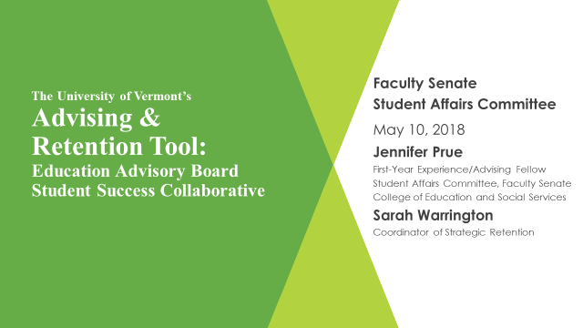

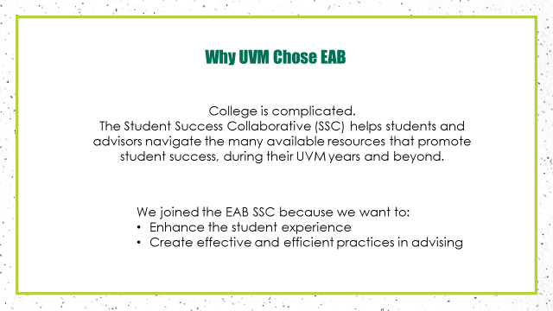

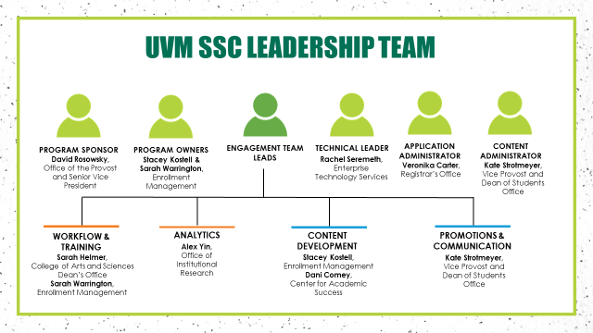

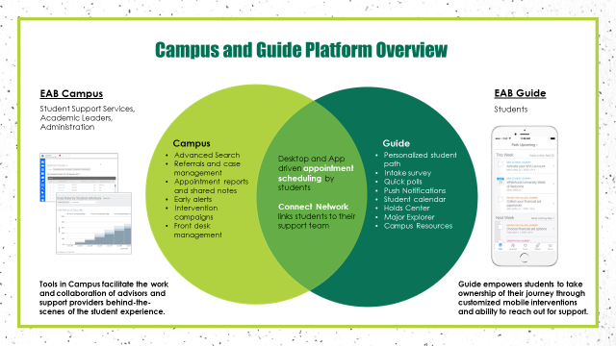

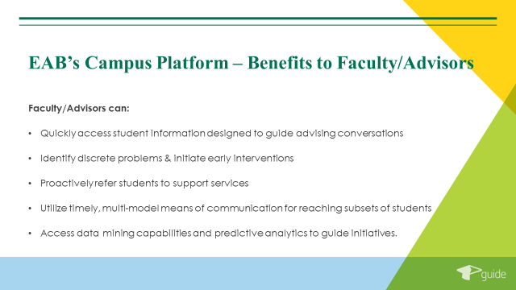



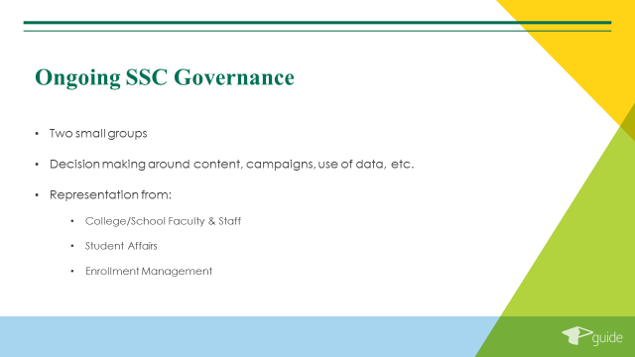

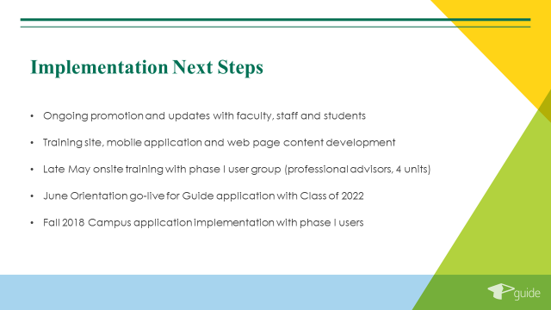

Sarah Warrington will continue to report back to the SAC throughout the implantation process**.**

**UVM Portal.** Ideas from SAC to be included to the UVM Portal

* Holiday Calendars
* ACCESS information
* Academic Integrity policies
* Libraries Information

Portal requests for content go directly through the Registrar’s Office (David Alles) and they coordinate with Student Life. Student Life has complete control over 1st year content. Both the Registrar’s Office and Student Life meet monthly to discuss any issues. The new advising software, EAB will be a good tool to add some of these topics in a way that students will be able to find easily. A new process on where the information should live, either in the portal or EAB will be created. There will be a link to EAB from the Portal and the Registrar website.

**Topics for the 2018-2019 Academic Year**

* Learning Communities (Partner with the FPPC)
  + WE Community
* Student Mandates
* GGP
* IBB
* Joint meeting with ERTC (December)
* CAS and the arts

The meeting adjourned at 10:07. The next meeting of the SAC is scheduled for September 13, 2018 from 8:30am to 10:00am in Waterman 427a.