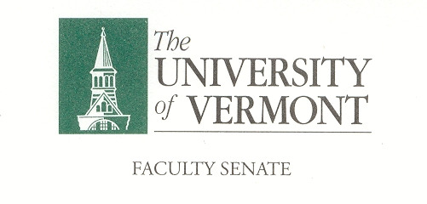

Student Affairs Committee
Minutes

427a Waterman
February 14, 2019
8:30-10:00

Present Kenneth Allen (CNHS), Sin Yee Chan (CAS), Thomas Chittenden (GSB), Jonathan Flyer (LCOM), Patricia Mardeusz (LIB), Omar Oyarzabal (CALS), Nancy Welch (CAS)

Absent Aarzoo Grover (GSS), Mia Hockett (LCOM), William Louisos (CEMS), Jennifer Prue (CESS), Trish O’Kane (RSENR), Cathy Paris (FS President),

Guests Laura Clemmons, Sharon Mone

Co-Chair Thomas Chittenden called the meeting to order at 8:32 in Waterman 427a.

- Minutes. The minutes of January 17, 2019 were approved as written.

- UVM Student Accessibility Services, Sharon Mone & Laura Clemmons. UVM Student Accessibility Services is currently serving 1518 active students, 48 perspective students and 63 provisional students. They also service temporary students, this includes students with temporary situations (broken arm, concussion, etc.). Mental health is the highest and fastest growing area for accommodations.

  - What is the availability of a psychiatrist?
CAPS will accommodate a same day appointment if the student needs it. For weekly appointments it would take about two weeks to get into the CAPS program.
  - International Students often use the counseling services, are their accommodations for translators for these students?
    - This is a question for CAPS, Vermont Physical Services, in Dewey Lab. The program is Cultural Cross Roads, it is a community wide service that also treats UVM students.

- Course Evaluation Software Update. The committee has decided on a vendor. It is still in the RFP process so the vendor cannot be disclosed at this time. Thomas will do a full presentation at the March or April meeting on the software.

- Student Survey Discussion, Omar Oyarzabal. The survey was sent on Monday, February 11th to 1,007 students. The group was selected by OIR. As of last night, there were less than 200 completed. Omar will follow up with a reminder, there is concern that we haven’t even hit 20% completion this first round. Nancy will draft a communication that would be sent to the Provost for the next meeting, she will work with Omar on this. Omar will explore finding someone with a legal background to help direct some of these conversations.

- SGA Safe Ride and Public Transportation Initiative. Charlotte Manning from the SGA is pushing this forward, her next step is an RFP. This initiative would add to the student fees. The fee could be as low as $1 but it has not yet been determined. They would contract with a company (like Green Cab) to provide rides to students during the peak times. These times would include Thursday through Saturday from 12am to 3am. These rides would be provided at a fixed or reduced rate.

- New Business. Nancy would like discuss the structure of student fees at a future SAC meeting.

The meeting adjourned at 10:03 am. The next meeting of the SAC is scheduled for March 7, 2019 from 8:30am to 10:00am in Waterman 427a.

