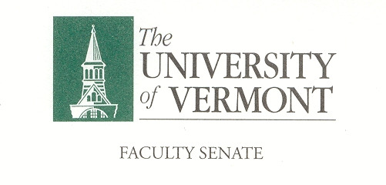
Student Affairs Committee
May 9, 2019
Waterman 427a
8:30am -10:00am

Agenda

- GGP/International Student Advisory Committee Update – Susan Marie Harrington. 20 Minutes

- Students Rights and Responsibilities Continued Discussion about Mandatory Outside of Class Meeting Events – Ken Allen. 20 Minutes

- Student Wellness Resources Advocacy – SGA Resolution – Cha Srna & Thomas Chittenden. (Resolution attached). 25 Minutes

- Priorities for Next Year Discussion. 10 Minutes

Charge of the SAC
This committee shall have responsibility for matters relating to student affairs, their effect on the educational process, and the academic climate of the University, including items referred to in Sections 1.1d, 1.2e, 1.2f, 1.4, and 1.5. It shall recommend policy with respect to honors programs, remedial programs, athletics, discipline, health service, placement, housing, student activities, etc. It shall include among its duties in-depth and ongoing review of University admissions and financial aid policies, including their relation to projected enrollments. This committee shall establish policy in matters related to general admissions standards and prerequisites, as referred to in Section 1.1d, and shall review, recommend and participate in formulation of admissions procedures. The committee shall establish a continuing liaison with student government groups and with all appropriate administrative and academic office

