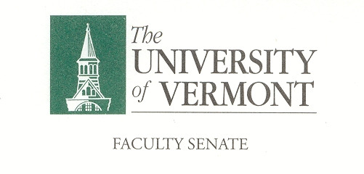
Student Affairs Committee
March 7, 2019
Waterman 427a
8:30am -10:00am

Agenda

- Agenda Review
- Minutes of February 14, 2018
- SAC Academic Calendar Resolution Update – Thomas Chittenden (5 minutes)
- Credit Bearing Residential Learning Communities Discussion – Thomas Borchert (30 minutes)
- Student Rights & Outside of Class Required Attendance Events Survey and Next Steps – Omar Oyarzabal (30 minutes)
- SAC Chair Nominations (10 Minutes)
- Adjourn

Meeting Schedule 2019:
SAC
Thursday
8:30-10:00
4/18/19
5/9/19

Charge of the SAC
This committee shall have responsibility for matters relating to student affairs, their effect on the educational process, and the academic climate of the University, including items referred to in Sections 1.1d, 1.2e, 1.2f, 1.4, and 1.5. It shall recommend policy with respect to honors programs, remedial programs, athletics, discipline, health service, placement, housing, student activities, etc. It shall include among its duties in-depth and ongoing review of University admissions and financial aid policies, including their relation to projected enrollments. This committee shall establish policy in matters related to general admissions standards and prerequisites, as referred to in Section 1.1d, and shall review, recommend and participate in formulation of admissions procedures. The committee shall establish a continuing liaison with student government groups and with all appropriate administrative and academic office

