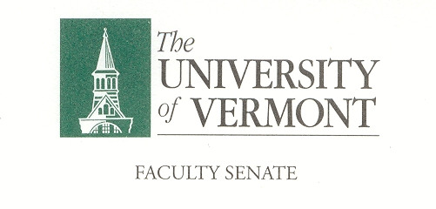

Student Affairs Committee

February 14, 2019

Waterman 427a

8:30am -10:00am

**Agenda**

1. Minutes of January 17, 2018– 5 Minutes.
2. UVM Student Accessibility Services, Laura Clemmons & Sharon Mone (45 minutes)
3. Course Evaluation Software Group RFP Final Report, Thomas Chittenden (20 minutes)
4. SGA Safe Ride and Public Transportation Initiative, Thomas Chittenden (20 minutes)
5. Student Survey on Outside of Class Required Events Check-In, Omar Oyarzabal

6.       Adjourn

**Meeting Schedule 2019:**

|  |
| --- |
| **SAC** |
| **Thursday** |
| 8:30-10:00 |
| **3/7/19** |
| **4/18/19** |
| **5/9/19** |

*Charge of the SAC*

*This committee shall have responsibility for matters relating to student affairs, their effect on the educational process, and the academic climate of the University, including items referred to in Sections 1.1d, 1.2e, 1.2f, 1.4, and 1.5. It shall recommend policy with respect to honors programs, remedial programs, athletics, discipline, health service, placement, housing, student activities, etc. It shall include among its duties in-depth and ongoing review of University admissions and financial aid policies, including their relation to projected enrollments. This committee shall establish policy in matters related to general admissions standards and prerequisites, as referred to in Section 1.1d, and shall review, recommend and participate in formulation of admissions procedures. The committee shall establish a continuing liaison with student government groups and with all appropriate administrative and academic office*