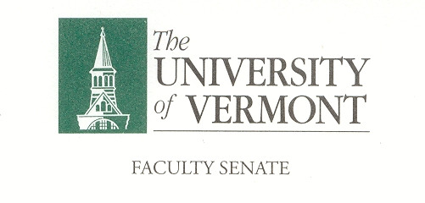

Research, Scholarship & the Creative Arts Committee

April 12, 2018

427a Waterman 12:30-2:00

Present: Chris Burns (LIB), Steve Keller (CALS), Tammy Kolbe (CESS), David Neiweem (CAS), Cathy Paris (Faculty Senate President), Jessica Sheehe (GSS), Albert van der Vliet (COM)

Absent: Steve Budington (CAS), Seth Fritz (CNHS)*, Rachelle Gould (RSENR)*, Vacant (COM), Jeffrey Marshall (CEMS), Matthew Price (CAS), Chuck Schnitzlein (GSB)*

Guests: No Guests

Chair Chris Burns called the meeting to order at 12:31pm in 427a Waterman.

- Approval of the Minutes. The minutes of March 8, 2018 were approved as written.

- University Distinguished Professors. The committee went into executive session to discuss nominations for the honor of University Distinguished Professor.

- RSCA Chair 2018/2019. Chris Burns expressed interest in continuing as the 2018 /2019 RSCA Chair. He also encouraged anyone else interested in the position to consider running. The idea for a co-chair was discussed. The Faculty Senate will e-mail the committee looking for nominations. Once the nomination process is complete there will be an election. The chair or Co-Chairs of the committee will be determined by the May meeting.

- Burack Lectures. The committee went into executive session to discuss Burack Lecture nominations. Chris Burns and Matthew Price recused themselves from the discussions as they had put forth nominations. The Faculty Senate Office will send the committee’s recommendations to Gary Derr.

- New Business. There was no new business at this time.
*Provided feedback on the Burack Lectures
The meeting was adjourned at 1:52pm
The next meeting of the RSCA is scheduled for Thursday, May 10, 2018 from 12:30 – 2:00 in 427a Waterman.

