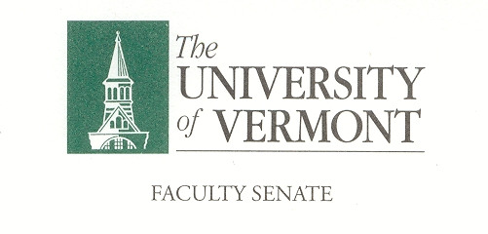

Research, Scholarship & the Creative Arts Committee

January 10, 2019

427a Waterman 12:30-2:00

Present: Brandon Ackley (GSS), Chris Burns (LIB), *Britt Holmen (CEMS), Steve Keller (CALS), Dimitry Krementsov (CNHS), David Neiweem (CAS), Cathy Paris (Faculty Senate President)

Absent: Steve Budington (CAS), Mary Cushman (LCOM), Rachelle Gould (RSENR), Tammy Kolbe (CESS), **Matthew Price (CAS), Chuck Schnitzlein (GSB), Albert van der Vliet (COM), Chun Zhang (GSB)

Guests: Cindy Forehand (Dean of Graduate College)

Chair Chris Burns called the meeting to order at 12:32pm in 427a Waterman.

- Approval of the Minutes. The minutes of December 6, 2018 will be voted on at the February meeting.

- Presidential Search. The candidates’ names have not been released. The Faculty Senate will have an opportunity to meet the candidates on they have been determined. There is also a chance for Graduate students to meet with the candidates. Themes the RSAC would like to see addressed in the interviews are as follows.

  - Graduate Students are concerned about interdisciplinary work.
  - Support of graduate student travel.
  - What is the plan for global exposure for UVM. Promoting an international presence.
  - Under IBB how the focus is shifting away from research and the value of it.
  - How would the new president lift the reputation of the University of Vermont
  - Funding and what are some ideas around finding ways to help with funding.

- Dean of Libraries Search, both Chris Burns and Michael Giangreco (PSC) are on this committee as representatives from the Faculty Senate. The RSCA would like a more formal role in the Dean of Libraries search. Chris will work with Gary Derr to see how this would be possible. A major concern of the committee is on research and how it is stored.
- Spring RSCA Items.
  - Cindy will be focusing more on curricular work this Spring however she is always willing to update the RSCA at any time.

- New Business. There was no new business at this time.
The meeting was
Adjourn at 2:00pm. A
*Via phone:5
**On Leave2pm
The next meeting of the RSCA is scheduled for Thursday, February 14, 2019 from 12:30 – 2:00 in 427a Waterman.

