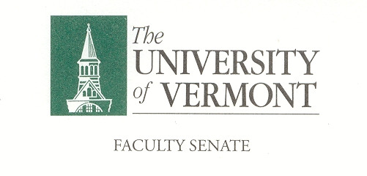

Research, Scholarship & The Creative Arts
January 10, 2018
Waterman 427a
12:30-2:00pm

Agenda

- Approval of the December Minutes
- Presidential Search
- Dean of Libraries Search
- Spring Agenda Items
- New Business
- Adjourn

Next meeting is 2-14-2019 from 12:30-2:00 in 427a Waterman

CHARGE OF THE RSCA
This committee is responsible for matters relating to research activities, scholarly work, and creative and performing arts carried out at the University, including graduate education and items referred to in Sections 1.1c, 1.2b, 1.2g, and 1.2k in the Faculty Senate bylaws. The RSCA reviews, recommends, and participates in the formulation of policy with respect to resources related to these activities, including physical facilities and allocation of appurtenant space, library resources and resources for graduate programs, and makes recommendations to assure effective use of these resources. The RSCA serves as liaison between the Senate and the administration on such matters as, but not limited to: the broad role of the University in advancing knowledge through research, scholarship, and the performing arts; external and internal support for encouraging these activities, including graduate and undergraduate research; intellectual property, and technology transfer; ethical issues and issues affecting the academic environment as these arise in research or scholarly work. The RSCA consults frequently with other University and collegiate committees that are charged to initiate, maintain, and monitor institutional support programs for research, scholarship, the creative arts, and graduate education, as well as maintains close liaison with appropriate administrative offices in its areas of responsibility.

