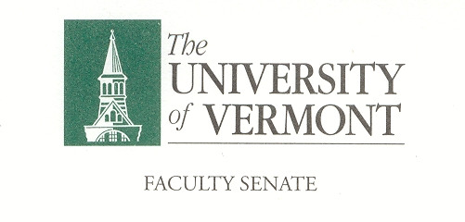
Financial & Physical Planning Committee
September 10, 2018
2:00-3:30pm
Waterman 427a

Agenda

- 2:00-2:05 Minutes

- 2:05-2:15 Review last year

- 2:15- 2:45 Richard Cate, Chief Financial Officer on UVM financial situation

- 2:45- 3:15 Rory Waterman, CAS Associate Dean on First year Courses for Learning Communities / changing COMU 1 from 3 to 1 credit.

- 3:15-3:30 New Business

- Adjourn

Charge of the Financial & Physical Planning Committee
This committee shall have responsibility for matters relating to planning and use of the institution's physical resources and for matters related to the formulation of the University budget with the exception of items subject to collective bargaining. It shall assist in the formulation of the University budget so that the Bylaws reflect the instructional, intellectual, and service priorities of the institution. The committee shall assume responsibility for informing the administration of educational priorities and needs and see that these are considered in all planning. It shall seek advice from the various academic units relative to planning for physical facilities, environmental resources, and the allocation of space, and make recommendations to assure effective and responsible use of resources. It shall maintain close liaison with all appropriate subcommittees of the Board of Trustees as well as all appropriate administrative offices and committees in its areas of responsibility.

