Cloud For Good

UVM Marketing Cloud Documentation

Table of Contents
Campaigns 2
Create New Campaign 2
View Existing Campaign 3
Use a Campaign 4
Reporting 6
Create a New Standard Report 6
Create a New Discover Report 8
Journey Builder 9
Create A New Journey 10
Entry Sources 12
Activities 12
Journey Settings 14
Automation Studio 18
Activities 19
Create New Automations 20
Email Send Process 22
Data 22
Create New Data Extension 26
Salesforce Data Extension or Data Extension 27
Create a Campaign 28
Build an Email 29
Sending the email 37

Campaigns
Campaigns are a way to report on and visually separate different emails and other elements inside of Marketing Cloud. When you first log in you will see in the top-level menu the link for Campaigns.
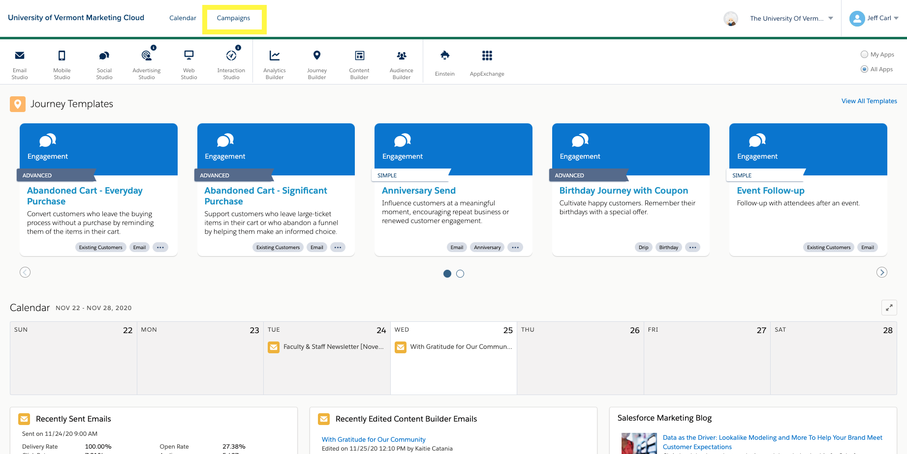

Once in the campaign section of Marketing Cloud you will see a list of your current campaigns and tags. Most of the Tags have been automatically created by Einstein to keep track of your content. From here you can create a new campaign or view details of your existing campaigns.

Create New Campaign
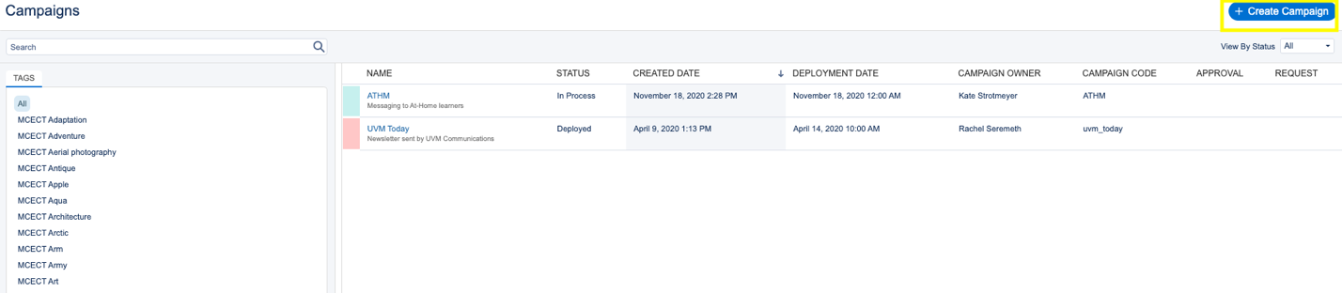
To create a new campaign, click the blue Create Campaign button in the upper right.

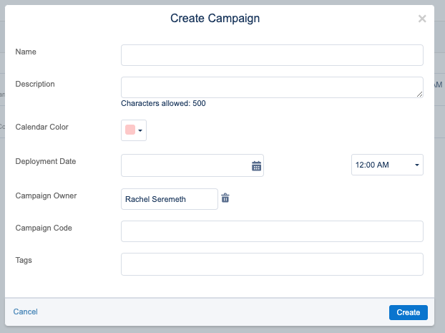
Then fill out the appropriate campaign details. It can be helpful if you have a lot of campaigns to pick a specific color for each, so you can easily tell the difference between them. The deployment date is when you want it to start tracking (usually you can just put today’s date). The campaign code is a shortened version of the name for tracking purposes. And again, Tags are optional and typically not needed.

View Existing Campaign
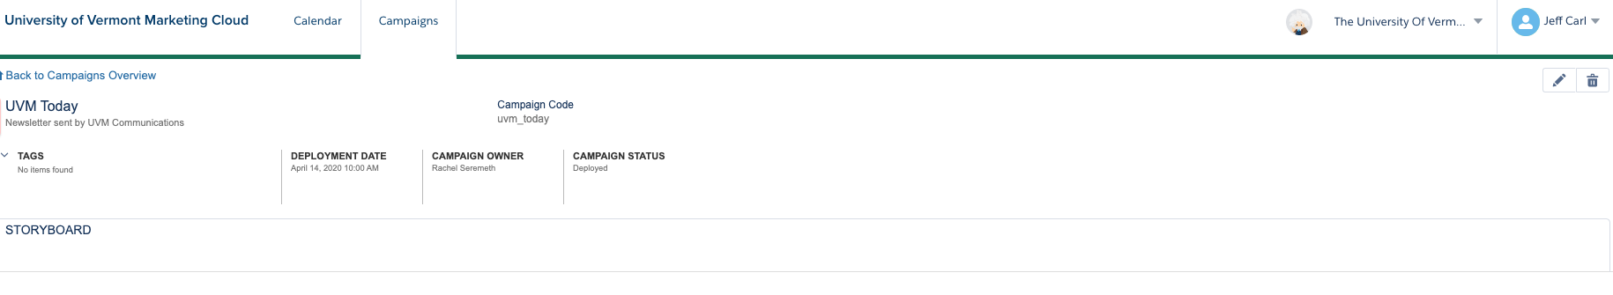
To view details and performance of a current campaign, click the name of the campaign in the list. From here you can see the details from when the campaign was created, edit, delete, and view the campaign history.

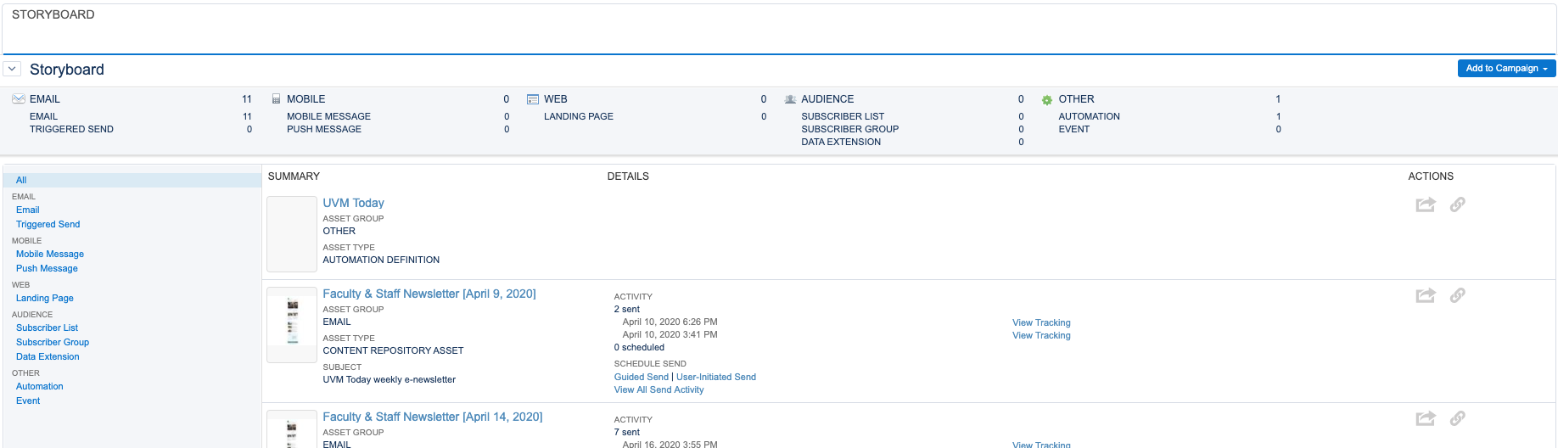
If you click STORYBOARD you can view the sending history for this campaign broken out by channel and type.

Use a Campaign
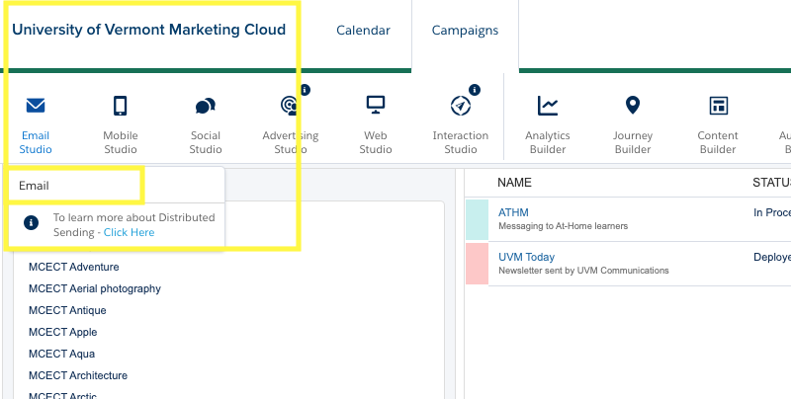
To use a campaign, you will assign the campaign to an email. From the campaign screen or any other place inside of Marketing Cloud, hover over the menu in the upper left titled “University of Vermont Marketing Cloud” then the submenu of “Email Studio” and finally click on “Email”.

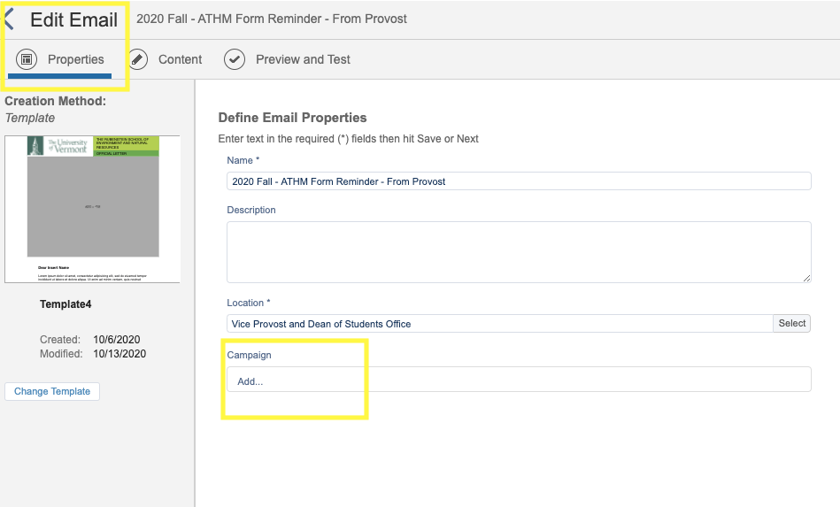
Select an existing email or create a new email and pick your campaign in the Properties section of the email.
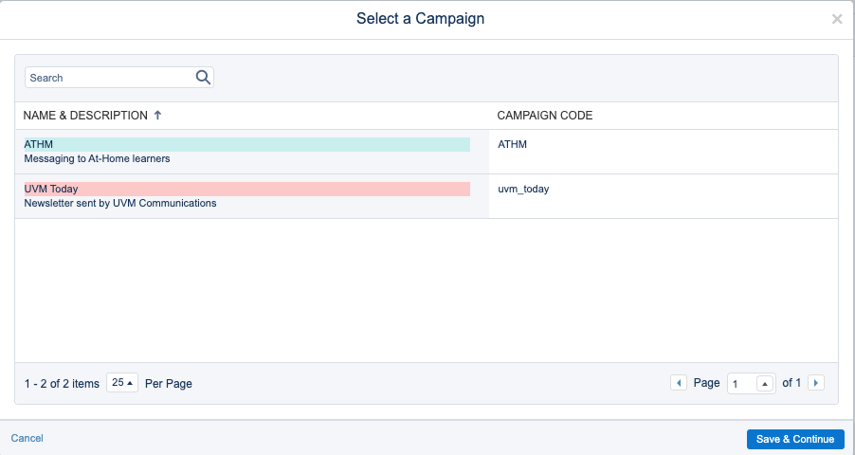
When you click Add you will see a list of all current campaigns to select from. Select your campaign and click Save & Continue.

Reporting
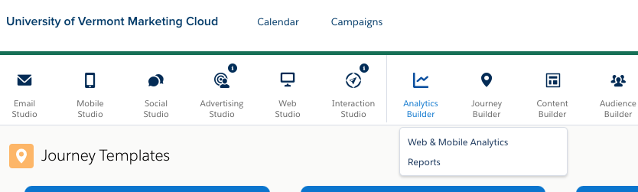
Aside from Campaign level reporting (see above) you can also run reports in the Analytics Builder tool. To get to these reports from the main menu hover of Analytics Builder and click Reports.

From here you will have two main report types, Standard and Discover. The overview page will show all saved reports. To create a new report click View Catalog to see all available reports.

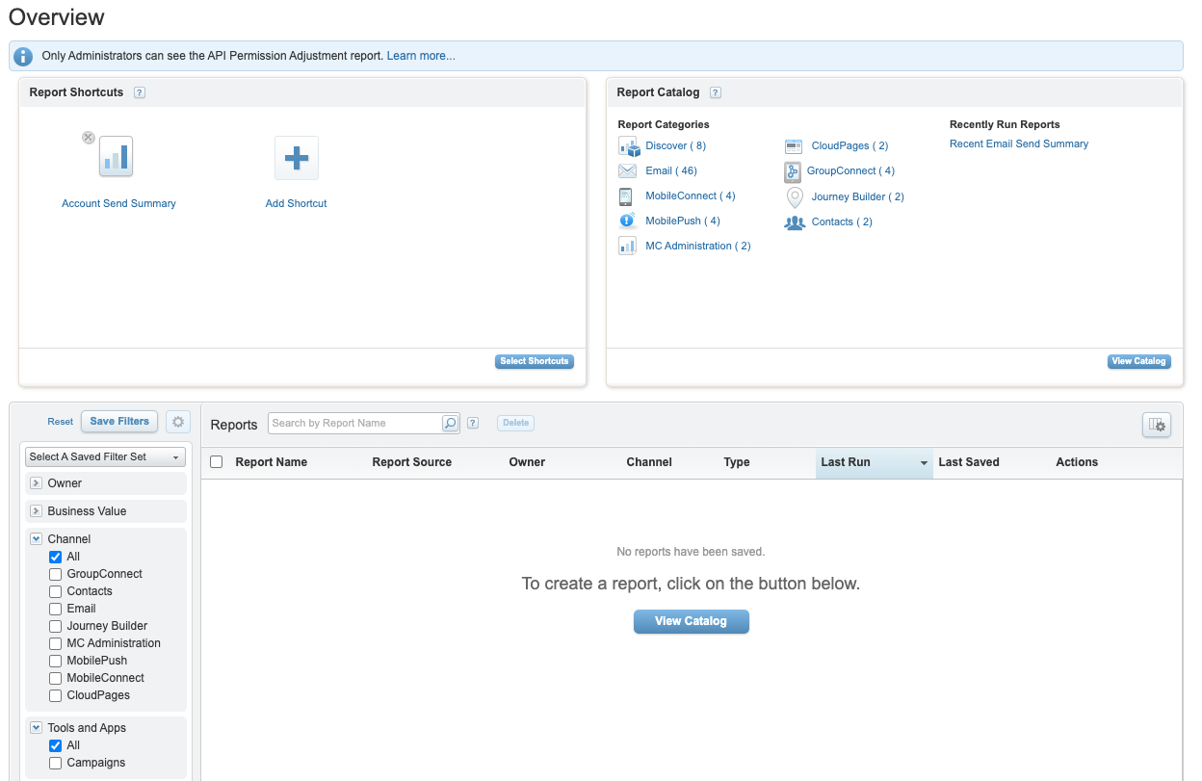
Create a New Standard Report
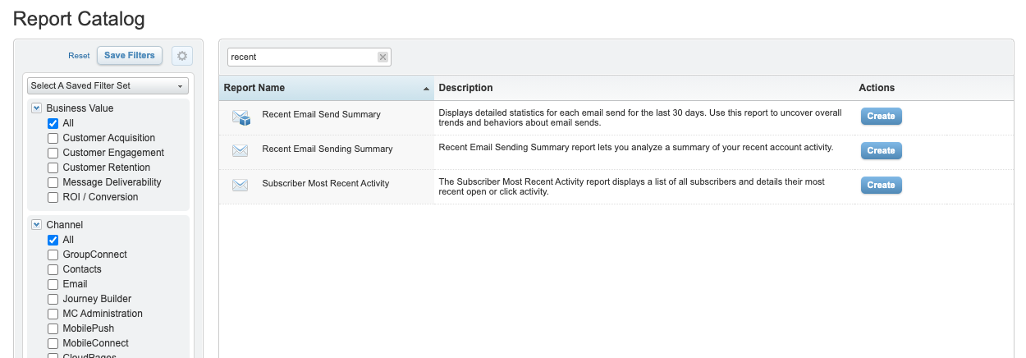
A popular standard report is the Recent Email Sending Summary. If you know the name of the report, you can search in the top search bar.

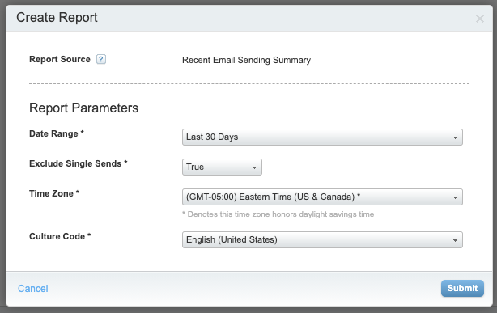
When you find the report you want click the Create button which will bring up some options unique to each report. For the Recent Email Sending Summary the following are your options:
After you hit Submit you will be taken to the report where, depending on the report, you can view the results on screen. For all reports you can export, email, or download the results.

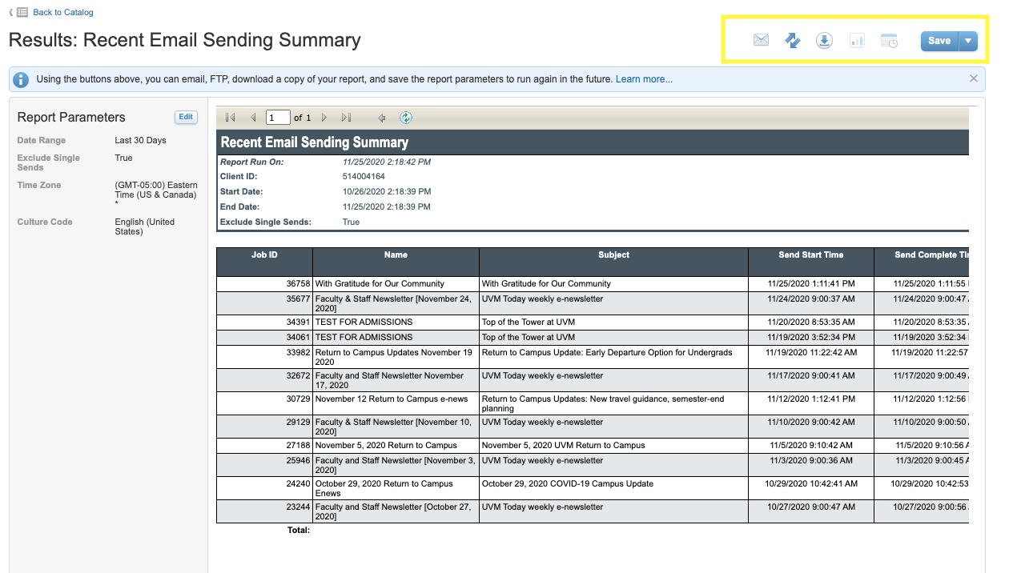
At this point you can also save the report to run with the same settings in the future.

Create a New Discover Report
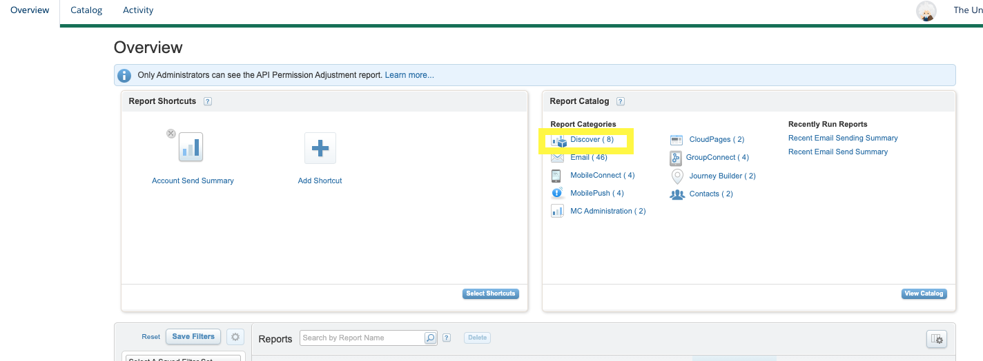
To create a Discover report you can either filter the report catalog on the Discover type. Or from the Overview page click Discover in the box to the right.

Here you will see the filtered list of the available Discover reports. Again, we will select the Recent Email Send Summary, but instead of seeing report parameters it takes us to the report builder.
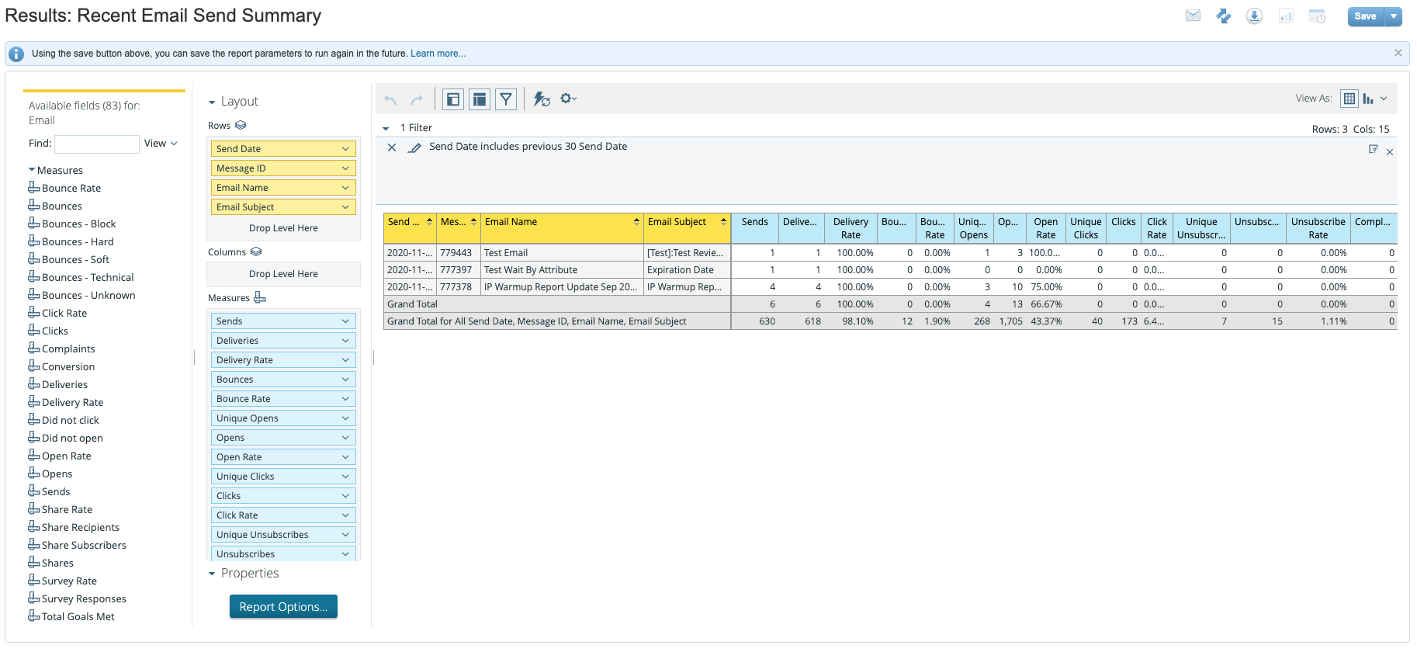
On this screen you will have all available fields on the far left, the layout sections which is where you drag the fields to the right of that, and the report preview on the main portion. Once you have the fields you want in the columns, rows, and measures you can also add a filter above the report sample that limits the results to a specific time frame or any of the other available fields you might want to filter on. Similar to standard reports you can save the report for easy access and you can have it emailed to you on a schedule.

Journey Builder

You will want to use Journey Builder anytime you are creating a multi-channel or a multi-step campaign. This could be as simple as Emailing subscribers with a couple days wait in between or more advanced where you are checking to see if they clicked a specific link or using Einstein AI to do send time optimization.

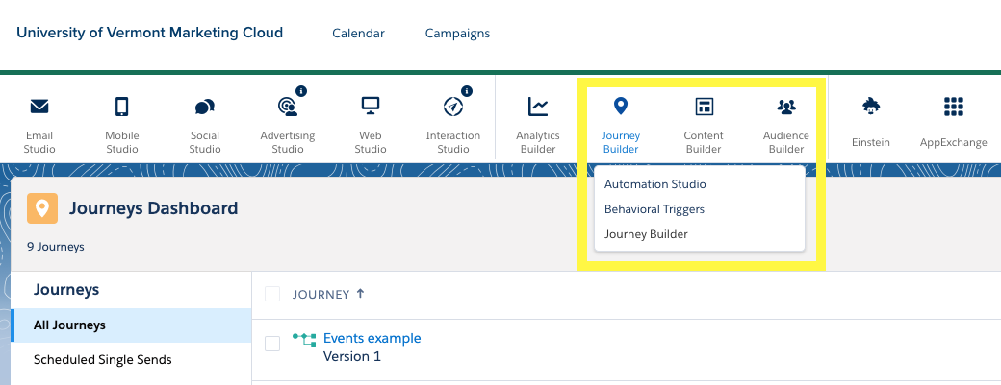
To get to Journey Builder select it from the main menu, and then the submenu (just like email studio it is listed twice).

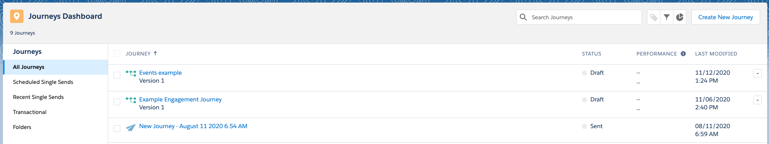
From here you will see the Journey Dashboard. This will list all of your Journeys and at a glance you can see their Status, when they were last modified, and if you set up a goal in your journey (we will touch on this later) how the journey is performing.

Create A New Journey

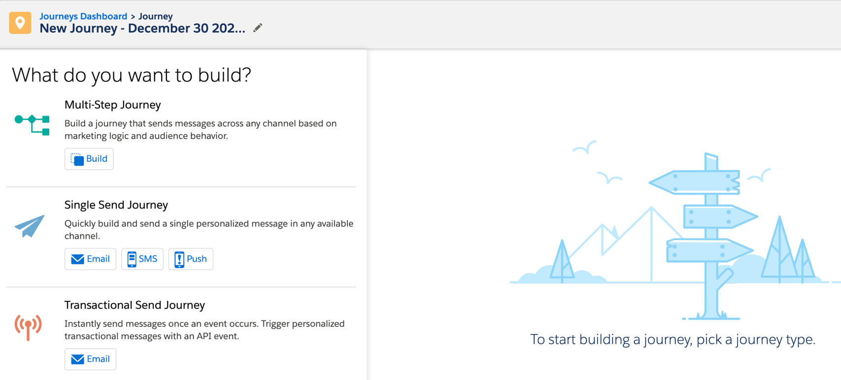
To create a new journey, click the Create New Journey button in the upper right. This will bring you to the new journey canvas. Most of the time you will be selecting a multi-step journey. The single send journey can be useful, but it just recreates a lot of the same steps as in the simple send workflow in email studio.

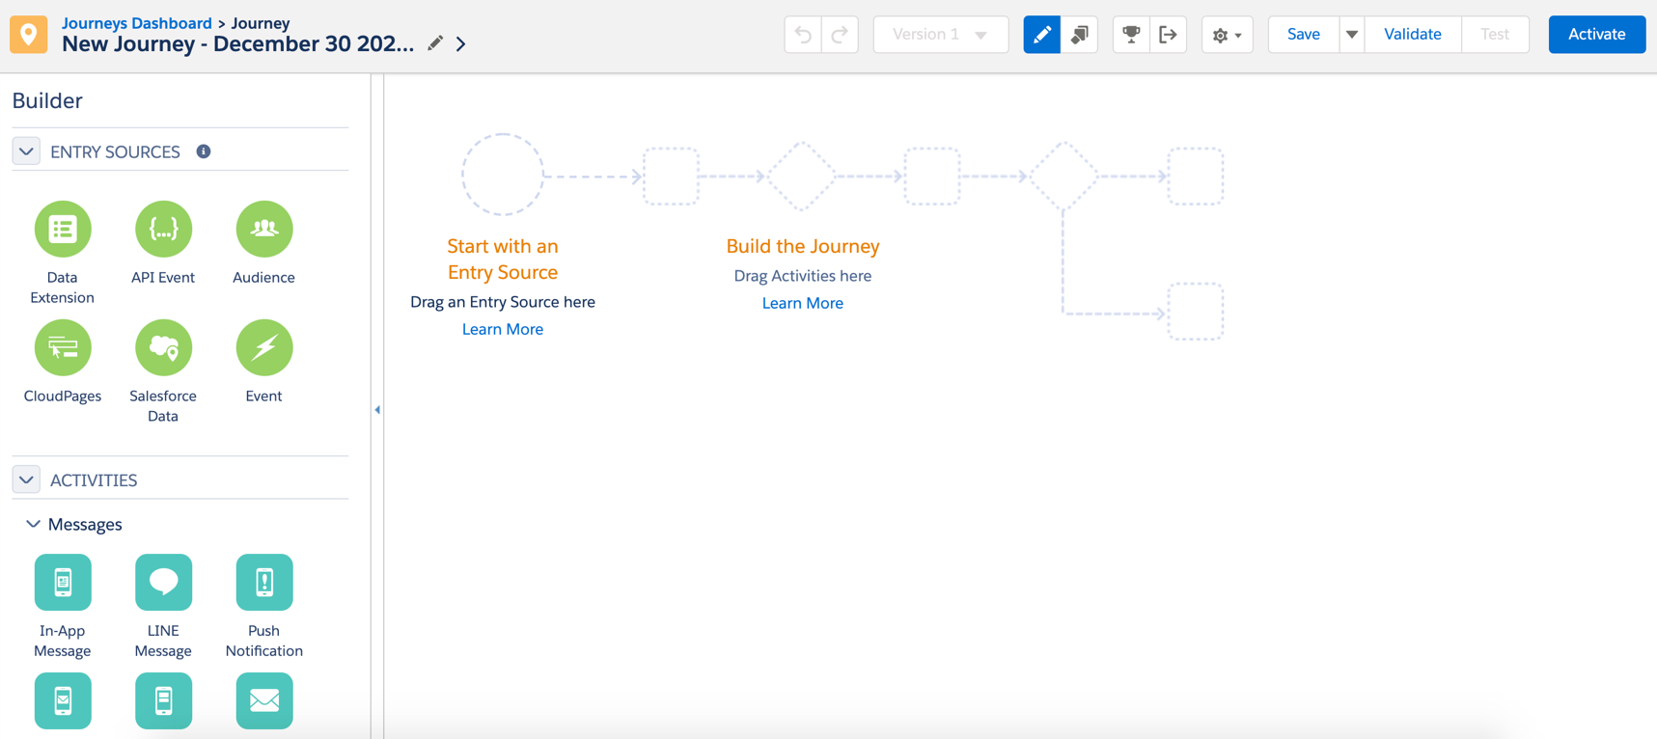
Once you select multi-step you will be on the journey canvas. The workflow will be built on the right and the activities will be on the left.

Entry Sources

As the canvas states, you can start with your entry source. Which will likely be a Data Extension. You can select an already filtered data extension, or you can use journey builder to trim down your audience using the drag and drop filters within journey builder. Another likely option would be to select Salesforce Data. This will give you access to all of the salesforce objects and records whether you are already synchronizing them or not. You can also set it up so that new records get added when an action happens on the CRM side.

Activities

You are not required to start with an entry source and sometimes I find it easier during brainstorming to start with the journey flow instead of the entry source. The activities are broken out into four sections.
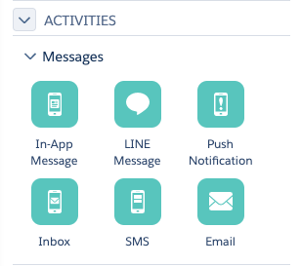

The first section is the outbound messages: Push, Chats, In-App Messaging, SMS, and Email. Currently in your account you will only be using Email messages although work has begun to use SMS in the future.
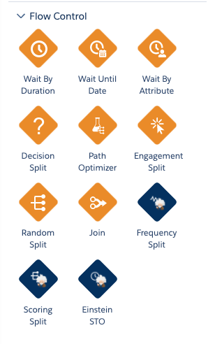

The next section is where you will add splits, waits, testing, and Einstein actions. The wait activities will add time in-between sends or other activities. You can do this by a specific duration, by a specific date, or based on data points in your entry criteria. The Split activities will divide your audience either based on data points (Decision Split), opens or clicks on previous emails in the current journey (Engagement Split), or randomly for testing purposes (Random Split). The Path Optimizer functions like a random split for testing but automatically sends people down the most successful path based on the criteria you decide. The Join is how you bring the paths back together after any of the splits. This can be helpful if you have an email everyone should receive after a split, so you don’t have to configure the email multiple times. The Einstein activities use the predictive intelligence based on the data collected in your account to further enhance your journey. The Frequency Split will prevent you from oversaturating your audience by splitting people into paths based on how often they have been receiving emails. The Scoring Split will break people out based on how likely they are to engage with your email. And the STO activity functions as a Wait activity that will wait until a subscriber is most likely to open within the window you specify.

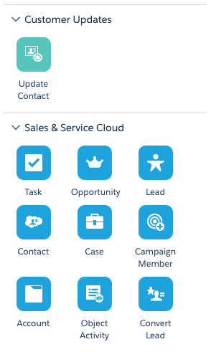
The next two sections are about updating data based on the Journey. The teal Update Contact activity will update data stored in a data extension inside of Marketing Cloud. The blue Service Cloud activities will update data inside of Salesforce CRM. Your options here are to update or create any of those objects and fields within the objects. You will most likely only need to use the Contact activity as that is where your subscriber data is stored.

Journey Settings

In the upper right of the canvas you will see the journey settings.

Aside from some standard features (undo, redo, save) you can also see the different versions, copy an activity, set goals and exit criteria, additional settings, validate, test, and activate. Whenever you activate a Journey it locks that in as a version. If you need to make edits or changes that will happen in a new version. The dropdown lets you see previous versions (including the tracking and how many people went through different paths). The Pencil icon is pre-selected which just hides/shows the panel on the left. Very rarely would you need to de-select this. Next to that is the Copy Activity button. This is used to copy a specific activity inside of your journey. For instance, if you had multiple paths but wanted to send an email to each path you could copy it.

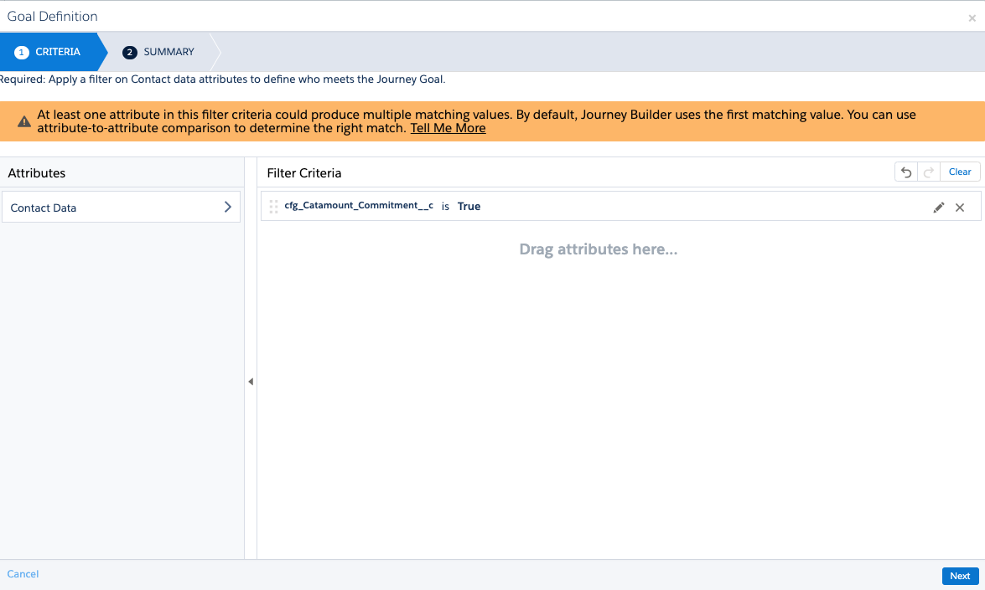
The next icon to the right is the trophy for the Goal Settings. This is to set a specific data point goal to measure at a high level how the Journey is performing. This is also the metric you will see on the main Journey Dashboard.

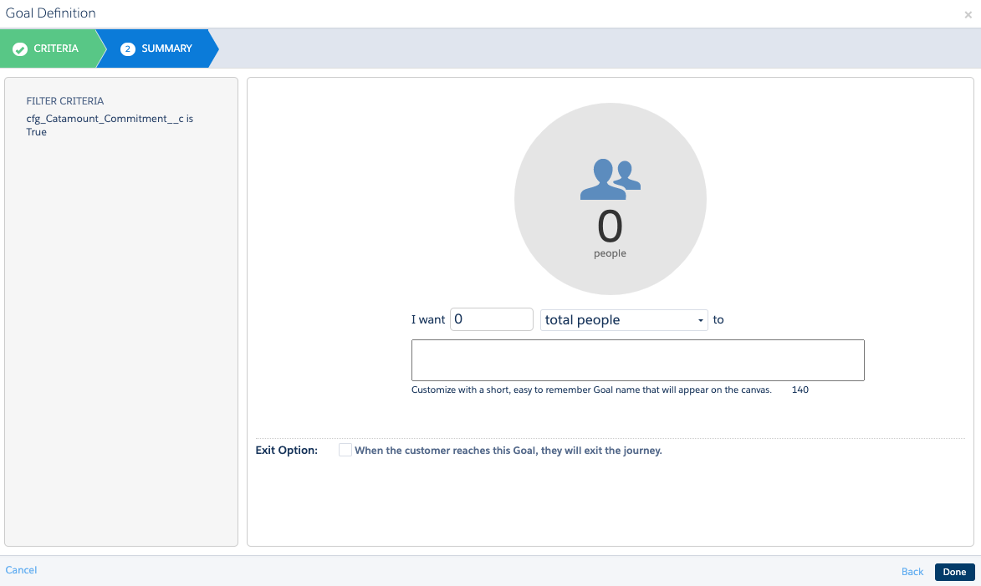
In this example I selected the goal of Catamount_Commitment equal true. For everyone that is in the Journey and prior to every activity it will check if the value is true. If it is, it will count toward to total goal progress.

The total goal progress is defined on the Summary page. You can select a certain number of people or a percentage of the audience. You also have the option here to remove people from the Journey once they meet the criteria.

Back on the settings menu, the next icon over is the Exit Criteria. This functions identically to the Goal Settings, but it does not show up on the Journey dashboard. You would typically use this if you want to remove people from the Journey based on specific criteria, but that criteria is typically negative. So if someone dropped out you might want to remove them from the Journey, but you wouldn’t consider this the ‘goal’ of the Journey.

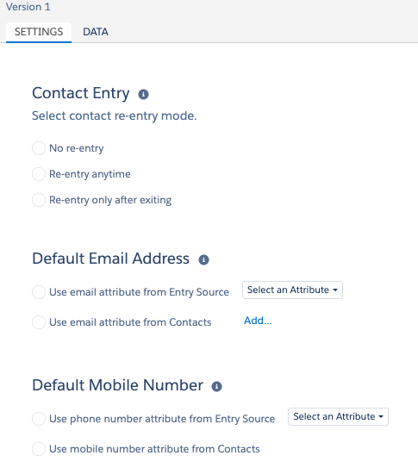
The next icon over is the gear for additional settings. Here you can copy the entire Journey. This does not create a new version, but instead a brand new Journey based on the current Journey starting it as Version 1. The Journey Settings will take you to a screen where you can select the re-entry criteria.
No re-entry will prevent a subscriber from ever being entered into the Journey more than once. Re-entry anytime will restart a subscriber to the beginning whenever the meet the entry criteria even if they are already in the Journey. Re-entry after exiting will re-entry them once they meet the criteria only after they have previously exited the Journey. The Default Email Address and Default Mobile Number settings you will not typically need to change. The email from entry source and the email from contacts should be the same value. When in doubt the Email from Contacts is going to be the correct choice 99% of the time.

Back to the settings menu the next section is for saving and testing. Validate will check all of the emails in the Journey to make sure there are no errors that would prevent the email from working. Test will send contacts through the journey without any outgoing messages. This way you can see that your decision splits are working correctly. Then finally once everything is set up and working correctly you can hit the blue Activate button. The Journey will now start listening for new contacts or evaluating the contacts in your data extension depending on what entry source you have selected. The journey will continue to run and evaluate until you turn it off.

Automation Studio

Automation is a great tool when you need to manipulate data regularly or for scheduling ongoing weekly or otherwise recurring sends.

To get to Automation Studio select Journey Builder from the main menu, then Automation Studio from the submenu.
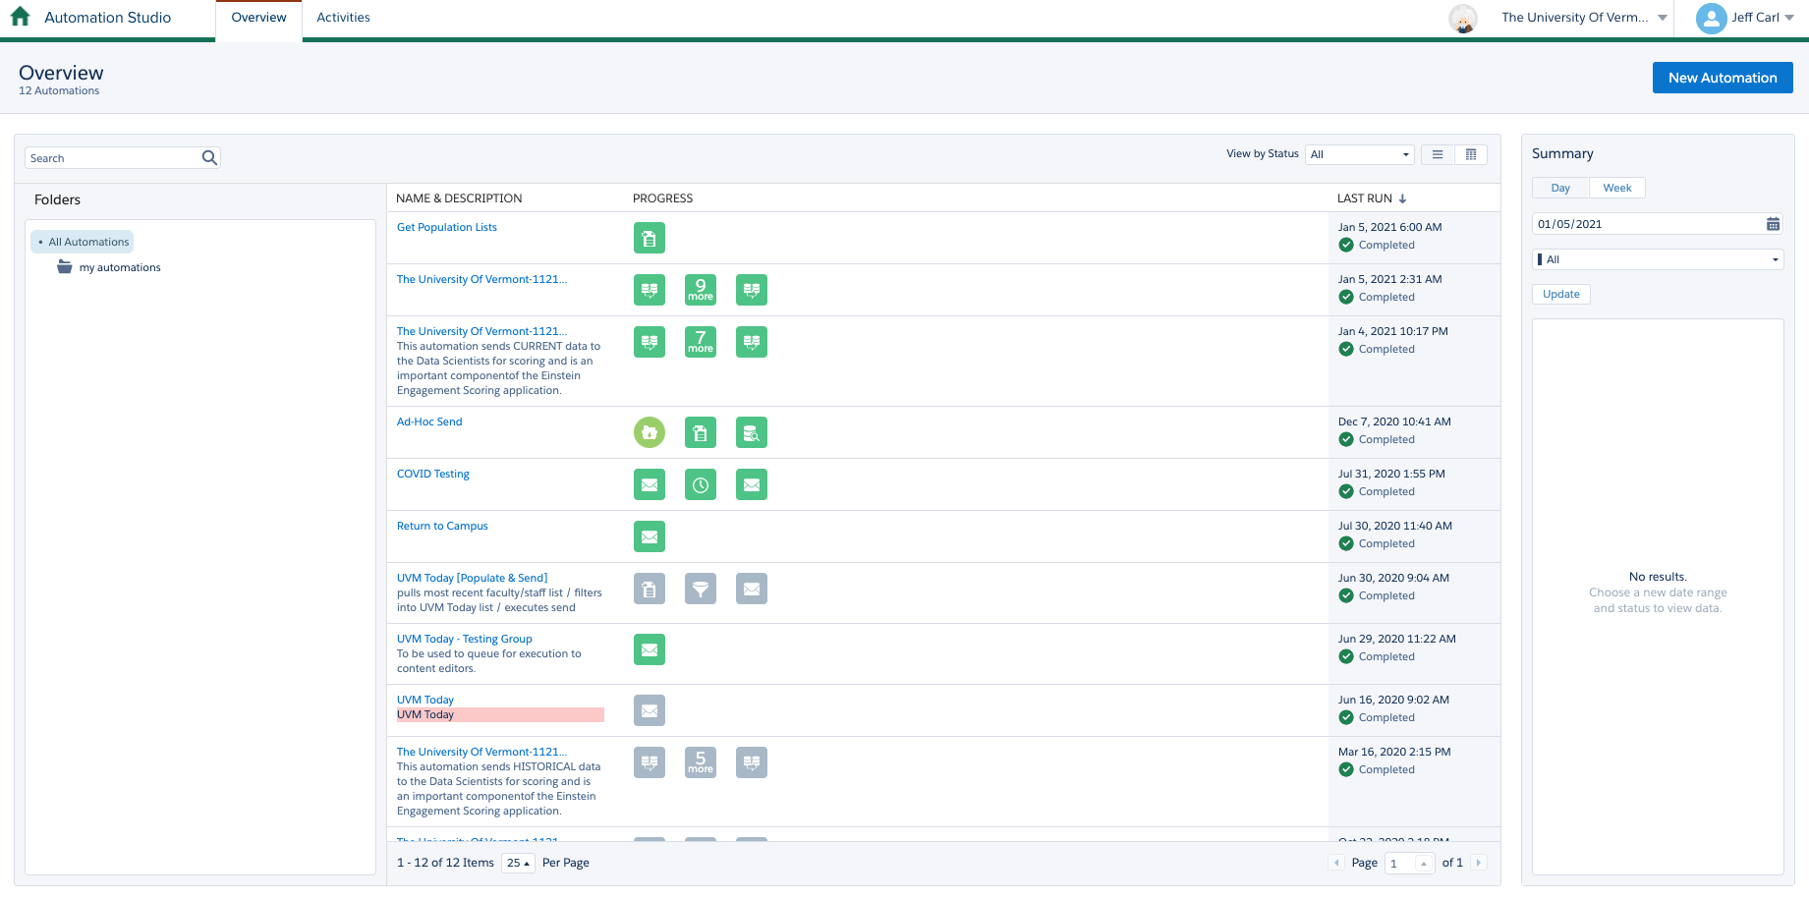
The overview page will list all of your automations including the ones that aren’t currently scheduled. To see just the scheduled or triggered automations you can filter on the right side on the dropdown that defaults to “All”. The automations with green icons in this view have successfully run, the grey ones have not run since being saved, and red icons would indicate an error.

Activities

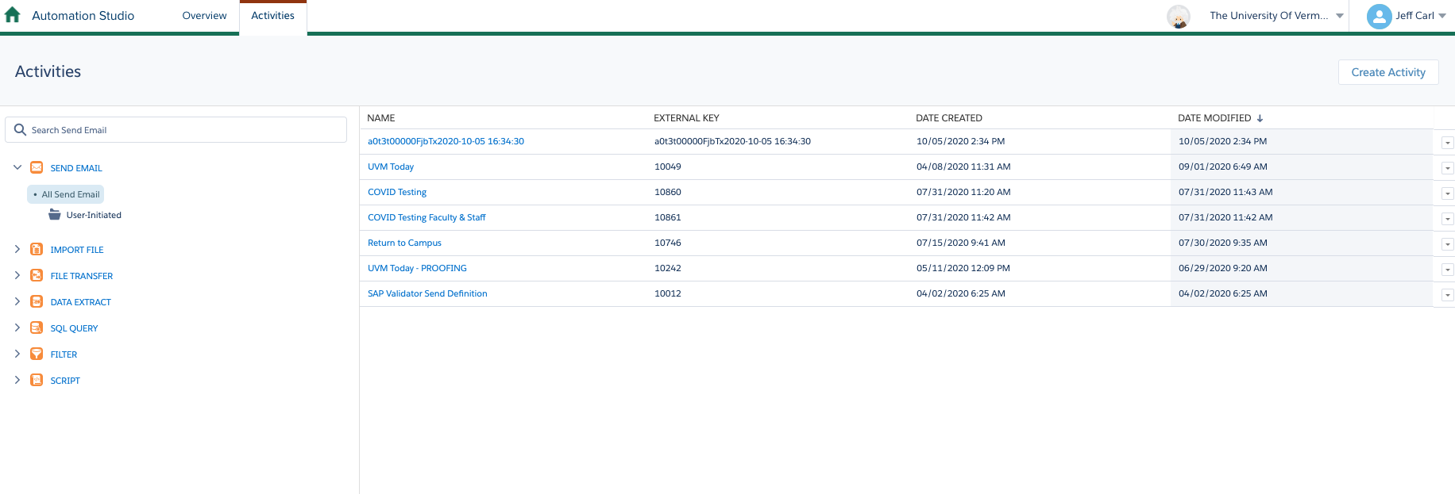
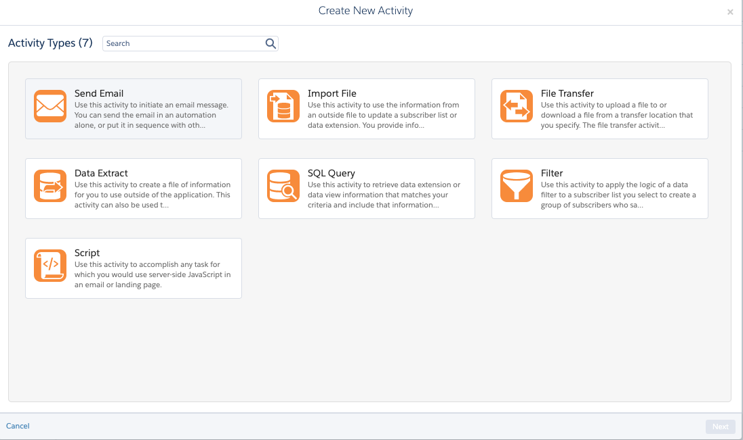
There are a couple of ways to create Automation Studio Activities. At the top of this page is another tab for Activities which will take you to all activities sorted by type regardless of what (if any) automation they might be used in. From here you can create a standalone activity by clicking Create Activity in the upper right.

This will show all the available activity types you can create. Send Email will be all of the same steps in the manual send email workflow, but it will be saved for repeated use. Import File is used to import data from the FTP (using cyberduck or other client) to a data extension. File Transfer is used to move data between file locations across multiple FTP accounts. Data Extract is the reverse of import to export from a DE to the FTP. SQL Query is to write a query to join or filter data across multiple data extensions. Filter creates a data filter (similar to when creating a filtered DE) for scheduled or repeated use. Script is a more advanced data manipulation option instead of SQL, it uses Server-Side JavaScript to use similar functions as the API.

Create New Automations

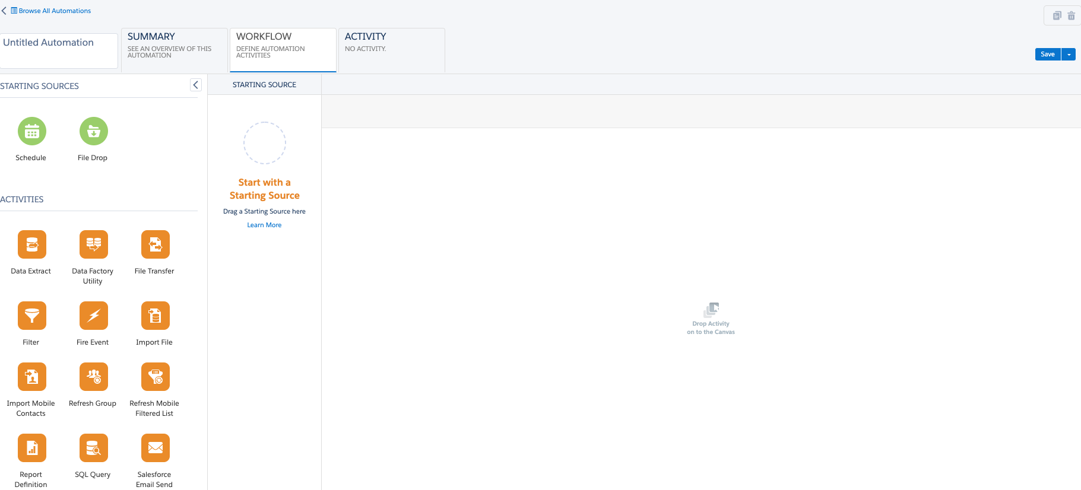
Back on the overview page you can create a new Automation using your newly created activities or you can create them on the fly inside of the automation. If you click the blue New Automation button in the upper right it will take you to a new blank Automation.

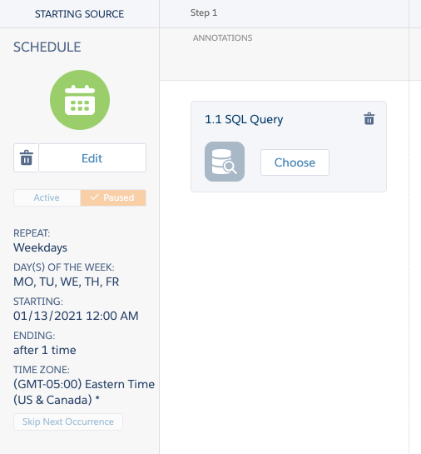
From here you can drag over the activities you want in your automation. As you do this it will automatically create steps so you can drag new activities in front of or behind the existing steps. You can also add multiple activities to each step. Steps will run in order, but activities in the same step will run concurrently. If you have already created your activity then when add it on to a step you can select Choose and pick the one already created. Otherwise, after you select Choose you will click Create New in the upper right of that box. The last piece here is to select a starting source. Unlike Journey Builder this is not dependent on individual subscribers so your options for a starting source are either a schedule or a file drop. The schedule will run and repeat based on your settings. The file drop will be based on a file showing up on your FTP site that will kick off the automation. This is typically used when you are doing an import so that the automation will run when the file is available to import. If you just want to run the automation once, or on whatever frequency you decide you can still select Schedule and then you will have the option next to the save button to “run once”. You can also toggle the schedule on and off when you need it.

Email Send Process
Like most things in Marketing Cloud there are a handful of ways to send an email. I’m going to go through the most straightforward way, which is the same way we have done in previous trainings.

Data

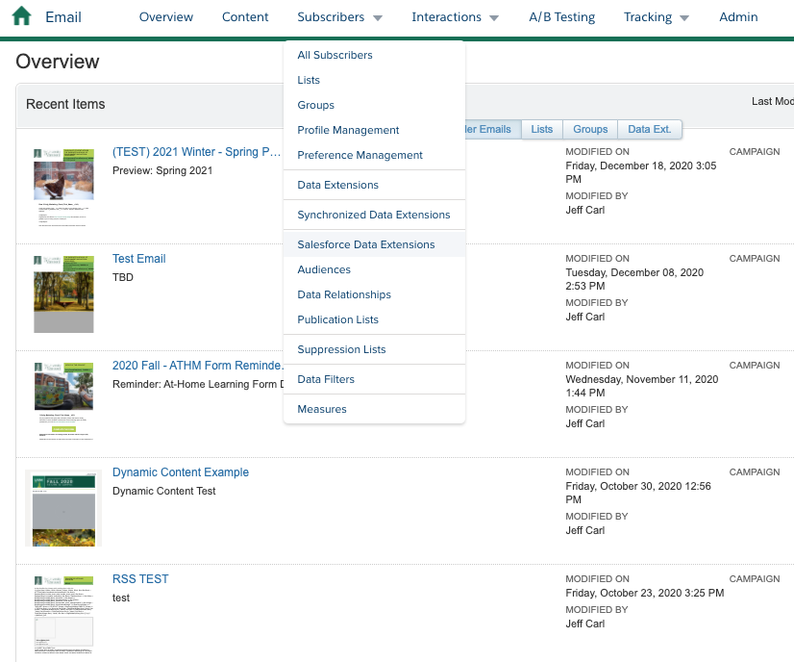
The first thing you want to ensure is that you have a pre-built audience to send to. To get to the pre-built segments navigate to Data Extensions go to Email Studio > Subscribers > Salesforce Data Extensions

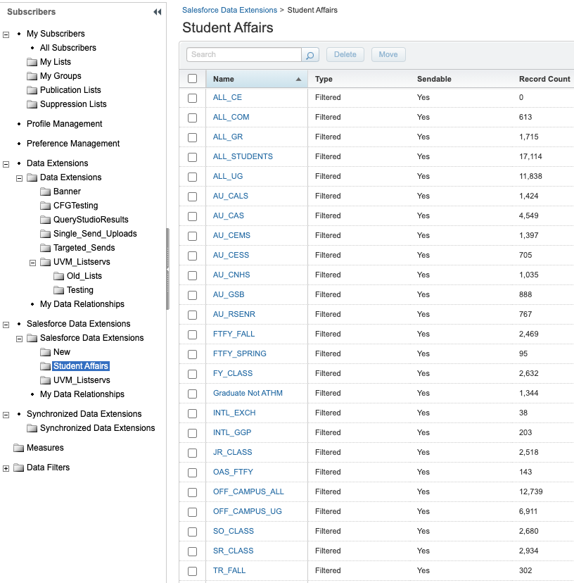
Most of the segments exist in the Student Affairs folder. If there are questions about the segments or values Georgia Kennedy will be your best contact for clarification.

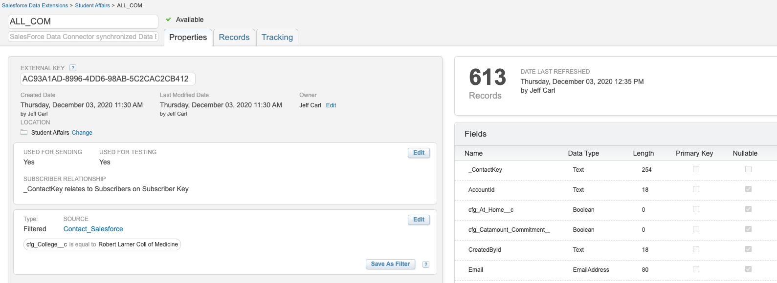
You can also click into any segment to see the filter details and fields available to use for email personalization. The filter criteria and the source data extension will be in the bottom left and the fields available are on the right. Additionally, if you want to see sample data you can click the Records tab towards the top to see the first 200 records and their values.

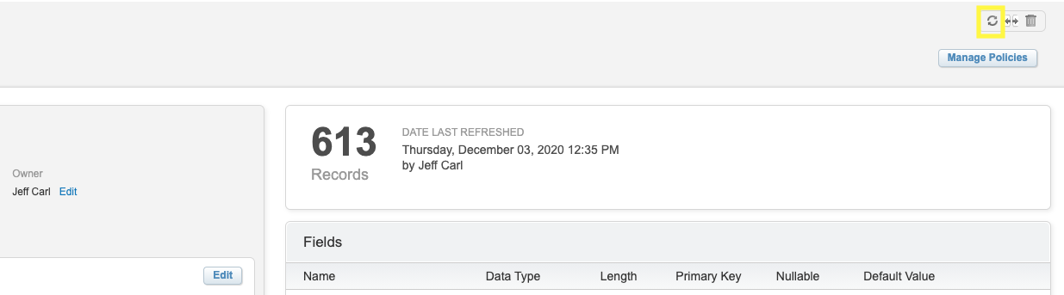
After you have identified the correct data extension, you will want to refresh it. In the upper right there is a circular icon. Click that and refresh.

Create New Data Extension

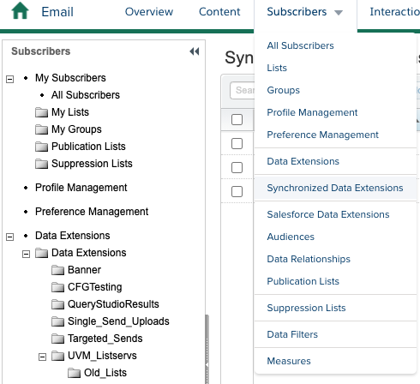
If the segment you need does not exist, you will need to create a new Filtered Data Extension. To do this you will need to go to the Synchronized Data Extension folder.

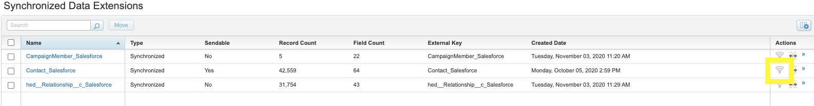
Then you will click the filter icon for the Contact_Salesforce Data extension.

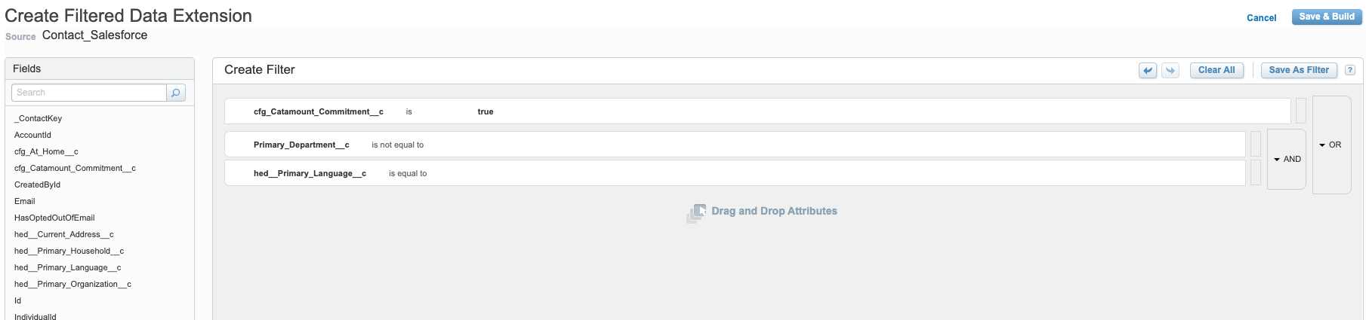
This will bring up the drag and drop filter builder. From here just drag the attributes from the left onto the filter canvas. Then select the value you want to filter for.

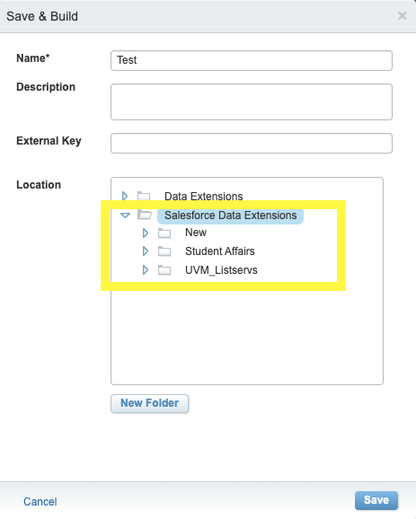
As you can see in this example you can group multiple attributes using “And” or “Or”. Once you have all the attributes you need to filter click the Save & Build button in the upper right to create your data extension. Give your data extension a unique name and make sure you select either the Salesforce Data Extension or a subfolder of it as your save location.

Salesforce Data Extension or Data Extension

There isn’t much that distinguishes a Salesforce Data Extension from a Data Extension. Inside of Marketing Cloud they function and look essentially the same. However, data extensions created inside of the Salesforce Data Extension folder are connected on the back end to your Salesforce CRM instance. This allows for tracking information to show up on the contact records. If there isn’t a matching record, there is no error or negative effect. So it’s generally a best practice to do all of your work in the Salesforce Data Extension folder.

Create a Campaign

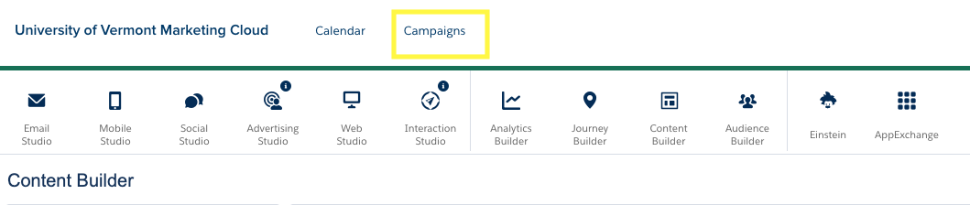
Before building the email, you might want to create a campaign for tracking purposes. You can use this feature to tag your emails with as many campaigns as relevant, then when creating reports or viewing performance you can sort results by campaign. You can also see on the home page which campaigns have scheduled sends for the upcoming week. To view or create a campaign hover over the home icon in the upper left and select Campaigns from the topmost menu.

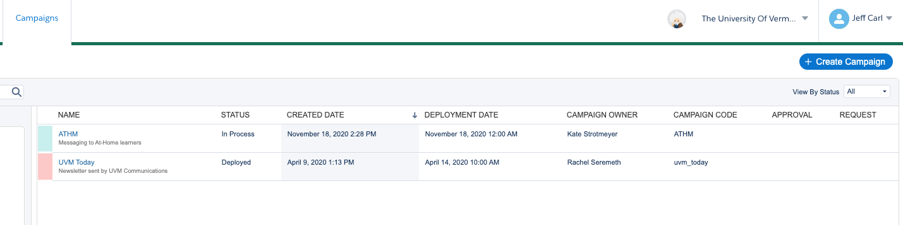
From here you will see your current campaigns. You can click into them to see all the activity related to each campaign. Or click the blue Create Campaign button in the upper right to create a new one.

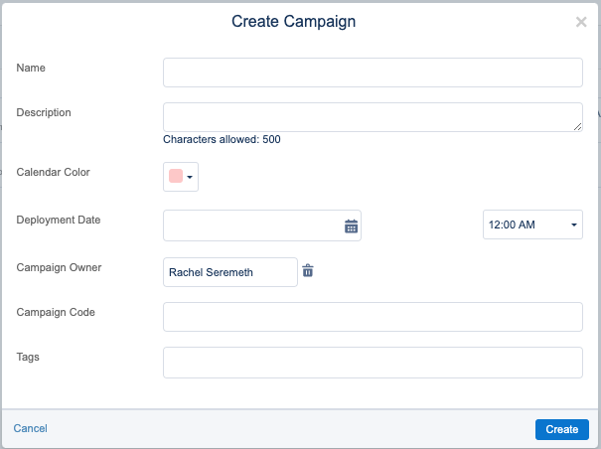
When creating a new campaign, you will need to give it a unique name and campaign code. The description and color are to help you distinguish it from other campaigns. The deployment date can be today’s date. Tags are optional ways to further assign sub-categories to the campaign. A lot of tags have already been created in your account for the Einstein features to work properly.

Build an Email

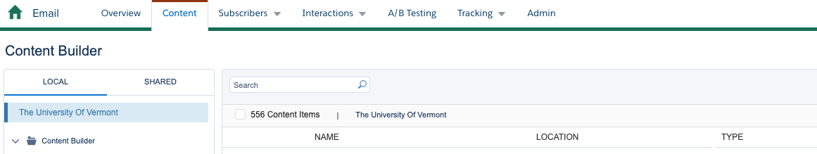
Now that you have your audience picked out or created and you have created a campaign (if necessary) you are ready to build the email. Your first step will be to navigate to Content Builder in Email Studio by clicking Content (if you are already in Email Studio or clicking Email Studio if you are not).

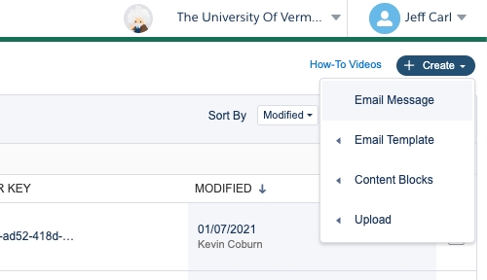
From here you will see all of the emails in your account sorted by most recent modified date. To find a specific email you can either search the name in the search bar or dive into the folders on the left. To create a new email click the blue Create button in the upper right and select Email Message.
On the next screen make sure the dropdown next to Create Email says “Template” and on the next row you are on “Saved”. This will show all of the UVM specific templates we have created.
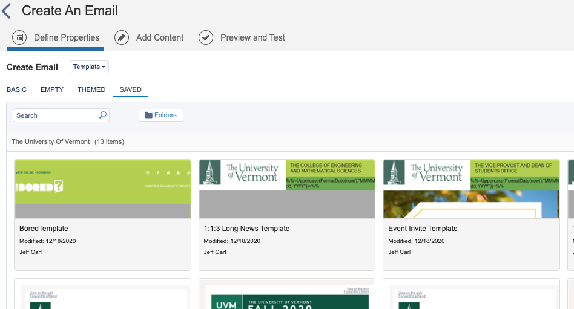

Click the template that closely aligns with your needs and then click Select in the bottom right.

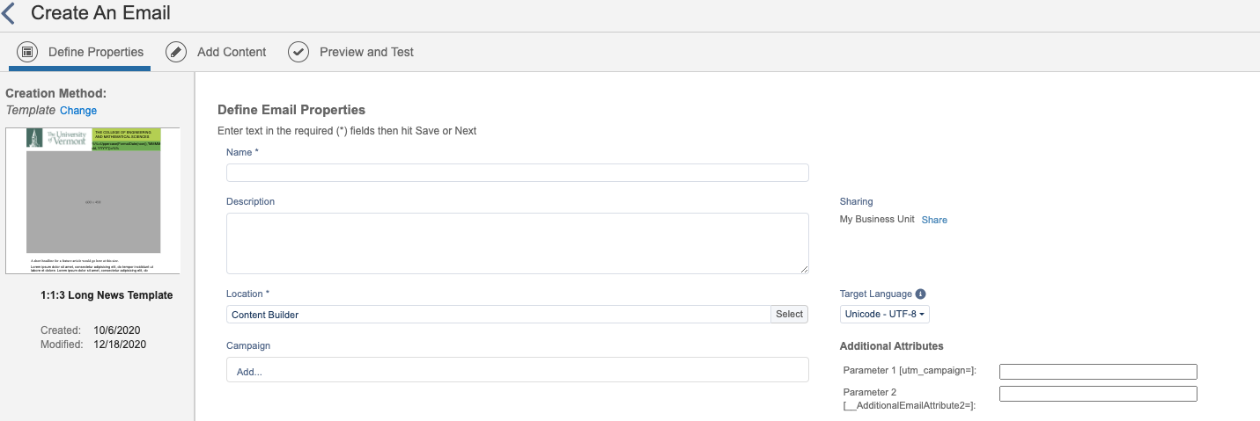
The next screen you will give the email a unique name, select a folder location, add a campaign (if necessary), and utm parameters (if necessary).

Campaigns will assign this email to that campaign for easy reporting. Utm parameters will add the values you type in to end of every url in your email for tracking purposes.

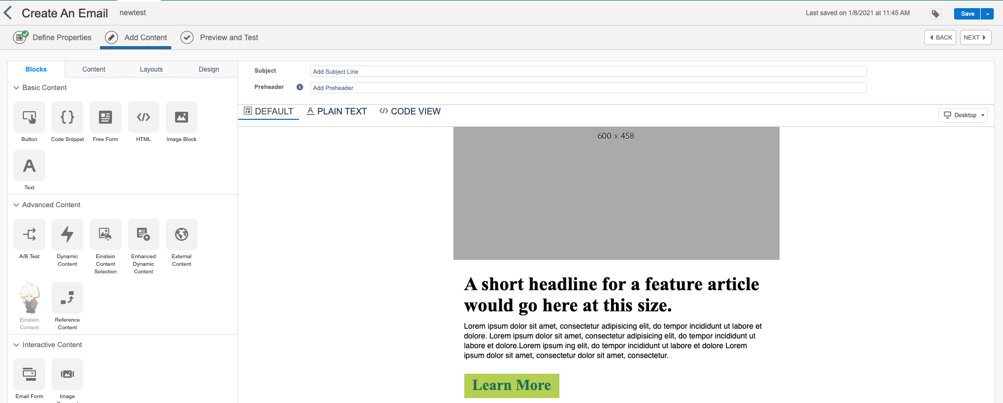
The next page is where you will actually build out the email. The template has content blocks in it already that should be styled and formatted correctly.

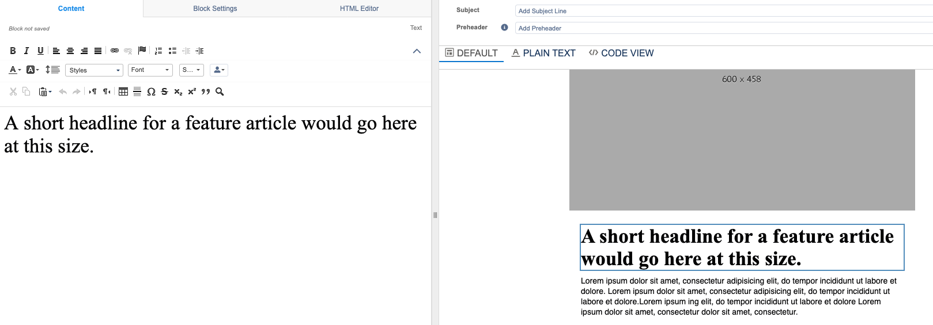
To edit any of the blocks just click into them to bring up the editor.
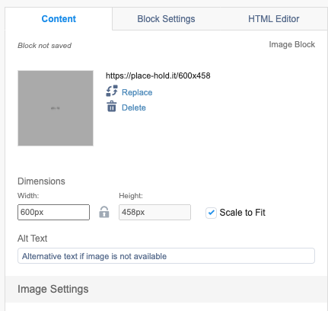
For images it’s a smidge different, but if you click into it you will be able to either remove the placeholder image by clicking delete or swapping it with another image hosted inside of Marketing Cloud by clicking replace. If you have an image hosted externally you can click Delete and then type in the URL of the external image. Additionally, if you want the image to be a clickable link you can assign a url if you scroll to the very bottom of the left panel.

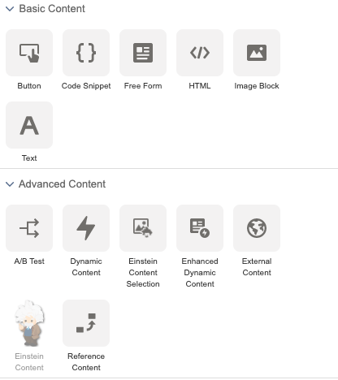
If there is something missing from the template or you need to add additional content you can either copy an existing block or drag a new content block over from the content panel.
If you need to use ampscript to create a dynamic section, you will select the HTML content type. If you are just using text and some simple personalization you would select the Text type.

Once the email is built out you will also assign a Subject Line and Preheader at the top of the editor.
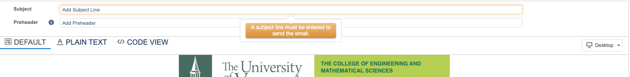
Once that is set hit next, which will take you to the Preview and Test screen. Here you can see how your email will look to specific records. It’s a best practice to select the actual audience you will be sending to on this step so you can make sure any personalization or dynamic content is working like you expect.

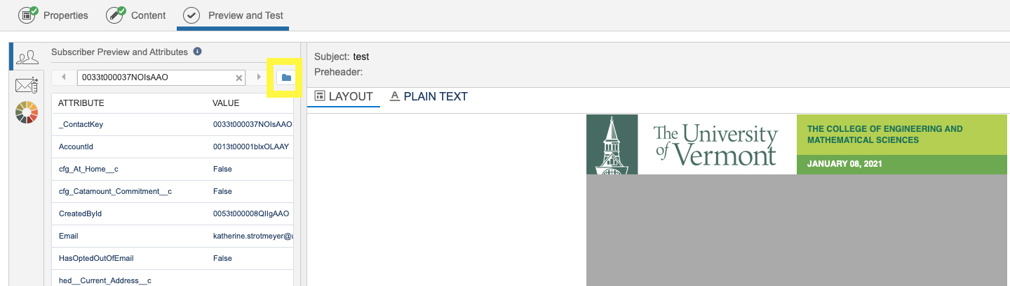
To do that click the blue folder icon on the Subscriber Preview pane.

Then select the data extension on the left side and a subscriber on the right.
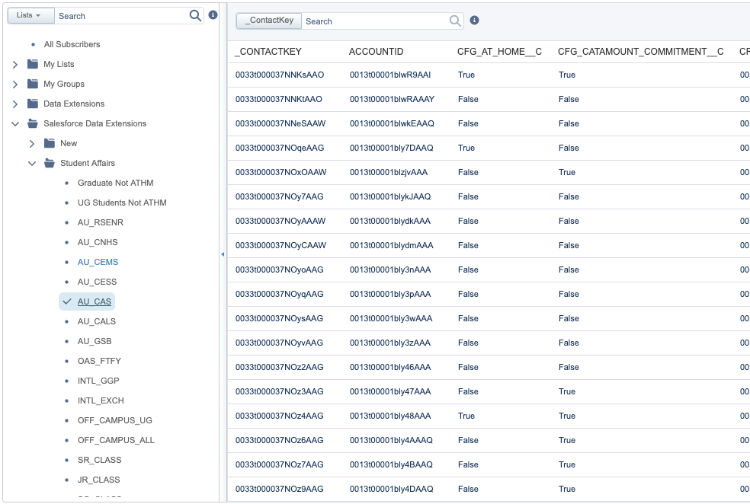
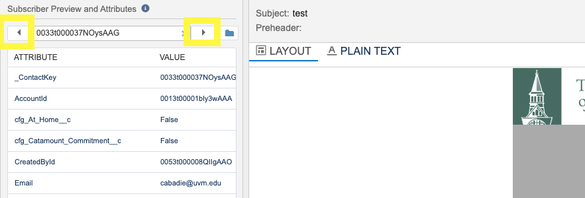
Once you have a subscriber click the blue Select button in the bottom right. Now you will see the email preview on the right and the specific information about that subscriber on the left. Also at this point you can click the left or right arrows next to the subsciberkey to change to other records in the data extension.
When you are confident the email is working correctly you can send your self (and others a test send). To do this click the Email icon on the left sidebar (highlighted below) which brings up the Test Send information. Your email address will be populated in the Recipients section already, but you can replace that or add up to 4 more emails. Below that is the From name settings which you can select from the pre-defined list of senders. Below that is the option to set a prefix. This is just to indicate to the person receiving the email that this is a test. Obviously you will know it’s a test, but if you are sending to others sometimes it is good to let them know via this method. Lastly click the blue Send Test button.

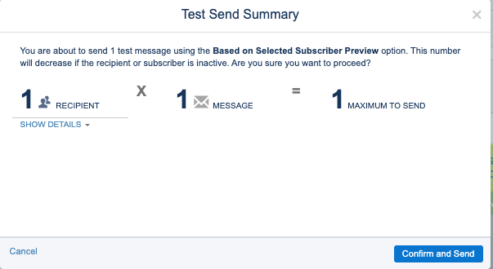
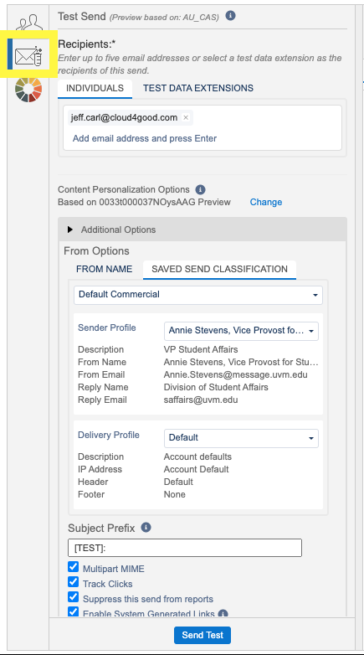
Clicking that will bring up the test send summary which confirms how many emails you are about to send, and the email addresses of the recipients.

Sending the email
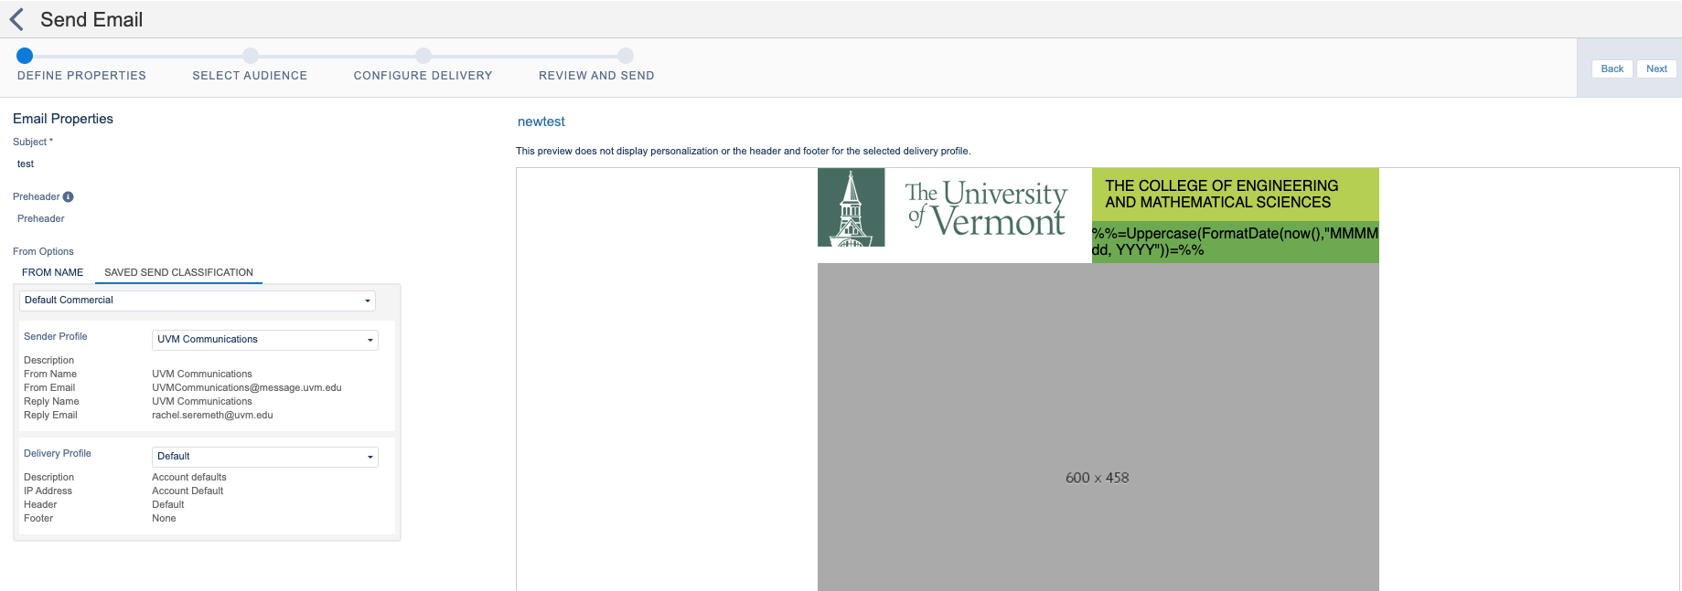
If you followed the steps above you should be on the Preview and Test screen. From here you can deploy they email by clicking the down arrow next to the save button and clicking Save and Send. Or if you are coming back to this process from somewhere else you would click into the email from Content Bulder then in the upper right will be Edit or Send options. Either way will take you to the Send Email workflow.
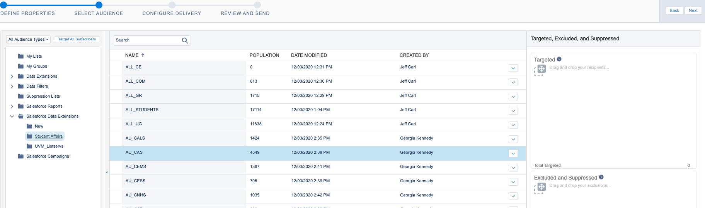
The first page is setting the email properties. Here you can set the Subject Line (although it will bring in what you set when building the email by default) and the Sender Profile.

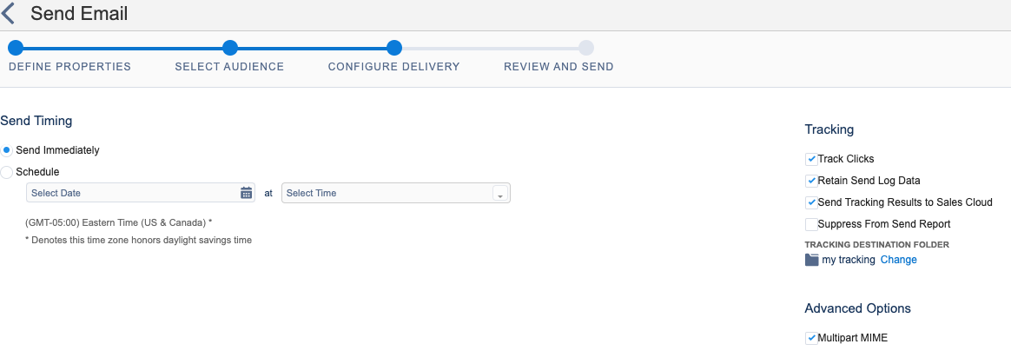
The next screen is where you select your audience. Click into the folder on the left pane. And then drag and drop the data extension you want to use from the main window to the Targeted box in the upper right. When you do this it will ask you to select a publication list. You will want to keep it as All Subscribers (which is selected by default) and click the blue Select button. If there are any data extensions you wish to exclude from this send you would drag them to the bottom right box. You can also see on this page that De-Duplicate subscribers is checked by default. In 99.9% of situations you would want to leave this checked. This will prevent someone from getting the same email twice. Once your audience is correct click next in the upper right.
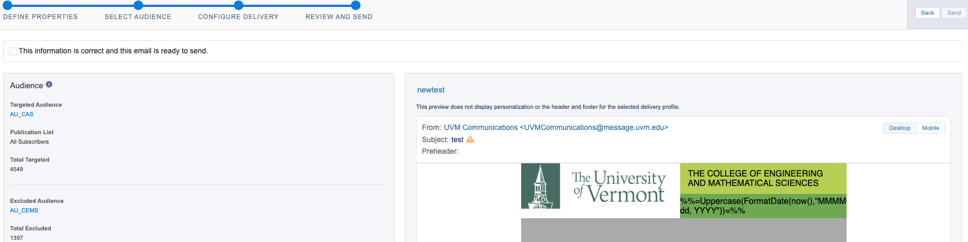
The next page is the scheduling and tracking information. You can leave it as send immediately (which will process at the end of the steps) or schedule it for a future date/time. On the right side is tracking information. You will want to leave all of the default boxes checked. However, you will likely want to change the location of the tracking destination to a different folder.

The next page is the summary screen. Here you can see all of the settings you selected and a preview of the email. Once everything looks correct you can check the box at the top of the page that confirms as much then click the blue Send button in the upper right.

