This plan is to be reviewed daily by the Site Safety Officer with all site personnel at a tailgate meeting before field daily activities commence.

Written Health & Safety Plans for Field Work must be submitted to and approved by your Dean and Department Head before field work begin or resume. Risk Management & Safety’s Lab Safety Coordinators (safety@uvm.edu) are available to review your draft plan or revised plan to offer safety recommendations before they are submitted to your upper administrators for approval.

Field Work Site Address(es)/Location(s)
List each field work site, address, City, State

Site Safety Officer: ____________________________Cell:_________________________

Email: _________________________________ UVM NetID: __________________________

Research Tasks: (check all that apply) Additional Comments:
- Topographic survey (e.g., total station equipment, survey rod, tripod, GPS)
- Unmanned aerial survey or terrestrial lidar survey
- Canoe, kayak or boating operations
- Water sampling
- Soil/Plant management/sampling
- Instrument maintenance (e.g., staff gauge, rain gauge, weir, structural health monitoring sensor)
- Discharge measurements
- Other:
- Other:

Emergency Notifications
Police: Emergency: 911 Non-Emergency: ( ) ____________-_________________

Fire/EMS: Emergency: 911 Non-Emergency: ( ) ____________-_________________

UVM Contact/Advisor:
Name: ____________________________________

Phone: ( ) ____________-_________________

Injuries and Accidents (check all that apply)
- Everyone has been trained to report injuries to the Site Safety Officer listed above.
- Everyone has been trained to report Injury and Accidents to their Supervisor.
- Supervisor is aware of UVM’s Injury and Accident Reporting Procedures: https://www.uvm.edu/riskmanagement/incident-claim-reporting-procedures

Nearest Hospital to the Field Site and Directions

Hospital Name: ________________________________________________________________

Phone: ( ) ____________-_________________

Address: __________________________________________

__________________________________________

(Insert Map and Directions from Site Address to Nearest Hospital)

COVID-19 Mandates, as of 6/29/2020
Assess your field activities and describe how you will prevent exposure to SARS-CoV-2 (COVID-19) and meet UVM’s and the State of Vermont’s Covid-19 mandates.

1.
Identify any non-essential field work activities that can be discontinued at this time to reduce potential Covid-19 exposure. Then, identify which critical research activities must continue at this time and why.

2.
Determine the level(s) of risk (high, medium or low) associated with your field site(s) and task(s) to be performed at each site.
Examples:
Low-risk field activities might be trips to places that are easy to access and in close proximity to medical facilities.
High-risk activities should be avoided, such as traveling long distances to remote areas, conducting work in areas with poor cell coverage, and places that are difficult to access on foot.

3.
Describe how you have eliminated the potential risk of exposure to SARS-CoV-2 for any faculty, staff, or students, such as field research that requires working in close proximity with others, in locations where work must be done in groups, or in known areas of community transmission.

Individual(s) Risk Factors
Consider field researchers’ individual risk factors (e.g., older in age; current or chronic medical condition(s), including being immunocompromised; pregnant, etc.). Describe how have you made adjustments to the field work to accommodate or reduce exposure to these personnel. See: https://www.cdc.gov/coronavirus/2019-ncov/need-extra-precautions/index.html

Review and check that you have considered each item:
Considerations have been made regarding service areas (e.g. highway rest areas, visitor centers) that may be closed; trail head facilities, porta-lets may also be locked and closed.
If soap and running water will not be immediately available in field research location, ensure researchers carry a supply of hand sanitizer with at least 60% alcohol and disinfectant wipes.
Two people (max) may travel together in one vehicle; BOTH must wear face coverings at all times. Individuals traveling alone need not.
Buddy system has been considered for safety and communication purposes.
Tools and equipment should not be shared. Equipment must be disinfected with soap and water or 70% ethanol before and after use.
Researchers must be able to keep 6 ft distance or more between themselves and others whether working inside or outdoors.
Cloth face covering must be worn by all individuals who work in close proximity to other people - even outdoors.
Follow CDC recommendations for social and physical distancing at all times, even in the field. Individuals can spread this virus before they know they are sick. https://www.cdc.gov/coronavirus/2019-ncov/prevent-getting-sick/social-distancing.html
There will be no more than 10 in any outdoor “group” gatherings and 6 ft distances will be kept.
If researcher(s) must go into a store to buy supplies to conduct field work, they must cover mouth and nose with a cloth face covering and keep a minimum of 6 feet between themselves and others.
Field workers be trained to know what the most common symptoms of COVID-19 currently are and know where to look for additional information. https://www.cdc.gov/coronavirus/2019-ncov/if-you-are-sick/index.html
Researchers should self-monitor their own symptoms. Do not report to work if sick/or have any COVID-19 symptoms. See the Pre-screening Health Survey: https://www.uvm.edu/riskmanagement/covid-19-laboratory-information

Everyone has been trained to know that if they develop symptoms while at work or in the field, they must go home immediately and report it through UVM’s online employee tracking form. See: https://www.uvm.edu/emergency/forms/covid-19-employee-tracking-form
UVM guidelines and NIOSH guidelines for Field Work Safety have been reviewed. https://www.uvm.edu/riskmanagement/safety-field-work-and-farm-operations and NIOSH Hazards for Outdoor Workers
Field Hazards and Risk Reduction Measures
Flora & Fauna Awareness
(Check all that may apply and add any additional hazards specific to your site in other)

_____ Insect Stings: Bee and/or wasp bites.
- Wear long sleeves and light-colored clothing to lessen chance for a sting
- If stung, run a clean fingernail or gauze from a first aid kit over the sting to draw the stinger out
- Apply ice to reduce swelling
- Monitor for signs of allergic reaction and, if so, seek medical attention immediately
_____ Venomous Spiders: Black widow
- Avoid wood piles, rock piles, outbuildings – and spider webs in these locations
- If bitten, wash the bite with soap and water, apply a cool compress or ice, and elevate the bite site above the heart, if possible
- Seek immediate medical attention for black widow spider bite
_____ Ticks: Carriers of Lyme disease, Anaplasmosis and (rarely) Powassan virus in the Northeast. (and Rocky Mountain spotted fever in the western US)
- Wear light colored long pants with pant legs tucked into socks
- Tie back long hair
- Use DEET or insect repellent
- Perform end-of-day tick check
- Remove field clothes to laundry and shower soon after end of field day
- Seek medical attention for confirmed tick bites
_____ Animal Bites: Skunks, foxes, bats, dogs, cats, raccoons, horses, snapping turtles, beers, moose, leeches, other: ____________________________________________________
- Avoid work at dawn & dusk hours
- Seek immediate medical attention for an animal bite that breaks the skin
_____ Poisonous Plants: Poison ivy, Poison oak, Poison parsnip, other: ___________________
- Wear long sleeves, long pants
- Avoid tall weeds, brush – stay on travelled paths where possible
- Wash exposed skin with soap and water as soon as possible

_____ Other: __________________________________________________________________

River/ Lake Awareness
(Check all that may apply and add any additional hazards specific to your site in other)

_____ Canoe/Boating
- Always wear personal flotation device
- Proficiency in swimming required
_____ Waders/Boots
- Always wear belt with chest waders to minimize waders filling with water
- Use walking stick or river staff to prevent slipping
General Physical Hazards
(Check all that may apply and add any additional hazards specific to your site in other)

_____ Falls/ Trips: Steep Slopes, Rocks, Tree Roots
- Seek immediate medical assistance for suspected sprain or broken bones
- Use bandages in first aid kit for small lacerations, abrasions
_____ Heat Stress
- Avoid field work during mid-day or very hot conditions
- Wear a hat/cap
- Take regular breaks in the shade and hydrate often with water
- Use the buddy system and monitor for signs of heat stress
- If a person is affected by heat stress, remove them to shade or a cooler location
- Apply cold packs, ice, or cool water compresses
- Encourage regular intake of cool water
- Seek medical attention
_____ Cold Stress
- Avoid field work during very cold conditions
- Wear layers of loose-fitting clothing and waterproof and insulated boots
- Take regular breaks to warm up indoors or in a car
- Stay hydrated and avoid caffeine or alcohol.
- Use the buddy system and monitor for signs of frost bite or hypothermia
_____ Electrical: (marine batteries, other power sources)
- Minimize the interaction of water with electrical cables
_____ Traffic
- Wear a reflective vest and OSHA-approved hard hat
_____ Construction Sites
- If entering a construction site, report to general contractor or site supervisor and follow prescribed safety guidance

_____ Weather Emergencies: Flash flooding, thunder and lightning
- Avoid field work on days where extreme weather is forecast
- If extreme weather occurs unexpectedly, immediately leave the river, lake or any water body; seek shelter.in a building, car, or away from hilltops, trees, and utility lines
_____ Other: __________________________________________________________________

Other General Precautions
Personal Protective Equipment (PPE)
Field PPE includes equipment necessary to safely carry out the field work:
_____ Waders
_____ Sunscreen/Sunglasses
_____ Reflective Vest
_____ DEET/ Insect Repellent (to repel ticks)
_____ Sturdy, closed-toe boots
_____ Hard hat
_____ Safety Glasses
_____ Steel-toed boots
_____ Baseball cap or other hat
_____ Light colored pants with socks (to see ticks)
_____ Other: __________________________________________________________________
_____ Other: __________________________________________________________________

First Aid Kit (Review the location of the first aid kit with all site personnel)
_____ Soap, biodegradable (to wash off wild parsnip oils or insect sting sites)
_____ Tecnu (to remove poison ivy oils from skin)
_____ Band-aids/ Bandages / First Aid Cream
_____ Ace Bandage
_____ Chemical hot packs
_____ Salt (for leach removal)
_____ Tick Remover
_____ Other: __________________________________________________________________
_____ Other: __________________________________________________________________

Acknowledgment of Risk Form
Each participant must complete an Acknowledgment of Risk Form.
This form may also be found on the Risk Management and Safety: Safety for Field Work and Farm Operations website (https://www.uvm.edu/riskmanagement/safety-field-work-and-farm-operations)

University of Vermont
Acknowledgment of Risk and Consent for Treatment during Field Labs or Activities

Section 1 (To be completed by field lab leader)

Class: ______________________________________________________

Field lab leader: _______________________________Telephone: ______________________________

Address: _____________________________________________________________________________

Field lab date(s): _______________________________________________________________________

Equipment/supplies to be provided:
- by participant: _________________________________________________________________
- by field trip leader: _____________________________________________________________

Immunizations required (check with Student Health Center): ____________________________________

____________________________________________________________________________________

Physical activities to be undertaken include: _________________________________________________

____________________________________________________________________________________

Risks inherent in this field trip include bodily injury due to: _____________________________________

Section 2 (To be completed by field lab participants)

I acknowledge that there are certain risks inherent in field laboratories, including but not limited to those indicated in Section 1. I acknowledge that all risks cannot be prevented. I represent that I am physically able, with or without accommodation, to participate in this field laboratories for this course, am able to use the equipment and/or supplies described above, and have obtained the required immunizations, if any.

Should I require emergency medical treatment as a result of accident or illness arising during the field lab, I consent to such treatment. I acknowledge that the University of Vermont does not provide health and accident insurance for field laboratory participants and I agree to be financially responsible for any medical bills incurred as a result of emergency medical treatment. I will notify the trip leader in writing if I have medical conditions about which emergency medical personnel should be informed.

If a student, I will follow the Code of Student Rights & Responsibilities [insert www.uvm.edu/~uvmppg/ppg/student/studentcode.pdf]. I will not possess or use alcohol or unlawful substances while participating in course work. I will wear a seatbelt at all times during transportation to and from the field site.

_____________________________________________
Name (please print)
_____________________________________________ ________________________________
Signature Date
_________________________________________ _____________________________
Signature of parent/guardian (if participant is a minor) Date

Section 3 (General Information)

To request disability accommodations for this field trip, please notify your trip leader or contact the Specialized Student Services Office at least 10 days in advance of the trip by calling (802) 656-7753 (voice); (802) 656-3865 (TTY); or (802) 656-0739 (FAX).

Immunizations may be obtained through the Student Health Center (802) 656-0847 or your primary care physician.

Section 4 (Health Insurance Information)

Participant’s Name: _________________________________________

Participant’s Health Insurance Company: ___________________________________________

Policy # _____________________________________

Field Team/Participant Roster - Training Documentation
I verify that I have read this Field Safety Plan, understand its contents, and agree to comply with its requirements.
Name/Phone Number | Affiliation | Signature | Date | Emergency Contact/Phone Number

POSION IVY
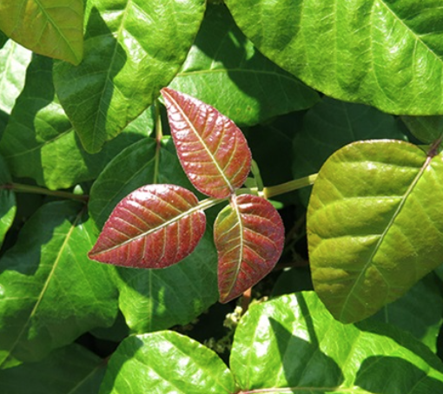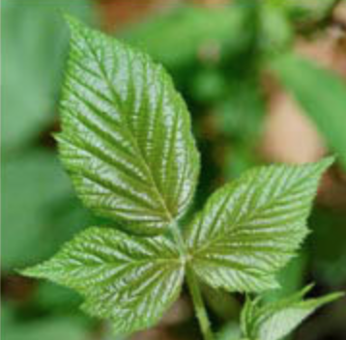
(https://www.pennmedicine.org/updates/blogs/health-and-wellness/2018/july/poison-ivy-sumac-oak)

POISON PARSNIP: SAP BURNS IF SAP GETS ON SKIN IN THE SUNLIGHT
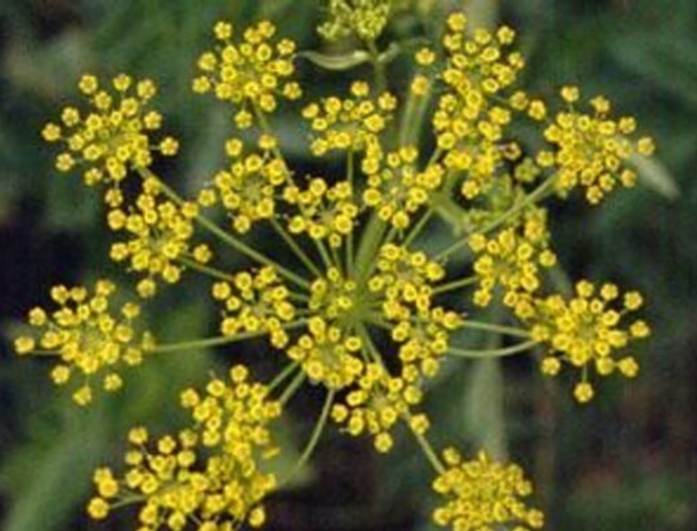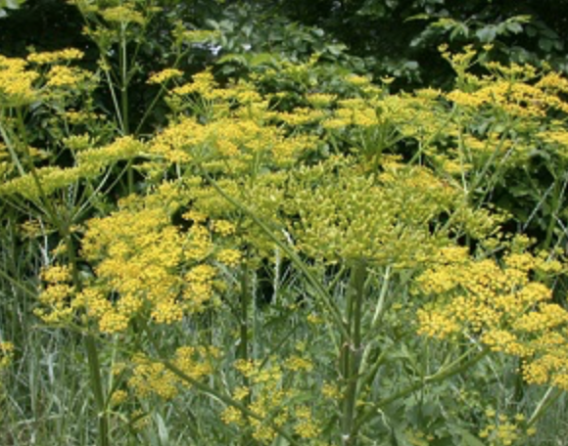
(https://www.burlingtonfreepress.com/story/life/2019/07/11/dangers-wild-poison-parsnip-vermont/1692017001/)
(https://www.dec.ny.gov/animals/105364.html)

COW PARSNIP BURN
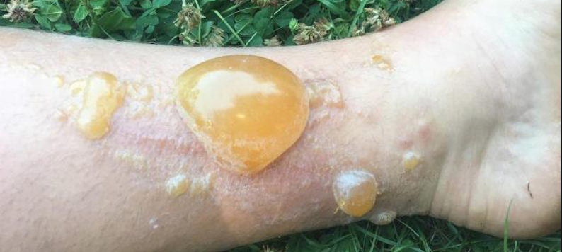
(https://www.usatoday.com/story/news/nation-now/2018/07/19/dangerous-hobo-parsnip-plant-severely-burns-blisters-woman/799636002/)

