2019 CHECKLIST FOR I-9 VERIFIERS
Last updated 08.03.2023

The Checklist should be used in its entirety for every I-9 verified.
Ensure you are using the most current Form I-9, dated 08.01.2023 in lower left corner

Section 1 – Employee Information and Attestation

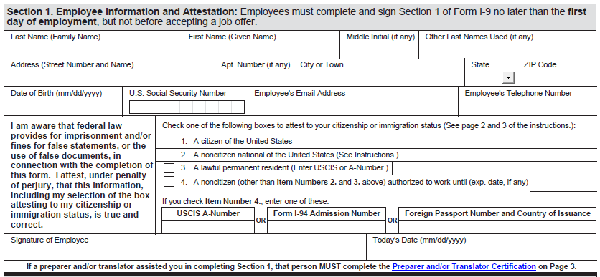
Departmental verifier confirms Employee’s Information:
- Name fields are complete and legible.
- If “Other Last Names Used” does apply, then only list the different last name (s)
- Address is a current U.S. address, not a work address
- Address is complete and legible
- Date of birth is accurate and formatted as mm/dd/yyyy
- Social Security number is accurate

In employee attestation section
- Employee checked only one box
- If box 3 is checked, the employee recorded the USCIS Number
- If box 4 is checked, the employee recorded expiration date for work authorization
- If box 4 is checked, the employee *either* recorded:
  - USCIS Number (if document is Employment Authorization Card)
OR
  - Form I-94 admission number

OR
  - Relevant passport information (number & Country of Issuance)
- Employee Signed
- Employee dated using mm/dd/yyyy format
Employee wrote TODAY’S date, not yesterday’s nor tomorrow’s

Is a correction needed?
Have employee draw one line thru incorrect info, initial, date and add correction

- If employee used a preparer or translator to assist, the preparer/translator must complete the Supplement A form and complete the information found in this link: https://www.uscis.gov/sites/default/files/document/forms/i-9.pdf

Section 2. Employer or Authorized Representative Review and Verification

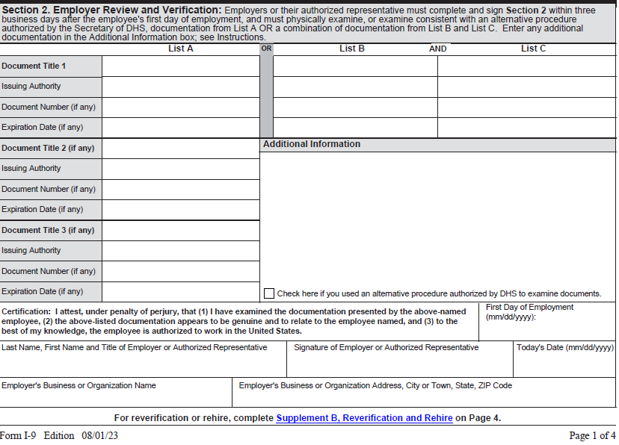
Departmental verifier confirms:
- For List of acceptable documents see page 2 of this link: https://www.uscis.gov/sites/default/files/document/forms/i-9.pdf
- First day of employment is recorded accurately (mm/dd/yyyy)
- Signed by the verifier & working job title
- Today’s Date (mm/dd/yyyy)
- Employer’s Business or Organization Name is University of Vermont – no abbreviations
- Employer’s Business Address is 85 South Prospect St, Burlington, VT 05405 for all University of Vermont employees

For additional information use “Handbook for Employers” found at the following website:
https://www.uscis.gov/i-9-central/form-i-9-resources/handbook-for-employers-m-274

*The New Online version of the form I-9 provides short explanations for each section. Click on the “Question Mark” in each box to see the explanation.

*The online version will “auto-fill” some information if the form is filled out online. The online form offers “drop down” choices in certain sections of the form. The form can be saved without losing the information.

*The online version cannot accept digital signatures. Once filled out electronically, the form must be printed and signed and dated with a pen.

*It is highly recommended to print a copy of this check list and follow the instructions while filling out the Form I-9 each time you complete an I9.

