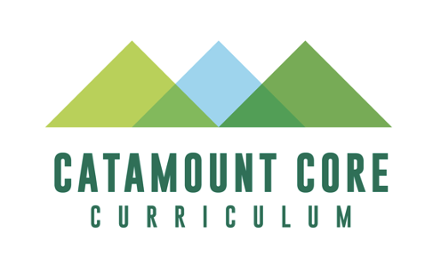
SU: Sustainability GenEd/Catamount Core Approval Supplemental Information Form

Purpose and Intent: To provide supplemental information relevant to the review of proposed courses for Sustainability designation and inclusion in UVM’s General Education/Catamount Core curriculum.

The Submission Process and Approval Criteria, as well as the Rubric that the Catamount Core Curriculum Committee will use to review this proposal, can be found on the following pages of this document.

With a well-developed syllabus, this form should take approximately 15-20 minutes to complete.

To assist students in understanding how courses in each Catamount Core category contribute to UVM’s general education program, please include the relevant following language in a prominent location in your syllabus (e.g. after the course description):

SU: Sustainability
At the University of Vermont, we recognize that the pursuit of ecological, social, and economic vitality must come with the understanding that the needs of the present be met without compromising the ability of future generations to meet their own needs. This course was given sustainability designation because, in addition to the course-level outcomes, the course meets the Sustainability General Education requirement, which includes the following four learning outcomes:
- Students can have an informed conversation about the multiple dimensions and complexity of sustainability.
- Students can evaluate sustainability using an evidence-based disciplinary approach and integrate economic, ecological, and social perspectives.
- Students think critically about sustainability across a diversity of cultural values and across multiple scales of relevance from local to global.
- Students, as members of society, can recognize and assess how sustainability impacts their lives and how their actions impact sustainability.

Course Information
Course Number:
Course Title:
Name of Faculty Member:
Email Address:
Please indicate if this course presently meets any of the current General Education requirements listed here (check all that apply): |  | ____D1 ____D2 ____FWIL ____QR ____SU
[v. 2.0, 01/2023]

Submission Process:

The overall purpose of the submission process for all General Education initiatives is to maintain the integrity of the General Education process at UVM and to ensure that courses dedicated for these purposes maintain alignment with the learning outcomes for which they were intended. At its heart, this process is intended to be a dialogue with instructors intending to teach courses that fulfill the Sustainability designation, and to provide feedback where appropriate. The review process can result in 1 of 3 outcomes:
- Approval (the course will be assigned Sustainability designation for a 5 year-period)
- Revisions requested (the CCCC may ask for changes made to the course prior to approval)
- Rejection (the course as currently constructed cannot carry a sustainability designation)
Submissions are reviewed at the committee’s monthly meeting; however, to qualify for inclusion in the UVM Catalogue, new proposals must be received by the CCCC no later than January 15 for inclusion in the following academic year’s Catalogue.

Sustainability Course Submission Form

Please submit the following components required to assess your course for Sustainability designation:

- Submit a Course Action Form through the CourseLeaf system, and attach the following items to your CourseLeaf submission.

  - A completed copy of this Sustainability Course Action Form to your CourseLeaf
  - A sample course syllabus that includes a list of key readings and assignments as well as the required description of the Sustainability category provided above.

  - Provide a brief history of the course/curriculum, general reasons why the course satisfies the sustainability learning outcomes, and any other contextual information that can assist the committee in its review process.

Sustainability Course Approval Criteria:
SU courses must be at least 3 credits and meet all three of the following:
- A sample course syllabus that includes a list of key readings and assignments as well as the required description of the SU category provided above, as well as listing the specific SU outcomes your course meets;
- A brief narrative (approximately one single-spaced page) that addresses the following:
  - Briefly describe how the course meets the SU criteria.
  - If not including the outcomes chart below, briefly summarize relevant topics/and learning activities and how and where students’ achievement of the outcomes will be assessed (e.g. research paper; creative work; exam question; presentation).
  - Any other contextual information that can assist the committee in its review.
- The student learning outcomes chart provided below, filled out for the relevant learning outcomes. Indicate for each chosen student learning outcome: activities and topics that will support their learning in this area; and the means by which student achievement of each outcome will be assessed (e.g. research paper; creative work; exam question; presentation). Information can be provided in bullet form, but should include substantive information on both topics/activities and assessment.

Describe how your course meets each of the four sustainability learning outcomes.

Sustainability Learning Outcome | Activities/Topics | Assessment
Knowledge - Students can have an informed conversation about the multiple dimensions and complexity of sustainability.

Skills - Students can evaluate sustainability using an evidence-based disciplinary approach and integrate economic, ecological, and social perspectives.

Values - Students think critically about sustainability across a diversity of cultural values and across multiple scales of relevance from local to global.

Personal Domain - Students, as members of society, can recognize and assess how sustainability impacts their lives and how their actions impact sustainability.

