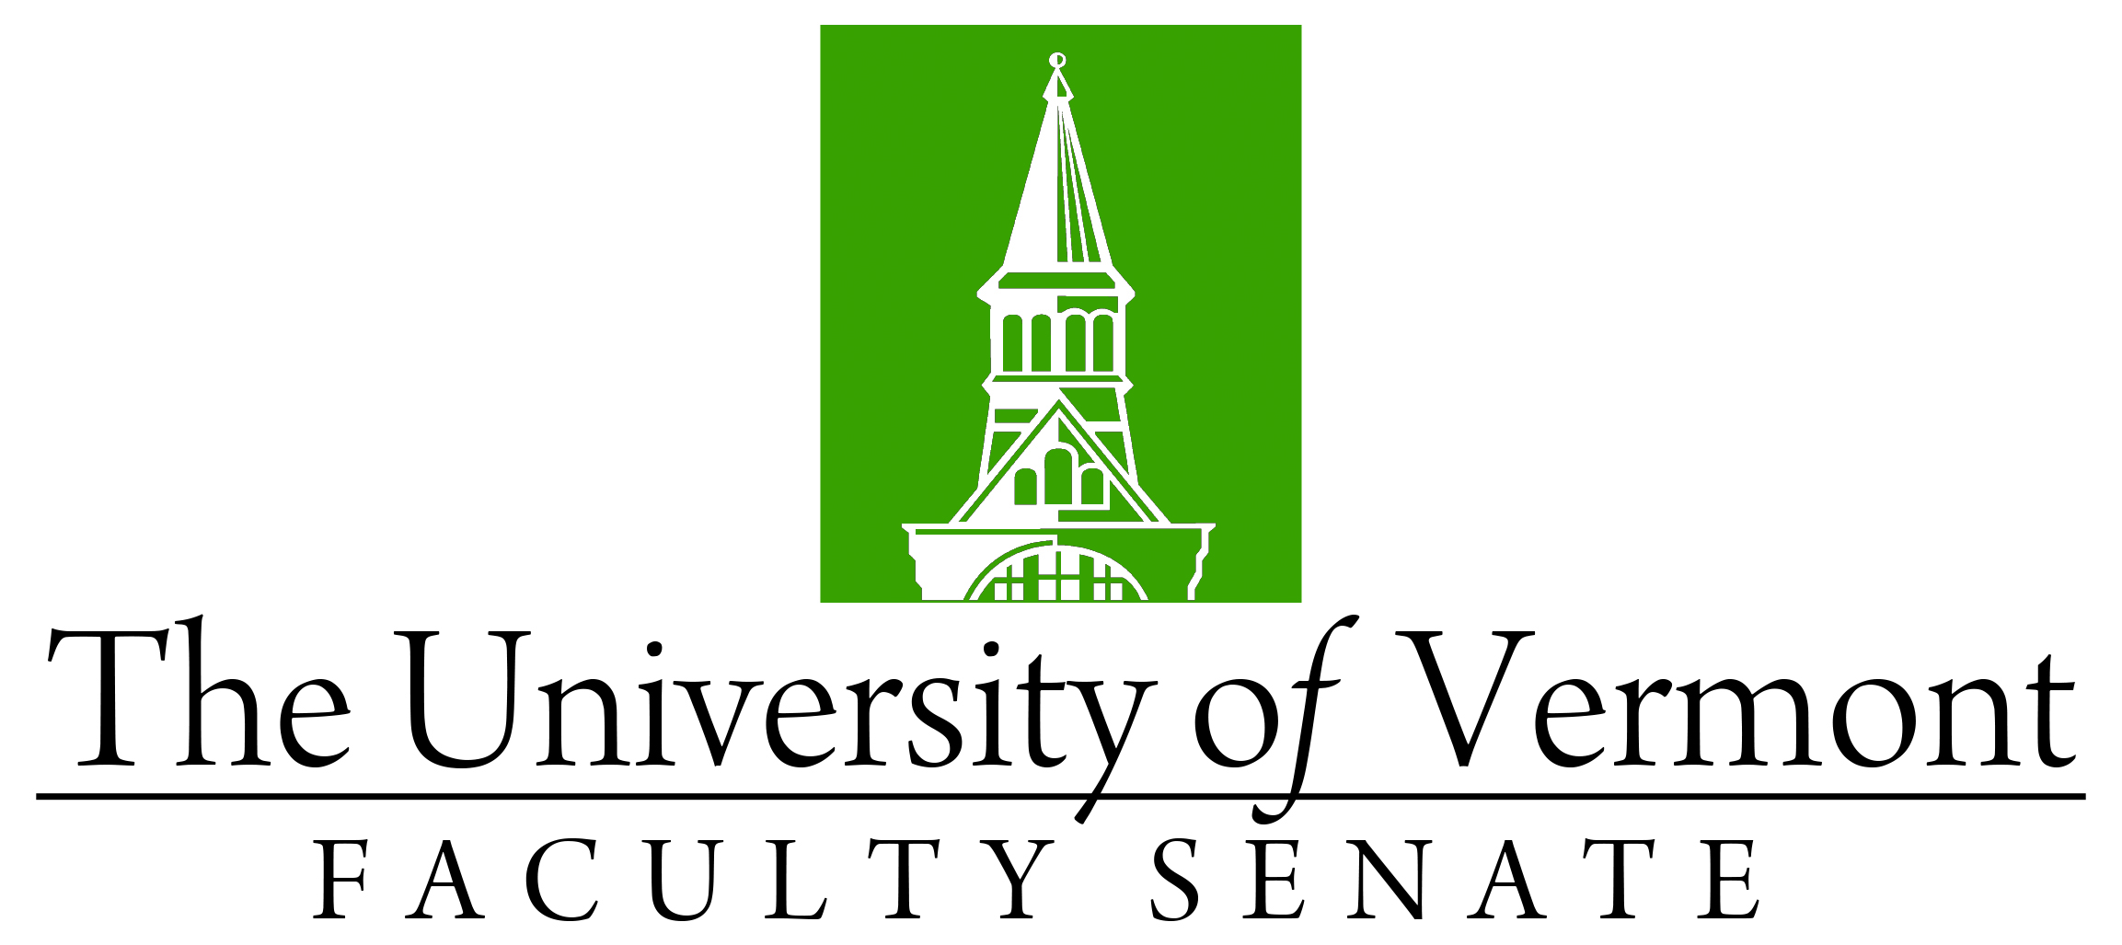

Faculty Senate Meeting
Monday, November 27, 2023
4:00 – 5:30 pm, Teams

Agenda

4:00 | - Faculty Senate President’s Welcome Remarks – Thomas Borchert
4:05 | - Consent Agenda (vote)  - Minutes of the October 2023 Faculty Senate Meeting
4:10 | - Reports that do not require a Senate vote:  - Curricular Affairs Committee  - Student Affairs Committee – extending student athlete policy to graduate students
4:15 | - Academic Freedom and Outside Speakers (Trent Klingerman, UVM General Counsel)
4:35 | - Water Resources Institute Proposal (Beverly Wemple, Professor of Geography)
4:50 | - Update on Admissions and the Impact of Supreme Court decision on Affirmative Action (Jay Jacobs, Vice Provost for Enrollment Management)
5:10 | - New Business
5:15 | - Adjourn

