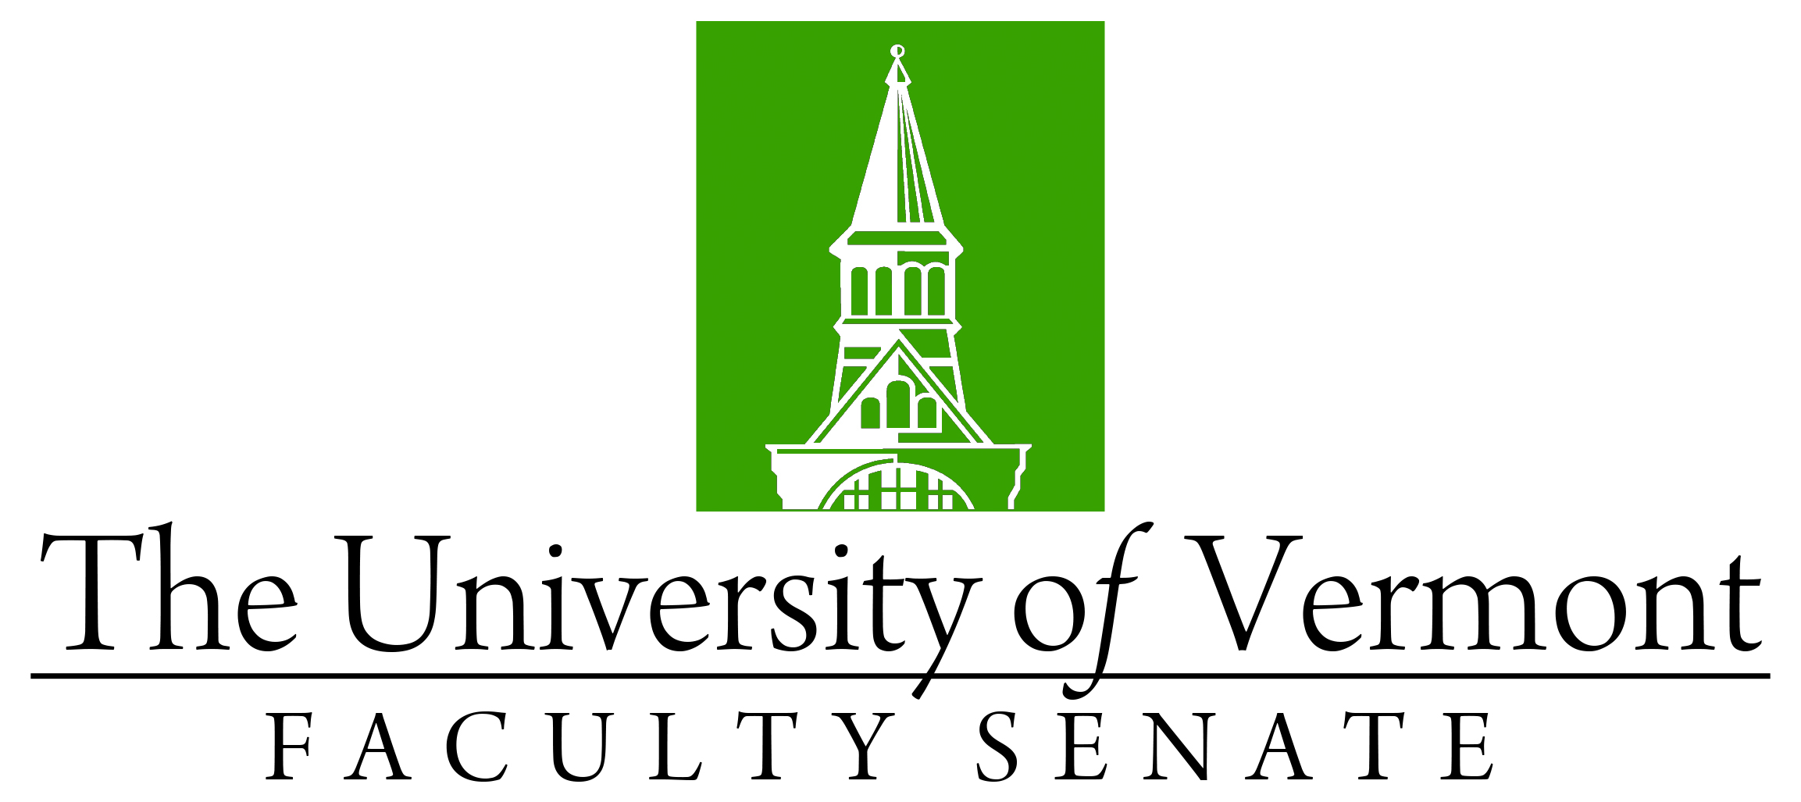

Faculty Senate Meeting
Monday, September 18, 2023
4:00 – 5:30 pm, on Teams

Agenda

4:00 | - Faculty Senate President’s Welcome Remarks – Thomas Borchert
4:03 | - Degree Conferrals (vote)
4:05 | - Consent Agenda (vote)  - Minutes of the August 2023 Faculty Senate Meeting
4:10 | - Reports that do not require a Senate vote:  - Curricular Affairs Committee Report of Actions Voted by CAC
4:15 | - Co-Major Credential at UVM (vote)  - Curricular Affairs Committee Approval Memo  - The proposal and templates are available on Faculty Senate SharePoint site (login required)
4:35 | - Eclipse Day (discussion)  - The proposal is available on Faculty Senate SharePoint site (login required)
5:05 | - Announcement about NECHE report
5:25 | - New Business
5:30 | adjourn

