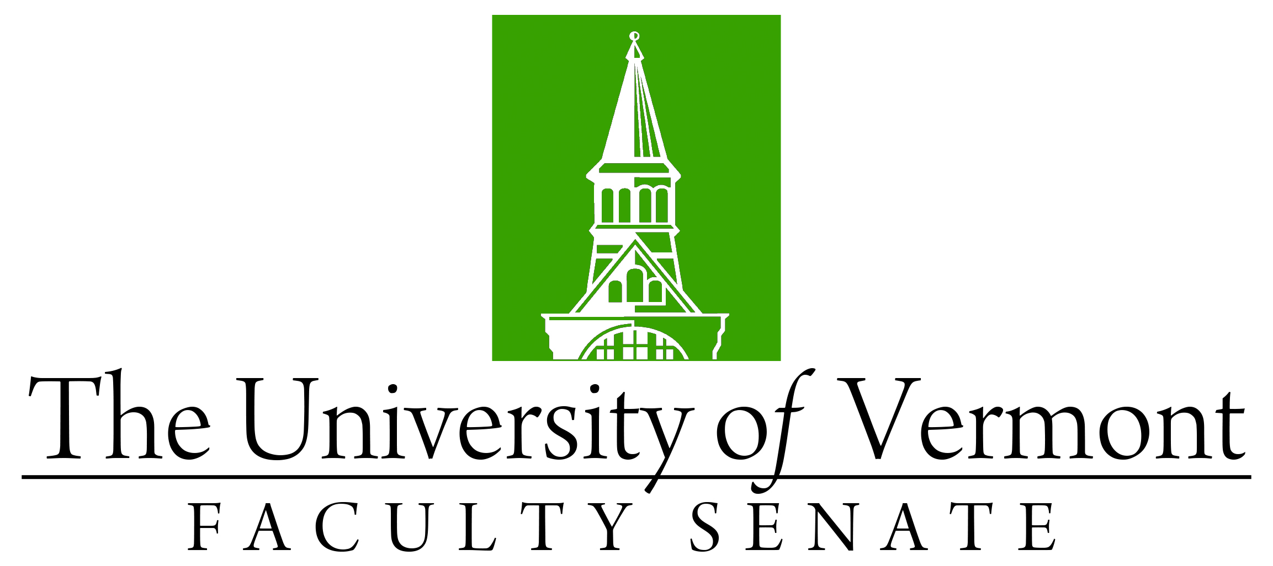

Faculty Senate Meeting
Monday, March 28, 2022
4:00 – 5:30 pm, Waterman 338

Agenda

4:00 | - Faculty Senate President’s Welcome Remarks – Thomas Borchert [5 min]
4:05 | - Consent Agenda (vote) [5 min]  - Minutes of the February 2022 Faculty Senate Meeting  - Curricular Affairs  - New minor in Medical Diagnostics (CNHS)  - No-contest Deactivation BS in Early Childhood Special Education (CESS)
4:10 | - Reports that do not require a Senate vote  - APR: Exercise Science Program (CNHS)  - Environmental Studies Minor move from RSENR to CAS
4:15 | - Resolutions in Memoriam (vote)  - Dean Corrigan, Professor and Dean (CESS) - Bud Meyers  - William E. Mitchell, Professor Emeritus of Anthropology (CAS) - Luis Vivanco
4:25 | - Call for Nominations  - Faculty Senate President Elect  - Members At-large to the Senate Executive Council (2-seats)
4:30 | - Proposal to move Physics Department from CAS to CEMS (vote)
4:50 | - Update on Board of Trustees and UVM governance bill
4:55 | - Changes to the Residential Learning System (Discussion) J. Dickinson,
5:10 | - New Learning Management System (Discussion) Simeon Ananou
5:25 | - New Business [5 min]
5:30 | - Adjourn

2021-2022 Faculty Senate Meetings
Mondays 4:00 – 5:30 PM (exceptions noted)
8/23/21 – 3:00 – 4:30 PM
9/20/21
10/18/21
11/15/21
12/20/21 – 3:00 – 4:30 PM
1/24/22
2/28/22
3/28/22
4/25/22
5/19/22 – 3:00 – 4:30 PM Thursday

