There are just a few simple steps to add an Attachment to a Purchasing Card journal. The Attachment functionality is useful for receipts, scanned conference agenda, and additional supporting documentation.
- There is an Attachments hyperlink on the PurCard journal.

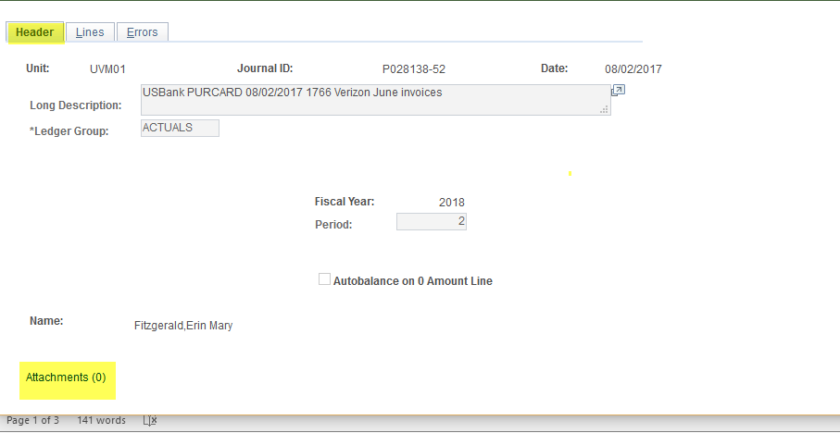

- Press the Add Attachment button.
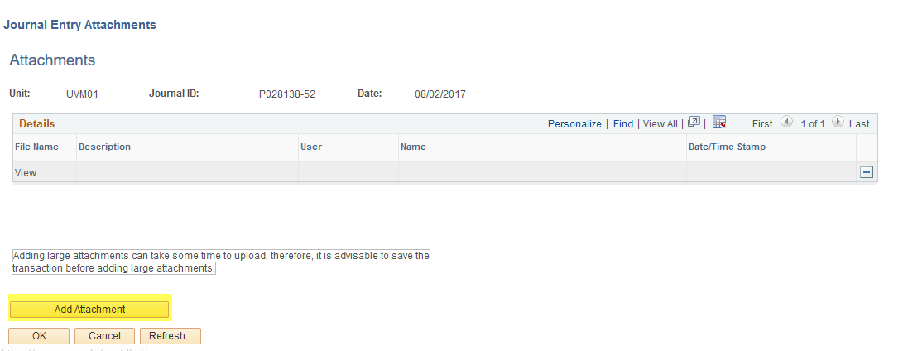
- Press the Browse button to search for a file.
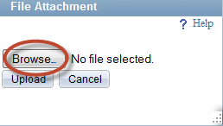

- Locate the desired file. Press Open.
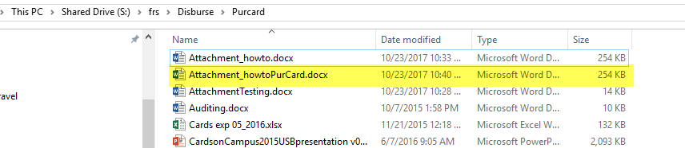

- After the file has been selected, press the Upload button.
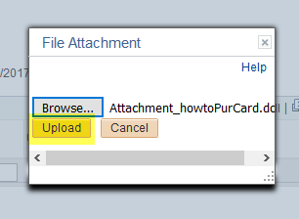

- Press the OK button.

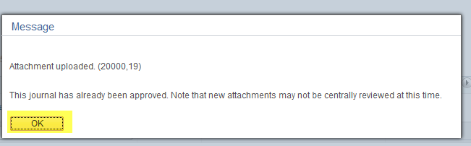

- Add description if desired.
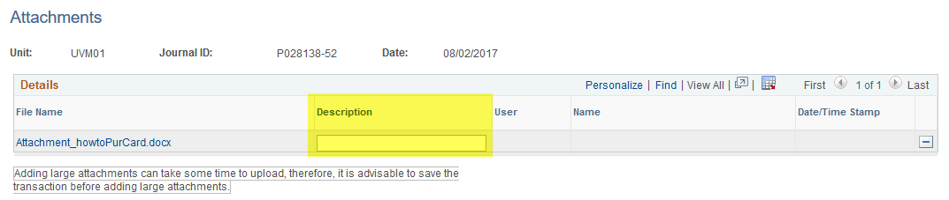

- On the PurCard journal, notice the counter on the Attachments hyperlink has changed to one. The document has successfully been attached to the Purchasing Card journal.

