PBIS Buy-In, Momentum, Sustainability

The following can be used to guide discussion!

- Buy-In
  - Develop a common understanding
  - Enlist leaders with integrity, authority, resources and willingness to assist
  - Expect, respect and respond to resistance (encourage questions and discussion)
  - Clarify how changes align with other initiatives
  - Emphasize clear and imminent consequences for not changing
  - Emphasize benefits
    - Conservation of time/effort
    - Alignment of processes/goals
    - Greater professional accountability
  - Share visuals (graphs) with faculty on a regular basis
  - The visuals are a powerful tool:
  - To let staff know the extra work they are doing is paying off
  - To show specific areas that may need a more intense focus

- Momentum
  - Braid with other initiatives under school improvement.
  - Sustain successful strategies by writing into policy.
  - Re-work hiring policies (staff who support PBIS). (McKevitt & Braaksma, 2007)
  - Promote ... PRIORITY
  - Ensure … EFFECTIVENESS
  - Increase … EFFICIENCY
  - Use data for … CONTINUOUS REGENERATION

- Sustainability

  - PBIS is most sustainable with a supportive administrator and strong team
  - School teams can benefit from training in running meetings and using data
  - Focus and agreement on outcomes for PBIS implementation
Examples:
  - Increase in attendance
  - Improvement in academic performance
  - Increase in the number of appropriate student behaviors
  - Students and teachers report a more positive and calm environment
  - Reduction in the number of behavioral disruptions, referrals, and incident reports
  - Reasons for making changes are not perceived as compelling enough
  - Staff feel a lack of ownership in the process
  - Insufficient modeling from leadership
  - Staff lack a clear vision of how the changes will impact them personally
  - Insufficient system of support

Additional Questions:

- How does the following rule apply to your school staff?

80/15/5 Rule – buy-in, momentum and sustainability for any school-wide effort generally requires at least 80% of staff and acknowledges that progress can be maintained with up to 15% of staff who may benignly support the effort and up to 5% of staff that do not support the effort.

- What stage is your school in regard to PBIS implementation? What is the evidence?

Stages of Implementation
- Exploration
- Installation
- Initial Implementation
- Full Implementation
Fixsen, Naoom, Blase, Friedman, & Wallace, 2005

- Rate your school by placing a number from 0-2 in each of the boxes in which a 0 means does not exist 1 means needs improvement and 2 means achieved. What is your score? Compare and discuss!

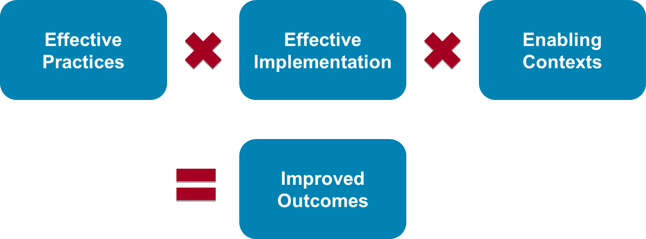
(The formula for success involves multiplication. If any component is weak then the intended outcomes will not be achieved, sustained, or used on a socially significant scale.)

https://kentmcintosh.files.wordpress.com/2011/04/subsist-checklist-1-1.pdf

