VTPBiS Calendar of Activities for
SU/SD Coordinators and School Coordinators

Building and sustaining PBIS implementation within a Multi-Tiered System of Supports (MTSS) requires coordination and coaching at all levels! The chart below describes Vermont’s structure of technical assistance, coaching and coordination for VTPBiS schools. Attached is a calendar summarizing monthly activities to guide coordinators in their work. For a complete description of the roles and responsibilities within the VTPBiS structure of supports go to http://www.pbisvermont.org/resources/coaches-a-coordinators. For more information about PBIS assessments go to http://www.pbisvermont.org/resources/evaluation-tools.
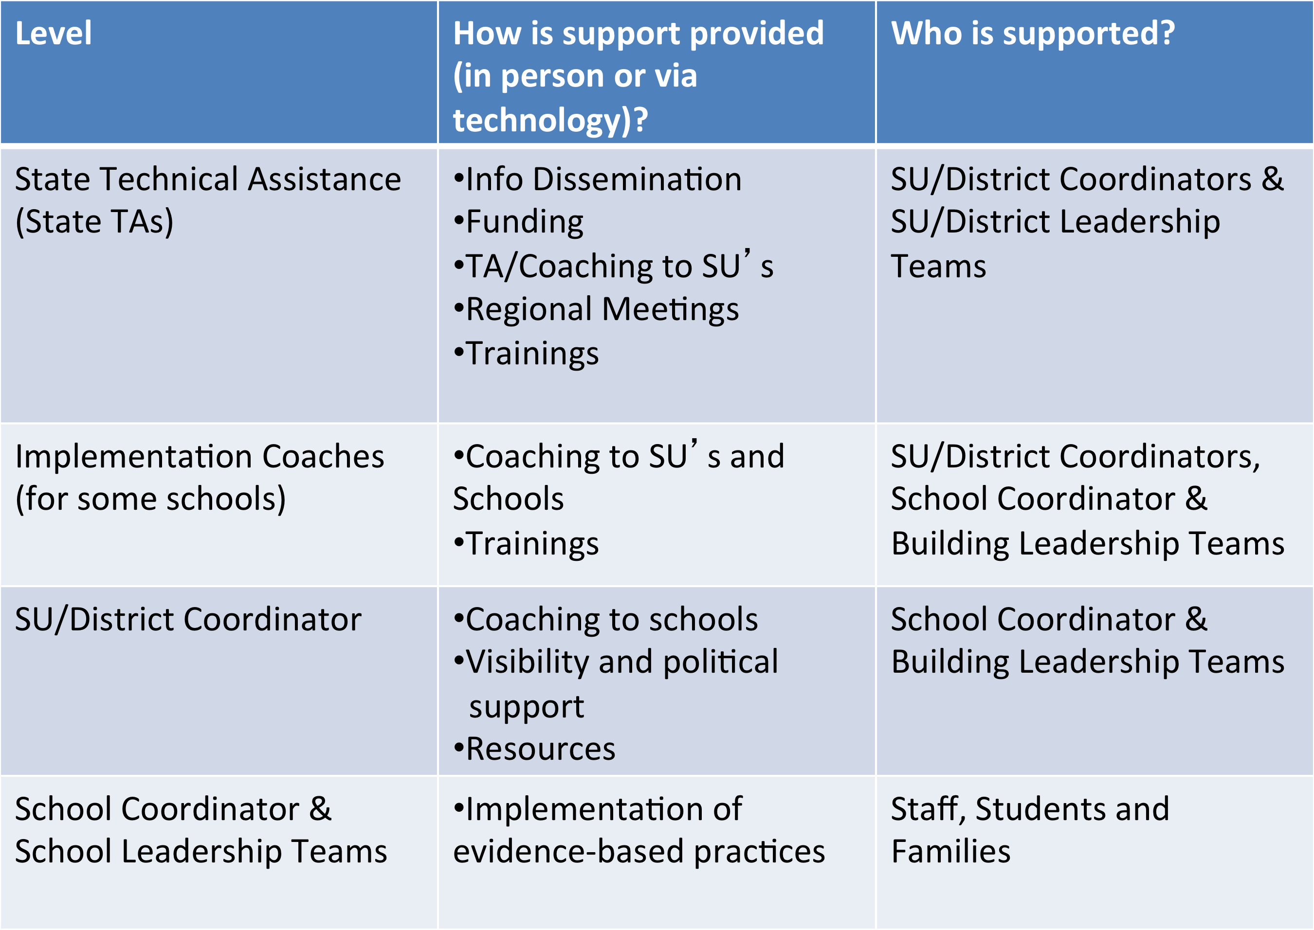

Month: | Activities:
July -September | School Coordinators:  - Complete VTPBiS Action Plan for Sustainability VTPBiS Action Plan for Sustainability (doc)  - Rollout (Staff, Students, Community and Families)  - Update contact information at http://www.pbisvermont.org/schools/how-to-update-contact-info  - Review the PBIS/BEST PD calendar and identify trainings for the upcoming year  SU/SD Coordinators:  - Make contact with your School Coordinators.  - Schedule 2 to 3 meetings with each school leadership teams  - Attend PBIS school-based leadership team meetings  - Establish SU/SD Team that meets 2 times per year  - Touch base with your State TA about resource and PD needs  - Review the PBIS/BEST PD Calendar and support your schools in determining what trainings they may need throughout the year
October | School Coordinators:  - Review September ODR data (SWIS or other school-wide information system)  - Receive SWIS Invoices and process for payment (if applicable)  - Attend Annual PBIS Leadership Forum. Receive annual PBIS school acknowledgements and share with SU/District/School/Community.  - Use Team Implementation Checklist at http://www.pbisvermont.org/resources/evaluation-tools/tic (recommended as an optional planning tool for new schools)  SU/SD Coordinators:  - Schedule and conduct post-implementation SETs (for new schools only)  - Attend Annual PBIS Leadership Forum. Receive annual PBIS school  - Review schools’ data and provide observations and feedback
November | School Coordinators:  - Publicize and celebrate annual state level PBIS acknowledgements  - Review ODR data (SWIS)  - Re-Teach Expectations, if needed  - Plan/conduct post-implementation SET (new schools only)  - Plan to attend Universal Data Day (optional)  SU/SD Coordinators:  - Conduct SU/SD Leadership Team Mtg  - Review schools’ data and provide observations and feedback  - Prompt schools to register for and complete action steps for Universal Data Day
December | School Coordinators:  - Run SWIS Data Integrity Report  - Attend Regional Data Day  - Review November ODR data (SWIS)  SU/SD Coordinators:  - Review school data and provide observations and feedback.  - Attend Data Day with your school leadership teams
January | School Coordinators:  - Review December ODR data (SWIS)  - Re-Teach Expectations, if needed  - Complete Self-Assessment Survey (SAS), survey window opens January 1 and closes February 28.  - Complete Self-Assessment Survey (SAS) between January 1 and February 28 and Benchmarks of Quality between January 1 and March 31  - Complete Benchmarks for Advanced Tiers (for Targeted and Intensive Schools only) between January 1 and March 31  SU/SD Coordinators:  - Attend PBIS school-based leadership team meetings  - Prompt schools to complete Self-Assessment Survey (SAS) between January 1 and February 28 and BoQ between January 1 and March 31  - Prompt Targeted and Intensive schools to complete the Benchmarks for Advanced Tiers (BAT) between January 1 and March 31.
February | School Coordinators:  - Review January ODR data (SWIS)  - Review Working Smarter, Not Harder Matrix with School Leadership Team to streamline, coordinate, eliminate.  - Help plan booster or refresher trainings for before or after school vacation  - Complete Self-Assessment Survey (SAS), survey window opens January 1 and closes February 28  - Complete Benchmarks of Quality (BoQ) between January 1 and March 31  - Complete Benchmarks for Advanced Tiers (for Targeted and Intensive Schools only) between January 1 and March 31  - SU/SD Coordinators:  - Prompt schools to complete the SAS between January 1 and February 28 and BoQ between January 1 and March 31  - Prompt Targeted and Intensive schools to complete the Benchmarks for Advanced Tiers (BAT) between January 1 and March 31.  - Review school data and provide observations and feedback.
March | School Coordinators:  - Review February ODR data (SWIS)  - Attend Regional Coordinators’ Mtg  - Complete Benchmarks of Quality (BoQ) between January 1 and March 31  - Complete Benchmarks for Advanced Tiers (for Targeted and Intensive Schools only) between January 1 and March 31  SU/SD Coordinators:  - Attend Regional Coordinators Meeting  - Provide feedback on the SAS using SAS Summary Form  - Prompt schools to complete BoQ by March 31  - Prompt schools to complete the BoQ between January 1 and March 31  - Prompt Targeted and Intensive schools to complete the Benchmarks for Advanced Tiers (BAT) between January 1 and March 31.  - Attend PBIS school-based leadership team meetings
April | School Coordinators:  - Review March ODR data (SWIS)  - Plan to attend Targeted Data Day (optional for schools implementing at the Targeted Level)  SU/SD Coordinators:  - Review completed BoQ at www.pbisapps.org and provide observation and feedback to coordinators.  - Prompt schools to attend Targeted Data Day (if implementing Targeted Level)  - Review school data and provide observations and feedback.  - Conduct SU/SD Leadership Team Mtg
May | School Coordinators:  - Review April ODR data (SWIS)  - Participate in Data Day Webinar  - Nominate your school for an Annual Acknowledgement  SU/SD Coordinators:  - Prompt schools to determine PD needs for next year based on needs identified at Data Days  - Prompt schools to complete steps needed to attend training at Summer Institute (if applicable)  - Ensure participation in Data Day Webinar  - Encourage your schools to nominate themselves for an Annual Acknowledgement
June | School Coordinators:  - Review May ODR data (SWIS)  - Print “School Summary” report (SWIS)  - Share successes with stakeholders  - Celebrate with Staff  - Schedule Pre-Service and In-Service Meetings for next year  SU/SD Coordinators:  - Review your school(s) Implementation Plan and facilitate action steps for next year  - Celebrate your school(s) successes  - Report highlights and successes at end of the year School Board Mtgs

Guidelines for VTPBiS Network of Active Schools:

Inclusion in the VTPBiS Network of Schools is demonstrated by the following:

- Data: The school completes annual assessments (SAS and BoQ).

- Communication: Contact with an Implementation Coach or State TA is maintained. Communication between the school and its Supervisory Union/Supervisory District Coordinator is ongoing.

- Participation: Relevant staff attends VTPBiS Regional Coordinators meetings and Regional Data Days.

- Training: School Teams need to be trained by a VTPBiS state recommended trainer. For questions please contact your State TA.

Inclusion in the Network results in access to technical assistance, implementation coaching and VTPBiS training. Network schools will be included in all electronic communications and will be eligible to receive annual VTPBiS acknowledgements based on fidelity of implementation.

