

PBiS at TBPS

Student Support Manual

A Guide for Teachers and Staff

Developed by BEST Team 2010
With Special Thanks to
Howard Muscott
&
Eric Mann
of NH CERESC

Table of Contents

Section Page #
I. Mission Statement & Guiding Principles 3

II. Behavioral Expectations & Procedures 3
- Classroom Expectations / School Codes 3
- Behavior Expectation Teaching Matrix 4
- Discipline Pyramid 5
- Minor vs. Major 6

III. Interventions (3 tiered approach) 7

IV. Support Teams 9
a. Universal- EAGLES 9
b. Targeted- BEAC 9
c. Intensive-TALoNS 10

V. Quick Reference and Forms 11
a. Discipline Referral 12
b. SST Referral 12
c. EST Referral 12
d. BEAC contract 12
e. BEAC sheet 12

VI. Glossary of Terms 13
Appendix1 14
PBiS:A 3-Tier Approach
- Why PBiS?
- Universal- Tier 1
- Targeted- Tier 2
- Intensive -Tier 3

Appendix 2: Basic Recess Rules 16

I. Mission Statement and Guiding Principles:

The mission of the Student Academic and Behavior Support System of TBPS is to provide universal supports, early identification of at risk behavior, and interventions that meet the needs of individual students. This system will help ensure that all students acquire the knowledge, skills, and attributes needed to achieve their full potential and to be contributing members of a democratic society in a changing global community.

Guiding Principle: Social Behavior and Academic Achievement are Linked
- To improve the academic success of our children, we must improve their social success.
- Academic and social failures are reciprocally and inextricably related.
- As a result, systems to support academics and behavior need to be integrated.

In order to change student behaviors….
- Adults must model behavior
- Students must experience academic success
- Students must be formally taught the behavior

Supporting systemic change in a school community is a long-term journey that begins with hopes, dreams and ideas….
…which can be embraced by faculty, administrators, families and community members, that….
- Initially begins with words,
- Which develops into actions and behaviors,
- Then becomes habits through practice,
- To ultimately form a climate and culture.

II. Behavioral Expectations and Procedures/Protocols/Communication

a. TBPS Codes of Behavior

We are respectful of ourselves, others and things by
- being safe
- making good choices
- doing our best

These codes of behavior should be prominently displayed in classrooms, specials, and any other settings students regularly visit or attend, and should guide classroom rules.
Also, Thatcher 3 Posters will be found in specific settings (ie. Bathrooms, buses, playground, and cafeteria) outlining how to follow the codes in specific settings.

b. Behavior Matrix

 | BE SAFE | Make Good Choices | Do your best
All Settings | -Respect yourself  -Respect others  -Respect Property | -Respect yourself  -Respect others  -Respect Property | -Respect yourself  -Respect others  -Respect Property
Hallways | - walk at all times  - keep your hands and body to yourself  - stay to the right | - use inside, quiet voices  - follow teacher directions | - keep areas clean  - respect other students’ work
Playground/Recess | - respect personal space  - use equipment as designed  - use words to solve problems | - respect personal space and other student requests  - be a good sport  - use kind language  - follow teacher directions | - include others  - share  - take turns  - be active  - play fair
Cafeteria | - walk at all times  - ask permission to leave  - wash hands  - respect the peanut-free table | - use inside voices  - sit in one place  - follow adult directions | - use good table manners  - clean up  - eat what you take  - say “please” and “thank you”
Buses | - stay seated while bus is moving  - keep your body inside the bus  - respect others personal space and requests | - use inside voices  - stay in your seat  - keep your feet still and under the seats  - follow bus driver directions | - leave bus in the condition, or better, that you found it  - keep food and drinks in backpacks
Bathrooms | - wash your hands | - inside voices  - keep area clean  - use bathroom responsibly  - flush  - use only the soap and water you need | - report problems  - use things responsibly

- Discipline Pyramid

The purpose of the Discipline Pyramid is to streamline the process of dealing with misbehavior.
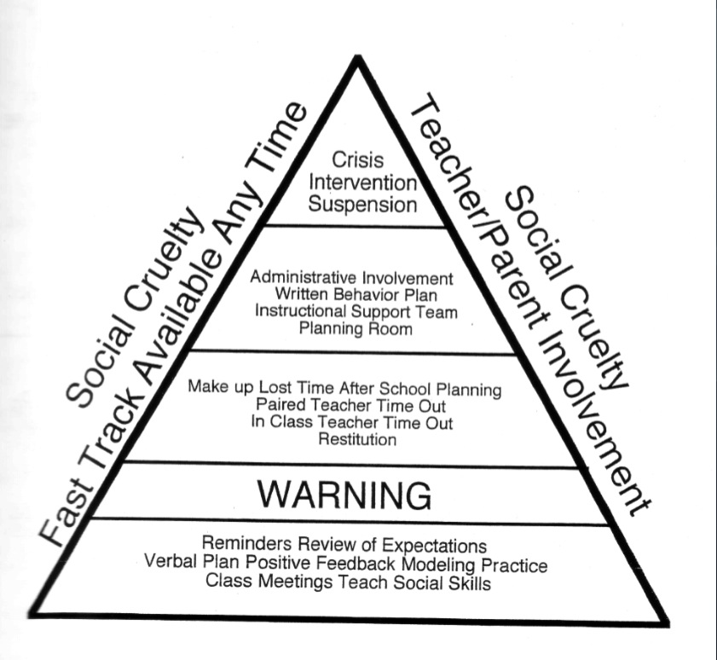

- Minor vs. Major

 | MINOR | MAJOR
Definition | A minor infraction is one that does not put the safety of another student or adult at risk. A minor infraction disrupts the student’s attention to his class work or activity but does not prevent a staff member from performing their duties. | A major behavior infraction is one that either puts the safety of others in jeopardy or disrupts the teaching and learning that is taking place in a classroom or school function.
Examples | - Excessive talking  - Noise level too high  - Not following directions  - Off task  - Teasing  - PDA  - Minor physical contact  - Misusing Materials  - Disrespectful peer interaction  - Disrespectful teacher interaction | - Repeated or directed profanity  - Physical aggression  - Stealing  - Cheating  - Vandalism  - Repeated refusal to follow directions- defiance  - “3-peats”  - Bullying  - Harassment  - Chronic disruptions  - Fighting/Aggression
Procedures | - Individual staff fill out Discipline Referral Form for all MINORS  - Processing/Information gathering with student  - Consequences are enforced by referring staff  - make a plan,  - re-teach expected behavior,  - time-away & make up missed time, or  - loss of privileges  - Send completed Discipline Referral Form to Jason for data entry reasons only  - Contact parents if multiple MINORS occur with same staff member | - Intervene to maintain safety.  - Discipline Referral Form is filled out by sending staff  - Contact Jason or Don, and give them Discipline Referral Form  - Staff and student Processing/Information gathering with Jason/Don  - Consequences are decided on by Jason/Don and according to protocol.*  - Follow up with referring staff member for agreement with consequences  - Jason, Don or staff member to call parents
*MAJOR Consequences will be natural and logical and may include:
    - Loss of privilege;
    - Reparation;
    - alternative learning space;
    - removal/suspension;
and will include a parent phone call, and possibly a parent meeting
III. Interventions

Tier 1: Universal interventions
These should be primarily preventative and include an abundance of adult positive interactions with students on the whole. Positive interactions with students should outweigh negative interactions at a rate of at least 5:1. Positive interactions around the codes may be paired with a sticker for a class’s sticker chart, especially during “booster” periods when specific behaviors or settings are the focus. Students not following the codes will be addressed according to the behavior pyramid and outline of major vs. minor behaviors.

Universal Interventions Mission Statement
To teach all students to be empowered by the knowledge of their own worth and to act with respect, empathy and integrity.

Tier 2: Targeted interventions
These are for the selected students who do note wholly respond to universal interventions, but are not identified as intensive level intervention students. These students will be identified through considering both indicators and referrals (nominations).

Targeted Interventions Mission Statement
To effectively and efficiently match children, who have not responded to the school-wide supports, to resources that help them feel successful, be accountable, and increase their self awareness.

Teacher or Parent Referral (Nomination)
Behavioral Indicators
(Cutscores*)
Academic Indicators
(ie. Avoidance)

Tier 2 Initiation

*Tier 2 Behavioral Indicators (Cutscores)

Indicators | Within 6 six weeks | Anytime during year
Discipline Referrals for Major Behaviors | 3 or more | 5 or more
Discipline Referrals for Minor Behaviors | 10 or more | 5 per month
Nurse “TLC” Visits | 4 or more | 8 or more
Attendance: Tardies | 5 or more | 10 or more
Attendance: Absences | 5 or more | 10 or more

Targeted interventions begin standardized, and move toward more personalization, depending on the individual student’s response to the intervention. Targeted interventions should always take into consideration the function of the student’s behavior (what the student is trying to get or avoid). Below are some examples:

Function of Behavior | Group Interventions
Gain adult attention | Check-in Check-out  Mentoring  Lunchdates with teachers  Everyone wins
Gain peer attention | Social skills groups  Social thinking groups  Interest groups/clubs  Adventure Group
Academic Avoidance | Tutoring  Everyone Wins  Homework groups
Social Avoidance | Social skills groups  Social thinking groups

Student responses to interventions will be assessed on a regular basis to determine if it is working, if it needs tweaking, or if Tier 3 interventions would be more appropriate.

Tier 3: Intensive interventions \
These are personalized and individualized for specific student needs. Intensive students exhibit chronic or intense behaviors. The goal of interventions is to teach replacement behaviors based on function, and to decrease the number or intensity of behavior exhibited. Interventions most frequently included behavior plans or contracts that are individualized for student’s behavioral functions and specific needs.

IV. Support Teams

Team Profiles and Meeting Schedules
2010-2011 School Year

Intensive/Tertiary

Individual student teams

Systems
(BEST)
WHO: Mandy, Sonja, Don,
Brenda, Nancy,Deanna

Monthly- Fridays 3:00 PM
Targeted
(SST)
WHO: Mandy, Deanna, Jason, Laura, Terri, Don, Barbara

Tuesdays 9:30-10:30

School-wide
Universal Team
WHO: Brenda, Don, Jason, Mandy, MK, Nancy, Carol, Laura, Harry, Nancy R.

Wednesdays 9:30-10:10

- The Universal Team- EAGLES (Education Around great Learning Everyday )
The Universal Team meets once a month to address areas that may need “boosters” due to data review. They are charged with maintaining the Universal or school-wide system. Responsibilities include, but are not limited to:
  - Schoolwide behavioral expectations are defined;
  - Behavior expectations are taught;
  - Recognition system for appropriate/expected behaviors;
  - Continuous collection and use of data for decision making.

- The Targeted Team- BEAC (Behavior Education Around the Codes)
The Targeted Team meets weekly during the SST time. The purpose of this team is to efficiently and effectively match students who have not responded to school-wide supports to supports more likely to produce successful outcomes. Responsibilities include, but are not limited to:
- Progress monitoring for students at risk;
- System for increasing structure and predictability;
- System for increasing contingent adult feedback;
- System for linking academic and behavioral performance;
- Collection and use of data for decision-making.

- The Intensive Team- TALoNS (Teaching Aspiring Learners New Skills )
These teams are currently student based and usually include a classroom teacher, administrator, special education case manager, service providers, student support or behavior person and other staff as necessary.

- The Systems Team- BEST
This team is the PBiS Leadership team. They meet monthly to assess implementation of the complete PBiS system.

V. Quick Reference and Forms

Behavior Management Strategies

Maximize Structures:
- Develop, define and teach predictable routines;
- Establish traffic flows;
- Minimize crowding and distractions;
- Seating arrangements need to math teaching methods.

Teach Behavior Expectations:
- Formally Teach behaviors you want;
- Post, teach, prompt corrections, review, monitor, evaluate, reinforce;
- Teaching expectations is only effective if you give performance feedback.

Actively Engage Students:
- High rates of opportunities for students to respond;
- Various ways to engage students;
- Link engagement with learning outcomes.

Establish a Continuum of Strategies to Acknowledge Appropriate Behaviors:
- Specific and contingent recognition, reinforcement or praise;
- Group contingencies;
- Behaviors contracts with group;
- Token economies.

Establish a Continuum of Strategies to Respond to inappropriate Behaviors:
- Error corrections;
- Differential reinforcement of appropriate behavior;
- Planned ignoring;
- Response costs
- Brief time away from reinforcement

Self Monitoring:
- Students can use counters, tallies, rate themselves, etc.

FORMS

- Discipline Referral:
- To be used for behaviors that are inappropriate/unexpected. Please see the list of major and minor behaviors listed on page 6.
- Minor referrals should be written and given to Jason only for data collection.
- Major referrals should be given to Jason or Don to address specified student behavior.

- SST/Targeted Referral
- This form is to be used if you have a concern about a student’s behavior (externalizing or internalizing) and are not responding to interventions attempted.
- SST Referral forms should be completed and given to Mandy.

- EST Referral Form
- This form is for students who are not responding to academic interventions.

- BEAC Sheet
- This form is a daily report card for behavior, for the students identified as needing Check-in Check-out (CICO) as a targeted intervention.
- Students will carry these forms and need to be addressed multiple times a day.
- These forms should go home for parent signature and come back to school the next morning.

- BEAC Contract
- This form is for the student who has been referred to CICO.

VI. Glossary of Terms:

BEAC- Behavior Education Around the Codes

PBiS- Positive Behavioral Interventions and Supports

Appendix 1

WHY PbiS?
- To improve the academic success of our children, we must also improve their social success.
- Academic and social failures are reciprocally and inextricably related.
- As a result, systems to support behavior and literacy should be integrated.
In order to change student behavior…
- Adults must model behavior
- Students must experience academic success
- Students must be formally taught the behavior

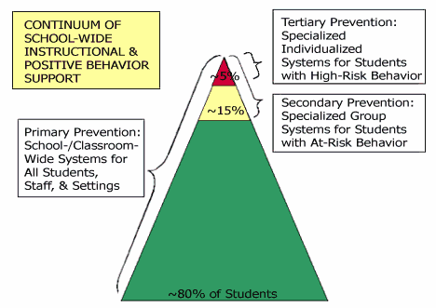
PBIS

Positive Behavioral Interventions and Supports aims to improve school culture and climate and improve student behavior so that teachers can teach and children can learn. PBIS supports all students in all school and preschool settings, builds school environments that are more positive, predictable and consistent and supports growth and achievement in academics and social skills. The principles and practices of PBIS can be also be used at home and in community settings such as youth athletic teams and youth clubs.

Goals
The goals of PBIS provide the foundation for good education and positive relationships:
- Regain the teaching time currently spent in managing misbehavior
- Maximize on-task time and academic achievement for all students
- Increase positive and civil social behavior
- Increase family engagement in schools
- Improve school climate for students and adults
Long-term outcomes include:
- Enduring, positive changes in behavior
- Reduction in the need for serious disciplinary measures such as suspension and expulsion
- Increase in graduation rates and
- Improvement of post-high school outcomes for all students, including those with challenging behavior and educational disabilities

PbiS: A 3-Tier Approach

- Tier 1, primary prevention, is designed to address the whole population
- While applied to the entire student body, the emphasis here is on reaching the approximately 80-90% of students who do not have serious behavior problems or mental health needs
- The purpose of universal strategies is to maximize achievement, deter problem behavior, and increase positive peer and adult interactions

- Tier 2, secondary prevention, is aimed at the roughly 5-10% of students considered at risk for developing behavioral disorders or mental illness.

- These students enter school with significant risk factors and are usually unresponsive to universal prevention strategies alone.
- The goal is two-fold:
  - To decrease opportunities in which high-risk behaviors might be fostered
  - To establish effective and efficient prosocial repertoires that would increase their responsiveness to primary interventions

- Tier 3, tertiary prevention, targets the 1-5% who display symptoms or behaviors related to EBD or mental illness.
- The goal of tertiary interventions is to reduce the frequency, intensity and complexity of students’ maladaptive behavior patterns and provide them with suitable, efficient and effective replacement behaviors that will compete with their more maladaptive ones.
- Tertiary interventions are implemented for students with significant needs and are adapted to meet individual needs.

Appendix 2

Basic Recess Rules

- When supervising adult determines any activity unsafe due to conditions or use of equipment, students must stop that activity.

- Use equipment only as designed.

- There is only one climbing tree, the large one east of the amphitheater.

- Active play (kickball, soccer, basketball, tag, etc.) takes place on the upper playground area.

- Stay on your feet during soccer games. Slide tackles are not permitted.

- Aim kickball at runner’s body. If a runner is accidentally hit in the head, they are automatically safe.

- Always go feet first down the slide.

- Bail off sled before the top of the berm.

