8

Positive Behavior Support

Non-Classroom Management:
Self-Assessment

George Sugai & Geoff Colvin

Center on Positive Behavioral Interventions and Supports
University of Oregon

Version: March 10, 2004

SCHOOL-WIDE POSITIVE BEHAVIOR SUPPORT

OSEP Center on Positive Behavioral Interventions and Supports
University of Oregon
www.pbis.org

The OSEP Center on Positive Behavioral Interventions and Supports is grateful to the students, educators, administrators, families, support providers, researchers, and teacher trainers who have worked tirelessly to improve educational outcomes for all students and who have contributed to our understanding of the critical practices and systems of positive behavior support.

These training materials have been developed to assist schools in their efforts to improve school climate and positive behavior support for all students. Photocopying, use, and/or sale of these materials is forbidden without expressed written permission by the OSEP Center for Positive Behavioral Interventions and Supports. To obtain a personal copy of these materials, contact the Center at 541-346-2505, pbis@oregon.uoregon.edu, or www.pbis.org.

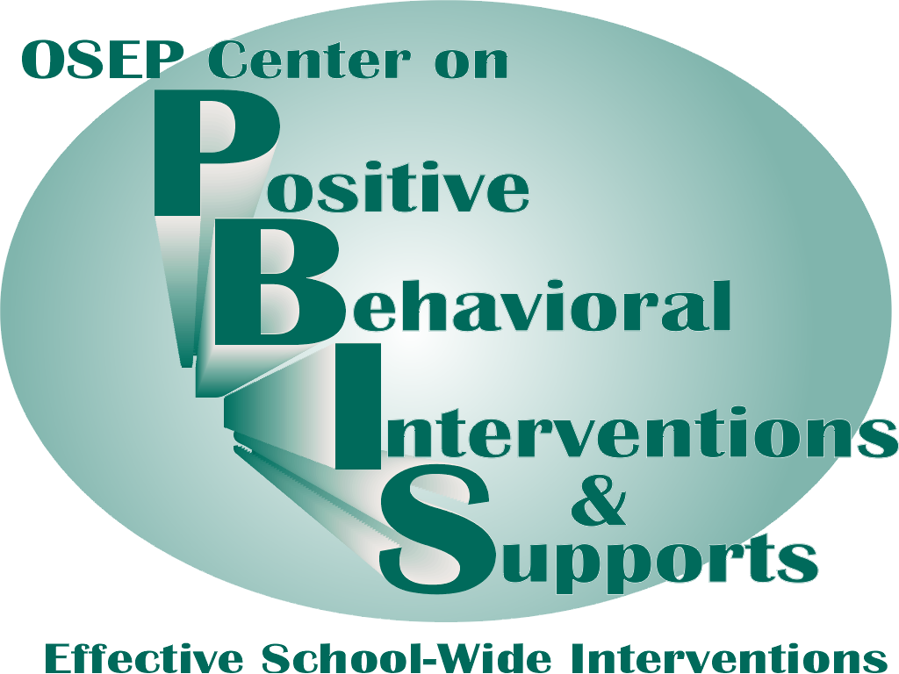 | 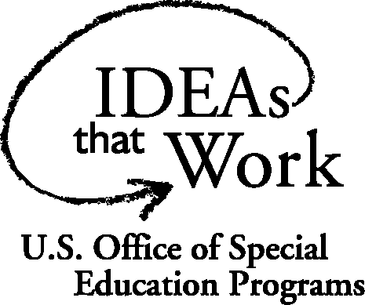
Supervision Self-Assessment

Name______________________________ |  | Date_____________
Setting □ Hallway □ Entrance □ Cafeteria  □ Playground □ Other_________________ |  | Time Start_________  Time End _________
Tally each Positive Student Contacts | Total # | Ratio of Positives to Negatives: _____: 1
Tally each Negative Student Contacts | Total # | Ratio of Positives to Negatives: _____: 1

- Did I have at least 4 positive for 1 negative student contacts? | Yes No
- Did I move throughout the area I was supervising? | Yes No
- Did I frequently scan the area I was supervising? | Yes No
- Did I positively interact with most of the students in the area? | Yes No
- Did I handle most minor rule violations quickly and quietly? | Yes No
- Did I follow school procedures for handling major rule violations? | Yes No
- Do I know our school-wide expectations (positively stated rules)? | Yes No
- Did I positively acknowledge at least 5 different students for displaying our school-wide expectations | Yes No
Overall active supervision score:  7-8 “yes” = “Super Supervision”  5-6 “yes” = “So-So Supervision”  <5 “yes” = “Improvement Needed” | # Yes________

Action Planning
The purposes of this assessment are to (a) determine the extent to which effective non-classroom management practices are in place and (b) develop an action plan for enhancement/maintenance based on this information. This assessment and action plan can be completed as a “self-assessment” or by an observer.
- Pick a typical non-classroom setting that has a specific learning outcome/objective.
- During the activity, count number of positive and negative student contacts that occur during the activity.
- After the activity,
  - Sum the number of positive and negative contacts and calculate the ratio of positive to negative contacts.
  - Assess whether each nonclassroom management practice was evident.
  - Sum the number of “yes” to determine overall classroom management score.
  - Based on your score, develop an action plan for enhancement/maintenance.

Action Plan
# | Current Level of Performance | Enhancement/Maintenance Strategies

Selected References
Colvin, G., Kame’enui, E.J., & Sugai. G. (1993). School-wide and classroom management: Reconceptualizing the integration and management of students with behavior problems in general education. Education and Treatment of Children, 16, 361-381.
Colvin, G., Sugai, G., Good, R., & Lee, Y. (1997). Effect of active supervision and precorrection on transition behaviors of elementary students. School Psychology Quarterly, 12, 344-363.
Colvin, G., Sugai, G., & Patching, B. (1993). Pre-correction: An instructional approach for managing predictable problem behaviors. Intervention in School and Clinic, 28, 143-150.
DePry, R. I., & Sugai, G. (2002). The effect of active supervision and precorrection on minor behavioral incidents in a sixth grade general education classroom. Journal of Behavioral Education, 11, 255-267.
Haydon, T., & Scott, T. M. (2008). Using common sense in common settings: Active supervision and precorrection in the morning gym. Intervention in School and Clinic, 43, 283-290.
Heck, A., Collins, J., & Peterson, L. (2001). Decreasing children’s risk taking on the playground. Journal of Applied Behavior Analysis, 34, 349-352.
Kartub, D., Taylor-Greene, S., March, R.E., & Horner, R.H. (2000). Reducing hallway noise: A systems approach. Journal of Positive Behavior Interventions, 2(3), 179-182.
Leedy, A., Bates, P., & Safran, S. P. (2004). Bridging the research-to-practice gap: Improving hallway behavior using positive behavior supports. Behavioral Disorders, 19, 130-139.
Lewis, T. J., Colvin, G., & Sugai, G. (2000). The effects of pre-correction and active supervision on the recess behavior of elementary school students. Education and Treatment of Children, 23, 109-121.
Lewis, T. J., & Garrison-Harrell, L. (1999). Effective behavior support: Designing setting specific interventions. Effective School Practices, 17, 38-46.
Lewis, T. J., Powers, L. J., Kelk, M. J., & Newcomer, L. L. (2002). Reducing problem behaviors on the playground: An investigation of the application of school-wide positive behavior and supports. Psychology in the Schools, 39, 181-190.
Lewis, T. J., Sugai, G., & Colvin, G. (1998). Reducing problem behavior through a school-wide system of effective behavioral support: Investigation of a school-wide scoal skills training program and contextual interventions. School Psychology Review, 27, 446-459.
Nelson, J. R., Colvin, G., & Smith, D. J. (1996). The effects of setting clear standards on students’ social behavior in common areas of the school. The Journal of At-Risk Issues, Summer/Fall, 10-17.
Putnam, R. F., Handler, M. W., Ramirez-Platt, C. M., & Luiselli, J. K. (2003). Improving student bus-riding behavior through a whole-school intervention. Journal of Applied Behavior Analysis, 36, 583-589.
Todd, A., Haugen, L., Anderson, K., & Spriggs, M. (2002). Teaching recess: Low-cost efforts producing effective results. Journal of Positive Behavior Interventions, 4(1), 46-52.

The Center is supported by a grant from the Office of Special Education Programs, with additional funding from the Safe and Drug Free Schools Program, US Department of Education (H326S980003). Opinions expressed herein are those of the authors and do not necessarily reflect the position of the US Department of Education, and such endorsements should not be inferred.
Draft 3-10-04 Sugai
To calculate, divide # positives by # of negatives.
Setting or activity in which academic instruction or teacher/staff-directed activities are not available to engage students (e.g., cafeteria, playground, common areas, bus, hallways, parking lots, assemblies, sporting events).
What? When? How? By When?

