7r

Positive Behavior Support

Classroom Management:
Self-Assessment Revised

Brandi Simonsen, Sarah Fairbanks, Amy Briesch, & George Sugai

Center on Positive Behavioral Interventions and Supports
University of Connecticut

Version: May 15, 2006

SCHOOL-WIDE POSITIVE BEHAVIOR SUPPORT

OSEP Center on Positive Behavioral Interventions and Supports
University of Oregon
University of Connecticut
www.pbis.org

The OSEP Center on Positive Behavioral Interventions and Supports is grateful to the students, educators, administrators, families, support providers, researchers, and teacher trainers who have worked tirelessly to improve educational outcomes for all students and who have contributed to our understanding of the critical practices and systems of positive behavior support.

These training materials have been developed to assist schools in their efforts to improve school climate and positive behavior support for all students. Photocopying, use, and/or sale of these materials are forbidden without expressed written permission by the OSEP Center for Positive Behavioral Interventions and Supports. To obtain a personal copy of these materials, contact the Center at 541-346-2505, pbis@oregon.uoregon.edu, or www.pbis.org.

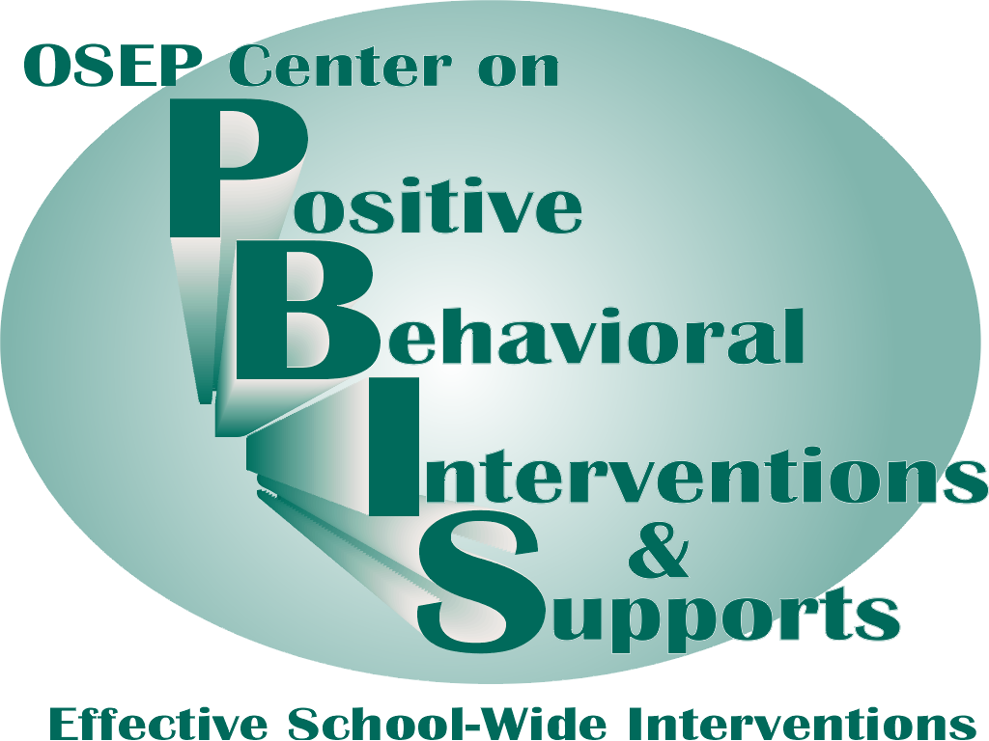 | 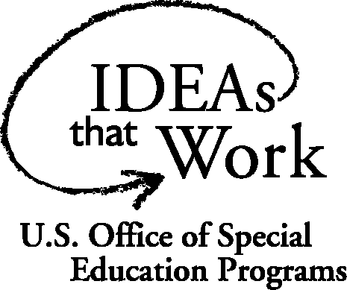
Classroom Management: Self-Assessment

This assessment tool is designed for a teacher to rate him or herself and develop an action plan. The teacher should complete this assessment at least quarterly.

It may also be used by a supervisor to evaluate a teacher and provide specific and contingent feedback that will assist in the development of an action plan.

If this tool is used as a self-assessment, the teacher should record the following data for him or herself and complete the checklist on the following page. If this tool is used by a supervisor, the supervisor would write his/her name on the line next to “Rater” and conduct the observation (take data and complete checklist).

Teacher | __________________________ |  |  | Date_____________
Rater | __________________________
Instructional Activity |  |  |  | Time Start | _________
 |  |  |  | Time End | _________
 |  |  |  | Total (min) | _________
Tally Positive Student Contacts |  | Total # | Tally Negative Student Contacts |  |  | Total #
Ratio of Positives to Negatives: _____ to 1
Tally of Opportunities to Respond (OTR) |  |  |  |  |  | Total #
OTR Rate (OTRs per minute): _____

Classroom Management Practice | Rating
- I maximized structure and predictability in my classroom.
- I explicitly taught and followed predictable routines. | Yes No
- I arranged my room to minimize crowding and distraction. | Yes No
- I posted, taught, reviewed, monitored, and reinforced a small number of positively stated expectations.
- I operationally defined and posted a small number of expectations (i.e., school wide rules) for all routines and settings in my classroom. | Yes No
- I explicitly taught and reviewed these expectations in the context of routines. | Yes No
- I prompted or pre-corrected students to increase the likelihood that they will follow the expectations. | Yes No
- I actively supervised my students. | Yes No
- I actively engaged students in observable ways.
- I provided a high rate of opportunities to respond during my instruction. | Yes No
- I engaged my students in observable ways during teacher directed instruction (i.e., I use response cards, choral responding, and other methods). | Yes No
- I used evidence based methods to deliver my instruction (e.g., Direct Instruction). | Yes No
- I used a continuum of strategies to acknowledge appropriate behavior.
- I provided specific and contingent praise for academic and social behaviors (e.g., following expectations). | Yes No
- I also used other systems to acknowledge appropriate behavior (group contingencies, behavior contracts, or token economies). | Yes No
- I used a continuum of strategies to respond to inappropriate behavior
- I provided specific, contingent, and brief error corrections for academic and social errors. | Yes No
- In addition, I used the least restrictive procedure to discourage inappropriate behavior (differential reinforcement, planned ignoring, response cost, time out) | Yes No
Overall classroom management score:  10-13 “yes” = “Super”  7-10 “yes” = “So-So”  <7 “yes” = “Improvement Needed” | # Yes ___

Action Planning
The purposes of this assessment are to (a) determine the extent to which effective general classroom management practices are in place and (b) develop an action plan for enhancement/maintenance based on this information. As stated, this assessment and action plan can be completed as a “self-assessment” or by an observer, and it should be completed at least quarterly.
- Pick a teacher-led/directed activity that has a specific learning outcome/objective.
- During the activity, count number of (a) positive and negative student contacts that occur during the activity and (b) opportunities to respond (i.e., specific instructions or questions that prompt a student response).
- After the activity,
  - Sum the number of positive and negative contacts and calculate the ratio of positive to negative contacts.
  - Sum the number of opportunities to respond (OTRs) and calculate the rate of OTRs per minute.
  - Assess whether each classroom management practice was evident (note that some items are lesson specific and others reflect practices that should be on-going).
  - Sum the number of “yes” to determine overall classroom management score.
  - Based on your score, develop an action plan for enhancement/maintenance.

Action Plan
# | Current Level of Performance | Enhancement/Maintenance Strategies
Selected Supporting References
Colvin, G., & Lazar, M. (1997). The effective elementary classroom: Managing for success. Longmont, CO: Sopris West.
Colvin, G., Sugai, G., & Patching, W. (1993). Pre-correction: An instructional strategy for managing predictable behavior problems. Intervention in School and Clinic, 28, 143-150.
Darch, C. B., & Kameenui, E. J. (2003). Instructional classroom management: A proactive approach to behavior management. (2nd ed.). White Plains, NY: Longman.
Jones, V. F. & Jones, L. S. (2001). Comprehensive classroom management: Creating communities of support and solving problems (6th ed.). Boston: Allyn & Bacon.
Kameenui, E. J., & Carnine, D. W. (2002). Effective teaching strategies that accommodate diverse learners (2nd ed.). Upper Saddle River, NJ: Merrill.
Latham, G. I. (1997). Behind the schoolhouse door: Eight skills every teacher should have. Utah State University.
Latham, G. (1992). Interacting with at-risk children: The positive position. Principal, 72(1), 26-30.
Martella, R. C., Nelson, J. R., & Marchand-Martella, N. E. (2003). Managing disruptive behaviors in the schools: A schoolwide, classroom, and individualized social learning approach. Boston, MA: Allyn & Bacon.
Paine, S. C., Radicchi, J., Rosellini, L. C., Deutchman, L., & Darch, C. B. (1983). Structuring your classroom for academic success. Champaign, IL: Research Press.

The Center is supported by a grant from the Office of Special Education Programs, with additional funding from the Safe and Drug Free Schools Program, US Department of Education (H326S980003). Opinions expressed herein are those of the authors and do not necessarily reflect the position of the US Department of Education, and such endorsements should not be inferred.
Revised from Sugai & Colvin
To calculate, divide # positives by # of negatives.
To calculate, divide # of OTRs by total # of minutes.
What? When? How? By When?

