VTPBiS Leadership Team Training
at the Targeted Level
Within a Multi-Tiered System of Supports



Activity Workbook

Name: _______________________________

School: _______________________________

Leadership Team Meeting Norms
Team Norm: | What does it look like?
1.
2.
3.
4.
5.
Other Notes:

Leadership Team Activities Prior to Targeted Training

Activity #1a: View the VTPBiS Family Engagement at the Targeted Level Leaning Module

As a team, view the learning module at https://www.youtube.com/watch?v=1w3DDUNJrbM:
- As a Team, review and discuss the Larry Falazo chart on Differences between Family Involvement and Family Engagement: http://larryferlazzo.edublogs.org/files/2013/03/LMC_March_April_2013_Ferlazzo-p3tzf9.pdf
- Complete Family Engagement Checklist (below) and create action steps.
- Review Family Engagement resources at: http://www.uvm.edu/~cdci/best/pbswebsite/FAMILYENGAGEMENT.htm

STATUS:  In place  Partially in place  Not in place | Family Engagement Checklist (Muscott & Mann, 2004)  TASK | PRIORITY:  High  Medium  Low
 | Climate
 | 1. There is a process for assessing how welcomed, valued, and satisfied parents are in and with the school.
 | 2. There is a plan for addressing ways to help families feel welcomed and valued.
 | 3. There is a plan for training all staff to work collaboratively and respectfully with families.
 | 4. Plans for addressing ways to help families feel welcomed and valued address diverse families including those with students in the universal, targeted and intensive levels of PBIS.
 | Parent Involvement in Learning Activities at Home
 | 5. There is a process for assessing parents’ opinions about their own involvement in learning activities at home.
 | 6. There is a plan or set of activities for helping families to support their child’s learning at home.
 | 7. The plan includes activities for helping diverse families, including those with students in the universal, targeted and intensive levels of PBIS, support their child’s learning.
 | Communication with Parents/Families
 | 8. There is a process for assessing parents’ opinions about how well schools communicate with them.
 | 9. There is a plan for communicating with families in varied and helpful ways.
School Name: ______________________________ Date: ________________________

10. The plan includes activities for communicating with diverse families, including those with students in the universal, targeted and intensive levels of PBIS, about important school/home matters including discipline.

Parent/Family Involvement at School (Volunteering, Assisting)

11. There is a process for assessing parents’ opinions about how they can support schools through their involvement at school.

12. There is a plan for how parents can be involved in supporting learning at school through volunteering and assisting.

13. The plan for parental involvement in school activities addresses how diverse families, including those with students in the universal, targeted and intensive levels of PBIS, can participate.

Parent/Family Involvement in Decision-Making

14. There is a process for assessing parents’ opinions about the extent to which they are encouraged to participate in decision-making committees and activities (e.g., leadership teams).

15. There is a plan for encouraging and supporting parent participation in decision-making committees and activities.

16. The plan for parental participation in decision-making committees and activities addresses how diverse families, including those with students in the universal, targeted and intensive levels of PBIS, can participate.

17. There is a process for assessing parents’ opinions about the extent to which they can provide input to school personnel about matters of importance including discipline that is taken seriously.

18. There is a plan for gathering and incorporating parents’ input about matters of importance including discipline that is taken seriously.

19. The plan for gathering and incorporating parents’ input about matters of importance including discipline addresses how diverse families, including those with students in the universal, targeted and intensive levels of PBIS, can be heard.

Activity #1b: Plan to sustain the Universal Level

As a team, answer the questions below:
- Who’s missing from the team?

- What steps can you take to make the team have a higher profile in the school?

- How will you use data to help in your planning?

- What competing initiatives (school improvement activities) do you need to align with PBIS?

- If up to 15% of Your Students need something more, how many students would that be in your school?

- Review your ODR data. (If using SWIS, look at “referrals by student graph”.) What percentage of your students receives 3-5 ODRs? Calculate based on your school enrollment.

7. Review your school’s BoQ

8. Complete the VTPBiS Universal Action Plan for Sustainability.

Universal Level Behavior Action Plan for Sustainability~
Adapted from Muscott & Mann 2008

TASKS
Faculty and Staff | Action? | Who? | When?

1. Review the elements and procedures of Universal PBIS (expectations, teaching plans, problem behavior definitions, reinforcement, ODR form, procedures for referral to the office, etc.) with ALL staff and faculty.

2. Develop a plan for obtaining annual staff buy-in for PBIS.

3. Develop a plan for orienting new and substitute faculty and staff to Universal PBIS.
Students | Action? | Who? | When?

4. Review the elements and procedures of Universal PBIS (expectations, acknowledgment system, lessons, procedures for addressing problem behavior) with ALL students.

5. Students will be taught the expectations in the various school environments.

6. Students will be acknowledged/rewarded for exhibiting are the behaviors associated with the schoolwide expectations.

7. A plan for Booster activities (reteaching, reinforcement) based on need and data will be developed.

8. A plan for orienting new students to Universal PBIS will be established.
Families/Community | Action? | Who? | When?

9. A plan for communicating and discussing the PBIS Universal System to families will be developed.

10. A method for gathering and responding to family input regarding school-wide PBIS has been developed.

11. A plan for orienting new families to Universal PBIS will be developed.

LOGISTICS | Action? | Who? | When?
12. Posters developed and printed for classroom and non-classroom areas.
13. Matrix developed and printed for classrooms, student handbooks, non-classroom areas.
14. Acknowledgement tangibles (tickets) developed and printed with directions printed for staff.
15. Acknowledgements menu developed and printed.
16. Personnel to manage SWIS or other data system identified.
17. Kick off activities planned.
18. Teaching activities planned.
19. Adult incentives planned.
20. Office Discipline Referral form finalized and printed.
21. Parent kick-off planned.

What is a Targeted Intervention?

“3•9•3”

3 Functions of Targeted Interventions:

- For low level problem behavior (e.g. talk-outs, minor disruption, task completion);

- Efficient because they use the same or similar practices for groups of students that do not need to be individualized for each student.

- Effective because they focus on decreasing problem behavior thereby increasing academic engagement and decreasing office discipline referrals.

9 Critical Features of Targeted Interventions:

- Meets the needs of groups of students
- Does not require individualizing for each student
- Uses positive approach
- Everyone knows about it
- Let’s students opt out
- Involves parents
- Based on function of behavior (get or avoid)
- Has some clear evidence that it works
- Has system resources (team and administrator support)

3 Reasons to Consider Targeted Interventions:

- When universal systems are not sufficient to impact behavior
- When students display chronic patterns of disruptive behavior
- When concerns arise regarding students’ academic or social behavior

Two Purposes of Targeted Planning

Systems level design and accountability (this is often an additional function of the Universal Team)
• Creates procedures for all targeted interventions (not individual students).
• Communicates to staff and families.
• Links between Targeted and Universal systems

Individual student intervention planning and monitoring
• Meets weekly or bi-weekly to review student referrals and place student on CICO (unless
otherwise specified)
• Communicates with staff and parents about student
• Evaluates student progress, needed plan change and exit from interventions
• Members include a coordinator, individual skilled in function-based behavior support
planning, administrator.

Roles & Responsibilities of Key Individuals

ADMINISTRATOR | SCHOOL-BASED BEHAVIOR COORDINATOR | SUPERVISORY UNION/DISTRICT COORDINATOR
- Know what the practices look like when implemented with fidelity  - Be aware of data using tracking tools; help decide what needs to change  - Be active/visible on teams  - Troubleshoot systems level issues | - Facilitates weekly targeted student meetings  - Active member of implementation team and student planning team  - Attends regional coordinator meetings and trainings  - Prioritizes students for Team meeting  - Prioritizes requests for service  - Creates graphs for meetings  - Facilitates meetings  - Maintains records | - Builds capacity to implement effective practices  - Focus on student outcomes  - Focus on fidelity of implementation of effective practices across  - District/Supervisory Union  - Align SU/district systems, data and practices

Activity #2: Team profile
Implementation Team Roster
School Name: Grades:
Town/City: Supervisory Union:

Implementation Team – Systems Level
Team Member Name Building Role Team Member Role
(facilitator, timekeeper,
recorder, other)
Day and Time of Monthly Meetings:
Individual Student Level Team
Team Member Name Building Role Team Member Role
(coor., behavior spec., data spec.) (facilitator, timekeeper,
recorder, other)
Day and Time of Weekly Meetings:

Examples of Targeted Interventions:
Function of Behavior: | Intervention: | Characteristics:
Access Peer Attention/Support | Social Skills  Curriculum Basics  (An ideal curriculum does not exist, but basic set of preferred teaching practices does) | • Must match the specific need.  • Initially, learning how to teach social skills takes time and energy.  • Interventions should be implemented as planned or intended  • Plan to adequately program for generalization & maintenance  •Match instructional procedures to specific types of deficits  •Target socially valid behaviors
Access Peer Attention/Support  Access Adult Attention/Support | Self- Management (with Peer or Adult Support) | • Teach self-monitoring & targeted social skills simultaneously  • Practice self-monitoring until students accurately self-monitor at 80% or better  • Periodic checks on accuracy
Access Peer Attention/Support  Access Adult Attention/Support | Mentoring (with Peer or Adult Support) | • Focus on “connections” at school  -Not monitoring work  -Not to “nag” regarding behavior  • Staff volunteer  -Not in classroom  -No administrators  • Match student to volunteer  10 minutes minimum per week
Access Peer Attention/Support | Peer Tutoring | • Tutors must be taught how to teach  • Tutors must be taught what to do if tutee does not comply  • Tutors must be given the option to drop out at any time without penalty
Academic Skills Support | - Organization/Homework planning support  - Homework completion club  - Tutoring | • Homework (If data indicate it doesn’t come back, build in-school homework support)  • Supplemental Instruction (Direct additional instruction along with current classroom teaching)  •Differentiated Instruction (Strategies to engage diverse learners)  • Accommodation within instruction

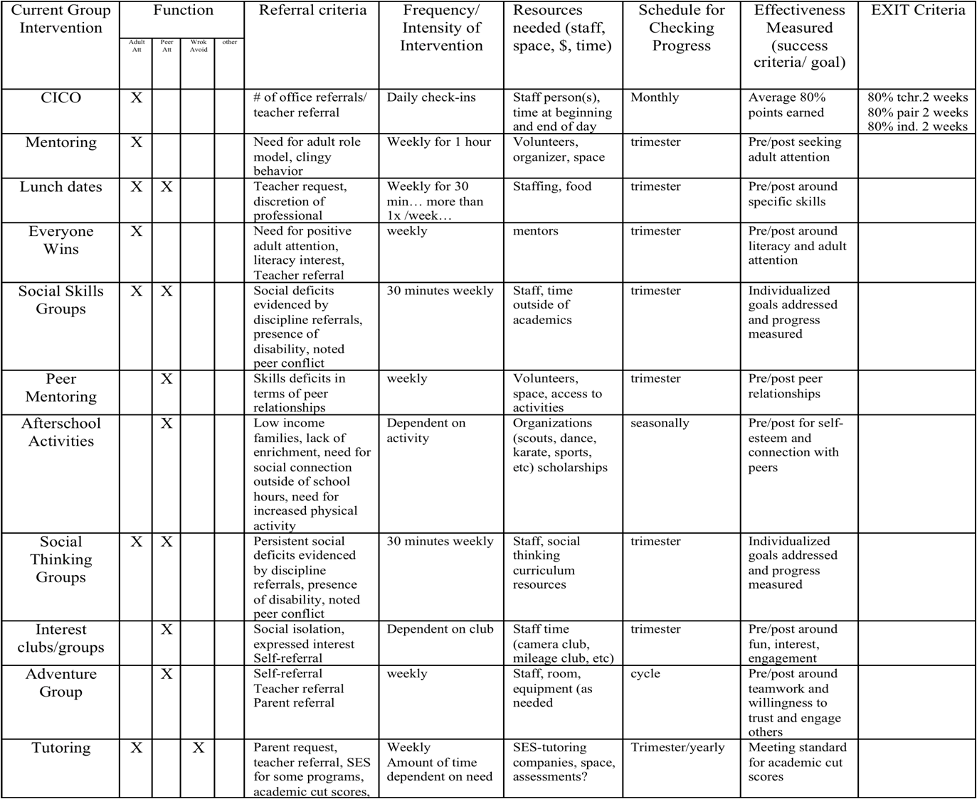
Activity #3: Complete your Inventory of Targeted Interventions

Intervention System Support or Practice | Function of Behavior |  |  |  | Purpose/Goal | Staff Involved | Referral  Criteria | Evidence of Effectiveness (Does practice achieve anticipated outcomes? Is there data?)

Activity #4: Complete your Team Purpose Statement

- Targeted Team Purpose Statement

Functional Behavior Assessment:
Assessing predictable relationships between the environment and behavior involves…
- Observing the student in natural environments
- Determining why problems occur
- Testing explanations
- Obtaining the right information necessary to develop a successful plan
- Developing plans that primarily focus on prevention
ERASE Problem Behavior
Explain - What is the problem?
Reason - What is he/she getting out of it or avoiding?
Appropriate - What do you want him/her to do instead?
Support - How can you help this happen more often?
Evaluate - How will you know if it works?

Activity #5: Process for FBA
Complete now: Determine who needs to be trained in FBA:
1)
2)
(To be completed after team members have been trained in conducting Simple/Full FBAs):
Who makes the referral?

What form do they use?

Where or to whom does the referral form go?

Who or what group reviews the referral form to see if Simple FBA needs to be done?

Who schedules the Simple FBA, informs teachers and others who need to know?

Who completes the Simple FBA? Assign a “FBA Coordinator”

Who or what group develops the testable hypothesis?

Who or what group develops the simple behavior support plan?

What is the proposed timeline from referral, decision, interview(s), summary of Simple FBA, testable hypothesis statement and development of simple behavior support plan?

When and by whom is BSP reviewed to see if it is working?

Who else needs to be trained to complete Simple FBA?
What is Check-In/Check-Out (CICO) and Teacher Check, Connect and Expect (TCCE)?

School-based programs for providing systematic and frequent reinforcement and encouragement for positive behaviors so that the student receives high rates of immediate feedback. Most useful with:

• Students who do not respond to school-wide interventions
• Students with repeated referrals
• Students seeking adult attention

Check-In/Check-Out (CICO)
How does it work?

1. Morning check-in
• Students checks in with coordinator within 15 minutes of arrival time
• Coordinator collects and hands out Daily Progress Report (DPR) form
• Daily goal set with students
• Students encouraged to make good choices

2. Student gives DPR form to each teacher prior to each period (section of time).
(Can also be used in cafeteria or playground… anywhere there is a supervisor).

3. End of day check-out

• During last 20 minutes of the day
• Goes over daily progress
• Reviews progress towards goals
• Points tallied
• Reward
• Graphs student progress

4. Daily Progress Report form copy taken home and signed.

5. Return signed copy next morning.

Teacher Check Connect and Expect (TCCE):
How does it work?

- Student is greeted in a friendly positive way by the teacher.
- Teacher reviews behavior expectations with the student, and encourages student to do well.
- After each time period, teacher checks in with student about progress during time period and indicates points on daily progress report (DPR).
- At end of day, teacher writes the total amount of points achieved for the day on DPR.
- Completed DPRs are sent to the targeted team for input into data information system.

With both CICO and TCCE Targeted Team reviews progress after four weeks unless otherwise indicated.

Activity #6: Determine how CICO or TCCE will be implemented in your school

6A: Look at the 15% identified students in your ODR data.
- Determine a group of students whose problem behavior is motivated by peer or adult attention.
- Looking at the definition of CICO and TCCE, what additional information do you need to make this doable at your school?
- As a group, look at the advantages/disadvantages of each (T-Chart)

CICO: More evidence of working; a designated person who checks in at beginning/end of the year
(more fidelity)
TCCE: The child comes to the teacher—teacher follows plan
- Determine which of the two strategies your team will implement
- What challenges can you identify that you will work through as we proceed?

6B: Establish the Team (student) and assign Check-In/Check-out Coordinator (if CICO). Use School
Profile Form.

6C:
- Who will you serve?
- How many students can you serve at one time?
- Using ODR data and other student data, brainstorm a list of students you would like to refer to
TCCE or CICO.

6D: Where will Check-in/Check-Out be located?
6E: Determine a catchy name for your program:

Activity #7: Daily Progress Report (DPR)
7A: Create DPR Form. Use samples from book – Responding to Problem Behavior in Schools.
  - Expectations should match Universal expectations
  - DPR should be teacher and student friendly.
  - There should be a place to write each student’s goals
  - Use Examples from the book Responding to Problem Behavior in Schools: The Behavior Education Program pages 201-204 and at PBISvermont.org CICO forms
  - Use SWIS and SWIS CICO Readiness Checklist for DPR compatibility

7B: Create DPR Progress Summary Form using examples from the BEP book pages 210-211

Activity #8: Create your Check-In/Check-Out Reinforcement System

A: What will the students’ daily point goal be?

B: What reinforcers will students receive for checking in and out (e.g., praise and lottery ticket)?

C: What reinforcers will students receive for checking out and meeting their daily point goal?

D: How will you ensure students do not become bored with the reinforcers?

E: Determine what resources you will need to access reinforcers:

Activity #9: Develop a Request for Assistance System

What are the criteria for placing students on Check-In/Check-Out? Other targeted interventions?

How will students be referred?

What is the process for screening students who transfer into the school?

What is the process for determining whether students will start the next school year on the Check-in/Check-out?

Create your Request for Assistance form (see BEP book page 197 and at PBISvermont.org for Example CICO Forms. Are the forms easy to access? Easy to complete? Contain the necessary information?

Create a Student Agreement or contract (see BEP book page 219)

Develop a parent consent form (see sample at http://www.pbisvermont.org/resources/training-presentations-a-materials/vtpbis-targeted-trainings

Activity #10A: Create a system for managing the daily data
Complete the questions below and items 28-31 on Benchmarks of Advanced Tiers:

Which computer system will you use? SWIS-CICO? Excel? Other?

How frequently will your team review the daily Check-In/Check-Out data? (at least bi-weekly)

Who is responsible for summarizing the data and bringing it to the meetings?

How frequently will summary data be shared with staff? Parents?

Activity #10B: Plan for fading students off the Check-In/Check-Out intervention

What are the criteria for fading students off of Check-In/Check-Out?

How will the program be faded, and who will be in charge of helping students fade off the Check-In/Check-Out?

Plan for student graduation celebrations
Activity #11: Develop Trainings

Develop and Schedule Staff Training

Schedule date and time for staff training:

Who will plan and deliver the training?

Training should include information on:
•How to make a referral
•How to fill out the DPR
•Types of feedback statements to be made to students
•Examples and activities that model staff rating of DPR

Develop Student Training

Who will meet with the students to train them on the intervention? When will this occur?

Training should include:
•Overview of the program
•How to check in and check out daily
•Adding up daily points
•Determining whether daily point goals are met
•Accepting feedback –both positive and negative
•Procedure for taking the DPR home and bringing it back the next school day

Develop Parent Training

How and when will the parents be trained on the intervention?

Training should include:
–How to provide feedback to their children
–How to focus on the positive
–What to do if there is a bad day

Implementation Planning Forms
and
Examples
VTPBiS Action Plan for Targeted Implementation

Activity | Activity Task Analysis | Who | When
Faculty and Staff Commitment | a.
Faculty and Staff Commitment | b.
Faculty and Staff Commitment | c.
Faculty and Staff Commitment | d.
Faculty and Staff Commitment | e.
Establish Team | a.
Establish Team | b.
Establish Team | c.
Establish Team | d.
Establish Team | e.
School-wide/Universal Behavior in Place | a.
School-wide/Universal Behavior in Place | b.
School-wide/Universal Behavior in Place | c.
School-wide/Universal Behavior in Place | d.
School-wide/Universal Behavior in Place | e.
Student Identification Process in Place | a.
Student Identification Process in Place | b.
Student Identification Process in Place | c.
Student Identification Process in Place | d.
Student Identification Process in Place | e.
Daily Progress Report (DPR) defined  Home Report Defined | a.
Daily Progress Report (DPR) defined  Home Report Defined | b.
Daily Progress Report (DPR) defined  Home Report Defined | c.
Daily Progress Report (DPR) defined  Home Report Defined | d.
Daily Progress Report (DPR) defined  Home Report Defined | e.
Data Collection, Summarization and Use for Decision-making Defined | a.
 | b.
 | c.
 | d.
 | e.

Morning Check-in Routine  Teacher Check-in Check-out Routine  Afternoon Check-out Routine  Home Review Routine | a.
 | b.
 | c.
 | d.
 | e.
Team Meeting Schedule | a.
Team Meeting Schedule | b.
Team Meeting Schedule | c.
Team Meeting Schedule | d.
Team Meeting Schedule | e.
Process defined for moving off CICO  Process defined for use of self-management strategies within CICO | a.
 | b.
 | c.
 | d.
 | e.

Process defined for moving student into Individualized Support Systems | a.
 | b.
 | c.
 | d.
 | e.
Process defined for informing substitute teachers  Process defined playground, cafeteria, bus areas  Other areas? | a.
 | b.
 | c.
 | d.
 | e.

School-wide Behavior Implementation Plan

Behavior Roll-Out for Staff

Date:

Time:

Location:

Materials Required (check or list all that apply):

Agenda ____ Handouts ____ Other _____________________________________

Technology Supports LCD ____ TV/DVD/VIDEO _____ Screen ______ Easel ______ Chart Paper ______ Markers ______ Other _______

Presenters: __________________ ; ___________________ ; ____________________ ;

______________________ ; ________________________; ______________________

Activities (attach work sheets, if needed) Amount of Time

1. ____________

2. ____________

3. ____________

4. ____________

Evaluation/ Feedback Method (check all that apply)

Survey _____ Process Activity _____ Interview ______ Other __ Describe __________

School-wide Behavior Implementation Plan

Behavior Roll-Out for Students

Date:

Time:

Location:

Materials Required (check or list all that apply):

Agenda ____ Handouts ____ Other _____________________________________

Technology Supports LCD ____ TV/DVD/VIDEO _____ Screen ______ Easel ______ Chart Paper ______ Markers ______ Other _______

Presenters: __________________ ; ___________________ ; ____________________ ;

______________________ ; ________________________; ______________________

Activities (attach work sheets, if needed) Amount of Time

1. ____________

2. ____________

3. ____________

4. ____________

Evaluation/ Feedback Method (check all that apply)

Survey _____ Process Activity _____ Interview ______ Other __ Describe __________

School-wide Behavior Implementation Plan

Behavior Roll-Out for Family and Community

Date:

Time:

Location:

Materials Required (check or list all that apply):

Agenda ____ Handouts ____ Other _____________________________________

Technology Supports LCD ____ TV/DVD/VIDEO _____ Screen ______ Easel ______ Chart Paper ______ Markers ______ Other _______

Presenters: __________________ ; ___________________ ; ____________________ ;

______________________ ; ________________________; ______________________

Activities (attach work sheets, if needed) Amount of Time

1. ____________

2. ____________

3. ____________

4. ____________

Evaluation/ Feedback Method (check all that apply)

Survey _____ Process Activity _____ Interview ______ Other __ Describe __________

Examples of Permission Slips:

Example #1:

Winder School
Permission for Check-In/Check-Out
Date ____________________
Student _____________________________________ Grade _______________
Teacher _____________________________________

Parent / Guardian _____________________________

I would like to include your child in our Check-In/Check-Out Program. A report will be filled out daily by the teacher(s) and checked at the end of the day by our coordinator, Mrs. Williams. Students will need to pick up their report every morning between 8:45 and 9:00 a.m. and then return to Mrs. Williams between 3:45 and 4:00 p.m. The student will be able to earn incentives and rewards for appropriate behavior. As parents, you are responsible for making sure your child arrives on time each day for check-in and that you review and sign the daily BEP Report. Together, we can make this a positive experience for your child.

_____ I do give consent for my student to participate.

_____ I do not give consent for my student to participate.

___________________________________ Date _________________________
( Parent / Guardian )

For further information, please call:
___________________________________ at 555-7525,
Sabrina Williams

or call ___________________________________.

Examples of Permission Slips:

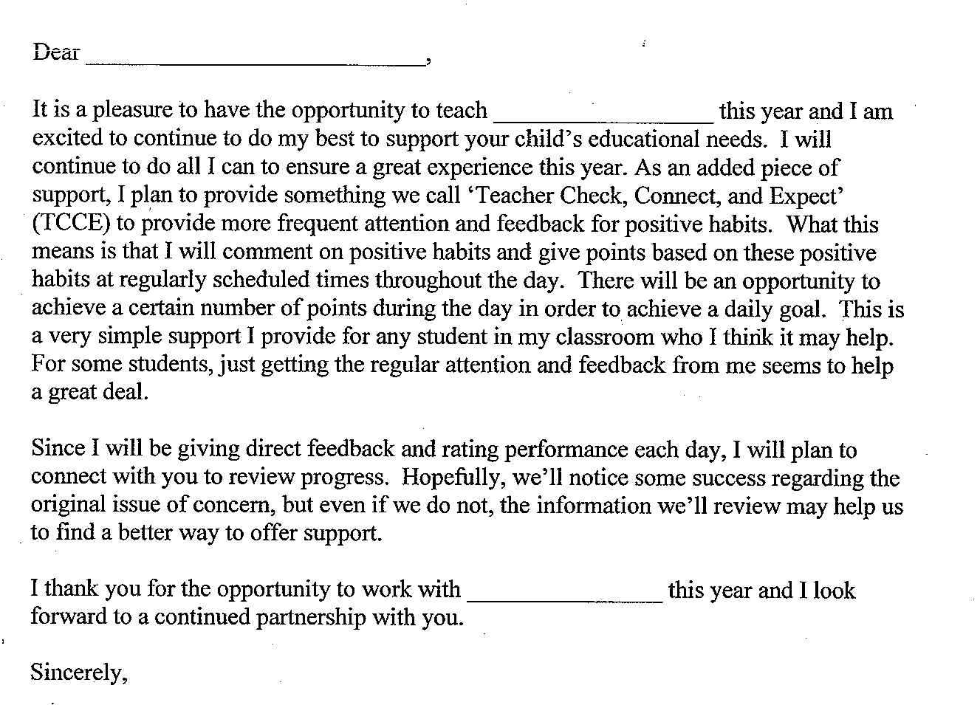
Example #2:
Examples of Daily Progress Reports (DPRs):


PAWS
(Positive Assistance With Support)
Hardwick Elementary School  Daily Progress Report |  |  |  | Name
 |  |  |  | Date |  | Teacher
GOALS | Before School | Practical/Fine Arts | Math |  | Lunch |  | Recess | Literacy
Respect People | 2 1 0 | 2 1 0 | 2 1 0 |  | 2 1 0 |  | 2 1 0 | 2 1 0
Respect Property | 2 1 0 | 2 1 0 | 2 1 0 |  | 2 1 0 |  | 2 1 0 | 2 1 0
Practice Safety | 2 1 0 | 2 1 0 | 2 1 0 |  | 2 1 0 |  | 2 1 0 | 2 1 0
Show Care and Concern | 2 1 0 | 2 1 0 | 2 1 0 |  | 2 1 0 |  | 2 1 0 | 2 1 0
Adult Initial
Total
Points

Total Possible: 48 Goal for Today: __________
Key
0 = Keep trying.
1 = Almost there . . .
2 = Great!!

Total for Today: __________ % _______

Parent Signature: _________________________________

Examples of Daily Progress Reports (DPRs):

Check In /Check Out Card (CICO)

Student_____________________________________________________________ Date________________

KEY: | 0 = Try again | 1 = Needs work | 2 = Got It!

EXPECTATION | SAFE | RESPECTFUL | READY to LEARN
 | Keeping hands, feet, other objects to self | Using kind words, actions, following directions | Working carefully, doing your best,  be prepared
Math | 0 1 2 | 0 1 2 | 0 1 2
Reading/Language | 0 1 2 | 0 1 2 | 0 1 2
AM Recess | 0 1 2 | 0 1 2 | 0 1 2
Lunch | 0 1 2 | 0 1 2 | 0 1 2
PM Recess | 0 1 2 | 0 1 2 | 0 1 2
Theme, Social Studies, Science | 0 1 2 | 0 1 2 | 0 1 2
Art/PE/Music | 0 1 2 | 0 1 2 | 0 1 2
Library/Tech/Choice/Other | 0 1 2 | 0 1 2 | 0 1 2
SUBTOTAL

# ___________ points received
# __________ points possible
% __________ of points

WOW ! Comments: _______________________________________________________________________________________________________________________________

Parent/Guardian Signature____________________________________________________

CICO monitor Initials_________
Examples of Daily Progress Reports (DPRs):

P.A.W.S. PLAN
Positive Assistance With Support
Woodbury Bears are Responsible, Respectful & Safe

Date______________________ Student______________________________

0= Keep Trying  1= Almost There  2= You Did It! | Responsible  Follow Directions  Be Prepared | Respectful  Use Kind Words & Actions  Be Helpful | Safe  Keep Hands, Feet and Objects to Self | Staff Initials
Arrival & Morning Meeting | 0 1 2 | 0 1 2 | 0 1 2
Morning Class Time | 0 1 2 | 0 1 2 | 0 1 2
Lunch | 0 1 2 | 0 1 2 | 0 1 2
Recess | 0 1 2 | 0 1 2 | 0 1 2
Special | 0 1 2 | 0 1 2 | 0 1 2
Afternoon Class Time | 0 1 2 | 0 1 2 | 0 1 2
Dismissal | 0 1 2 | 0 1 2 | 0 1 2
Total Points = _______  Possible Points = 42  Goal (80%) = 34 | Today __________%  Goal __________%

Successes:_______________________________________________________________________________________________________________________________
Parent Signature____________________________________________________

