VTPBiS Leadership Team Training
at the Targeted Level
Within a Multi-Tiered System of Supports



Activity Workbook
Part One: Readiness Activities

Name: _______________________________

School: _______________________________

Leadership Team Activities Prior to Targeted Training

Activity #1a: View the VTPBiS Family Engagement at the Targeted Level Leaning Module

As a team, view the learning module at https://www.youtube.com/watch?v=1w3DDUNJrbM:
- As a Team, review and discuss the Larry Falazo chart on Differences between Family Involvement and Family Engagement: http://larryferlazzo.edublogs.org/files/2013/03/LMC_March_April_2013_Ferlazzo-p3tzf9.pdf
- Complete Family Engagement Checklist (below) and create action steps.
- Review Family Engagement resources at: http://www.uvm.edu/~cdci/best/pbswebsite/FAMILYENGAGEMENT.htm

STATUS:  In place  Partially in place  Not in place | Family Engagement Checklist (Muscott & Mann, 2004)  TASK | PRIORITY:  High  Medium  Low
 | Climate
 | 1. There is a process for assessing how welcomed, valued, and satisfied parents are in and with the school.
 | 2. There is a plan for addressing ways to help families feel welcomed and valued.
 | 3. There is a plan for training all staff to work collaboratively and respectfully with families.
 | 4. Plans for addressing ways to help families feel welcomed and valued address diverse families including those with students in the universal, targeted and intensive levels of PBIS.
 | Parent Involvement in Learning Activities at Home
 | 5. There is a process for assessing parents’ opinions about their own involvement in learning activities at home.
 | 6. There is a plan or set of activities for helping families to support their child’s learning at home.
 | 7. The plan includes activities for helping diverse families, including those with students in the universal, targeted and intensive levels of PBIS, support their child’s learning.
 | Communication with Parents/Families
 | 8. There is a process for assessing parents’ opinions about how well schools communicate with them.
 | 9. There is a plan for communicating with families in varied and helpful ways.
School Name: ______________________________ Date: ________________________

10. The plan includes activities for communicating with diverse families, including those with students in the universal, targeted and intensive levels of PBIS, about important school/home matters including discipline.

Parent/Family Involvement at School (Volunteering, Assisting)

11. There is a process for assessing parents’ opinions about how they can support schools through their involvement at school.

12. There is a plan for how parents can be involved in supporting learning at school through volunteering and assisting.

13. The plan for parental involvement in school activities addresses how diverse families, including those with students in the universal, targeted and intensive levels of PBIS, can participate.

Parent/Family Involvement in Decision-Making

14. There is a process for assessing parents’ opinions about the extent to which they are encouraged to participate in decision-making committees and activities (e.g., leadership teams).

15. There is a plan for encouraging and supporting parent participation in decision-making committees and activities.

16. The plan for parental participation in decision-making committees and activities addresses how diverse families, including those with students in the universal, targeted and intensive levels of PBIS, can participate.

17. There is a process for assessing parents’ opinions about the extent to which they can provide input to school personnel about matters of importance including discipline that is taken seriously.

18. There is a plan for gathering and incorporating parents’ input about matters of importance including discipline that is taken seriously.

19. The plan for gathering and incorporating parents’ input about matters of importance including discipline addresses how diverse families, including those with students in the universal, targeted and intensive levels of PBIS, can be heard.

Activity #1b: Plan to sustain the Universal Level

As a team, answer the questions below:
- Who’s missing from the team?

- What steps can you take to make the team have a higher profile in the school?

- How will you use data to help in your planning?

- What competing initiatives (school improvement activities) do you need to align with PBIS?

- If up to 15% of Your Students need something more, how many students would that be in your school?

- Review your ODR data. (If using SWIS, look at “referrals by student graph”.) What percentage of your students receives 3-5 ODRs? Calculate based on your school enrollment.

7. Review your school’s BoQ

8. Complete the VTPBiS Universal Action Plan for Sustainability.

Universal Level Behavior Action Plan for Sustainability~
Adapted from Muscott & Mann 2008

TASKS
Faculty and Staff | Action? | Who? | When?

1. Review the elements and procedures of Universal PBIS (expectations, teaching plans, problem behavior definitions, reinforcement, ODR form, procedures for referral to the office, etc.) with ALL staff and faculty.

2. Develop a plan for obtaining annual staff buy-in for PBIS.

3. Develop a plan for orienting new and substitute faculty and staff to Universal PBIS.
Students | Action? | Who? | When?

4. Review the elements and procedures of Universal PBIS (expectations, acknowledgment system, lessons, procedures for addressing problem behavior) with ALL students.

5. Students will be taught the expectations in the various school environments.

6. Students will be acknowledged/rewarded for exhibiting are the behaviors associated with the schoolwide expectations.

7. A plan for Booster activities (reteaching, reinforcement) based on need and data will be developed.

8. A plan for orienting new students to Universal PBIS will be established.
Families/Community | Action? | Who? | When?

9. A plan for communicating and discussing the PBIS Universal System to families will be developed.

10. A method for gathering and responding to family input regarding school-wide PBIS has been developed.

11. A plan for orienting new families to Universal PBIS will be developed.

LOGISTICS | Action? | Who? | When?
12. Posters developed and printed for classroom and non-classroom areas.
13. Matrix developed and printed for classrooms, student handbooks, non-classroom areas.
14. Acknowledgement tangibles (tickets) developed and printed with directions printed for staff.
15. Acknowledgements menu developed and printed.
16. Personnel to manage SWIS or other data system identified.
17. Kick off activities planned.
18. Teaching activities planned.
19. Adult incentives planned.
20. Office Discipline Referral form finalized and printed.
21. Parent kick-off planned.

What is a Targeted Intervention?

“3•9•3”

3 Functions of Targeted Interventions:

- For low level problem behavior (e.g. talk-outs, minor disruption, task completion);

- Efficient because they use the same or similar practices for groups of students that do not need to be individualized for each student.

- Effective because they focus on decreasing problem behavior thereby increasing academic engagement and decreasing office discipline referrals.

9 Critical Features of Targeted Interventions:

- Meets the needs of groups of students
- Does not require individualizing for each student
- Uses positive approach
- Everyone knows about it
- Let’s students opt out
- Involves parents
- Based on function of behavior (get or avoid)
- Has some clear evidence that it works
- Has system resources (team and administrator support)

3 Reasons to Consider Targeted Interventions:

- When universal systems are not sufficient to impact behavior
- When students display chronic patterns of disruptive behavior
- When concerns arise regarding students’ academic or social behavior

Two Purposes of Targeted Planning

Systems level design and accountability (this is often an additional function of the Universal Team)
• Creates procedures for all targeted interventions (not individual students).
• Communicates to staff and families.
• Links between Targeted and Universal systems

Individual student intervention planning and monitoring
• Meets weekly or bi-weekly to review student referrals and place student on CICO (unless
otherwise specified)
• Communicates with staff and parents about student
• Evaluates student progress, needed plan change and exit from interventions
• Members include a coordinator, individual skilled in function-based behavior support
planning, administrator.

Roles & Responsibilities of Key Individuals

ADMINISTRATOR | SCHOOL-BASED BEHAVIOR COORDINATOR | SUPERVISORY UNION/DISTRICT COORDINATOR
- Know what the practices look like when implemented with fidelity  - Be aware of data using tracking tools; help decide what needs to change  - Be active/visible on teams  - Troubleshoot systems level issues | - Facilitates weekly targeted student meetings  - Active member of implementation team and student planning team  - Attends regional coordinator meetings and trainings  - Prioritizes students for Team meeting  - Prioritizes requests for service  - Creates graphs for meetings  - Facilitates meetings  - Maintains records | - Builds capacity to implement effective practices  - Focus on student outcomes  - Focus on fidelity of implementation of effective practices across  - District/Supervisory Union  - Align SU/district systems, data and practices

Activity #2: Team profile
Implementation Team Roster
School Name: Grades:
Town/City: Supervisory Union:

Implementation Team – Systems Level
Team Member Name Building Role Team Member Role
(facilitator, timekeeper,
recorder, other)
Day and Time of Monthly Meetings:
Individual Student Level Team
Team Member Name Building Role Team Member Role
(coor., behavior spec., data spec.) (facilitator, timekeeper,
recorder, other)
Day and Time of Weekly Meetings:

Examples of Targeted Interventions:
Function of Behavior: | Intervention: | Characteristics:
Access Peer Attention/Support | Social Skills  Curriculum Basics  (An ideal curriculum does not exist, but basic set of preferred teaching practices does) | • Must match the specific need.  • Initially, learning how to teach social skills takes time and energy.  • Interventions should be implemented as planned or intended  • Plan to adequately program for generalization & maintenance  •Match instructional procedures to specific types of deficits  •Target socially valid behaviors
Access Peer Attention/Support  Access Adult Attention/Support | Self- Management (with Peer or Adult Support) | • Teach self-monitoring & targeted social skills simultaneously  • Practice self-monitoring until students accurately self-monitor at 80% or better  • Periodic checks on accuracy
Access Peer Attention/Support  Access Adult Attention/Support | Mentoring (with Peer or Adult Support) | • Focus on “connections” at school  -Not monitoring work  -Not to “nag” regarding behavior  • Staff volunteer  -Not in classroom  -No administrators  • Match student to volunteer  10 minutes minimum per week
Access Peer Attention/Support | Peer Tutoring | • Tutors must be taught how to teach  • Tutors must be taught what to do if tutee does not comply  • Tutors must be given the option to drop out at any time without penalty
Academic Skills Support | - Organization/Homework planning support  - Homework completion club  - Tutoring | • Homework (If data indicate it doesn’t come back, build in-school homework support)  • Supplemental Instruction (Direct additional instruction along with current classroom teaching)  •Differentiated Instruction (Strategies to engage diverse learners)  • Accommodation within instruction

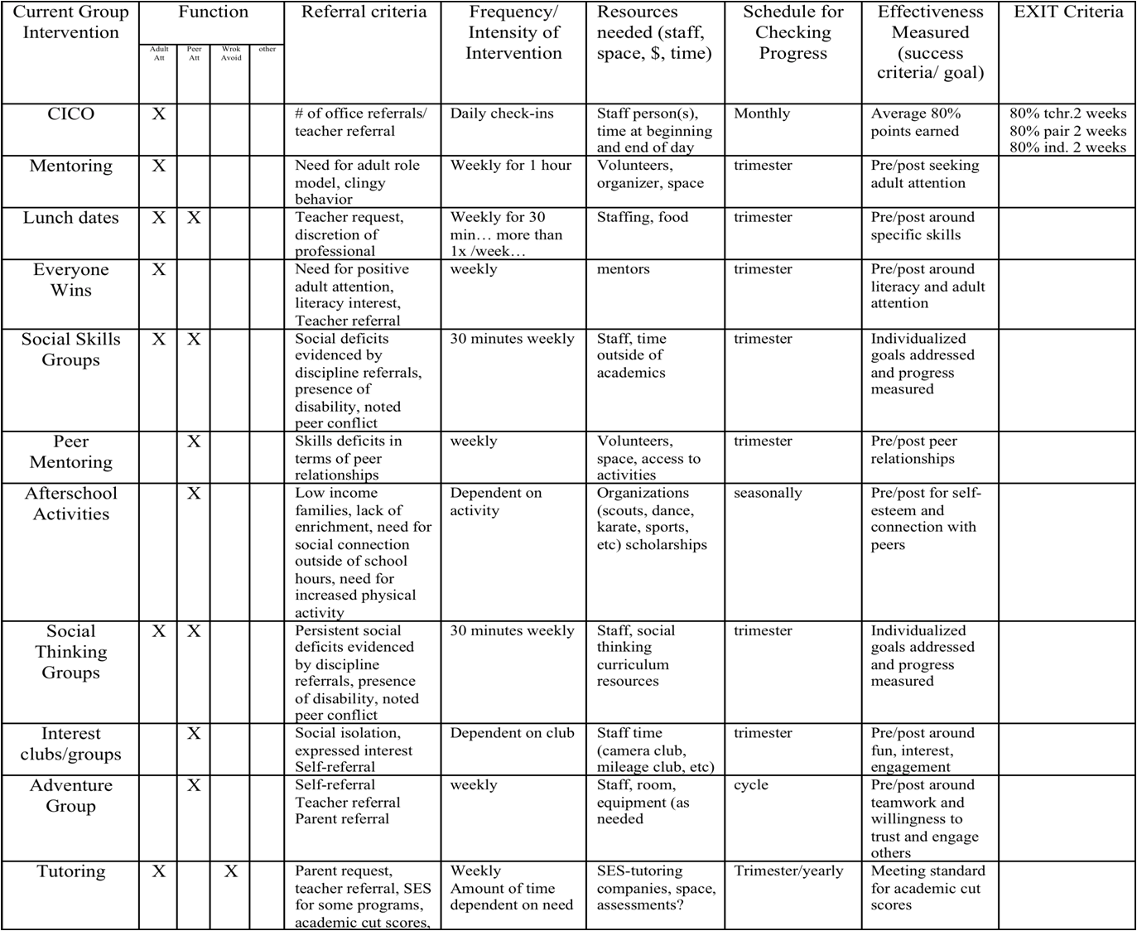
Activity #3: Complete your Inventory of Targeted Interventions

Intervention System Support or Practice | Function of Behavior |  |  |  | Purpose/Goal | Staff Involved | Referral  Criteria | Evidence of Effectiveness (Does practice achieve anticipated outcomes? Is there data?)

NOTES:

