VTPBiS Leadership Team Training
at the Targeted Level
Within a Multi-Tiered System of Supports



Activity Workbook

Name: _______________________________

School: _______________________________

Who We Are:
Vermont Positive Behavior Interventions and Supports (VTPBiS) is a State-wide effort designed to help school teams form a proactive, school-wide, systems approach to improving social and academic competence for all students. Schools in Vermont are engaged in using a formal system of positive behavioral supports in their schools. Involved schools who implement PBIS with fidelity and integrity see a dramatic decrease in the number of behavior problems experienced in their schools. Additionally, students in these schools enjoy greater levels of support and inclusion than those in comparable schools that do not use a system of Positive Behavioral Interventions and Supports.

What We Do:
The VTPBiS State Team supports VTPBiS implementation in Vermont schools state-wide. Each year more and more Vermont schools are actively implementing systems of Positive Behavior Interventions and Supports in their schools.

How to Contact Us:
If you have any questions about VTPBiS, this training, or support for your school, please visit our website (www.pbisvermont.org) or contact your State TA or Implementation Coach.

EIGHT STEPS OF THIS DESIGN

WHO? Participants will include Targeted Team Coordinators, Targeted Team Members, and School Administrators from the following schools:
- Bethel Elementary & Whitcomb Jr./Sr. High School (K-12): 5 Participants
- Ottauquechee School (PK-5): 3 Participants
- Windsor State Street School (K-8): 6 Participants
- Milton Elementary School (K-6): 4 Participants
- Washington Village School (PK-8): 2 Participants

WHY? This training is intended to help teams identify and support students who are not responding to Universal interventions & supports as defined by data, observation and teams…

SO THAT? ...systems and practices can be developed that will allow students to be effective members of their school community and access/acquire learning (i.e. participates, contributes, feels sense of belonging, etc.)

WHEN? 12 Learning Hours plus 15 minute breaks, lunch and additional team time each day:

Monday, June 24th, 2013: 9:30 am -12:30 pm
Tuesday, June 25th, 2013: 9:00 am - 12:30 pm
Wednesday, June 26th, 2013: 9:45 am -12:30 pm
Thursday, June 27th, 2013: 9:15 am - 10:30 am; 11:00 am – 12:30 pm

WHERE? 2013 BEST Summer Institute
Killington Grand Resort
Killington, VT

WHAT?  Content  Skills, Knowledge, Attitudes | WHAT FOR?  Achievable Learning Objectives  By the end of this training you will have:
Sustaining the Universal Effort | - Practiced analyzing data to determine successes and needs at school, classroom and individual levels
Sustaining the Universal Effort | - Used data to develop action plans for improving outcomes
Overview of Targeted Level | - Identified when targeted supports are needed
Targeted Systems | - Developed targeted systems
Targeted Practice & Interventions | - Selected & matched targeted practices
Continuous Data Review and Problem Solving | - Practiced using & analyzing data  for assessment of targeted interventions

HOW?
Presentation with Power Point
Interative Activities
Examples
Videos
Activity Workbook
Flash drives

Day One:
Setting the Stage
Sustaining the Universal Level
Introduction to Targeted Supports

Days Two – Four:
Functional Understanding of Targeted Interventions
Inventory of Targeted Interventions
Check-Out/CheckOut (CICO), Teacher Check, Connect and Expect (TCCE)
Planning for CICO/TCCE Implementation
Next Steps

DAY ONE:

Activity #1: The Heart of the Matter (Warm Up Activity)

Vermont Multi-tiered System of Supports Principle #1:
"Success begins with committed educators who believe that all students learn and can achieve high standards as a result of effective teaching."
Knowing and honoring what gifts our students bring with them to our school community is the first step.
Listen to the following story:

What they don’t understand about birthdays and what they never tell you is that when you’re eleven, you’re also ten, and nine, and eight, and seven, and six, and five, and four, and three, and two and one. And when you wake up on your eleventh birthday you expect to feel eleven, but you don’t. You open your eyes and everything’s just like yesterday only it’s today. And you don’t feel eleven at all. You feel like you’re still ten. And you are – underneath the year that makes you eleven. Like some days you might say something stupid, and that’s the part of you that’s still ten. Or maybe some days you might need to sit on your mama’s lap because you’re scared, and that’s the part of you that’s five. And maybe one day when you’re all grown up maybe you will need to cry like if you’re three, and that’s okay.

That’s what I tell Mama when she’s sad and needs to cry. Maybe she’s feeling three. Because the way you grow old is kind of like an onion or like the rings inside a tree trunk or like my little wooden dolls that fit one inside the other, each year inside the next one -That’s how being eleven years old is. You don’t feel eleven. Not right away. It takes a few days, weeks even, sometimes even months before you say eleven when they ask you. And you don’t feel smart at eleven, not until you’re almost twelve. That’s the way it is.

--Sandra Cisneros; Excerpted from Woman Hollering Creek and Other Stories

- Reflect upon your own life as a child or the life of a child whom you know well. Consider the questions below and write your responses. You do not have to share this information with anyone if you choose. (5 minutes)
- What made this child happy? (What did this child love to do? What was this child curious about?)
- Who observed and named this child’s gifts? (How was this child described by others?)
- Is there a story about a time during this child’s life when he/she was filled with a sense of who they were?

2. Next, find a partner and take turns sharing as much of this story as you are comfortable with (10 minutes)

3. Now, think of your class or of a group of students (or adults) whom you work with - no less than 10 -
and list their names on a piece of paper.

4. For each name that you listed, note one (or more) of each person’s gifts.

5. Now, look over your list. Circle the names you listed only if you are certain that the
student/adult knows that you recognize at least one of their gifts.

Consider how you will use this experience to keep yourself and your team connected
to the heart of this work as we proceed.
Activity #2: Setting the Stage

2A. Read the set of Objectives below and select the one that you especially want to achieve during our time together. Choose one and explain your interest to 3 people, one at a time, like a ‘Party Conversation”. Introduce yourself and tell:

“Why this objective and the difference it can make to your work.”

Achievable Learning Objectives
By the end of this training you will have:
- Practiced analyzing data to determine successes and needs at school, classroom and individual levels
- Used data to develop action plans for improving outcomes
- Identified when targeted supports are needed
- Developed targeted systems
- Selected & matched targeted practices
- Practiced using & analyzing data for assessment of targeted interventions

2B. Review the BEST Expectations and add any Group Guidelines you may want to help ensure an effective learning environment.

BEST Expectation | Training Setting
Be Present | Be On Time  Silent cell phones  Eyes and ears in focus
Engage | Take a Team role; Ask questions; Follow along with the Power Point and Activity Sheets.
Support Each Other | Bring snacks to share; Seek clarification;  Use positive statements and re-statements
Team Solutions | Establish and follow team roles and norms  Contribute ideas to Team Planning

Activity #3: Plan to sustain the Universal Level
3A. As a team, answer the questions below: 20 minutes
PBIS Systems:
- Who’s missing from the team?

- What steps can you take to make the team have a higher profile in the school?

- How will you use data to help in your planning?

- What competing initiatives (school improvement activities) do you need to align with PBIS?

3B. Complete the following: 30 minutes

PBIS Data:

- If up to 15% of Your Students need something more, how many students would that be in your school?

- Review your ODR data. (If using SWIS, look at “referrals by student graph”.) What percentage of your students receives 3-5 ODRs. Calculate based on your school enrollment.

- Review your school’s BoQ and answer questions 1-3 in Benchmarks for Advanced Tiers (BAT) on Page 8.

- Complete the VTPBiS Universal Action Plan for Sustainability on Page 9.

Universal Level Behavior Action Plan for Sustainability~
Adapted from Muscott & Mann 2008

TASKS
Faculty and Staff | Action? | Who? | When?

1. Review the elements and procedures of Universal PBIS (expectations, teaching plans, problem behavior definitions, reinforcement, ODR form, procedures for referral to the office, etc.) with ALL staff and faculty.

2. Develop a plan for obtaining annual staff buy-in for PBIS.

3. Develop a plan for orienting new and substitute faculty and staff to Universal PBIS.
Students | Action? | Who? | When?

4. Review the elements and procedures of Universal PBIS (expectations, acknowledgment system, lessons, procedures for addressing problem behavior) with ALL students.

5. Students will be taught the expectations in the various school environments.

6. Students will be acknowledged/rewarded for exhibiting are the behaviors associated with the schoolwide expectations.

7. A plan for Booster activities (reteaching, reinforcement) based on need and data will be developed.

8. A plan for orienting new students to Universal PBIS will be established.
Families/Community | Action? | Who? | When?

9. A plan for communicating and discussing the PBIS Universal System to families will be developed.

10. A method for gathering and responding to family input regarding school-wide PBIS has been developed.

11. A plan for orienting new families to Universal PBIS will be developed.

LOGISTICS | Action? | Who? | When?
12. Posters developed and printed for classroom and non-classroom areas.
13. Matrix developed and printed for classrooms, student handbooks, non-classroom areas.
14. Acknowledgement tangibles (tickets) developed and printed with directions printed for staff.
15. Acknowledgements menu developed and printed.
16. Personnel to manage SWIS or other data system identified.
17. Kick off activities planned.
18. Teaching activities planned.
19. Adult incentives planned.
20. Office Discipline Referral form finalized and printed.
21. Parent kick-off planned.

What is a Targeted Intervention?

“3•9•3”

3 Functions of Targeted Interventions:

- For low level problem behavior (e.g. talk-outs, minor disruption, task completion);

- Efficient because they use the same or similar practices for groups of students that do not need to be individualized for each student.

- Effective because they focus on decreasing problem behavior thereby increasing academic engagement and decreasing office discipline referrals.

9 Critical Features of Targeted Interventions:

- Meets the needs of groups of students
- Does not require individualizing for each student
- Uses positive approach
- Everyone knows about it
- Let’s students opt out
- Involves parents
- Based on function of behavior (get or avoid)
- Has some clear evidence that it works
- Has system resources (team and administrator support)

3 Reasons to Consider Targeted Interventions:

- When universal systems are not sufficient to impact behavior
- When students display chronic patterns of disruptive behavior
- When concerns arise regarding students’ academic or social behavior

Activity #4: Video

As you watch the upcoming video clip of “Tariq”, consider how Targeted Interventions could have made a difference in this student’s experience. Report back to the group following the video.

Two Purposes of Targeted Planning

Systems level design and accountability (this is often an additional function of the Universal Team)
• Creates procedures for all targeted interventions (not individual students).
• Communicates to staff and families.
• Links between Targeted and Universal systems

Individual student intervention planning and monitoring
• Meets weekly or bi-weekly to review student referrals and place student on CICO (unless
otherwise specified)
• Communicates with staff and parents about student
• Evaluates student progress, needed plan change and exit from interventions
• Members include a coordinator, individual skilled in function-based behavior support
planning, administrator.

Roles & Responsibilities of Key Individuals

ADMINISTRATOR | SCHOOL-BASED BEHAVIOR COORDINATOR | SUPERVISORY UNION/DISTRICT COORDINATOR
- Know what the practices look like when implemented with fidelity  - Be aware of data using tracking tools; help decide what needs to change  - Be active/visible on teams  - Troubleshoot systems level issues | - Facilitates weekly targeted student meetings  - Active member of implementation team and student planning team  - Attends regional coordinator meetings and trainings  - Prioritizes students for Team meeting  - Prioritizes requests for service  - Creates graphs for meetings  - Facilitates meetings  - Maintains records | - Builds capacity to implement effective practices  - Focus on student outcomes  - Focus on fidelity of implementation of effective practices across  - District/Supervisory Union  - Align SU/district systems, data and practices

Activity #5A & 5B: Team profile & BAT Questions 4-6
Implementation Team Roster
School Name: Grades:
Town/City: Supervisory Union:

Implementation Team – Systems Level
Team Member Name Building Role Team Member Role
(facilitator, timekeeper,
recorder, other)
Day and Time of Monthly Meetings:
Individual Student Level Team
Team Member Name Building Role Team Member Role
(coor., behavior spec., data spec.) (facilitator, timekeeper,
recorder, other)
Day and Time of Weekly Meetings:

Activity # 6A & 6B: Complete your Targeted Team Purpose Statement and Meeting Norms

6A: Targeted Team Purpose Statement:

6B: Targeted Team Norms
Assessing predictable relationships between the environment and behavior involves…
- Observing the student in natural environments
- Determining why problems occur
- Testing explanations
- Obtaining the right information necessary to develop a successful plan
- Developing plans that primarily focus on prevention

ERASE Problem Behavior
Explain - What is the problem?
Reason - What is he/she getting out of it or avoiding?
Appropriate - What do you want him/her to do instead?
Support - How can you help this happen more often?
Evaluate - How will you know if it works?

Activity # 7: Plan/Process for Simple FBA
Complete now:
Determine who needs to be trained in FBA:
1)

2)

Complete later: (To be completed after team members have been trained in conducting Simple/Full FBAs):

Who makes the referral?

What form do they use?

Where or to whom does the referral form go?

Who or what group reviews the referral form to see if Simple FBA needs to be done?

Who schedules the Simple FBA, informs teachers and others who need to know?

Who completes the Simple FBA? Assign a “FBA Coordinator”

Who or what group develops the testable hypothesis?

Who or what group develops the simple behavior support plan?

What is the proposed timeline from referral, decision, interview(s), summary of Simple FBA, testable hypothesis statement and development of simple behavior support plan?

When and by whom is BSP reviewed to see if it is working?

Who else needs to be trained to complete Simple FBA?

Examples of Targeted Interventions:
Function of Behavior: | Intervention: | Characteristics:
Access Peer Attention/Support | Social Skills  Curriculum Basics  (An ideal curriculum does not exist, but basic set of preferred teaching practices does) | • Must match the specific need.  • Initially, learning how to teach social skills takes time and energy.  • Interventions should be implemented as planned or intended  • Plan to adequately program for generalization & maintenance  •Match instructional procedures to specific types of deficits  •Target socially valid behaviors
Access Peer Attention/Support  Access Adult Attention/Support | Self- Management (with Peer or Adult Support) | • Teach self-monitoring & targeted social skills simultaneously  • Practice self-monitoring until students accurately self-monitor at 80% or better  • Periodic checks on accuracy
Access Peer Attention/Support  Access Adult Attention/Support | Mentoring (with Peer or Adult Support) | • Focus on “connections” at school  -Not monitoring work  -Not to “nag” regarding behavior  • Staff volunteer  -Not in classroom  -No administrators  • Match student to volunteer  10 minutes minimum per week
Access Peer Attention/Support | Peer Tutoring | • Tutors must be taught how to teach  • Tutors must be taught what to do if tutee does not comply  • Tutors must be given the option to drop out at any time without penalty
Academic Skills Support | - Organization/Homework planning support  - Homework completion club  - Tutoring | • Homework (If data indicate it doesn’t come back, build in-school homework support)  • Supplemental Instruction (Direct additional instruction along with current classroom teaching)  •Differentiated Instruction (Strategies to engage diverse learners)  • Accommodation within instruction

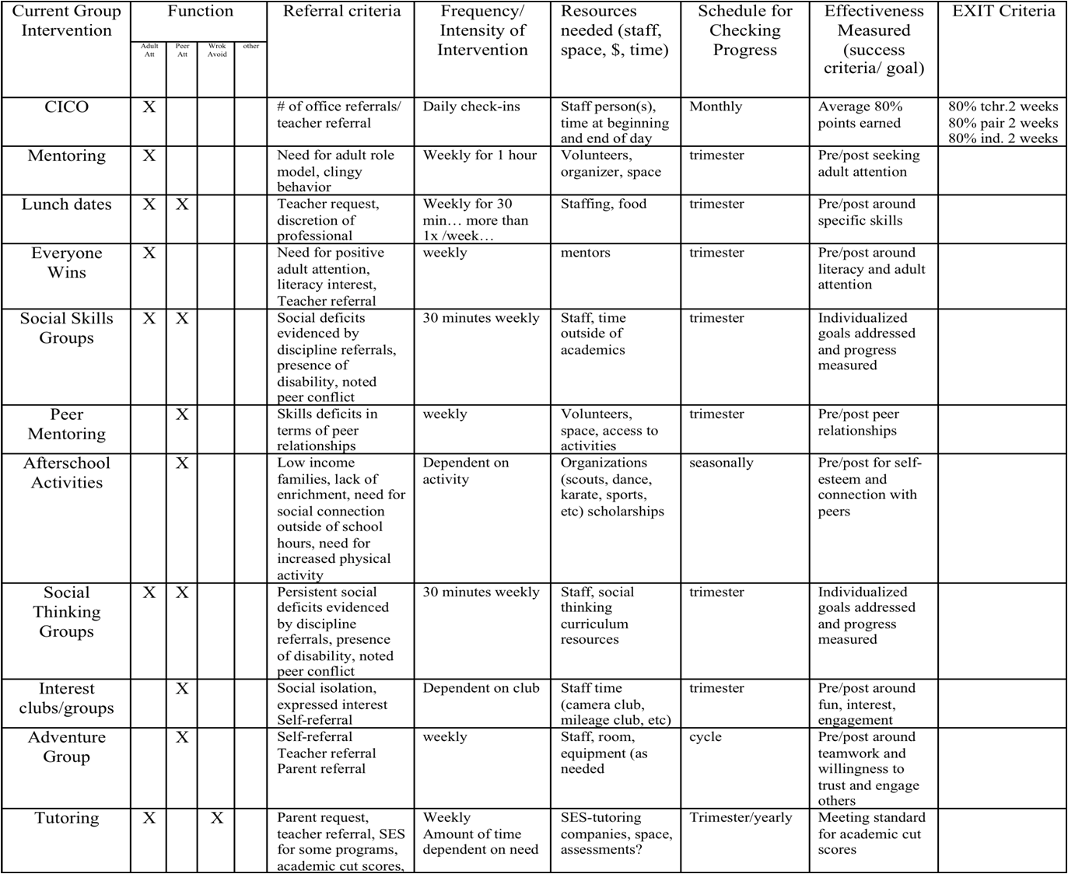
Activity #8: Complete your Inventory of Targeted Interventions

Intervention System Support or Practice | Function of Behavior |  |  |  | Purpose/Goal | Staff Involved | Referral  Criteria | Evidence of Effectiveness (Does practice achieve anticipated outcomes? Is there data?)

What is Check-In/Check-Out (CICO) and Teacher Check, Connect and Expect (TCCE)?

School-based programs for providing systematic and frequent reinforcement and encouragement for positive behaviors so that the student receives high rates of immediate feedback. Most useful with:

• Students who do not respond to school-wide interventions
• Students with repeated referrals
• Students seeking adult attention

Check-In/Check-Out (CICO)
How does it work?

1. Morning check-in
• Students checks in with coordinator within 15 minutes of arrival time
• Coordinator collects and hands out Daily Progress Report (DPR) form
• Daily goal set with students
• Students encouraged to make good choices

2. Student gives DPR form to each teacher prior to each period (section of time).
(Can also be used in cafeteria or playground… anywhere there is a supervisor).

3. End of day check-out

• During last 20 minutes of the day
• Goes over daily progress
• Reviews progress towards goals
• Points tallied
• Reward
• Graphs student progress

4. Daily Progress Report form copy taken home and signed.

5. Return signed copy next morning.

Teacher Check Connect and Expect (TCCE):
How does it work?

- Student is greeted in a friendly positive way by the teacher.
- Teacher reviews behavior expectations with the student, and encourages student to do well.
- After each time period, teacher checks in with student about progress during time period and indicates points on daily progress report (DPR).
- At end of day, teacher writes the total amount of points achieved for the day on DPR.
- Completed DPRs are sent to the targeted team for input into data information system.

With both CICO and TCCE Targeted Team reviews progress after four weeks unless otherwise indicated.

Activity #9: Determine how CICO or TCCE will be implemented in your school

9A:
- Look at the 15% identified students in your ODR data.
- Determine a group of students whose problem behavior is motivated by peer or adult attention.
- Looking at the definition of CICO and TCCE, what additional information do you need to make this doable at your school?
- As a group, look at the advantages/disadvantages of each (T-Chart)

CICO: More evidence of working; a designated person who checks in at beginning/end of the year
(more fidelity)
TCCE: The child comes to the teacher—teacher follows plan
- Determine which of the two strategies your team will implement
- What challenges can you identify that you will work through as we proceed?

9B: Establish the Team (student) and assign Check-In/Check-out Coordinator (if CICO). Use School
Profile Form.

9C:

- Who will you serve?
- How many students can you serve at one time?
- Using ODR data and other student data, brainstorm a list of students you would like to refer to
TCCE or CICO.

9D: Where will Check-in/Check-Out be located?
9E: Determine a catchy name for your program:

Activity #10: Daily Progress Report (DPR)

9A: Create DPR Form. Use samples from book – Responding to Problem Behavior in Schools.
  - Expectations should match Universal expectations
  - DPR should be teacher and student friendly.
  - There should be a place to write each student’s goals
  - Use Examples from the book Responding to Problem Behavior in Schools: The Behavior Education Program pages 201-204 and at PBISveromont.org CICO forms
  - Use SWIS and SWIS CICO Readiness Checklist for DPR compatibility

9B: Create DPR Progress Summary Form using examples from the BEP book pages 210-211

Activity #11: Create your Check-In/Check-Out Acknowledgement System

10A: What will the students’ daily point goal be?

10B: What reinforcers will students receive for checking in and out (e.g., praise and lottery ticket)?

10C: What reinforcers will students receive for checking out and meeting their daily point goal?

10D: How will you ensure students do not become bored with the reinforcers?

10E: Determine what resources you will need to access reinforcers:

Activity #12: Develop a Request for Assistance System

What are the criteria for placing students on Check-In/Check-Out? Other targeted interventions?

How will students be referred?

What is the process for screening students who transfer into the school?

What is the process for determining whether students will start the next school year on the Check-in/Check-out?

Create your Request for Assistance form (see BEP book page 197 and at PBISveromont.org CICO forms). Are the forms easy to access? Easy to complete? Contain the necessary information?

Create a Student Agreement or contract (see BEP book page 219)

Develop a parent consent form (see sample at PBISveromont.org CICO forms).

Activity #13a: Create a system for managing the daily data
Complete the questions below and items 28-31 on Benchmarks of Advanced Tiers:

Which computer system will you use? SWIS? Excel? Other?

How frequently will you Team the daily Check-In/Check-Out data? (at least bi-weekly)

Who is responsible for summarizing the data and bringing it to the meetings?

How frequently will summary data be shared with staff? Parents?
Activity 13b: Plan for fading students off the Check-In/Check-Out intervention

What are the criteria for fading students off of Check-In/Check-Out?

How will the program be faded, and who will be in charge of helping students fade off the Check-In/Check-Out?

Plan for student graduation celebrations
Activity #14: Develop Trainings

Develop and Schedule Staff Training

Schedule date and time for staff training:

Who will plan and deliver the training?

Training should include information on:
•How to make a referral
•How to fill out the DPR
•Types of feedback statements to be made to students
•Examples and activities that model staff rating of DPR

Develop Student Training

Who will meet with the students to train them on the intervention? When will this occur?

Training should include:
•Overview of the program
•How to check in and check out daily
•Adding up daily points
•Determining whether daily point goals are met
•Accepting feedback –both positive and negative
•Procedure for taking the DPR home and bringing it back the next school day

Develop Parent Training

How and when will the parents be trained on the intervention?

Training should include:
–How to provide feedback to their children
–How to focus on the positive
–What to do if there is a bad day

Implementation Planning Forms
and
Examples
VTPBiS Action Plan for Targeted Implementation

Activity | Activity Task Analysis | Who | When
Faculty and Staff Commitment | a.
Faculty and Staff Commitment | b.
Faculty and Staff Commitment | c.
Faculty and Staff Commitment | d.
Faculty and Staff Commitment | e.
Establish Team | a.
Establish Team | b.
Establish Team | c.
Establish Team | d.
Establish Team | e.
School-wide/Universal Behavior in Place | a.
School-wide/Universal Behavior in Place | b.
School-wide/Universal Behavior in Place | c.
School-wide/Universal Behavior in Place | d.
School-wide/Universal Behavior in Place | e.
Student Identification Process in Place | a.
Student Identification Process in Place | b.
Student Identification Process in Place | c.
Student Identification Process in Place | d.
Student Identification Process in Place | e.
Daily Progress Report (DPR) defined  Home Report Defined | a.
Daily Progress Report (DPR) defined  Home Report Defined | b.
Daily Progress Report (DPR) defined  Home Report Defined | c.
Daily Progress Report (DPR) defined  Home Report Defined | d.
Daily Progress Report (DPR) defined  Home Report Defined | e.
Data Collection, Summarization and Use for Decision-making Defined | a.
 | b.
 | c.
 | d.
 | e.

Morning Check-in Routine  Teacher Check-in Check-out Routine  Afternoon Check-out Routine  Home Review Routine | a.
 | b.
 | c.
 | d.
 | e.
Team Meeting Schedule | a.
Team Meeting Schedule | b.
Team Meeting Schedule | c.
Team Meeting Schedule | d.
Team Meeting Schedule | e.
Process defined for moving off CICO  Process defined for use of self-management strategies within CICO | a.
 | b.
 | c.
 | d.
 | e.

Process defined for moving student into Individualized Support Systems | a.
 | b.
 | c.
 | d.
 | e.
Process defined for informing substitute teachers  Process defined playground, cafeteria, bus areas  Other areas? | a.
 | b.
 | c.
 | d.
 | e.

School-wide Behavior Implementation Plan

Behavior Roll-Out for Staff

Date:

Time:

Location:

Materials Required (check or list all that apply):

Agenda ____ Handouts ____ Other _____________________________________

Technology Supports LCD ____ TV/DVD/VIDEO _____ Screen ______ Easel ______ Chart Paper ______ Markers ______ Other _______

Presenters: __________________ ; ___________________ ; ____________________ ;

______________________ ; ________________________; ______________________

Activities (attach work sheets, if needed) Amount of Time

1. ____________

2. ____________

3. ____________

4. ____________

Evaluation/ Feedback Method (check all that apply)

Survey _____ Process Activity _____ Interview ______ Other __ Describe __________

School-wide Behavior Implementation Plan

Behavior Roll-Out for Students

Date:

Time:

Location:

Materials Required (check or list all that apply):

Agenda ____ Handouts ____ Other _____________________________________

Technology Supports LCD ____ TV/DVD/VIDEO _____ Screen ______ Easel ______ Chart Paper ______ Markers ______ Other _______

Presenters: __________________ ; ___________________ ; ____________________ ;

______________________ ; ________________________; ______________________

Activities (attach work sheets, if needed) Amount of Time

1. ____________

2. ____________

3. ____________

4. ____________

Evaluation/ Feedback Method (check all that apply)

Survey _____ Process Activity _____ Interview ______ Other __ Describe __________

School-wide Behavior Implementation Plan

Behavior Roll-Out for Family and Community

Date:

Time:

Location:

Materials Required (check or list all that apply):

Agenda ____ Handouts ____ Other _____________________________________

Technology Supports LCD ____ TV/DVD/VIDEO _____ Screen ______ Easel ______ Chart Paper ______ Markers ______ Other _______

Presenters: __________________ ; ___________________ ; ____________________ ;

______________________ ; ________________________; ______________________

Activities (attach work sheets, if needed) Amount of Time

1. ____________

2. ____________

3. ____________

4. ____________

Evaluation/ Feedback Method (check all that apply)

Survey _____ Process Activity _____ Interview ______ Other __ Describe __________

Examples of Permission Slips:

Example #1:

Winder School
Permission for Check-In/Check-Out
Date ____________________
Student _____________________________________ Grade _______________
Teacher _____________________________________

Parent / Guardian _____________________________

I would like to include your child in our Check-In/Check-Out Program. A report will be filled out daily by the teacher(s) and checked at the end of the day by our coordinator, Mrs. Williams. Students will need to pick up their report every morning between 8:45 and 9:00 a.m. and then return to Mrs. Williams between 3:45 and 4:00 p.m. The student will be able to earn incentives and rewards for appropriate behavior. As parents, you are responsible for making sure your child arrives on time each day for check-in and that you review and sign the daily BEP Report. Together, we can make this a positive experience for your child.

_____ I do give consent for my student to participate.

_____ I do not give consent for my student to participate.

___________________________________ Date _________________________
( Parent / Guardian )

For further information, please call:
___________________________________ at 555-7525,
Sabrina Williams

or call ___________________________________.

Examples of Permission Slips:

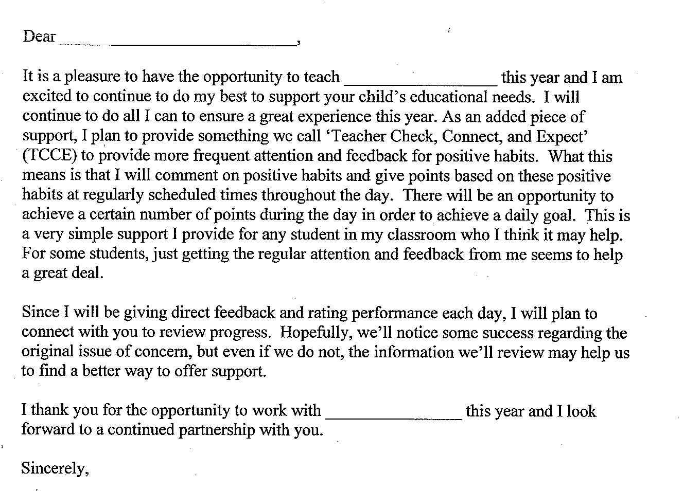
Example #2:
Examples of Daily Progress Reports (DPRs):


PAWS
(Positive Assistance With Support)
Hardwick Elementary School  Daily Progress Report |  |  |  | Name
 |  |  |  | Date |  | Teacher
GOALS | Before School | Practical/Fine Arts | Math |  | Lunch |  | Recess | Literacy
Respect People | 2 1 0 | 2 1 0 | 2 1 0 |  | 2 1 0 |  | 2 1 0 | 2 1 0
Respect Property | 2 1 0 | 2 1 0 | 2 1 0 |  | 2 1 0 |  | 2 1 0 | 2 1 0
Practice Safety | 2 1 0 | 2 1 0 | 2 1 0 |  | 2 1 0 |  | 2 1 0 | 2 1 0
Show Care and Concern | 2 1 0 | 2 1 0 | 2 1 0 |  | 2 1 0 |  | 2 1 0 | 2 1 0
Adult Initial
Total
Points

Total Possible: 48 Goal for Today: __________
Key
0 = Keep trying.
1 = Almost there . . .
2 = Great!!

Total for Today: __________ % _______

Parent Signature: _________________________________

Examples of Daily Progress Reports (DPRs):

Check In /Check Out Card (CICO)

Student_____________________________________________________________ Date________________

KEY: | 0 = Try again | 1 = Needs work | 2 = Got It!

EXPECTATION | SAFE | RESPECTFUL | READY to LEARN
 | Keeping hands, feet, other objects to self | Using kind words, actions, following directions | Working carefully, doing your best,  be prepared
Math | 0 1 2 | 0 1 2 | 0 1 2
Reading/Language | 0 1 2 | 0 1 2 | 0 1 2
AM Recess | 0 1 2 | 0 1 2 | 0 1 2
Lunch | 0 1 2 | 0 1 2 | 0 1 2
PM Recess | 0 1 2 | 0 1 2 | 0 1 2
Theme, Social Studies, Science | 0 1 2 | 0 1 2 | 0 1 2
Art/PE/Music | 0 1 2 | 0 1 2 | 0 1 2
Library/Tech/Choice/Other | 0 1 2 | 0 1 2 | 0 1 2
SUBTOTAL

# ___________ points received
# __________ points possible
% __________ of points

WOW ! Comments: _______________________________________________________________________________________________________________________________

Parent/Guardian Signature____________________________________________________

CICO monitor Initials_________
Examples of Daily Progress Reports (DPRs):

P.A.W.S. PLAN
Positive Assistance With Support
Woodbury Bears are Responsible, Respectful & Safe

Date______________________ Student______________________________

0= Keep Trying  1= Almost There  2= You Did It! | Responsible  Follow Directions  Be Prepared | Respectful  Use Kind Words & Actions  Be Helpful | Safe  Keep Hands, Feet and Objects to Self | Staff Initials
Arrival & Morning Meeting | 0 1 2 | 0 1 2 | 0 1 2
Morning Class Time | 0 1 2 | 0 1 2 | 0 1 2
Lunch | 0 1 2 | 0 1 2 | 0 1 2
Recess | 0 1 2 | 0 1 2 | 0 1 2
Special | 0 1 2 | 0 1 2 | 0 1 2
Afternoon Class Time | 0 1 2 | 0 1 2 | 0 1 2
Dismissal | 0 1 2 | 0 1 2 | 0 1 2
Total Points = _______  Possible Points = 42  Goal (80%) = 34 | Today __________%  Goal __________%

Successes:_______________________________________________________________________________________________________________________________
Parent Signature____________________________________________________

