VTPBiS Leadership Team Training
at the Intensive Level
Within a Multi-Tiered System of Supports

Activity Workbook 2015

Name: _______________________________

School: _______________________________

What is PBIS at the Intensive Level?
The intensive level of VTPBiS is designed to provide a continuum of individualized, comprehensive, and team-based interventions for students with complex issues whose needs have not been adequately addressed with less intensive PBIS interventions at the Universal and Targeted levels.

Students receiving supports at the Intensive Level of PBIS also access the interventions and supports in place at the Universal and Targeted Levels but may need further assessment and individualized planning. Some students with complex needs across home, school and community may need Intensive Level Wraparound supports. The chart below shows the differentiation between PBIS Targeted, Intensive and Intensive Wraparound supports in five key areas: (a) forming teams to develop student plans, (b) setting goals (c) assessing student behavior, (d) providing individualized interventions, and (e) evaluating progress for decision making
 | TIER 2  (Targeted Level) | TIER 3  (Intensive Level) | TIER 3  (Intensive Level with Wraparound)
TEAMING | Small behavior planning team reviewing students who need more than Tier 1 interventions | Student-specific team members (student, parent, peer, administrator, teacher, behavioral staff member, etc.) | Student and family identify team members which may include peers and professionals outside of school
GOALS | Similar goals for all students: in class, on task, responding successfully to Tier 1 supports | Individualized school-based goals to address 1-2 specific problem behaviors | Student and family choose goals focused on addressing BIG needs occurring in the home, school, community
ASSESSMENT | Practical Functional Behavior Assessment (FBA) of problem behavior | FBA including observations and interviews | More comprehensive measures assessing strengths & needs in home, school and community
INTERVENTION | Tiers 1 and 2 interventions with individualized components to Tier 2 interventions if needed | Tiers 1 and 2 interventions and Behavior Intervention Plan (BIP) including Safety Plan | Same as Tiers 1, 2 and 3; Crisis/safety plan; Community services, as needed
EVALUATION | Office discipline referrals, Check-in/Check out data attendance, nurse visits, other | Same as Tier 2, and  SWIS Student Support Information System (ISIS) | Same as Tier 3,and other data tools
School Leadership Training Agenda
Day 1 Agenda
- Introductory Activities and Logistics
- Revisit and Strengthen Targeted Interventions
- Building Intensive Team Structure
- Activity facilitated by representatives from Vermont Family Network

Day 2 Agenda
- Teaming
- Setting Goals
- Functional Behavior Assessment / Behavior Support Plans (FBA/BSP)

Day 3 Agenda
- Specific Interventions
Setting event interventions
Antecedent interventions
Behavioral Teaching interventions
Consequence interventions

Day 4 Agenda
- Evaluation
- Crisis Planning
- Rolling Out

By the end of this training you will have:
- Strengthened targeted & built readiness
- Explored 5 Steps for Intensive Process
- Practiced FBA/BSP
- Examined Tier 3 practices
- Considered Proactive Crisis Planning
- Reviewed data systems at Tier 3
- Planned for next steps

The Heart of the Matter: Part 1

Knowing and honoring what gifts our students bring with them to the school community is the first step. Listen to the following story:

Does your resume include the fact that you are cranky when you get up in the morning? Does it admit that, when you are under pressure, you don’t perform as well as you do at other times? Of course not! But don’t we do this to young people all the time? At times, human service agencies or schools create resumes that only focus on child and youth weaknesses! That’s not very fair, is it?

When Karl first met Brenda, she had a very low sense of self-esteem. She did not think she was a good person, that she was likeable or that she could do anything. She had failed as a student and as a responsible citizen. The only thing she was good at was hurting herself (suicide attempts) or hurting others. That’s how she had been labeled and treated and that’s how she had come to accept herself.

Karl refused to see her that way. He insisted on seeing her as a girl – a girl with competencies. He knew that, unless she began to see herself in a more positive light, she would be doomed to always seeing hurting herself as an answer. Karl’s aim was to find some things about Brenda that she could be proud of and that could be used to change her self-image from negative to positive. Karl’s discovery about Brenda was that she was a good and likeable person; that she could do something well and that she had positive personal characteristics of which she could take advantage.

- Adapted from Everything is Normal Until Proven Otherwise

Think about the student or students for which you will be planning Intensive supports. Consider the questions below and write down your responses. (5 minutes)

- What makes this child happy? (What does this child love to do? What is this child curious about?)

- Note one (or more) of the child’s gifts.

- Does anyone in the school (adults or students) recognize or acknowledge this child’s gifts?

- Name 3 things you can do to help others recognize this student’s gifts.

Plan to sustain the Targeted Level (BAT Sections B and F):

If up to 12% students could benefit from CICO, how many students is that for your school? _______

Complete the CICO Self-Assessment:

VTPBiS
Check-In / Check-Out Self-Assessment
Instructions: As a team, review and record each of the CICO elements. For all elements that are rated as “in progress” or “not in place” build action planning steps.

CICO Element | In  Place | In Progress | Not In Place
1. Faculty and Staff Commitment for CICO

2. Targeted Team Defined and Coordinator Identified

3. School-wide/Universal PBIS in place

4, Student Identification Process for CICO developed

5. CICO Daily Progress Report (DPR) card developed

6. School to Home reporting process defined

7. Process for collecting, summarizing and using data

8. Morning check-in routine established

9.Teacher check-in/ check-out routine established

10. Afternoon check-out routine established

11. Home review routine established

12. Team meeting schedule, routine, process

13, Planning for Success (fading support; establishing self-management elements)

14. Planning for Individualized Support Enhancement

15. Substitute Teacher routine established

16. Playground, cafeteria, bus routine (Other areas) established

VTPBiS Action Plan for Completion of Start-Up Activities

Activity | Activity Task Analysis | Who | When
Faculty and Staff Commitment | a.
 | b.
 | c.
 | d.
 | e.
Establish Team | a.
 | b.
 | c.
 | d.
 | e.
School-wide/Universal PBIS in Place | a.
 | b.
 | c.
 | d.
 | e.
Student Identification Process in Place | a.
 | b.
 | c.
 | d.
 | e.
Daily Progress Report (DPR) defined  Home Report Defined | a.
 | b.
 | c.
 | d.
 | e.
Data Collection, Summarization and Use for Decision-making Defined | a.
 | b.
 | c.
 | d.
 | e.

Morning Check-in Routine  Teacher Check-in Check-out Routine  Afternoon Check-out Routine  Home Review Routine | a.
 | b.
 | c.
 | d.
 | e.
Team Meeting Schedule | a.
 | b.
 | c.
 | d.
 | e.
Process defined for moving off CICO  Process defined for use of self-management strategies within CICO | a.
 | b.
 | c.
 | d.
 | e.

Process defined for moving student into Individualized Support Systems | a.
 | b.
 | c.
 | d.
 | e.
Process defined for informing substitute teachers  Process defined playground, cafeteria, bus areas  Other areas? | a.
 | b.
 | c.
 | d.
 | e.

Complete the Targeted Inventory of Supports (next page) (BAT, Section B)

- In school teams, review your Inventory of Targeted Supports

- Share two most successful practices with large group

Targeted Inventory of Supports:
Current Group Intervention | Function |  |  |  | Referral  criteria | Frequency/ Intensity of Intervention | Resources needed (staff, space, $, time) | Schedule for Checking Progress | Effectiveness Measured  (success criteria/ goal) | EXIT Criteria
 | Adult att. | Peer att. | Work avoid | other

As a team review or complete the Readiness Checklist:

Vermont Positive Behavior Interventions & Supports (VTPBiS) School Steps to Readiness: VTPBiS Tier 3 Intensive Level

(Review prior to VTPBiS Tier 3 Intensive Level webinar and complete prior to VTPBiS Tier 3 Intensive Level training)

School: SU: Date:

Documents / Evidence Complete? |  | Schools are “ready” for Tier 3 Intensive Level training once they have:
YES | NO | - Completed the Benchmarks for Advanced Tiers (BAT) Sections A-G (items 1 – 31) and I (items 44 – 53):  - Fully in place for Tier 1: Implementation of School-wide PBIS (items 1 – 3)  - Partially to Fully in place for Tier 2-3 Foundations (items 4 – 12)  - Partially to Fully in place for Tier 2 Targeted Interventions (items 13 – 31)  - Partially to Fully in place for Tier 3 Assessment & Plan Development (items 44 – 53)  Note: Items 44-53 should be completed by staff trained in ABA reviewing FBAs and BIPs developed at the school during the school year. This reviewer should be someone other than the individual who developed the FBAs and BIPs. Please contact your State TA or your PBIS implementation coach if you need assistance completing this section.
YES | NO | - Have identified school personnel who can complete a simple FBA, and have access to people who are available to complete a full FBA.
YES | NO | - Been recommended by their school’s Regional State TA as ready to pursue VTPBiS Tier 3 Intensive Level based on implementation progress of PBIS at other levels and administrative commitment.
YES | NO | - Developed or reconfigured your School Leadership Team to include members relevant to VTPBiS Intensive Level:
 |  | - Administrator  - behavior specialist, | - teacher(s)  - counselor | - special educator, and  - a family member of a student.
YES | NO | - Committed to identify VTPBiS School Coordinator to actively participate in VTPBiS at the Intensive Level who is assigned sufficient FTE to support intensive level coordination. This could be existing school coordinator for PBIS.
YES | NO | - Agreed to use an information system to make data-based decisions regarding student behavior receiving supports at the intensive level.
YES | NO | - Committed to annually self-assess Targeted and Intensive implementation. Additionally, use data to develop, review, and refine a clear action plan outlining school efforts to develop, maintain, and sustain fidelity at all tiers.
As a team, complete Team Profile and Meeting Schedule (BAT, Section B and H)
Intensive Intervention Team Roster
School Name: Grades:
Town/City: Supervisory Union:
Intensive Team – Systems Level
Team Member Name Building Role Team Member Role
(administrator, Coordinator, teacher, etc.)
Day and Time of Monthly Meetings:
Intensive Team – Individual Student Level
Team Member Name Building Role Team Member Role
(coordinator, behavior spec., data spec.)
Day and Time of Weekly Meetings:

The Heart of the Matter Part Two

Honoring the stories of families is key to student success. Listen to the following story:

When my son was diagnosed with depression, anxiety and attention deficit/hyperactivity disorder, I remember the unspoken accusation and implied responsibility that came with the diagnoses and that hung, almost visibly, in the air before settling across my shoulders like a mantle of lead. No one thought to ask the questions, “Do you have other children and how are they? What do you think we should do? What is your son really good at? What are some of the things you do to support your child emotionally? How can we work together? Instead, [the therapist] recommended parenting classes and asked what other family “problems” existed. I was not consulted about the area in which I possessed the greatest expertise – my own child. On that day, I became the origin or the problem, not the knowledgeable collaborator.

A family story is a shared learning experience. It requires a Teller and a Listener, a very safe environment, and an understanding that each teller relates his or her story as it is remembered, either positively or negatively. Stories are not just statements of fact; they convey the teller’s perspective, expectations, skills, judgments, and feelings. Stories transmit all kinds of knowledge, when the listener has the capacity to hear themes and translates the themes into supports and services. Listening to the family story requires respecting the story as the story that teaches its listeners about the core capabilities and strengths of each family.

- Excerpted from Dixie Jordan in Everything is Normal Until Proven Otherwise

Families that share their stories allow service providers to help build upon their desired outcomes for their children.

Think about the family/families of the children you identified.

- What is their story? How can you make it safe for them to share it?

- What are they proud of in their child? What do they think their child is really good at?

- How can you find out these answers if you don’t know?

Family Engagement Checklist (BAT, Sections D and H)

Muscott & Mann, 2004

STATUS:  In place  Partially in place  Not in place | TASK | PRIORITY:  High  Medium  Low
 | Climate
 | 1. There is a process for assessing how welcomed, valued, and satisfied parents are in and with the school.
 | 2. There is a plan for addressing ways to help families feel welcomed and valued.
 | 3. There is a plan for training all staff to work collaboratively and respectfully with families.
 | 4. Plans for addressing ways to help families feel welcomed and valued address diverse families including those with students in the universal, targeted and intensive levels of PBIS.
 | Parent Involvement in Learning Activities at Home
 | 5. There is a process for assessing parents’ opinions about their own involvement in learning activities at home.
 | 6. There is a plan or set of activities for helping families to support their child’s learning at home.
 | 7. The plan includes activities for helping diverse families, including those with students in the universal, targeted and intensive levels of PBIS, support their child’s learning.
 | Communication with Parents/Families
 | 8. There is a process for assessing parents’ opinions about how well schools communicate with them.
 | 9. There is a plan for communicating with families in varied and helpful ways.

STATUS:  In place  Partially in place  Not in place | TASK | PRIORITY:  High  Medium  Low
 | 10. The plan includes activities for communicating with diverse families, including those with students in the universal, targeted and intensive levels of PBIS, about important school/home matters including discipline.
 | Parent/Family Involvement at School (Volunteering, Assisting)
 | 11. There is a process for assessing parents’ opinions about how they can support schools through their involvement at school.
 | 12. There is a plan for how parents can be involved in supporting learning at school through volunteering and assisting.
 | 13. The plan for parental involvement in school activities addresses how diverse families, including those with students in the universal, targeted and intensive levels of PBIS, can participate.
 | Parent/Family Involvement in Decision-Making
 | 14. There is a process for assessing parents’ opinions about the extent to which they are encouraged to participate in decision-making committees and activities (e.g., leadership teams).
 | 15. There is a plan for encouraging and supporting parent participation in decision-making committees and activities.
 | 16. The plan for parental participation in decision-making committees and activities addresses how diverse families, including those with students in the universal, targeted and intensive levels of PBIS, can participate.
 | 17. There is a process for assessing parents’ opinions about the extent to which they can provide input to school personnel about matters of importance including discipline that is taken seriously.
 | 18. There is a plan for gathering and incorporating parents’ input about matters of importance including discipline that is taken seriously.
 | 19. The plan for gathering and incorporating parents’ input about matters of importance including discipline addresses how diverse families, including those with students in the universal, targeted and intensive levels of PBIS, can be heard.

Review first page of VTPBiS Intensive Level: Behavior Support Plan to see how plan aligns with five-stage planning process.

Stage 1: Teaming

Student team roster, page 2

Day and time of meetings, page 2

Recommended meeting agenda, page 2

Stage 2: Goals

Broad Goal, page 2

Pro-Social Behavior to Increase, page 2

Problem Behaviors to Decrease, page 2

Stage 3: Assessment

Functional Behavior Assessment Protocol (F-BSP)

FBA Interview –Teachers/Staff/Parent

Step 1: Interview Teacher, Staff, Parent, pages 3-4

Step 2: Propose a Testable Explanation, page 4

FBA Interview – Students

Step 1: Interview Student, pages 5-6

Step 2: Develop a Testable Explanation, page 6

Step 3: Rate Your Confidence in Testable Explanation, page 7

Step 4: Conduct Observations, page 7

Step 5: Confirm/Modify Testable Explanation, page 7

Step 6: Build a Competing Behavior Pathway, page 8

Stage 4: Intervention

Step 6: Strategies for Competing Behavior Pathway, page 8

Step 7: Select Initial Intervention Strategies, page 9

Proactive crisis plan, page 10

Stage 5: Evaluation

Step 8: Evaluate Plan, pages 11-12

Plan review date and signatures, page 12

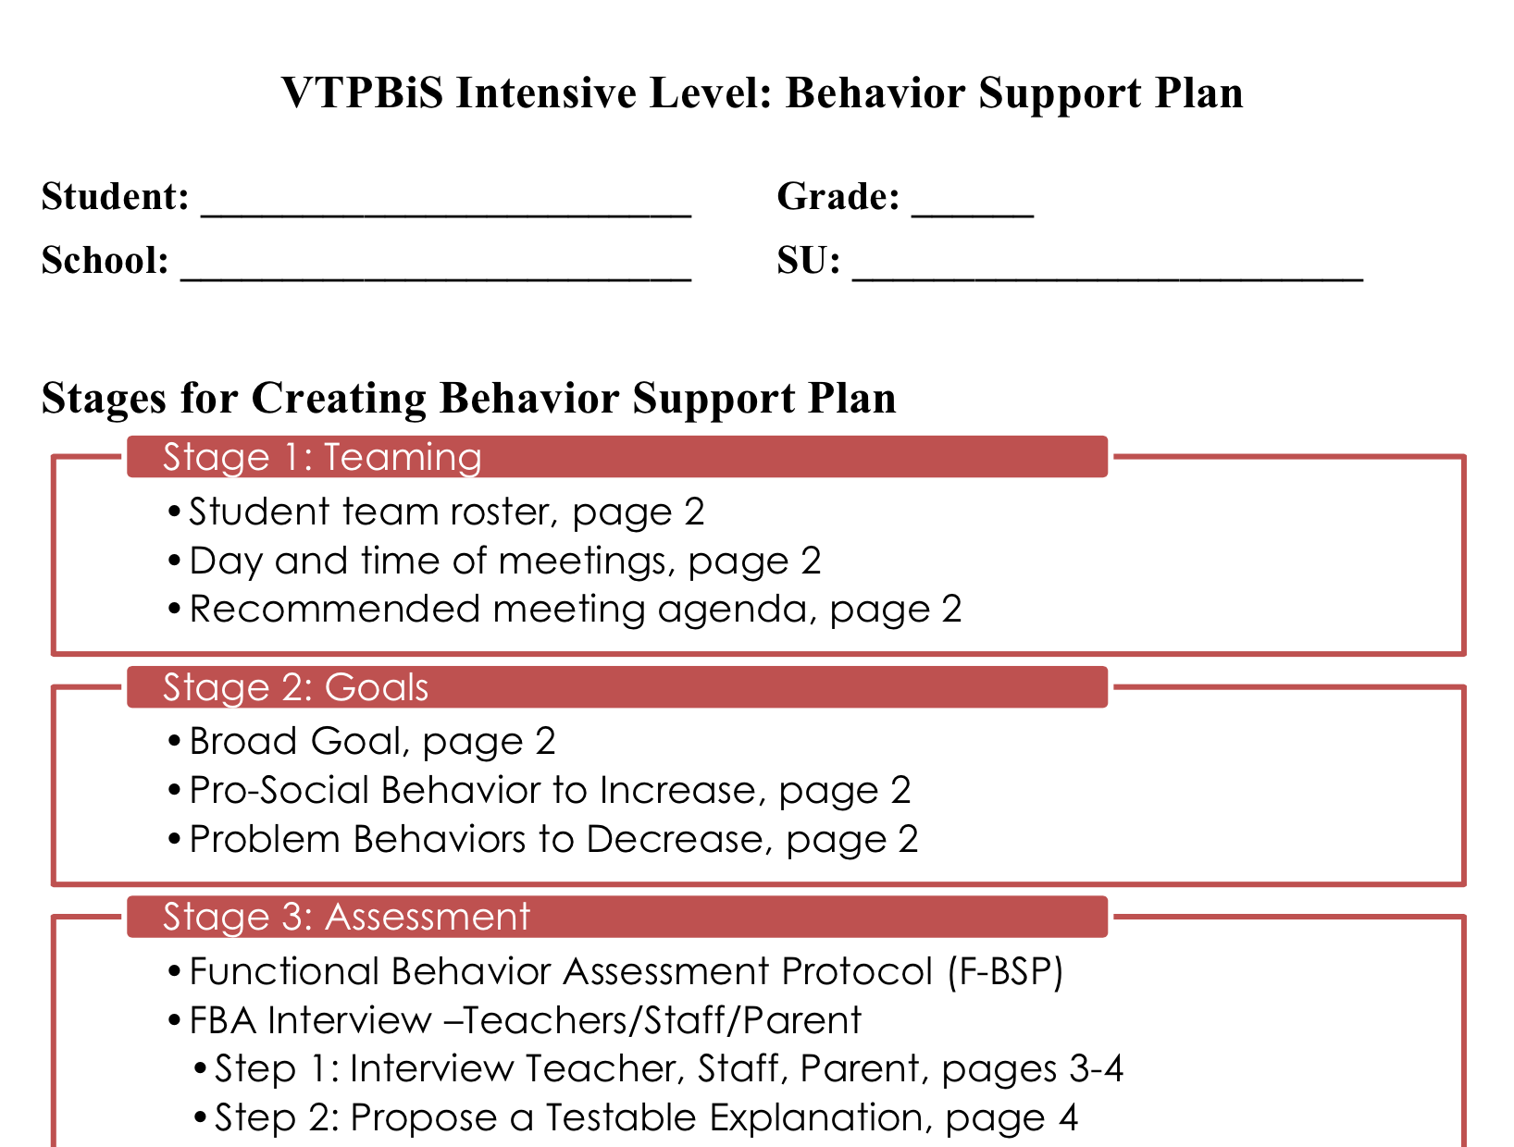
Clarifying Roles and Goals of Team Members
From Art & Science of Wraparound Manual (Eber, 2003)

This activity is intended to help facilitators understand the importance of clarifying roles and goals of team members and to provide some experience in examining roles/goals in relation to job titles and behavior of individual team members.
- For a student you are working with through a team process, list all the people involved with the student at home, school, or in the community.
- For each person you identified, see if you can identify the role they would say they are engaged in with that student and the goal they would say they have in mind in their role with the student.
- If you are unclear about perceived roles/goals of some people, think of their behavior at team meetings or the type of interactions they have with the student and/or family.
People Involved w/Student | Their Role | Their Goal

Then ask yourself the following questions:
- Were you able to identify each person’s perception of their role with the student and each person’s perception of their goal with the student?
- Were the roles some people perceive they play different than what is expected by their job title? By other team members?
- Did you identify people who were involved with the student who haven’t been included on the team who may be helpful to include?
- Did you identify any potential overlap of roles among team members?
- Did you identify any team members who have the potential for multiple roles, which may be confusing or overwhelming?
- Did you identify any people with unclear roles?

Complete Behavior Support Plan Stage 2 Goals

Stage 2: Goals

Team identifies broad goals that they all agree will be focus for assessment & intervention.
Broad Goal (positive, long-term goal for student)
Pro-Social Behaviors to Increase (prioritize what behaviors you want to increase)
Problem Behaviors to Decrease (prioritize what behavior to focus on in FBA)

STEP 6: BUILD A COMPETING BEHAVIOR PATHWAY

Antecedent

Setting Event

Consequence

Desired Behavior

Function
Consequence

ProblemBehavior

=

AlternativeBehavior

Setting Event Strategies | Antecedent Strategies | Behavior Teaching Strategies | Consequence Strategies

Develop FBA Capacity in your School (BAT, Sections I and J)

List the people who are responsible for conducting FBAs in your school:

Determine who needs to be trained in FBA:
1)
2)

Who makes the referral?

What form do they use?

Where or to whom does the referral form go?

Who or what group reviews the referral form to see if Simple FBA needs to be done?

Who schedules the Simple FBA, informs teachers and others who need to know?

Who completes the Simple FBA? Assign a “FBA Coordinator”

Who or what group develops the testable hypothesis?

Who or what group develops the simple behavior support plan?

What is the proposed timeline from referral, decision, interview(s), summary of Simple FBA, testable hypothesis statement and development of simple behavior support plan?

When and by whom is BSP reviewed to see if it is working?

What is your plan for training ALL staff in understanding behavior and function of behavior?

Intensive Level Roll-Out Plan

Develop a Request for Assistance Process, (BAT Sections B and C)

What is the process for referring students for Tier 3 Supports?

How will students be referred?

Create your Request for Assistance process and form? Are the forms easy to access? Easy to complete? Contain the necessary information?

Create a process for gaining student agreement

Develop a parent consent form (or process)

Create a system for managing the daily data (BAT Sections E and G)

Complete the questions below (based on Benchmarks of Advanced Tiers items 28-31):

Which computer system will you use? SWIS ISIS? Excel? Other?

How frequently will your Team review Tier 3 data?

Who is responsible for summarizing the data and bringing it to the meetings?

How frequently will summary data be shared with staff? Parents?

Plan for fading students off the Individual Behavior Support Plan interventions (BAT, Sections I and J)

What are the criteria for fading students off of Tier 3 Supports?

Develop and Schedule Staff Training

Schedule date and time for staff training:

Who will plan and deliver the training?
Training should include information on:
• How to make a referral
• How to determine function of behavior
- Role of staff in FBAs/BIPs

Develop Student Awareness

Who will meet with the students to plan and share the intervention? When will this occur?

Information should include:
•Overview of the BSP
• Goals of BSP

Develop Parent Awareness and Consent

How and when will the parents be informed about the Tier 3 supports?

Information should include:
–Parent role in BSP
–How to focus on the positive
–Communication process

