VTPBiS December 2013 Data Day Workbook:

School: _______________________________________

Conducting Leadership Team Meetings Self-Assessment
(Adapted from Sugai & Todd, 10-22-03)

This Self-Assessment has been developed to facilitate the preparation, conducting, and evaluation of leadership team meetings. As a team, place and “X” in the appropriate box.
 | STATUS:
PREPARING: | In Place | Partially In Place | Not In Place | N/A
Review agreements/tasks from previous minutes
Identify/review/develop agenda items
Invite/remind/prepare participants
Prepare/review materials
Check/confirm logistics (e.g., room, location, time)
Data Analyst prepares data for meeting (e.g. Academic & Behavior)
BEGINNING:
Acknowledge/introduce participants
Review purpose
Review/assign roles
Rotate meeting role responsibilities (e.g. facilitator, time keeper)
Review/modify agenda items (e.g., discussion, decision, information)
Assign # of minutes for each agenda item
Set/review meeting rules/routines (Routines below)

CONDUCTING:
Follow agenda items
Stay within timelines
Follow/review rules/routines
Restate/review/remind of purpose/outcomes
Use the TIPS model to review data and problem solve
CONCLUDING: | In Place | Partially In Place | Not In Place | N/A
Review purpose
Review/summarize agreements/products/assignments
Review/evaluate extent to which agenda items addressed
Review new agenda items
Review compliance with rules/routines
Acknowledge/reinforce participation/actions/outcomes
Indicate next meeting date/time/place
Share workload among team members
FOLLOW-UP:
Distribute minutes to team and other stakeholders
Complete agreements/products/assignments
Contact/remind participants
Prepare for next agenda
Share data and successes with staff

Other Notes/Observations:

Routines for Conducting Effective and Efficient Meetings

- How are decisions made?
- How are problems/conflicts/disagreements resolved/processed?
- How are roles/responsibilities (e.g., leadership/facilitation, recording minutes, reporting) assigned and conducted?
- How is participation encouraged/reinforced?

Team Profile and Meeting Schedule

Leadership Team Roster

School Name: Grades:

Town/City: Supervisory Union:

Team Norms:

Team Member Name Building Role Team Member Role

Dates and Times of Monthly Meetings:

The leadership team plays a critical role in developing systems to support universal and targeted practices:
- Create procedures for all Universal and Targeted interventions.
- Communicate to staff and families
- Create links between universal and targeted systems

ODR Data Focus Chart:

ODR Data Focus Worksheet

Determine the percentage based on your data… | Determine Area of Focus...
What % of students receive one or more ODRs?  _______________ | If more than 40% of students received one or more ODRs or you have an average of 2.5 ODRs per student focus on:  School-Wide Systems
What % of ODRs come from non-classroom settings?  _______________ | If more that 35% of ODRs come from non-classroom settings or more than 15% of students referred from non-classroom settings focus on:  Non-Classroom Systems
What % of ODRs come from the classroom?  _______________ | If more than 60% of ODRs come from the classroom or 50% or more ODRs come from less than 10% of classrooms focus on:  Classroom Systems
What % of students receive 5 or more ODRs?  _______________ | If more than 5% of students received 5 or more ODRs focus on:  Targeted Group Interventions/Classroom Systems
What % of students receive 10 or more ODRs?  _______________ | If less than 5% of students with 10 or more ODRs or less than 5% of students continue to receive ODRs after receiving targeted group interventions or small number of students are destabilizing overall function of school focus on:  Individual Student Systems
Please identify the top 2 systems you will focus on based on your data:

Priority Focus Area 1: _______________________________________________________________________

Priority Focus Area 2: _______________________________________________________________________

Use the ODR Data Focus Worksheet to determine which assessment tool you will use. Review or complete the BoQ or SET if you need to focus on your School-wide System, Classroom System and/or Non-Classroom System. Complete the BAT if you need to focus on your Targeted and/or your Individual Student System.
You’ll find both tools at the following links:
BoQ: http://www.pbisvermont.org/resources/evaluation-tools/boq
BAT: http://www.pbisvermont.org/resources/evaluation-tools/benchmarks-for-advanced-tiers-bat

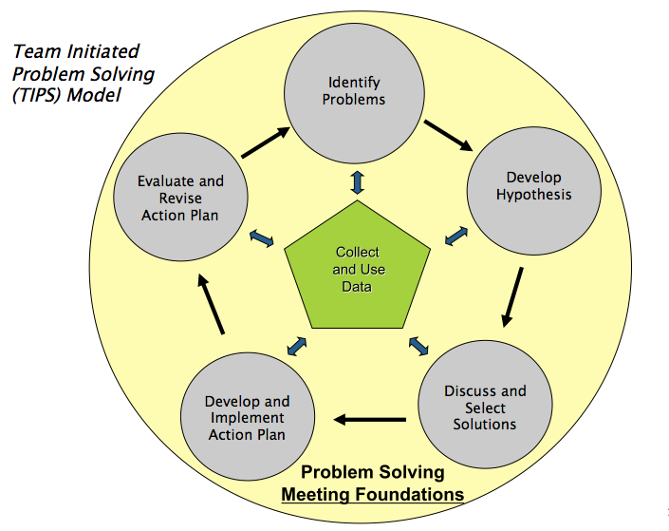

TIPS Problem-Solving “Mantra”

- Do we have a problem?
(identify)
- A problem is a gap between the desired outcome or objective and current status.
- Data assists in defining the problem.
- When identifying if a problem exits, consider the following:
  - What data to monitor
    - ODR per day per month
    - OSS, ISS, Attendance, Teacher report
    - Team Checklist/ SET (are we doing what we planned to do?)
  - What question to answer
    - Do we have a problem?
  - What questions to ask of Level, Trend, Peaks
    - How do our data compare with last year?
    - How do our data compare with national/regional norms?
    - How do our data compare with our preferred/expected status?
  - If a problem is identified, then ask
    - What are the data we need to make a good decision?

- What is the precise nature of our problem?
(define, clarify, confirm/disconfirm inferences)
- Define a clear problem statement by using data to answer the following questions:
  - What problem behaviors are occurring?
  - When are problem behaviors occurring?
  - Where are problem behaviors occurring?
  - Who is engaging in problem behaviors?
  - Why do problem behaviors keep happening

- Why does the problem exist, & what can we do about it?
(hypothesis & solution)
- Develop a hypothesis based on your problem statement
- When developing solutions consider the following:
  - Prevent
    - Remove or alter “trigger” for problem behavior
  - Define & Teach
    - Define behavioral expectations; provide demonstration/instruction in expected behavior (alternative to problem behavior
  - Reward/reinforce
    - The expected/alternative behavior when it occurs; prompt for it, as necessary
  - Extinction
    - Withhold reward/reinforcement for the problem behavior, if possible
  - Correct
    - Use non-rewarding/non-reinforcing corrective consequences, when problem behavior occurs
  - Safety
    - Although not a “solution strategy,” Safety may need to be considered (i.e., procedures that may be required to decrease likelihood of injuries or property damage)

- What are the actual elements of our plan?
(Action Plan)
- When developing an action plan consider the following Action Plan Elements:
  - Who?
  - By When?
  - Goal with Timeline
  - Fidelity of Implementation Measure
  - Effectiveness of Implementation Measure

- Is our plan being implemented, & is it working?
(evaluate & revise plan)
- Define the goal for solving the problem
  - What will ‘it’ look like when you say it is not a problem
- Define how you will know that the solutions were implemented as planned (with fidelity)?
  - How often will you conduct a status review?
- Define how you will know that the solutions had a positive effect on student achievement, social competence, and/or safety?
  - How often will you monitor student progress?
- What will the data tell you when the problem is solved?
  - Base on team-established standard
  - Easier to monitor if quantifiable (“countable”)
  - Record on meeting minute form for progress monitoring at future meeting(s)

Problem-Solving Plan
Precise Problem Statement, based on review of data  (What, When, Where, Who, Why) | Solution Actions (e.g., Prevent, Teach, Prompt, Reward, Correction, Extinction, Safety) | Who? | By When? | Goal with Timeline | Fidelity of Imp measure | Effectiveness of Imp measure | Updates
Evaluation of Team Meeting (Mark your ratings with an “X”)
 | Our Rating
 | Yes | So-So | No
1. Was today’s meeting a good use of our time?
2. In general, did we do a good job of tracking whether we’re completing the tasks we agreed on at previous meetings?
3. In general, have we done a good job of actually completing the tasks we agreed on at previous meetings?
4. In general, are the completed tasks having the desired effects on student behavior?
If some of our ratings are “So-So” or “No,” what can we do to improve things?

Newton, J.S., Todd, A. W., Horner, R.H., Algozzine, B., & Algozzine K., 2010

The VTPBiS model involves creating internal systems of support for our schools to help them sustain PBIS efforts. Having an identified School Coordinator and a SU/District Coordinator who understands the importance of using data is essential to this model.

WHY?
- To assess your leadership team for continuous improvement
- To assess your fidelity of implementation for identifying needed systems changes
- To problem-solve around school-wide and individual outcome data
- To garner staff perceptions about status of PBIS and their priorities for improvement
- To communicate outcomes to staff, students, families, community, etc.

SO THAT…
- You never have to stop doing what is already working
- You identify problems early in order to find the most efficient and effective solutions
- You find the smallest change that will produce the largest effect
- You can celebrate your successes!!!!

WHEN? WHO?
- Bi-weekly review of students receiving CICO or other targeted interventions - Targeted Student Level Team
- Monthly review of school-wide and student outcome data – School Leadership Team
- Data Days: 2-3 times per year review of fidelity tools, school-wide behavior data and student outcome data – School Leadership Team

HOW?
- Leadership Team uses the TIPS process at monthly meetings
- Targeted Student Level Team uses CICO reports (and other data)
- Leadership Team at Fall Data Day uses:
  - Leadership Team Self Assessment
  - Administrator Self Assessment
  - BoQ or BAT for fidelity of implementation
  - SWIS to determine systems focus
  - SWIS to identify problems and solutions
- Leadership Team at Spring Data Day uses:
  - Leadership Team Self-Assessment
  - BoQ or BAT
  - Self Assessment Survey (SAS) - staff perception data
  - VTPBiS Action Plan for Sustainability to be ready for next year

