News from the Speech & Debate Program, September 2016

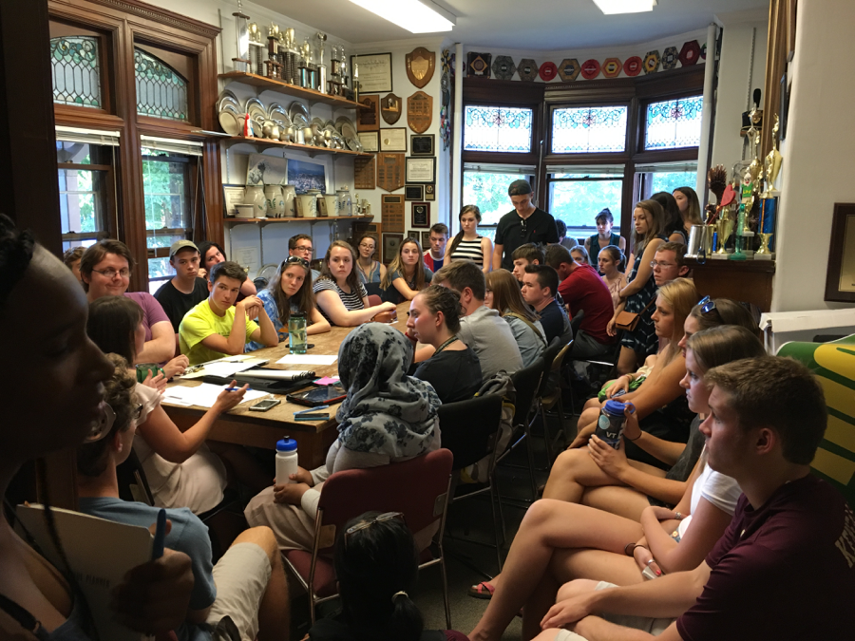

First meeting of the academic year.

New Program:
Speech & Debate is a newly formed program in the College of Arts and Sciences. Speech and Debate have long been a part of the UVM community, however, with the debate team in particular starting in 1899.

Alfred Tuna Snider:
The Speech & Debate Program continues to mourn the passing of its long-time leader, Alfred “Tuna” Snider, who passed away unexpectedly in December, 2015. The team expects to engage in numerous events throughout the year in order to honor his legacy, including the hosting of a tournament on his birthday weekend October 28-31.

Student Achievements:
The Lawrence Debate Union is proud to be the reigning national debate champions! Taylor Brough and Khalil Lee won the Cross Examination Debate Association National Championship tournament in March 2016. Taylor is now coaching debate and attending graduate school at Standford University. Khalil is now a graduate student and debate coach at Wake Forest University.

New Director named to the Speech & Debate Program:
Helen Morgan Parmett was named the Edwin W. Lawrence Endowed Professor of Forensics and an Assistant Professor in the Department of Theater. She is also Director of the Speech and Debate Program and the Lawrence Debate Union. She completed her B.A. at the University of Vermont (2000), graduating summa cum laude with a degree in Sociology and Political Science and a minor in Speech. While at UVM, she was an active member of the Lawrence Debate Union. After graduating, she completed her M.A. at the University of Pittsburgh (2002) in the Department of Communication Studies, with emphases in Rhetoric and Media Studies. After completing her M.A., she returned to UVM as a Lecturer and Assistant Debate Coach of the Lawrence Debate Union, where she coached the team to numerous novice, JV, and Varsity Championships. She received her Ph.D. from the University of Minnesota (2012) in Communication Studies with an emphasis on Critical Media Studies. Prior to coming to UVM, she was an Assistant Professor in Communication Studies at Western Washington University in Bellingham, WA (2012-2016).

Morgan-Parmett’s work centers on critical media studies, where she considers the role of media in struggles over social, cultural, economic, and political power, focusing on relationships between media and urban space, identity, branding, cultural policy, television studies, and production studies. Her research is invested in how media’s production practices (particularly those of radio, film, TV, interactive new media, and sports media) are materially implicated in urban spatiality and the constitution of place, especially in the production of racialized senses of place and the urban neighborhood.

New Partnerships:
SPEAK: SPEECH. PERSUASION. EDUCATION. ADVOCACY. KNOWLEDGE

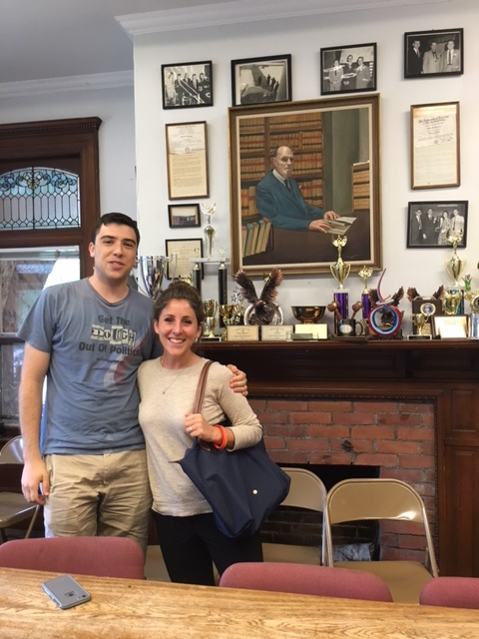 SPEAK is a non-profit organization partnered with the Vermont Law School and the Lawrence Debate Union at UVM started by UVM students Jessica Bullock (current executive director of SPEAK) and Luke Dodge (pictured). The SPEAK Vermont Prison Debate Initiative provides debate and public speaking training to increase educational opportunities and advocacy skills to incarcerated individuals. Together, UVM debate students and Vermont Law School students volunteer their time to assist students at three correctional facilities in the state to generate research, construct persuasive arguments defend their position, and hone their speaking and advocacy skills. Another LDU alum, Mariel Golden, has also spearheaded an international SPEAK program in Israel. We are proud to partner with SPEAK and all of the great work the organization is doing! You can learn more about SPEAK here: http://speaksolutions.wixsite.com/speak/find-programs

UPWARD BOUND

The LDU is embarking on a new partnership with Upward Bound starting this month. Spearheaded by LDU treasurer, Kierstin Brewton, members of the team will serve as tutors with local first-generation and low income high school students at their Saturday School, while others will mentor juniors and seniors from the local Burlington area. We are also hoping to start a debate training program to help the students with their public speaking skills, writing, and to have fun! You can learn more about UVM’s involvement in the Upward Bound program here: http://www.uvm.edu/upbound/. We are excited about this new partnership and the service opportunities it provides for our current students as well as the possibilities it provides in helping the LDU to do outreach to underserved communities.

Upcoming Events:
Huber Debate Tournament (open to the public)—Debates will be happening throughout campus all day Saturday and Sunday. Please join us for the tournament’s final debate, where the top teams from the tournament will compete for the championship title, at 4 pm on Sunday, October 30 in Marsh Life Sciences 235.

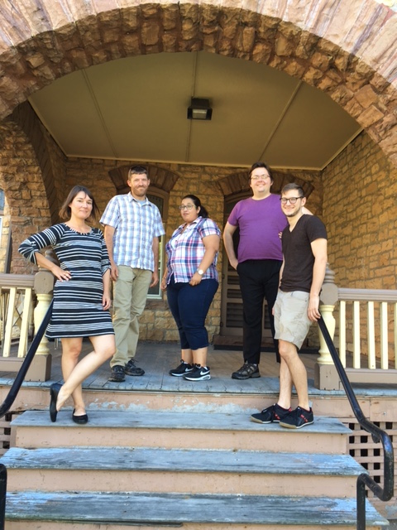

Speech & Debate coaches from left: Helen Morgan Parmett, Justin Morgan Parmett, Jillian Marty-Dushane, Duncan Crowe, and Luke Dodge. Bojana Skrt is not pictured. Justin, Luke, and Bojana are all friends of the Lawrence Debate Union and work as volunteer coaches.

Here, we highlight our core crew who will be helping to coach, watch practice debates, travel with the team, and provide all around support.

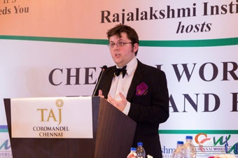 Duncan Crowe comes from Glasgow in Scotland. He has a degree in philosophy and psychology from Cambridge University and degrees in law and philosophy from the University of Glasgow. He reached the World Universities Debating Championship Final in 2014, and the European Universities Debating Championship Final in 2015, having been a Semi-Finalist of the latter in 2013. He has trained EUDC and WUDC breaking teams at the Universities of St Andrews and Glasgow. He judged the WUDC Final in Thessaloniki in 2016 and has judged outrounds at Oxford, Cambridge, EUDC, USU, PanAms, Hart House, Yale, NAUDC and Cape Town and is going to be the Chief Adjudicator of the 2018 EUDC in Scotland.

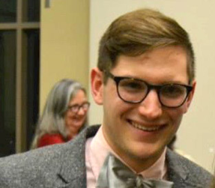 Luke Dodge was a member of the LDU for his entire four years at UVM. While there, he was a founding member of SPEAK, a non-profit organization that helps to teach debate to people in underserved areas like prisons and refugee communities. He recently graduated in May with degrees in Political Science and Economics, and wrote his thesis on post-secondary educational programming in the US prison system. He is currently serving as an A*VISTA Volunteer with the Vermont Affordable Housing Coalition and the Vermont Coalition to End Homelessness as the Communications and Outreach Coordinator for both coalitions. Luke looks forward to working with younger debaters to help them find the same home at the LDU as he did.

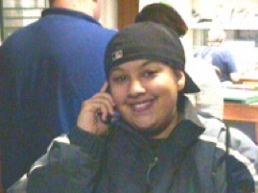 Jillian Marty-Dushane grew up in New York City and met debate while in high school through the New York Urban Debate League. She debated for the University of Vermont, was the Junior Varsity National Champion, won several varsity tournaments and reached the elimination rounds at CEDA Nationals. She got her MA from the University of Alabama and is currently completing her dissertation for her doctoral degree from the University of Massachusetts. She coached at Towson University with extraordinary success, with her team reaching the final round at CEDA Nationals and the elimination rounds at the National Debate Tournament. She is most recently the coach of the reigning CEDA Nationals Championship Team from the University of Vermont! She is a Yankee fan.

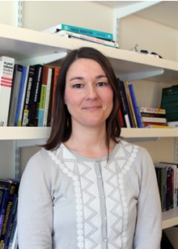 Helen Morgan Parmett (see complete bio on the first page) is the new Director of the Lawrence Debate Union. Helen is happy to be returning to the Huber House and the Lawrence Debate Union and, in particular, to help guide the team through this difficult transition and period of grief following the passing of her former coach and mentor, Alfred Tuna Snider. Helen looks forward to reconnecting with old friends and making new ones from the long green line!

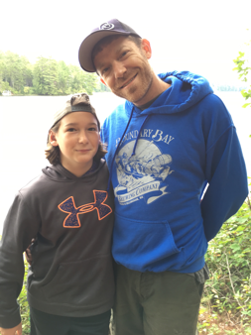 Justin Morgan Parmett is so excited to be back to volunteer for the LDU. Justin is a former LDU debater and assistant coach, having been the top speaker and champion of the East Region Championship Tournament, has coached multiple novice and JV national Champions (including current coach Jillian Marty) and has a real love for the LDU and its uniqueness throughout the debate universe. Justin received his Master’s Degree in Communication and coached debate at the University of South Carolina. He has also coached high school debate for the Minnesota Urban Debate League. He recently comes back to UVM after coaching debate and teaching at Western Washington University where he just coached the top and second speaker at the National Parliamentary Debate Association National Championship Tournament. When not at work, Justin enjoys biking, snowboarding, hiking and basically enjoying time outside with the family.

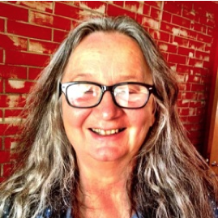 Bojana Skrt is director of Slovenian national debate organisastion Za in proti, zavod za kulturo dialoga where she serves as a coordinator for national high schools and middle schools debate clubs networks, responsible for fundraising, promotion, outreach, training and coordination of debate activities. She prepared and run numerous national and international debate projects and serves as a trainer for teachers and trainer of trainers. She funded and run two international training programs IDAS – International Debate Academy for university students and WSDA – Worlds Schools Debate Academy for high school students and co-funded the International Conference for Argumentation, Rhetoric, Debate and Pedagogy of Empowerment “Thinking and speaking a better world.” She has been a coach of Team Slovenia debating at Worlds Schools Debate Championships for the last 15 years – breaking 7 times in the last 10 years, three times winning the award for the best English Foreign Language or English Second Language Team. Bojana Skrt is also a co-author of two debate manuals and several articles about debate.

