The 2013 Phenology Field/Satellite Challenge
Let’s see if you can take some sample photos, and NDVI values from a corresponding location to quantify phenology.
We’ll start with some field measurements at a dense forest canopy just northeast of Shelburne Pond. We want to see how the Percent Open Canopy changed over the course of the spring.
- Install Gap Light Analyzer on your Windows XP (or earlier) machine.
- Download the 10 sample images from the SWAC download site.
- Using GLA, compute the canopy gap fractions for each photo.
- Record these in the xls. Template.

Now open the Pekko MODIS NDVI time series product: http://pekko.geog.umd.edu/usda/test/
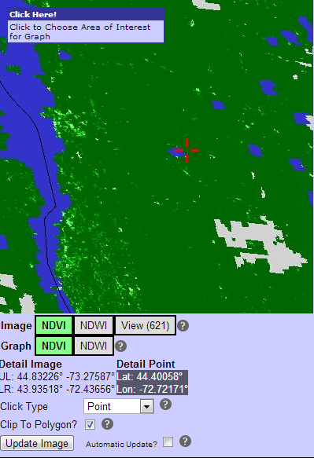
- Navigate to the US-Northeast and find a point close to the following coordinates:
Lat: 44.40058° Lon: -72.72171°
Note that this point is just northeast of Shelburne Pond.
- Graph the NDVI data values for 2011 at this point for each available date.
- Record these values in the .xls template

Now that you have all of your data entered and graphed, can you tell me…..
What is the predicted Start of Spring (SOS) based on your canopy metrics
What is the predicted Start of Spring (SOS) based on the NDVI values?
How does 2012 compare to the mean (2000-2013) mean phenology curve?
Was spring earlier or later than normal in 2012?

