Satellites Weather and Climate

MODULE 16:
Overview of Streams

Overview of Streams Module

Learning Objective – Introduce the fundamentals of fluvial (stream) geomorphology and how streams both respond to and influence watershed processes. We will focus on how streams and rivers adjust to changing environmental and climatic conditions over time by eroding and depositing sediments along the stream channel.
Rationale - Streams are dynamic landscape features continuously adjusting to local and watershed scale changes in discharge and sediment load. Driven by numerous stressors, including forest clearing, impervious area, draining of wetlands, encroachment, channelization, stream bank armoring, etc., stream dynamics are largely influenced by runoff during storm events. Adjustments involve changes in sinuosity, channel width, depth over time that in turn results in erosion (e.g. degradation) or aggradation of sediment and associated pollutants within the stream channel as the stream attempts to return to dynamic equilibrium with its inputs. Channel erosion in particular is an important but poorly quantified source of sediment to rivers and streams worldwide, contributing to water quality degradation, loss of agricultural lands, damaged infrastructure, inputs of sediment-bound nutrients to receiving waters, and decreased habitat health. The high cost and limited success of traditional engineering (e.g., armor banks, culverts, channelization) and historic land use management efforts, however, intended to promote agricultural development or reduce ecological and hazard risks posed by channel erosion has stimulated a change in river management over the past decade. This change is driven by improved understanding of underlying causal mechanisms of erosion and flooding operating at local and watershed scales and a change in how best to limit the associated risks (Kline and Cahoon, 2010). Vermont’s Agency of Natural Resources River Management Program (VT ANR RMP) has been a major lead in this initiative.

Suggested Model Sequence
- Lecture on streams and fluvial geomorphology (PowerPoint presentation provided).
- Activity - Photointerpretation of stream features using Google Earth.
  - Identify features indicative of stream adjustment in response to changing environmental conditions.
  - The lesson provided focuses on the Browns River but can be applied to any local stream or river.
  - Use Google Earth Placemarks to identify the location of stream features.
  - Save the Placemarks in GoogleEarth’s My Places to be viewed later by the instructor or create a Google Earth *.kmz file for each feature that can be emailed to the instructor.
    - Alternatively instructor review could be completed real time during lab period.
(Potential) Additional Activities
- Collect local ground photos of stream features near your school and link them to their associated Placemarks using Google Earth imagery.
- Walk the local stream to identify stream features in the field.
- Contact VT ANR River Management Program personnel to come to your class to discuss the VT fluvial geomorphic assessment program, or take a field tour of a local stream:
http://www.anr.state.vt.us/dec/waterq/rivers/htm/rv_geoassess.htm
- Use the History toolbar in Google Earth to view or map changes in channel boundaries over time.

Materials provided by Leslie A. Morrissey (UVM)

Streams Module Activity

Water is a powerful force of erosion. Give it enough time and it will reduce mountains or carve great canyons. Water moving across the surface of the earth – in the form of streams and rivers – provides drinking water and serves agricultural and industry needs, or can lead to disastrous floods modifying the landscape and destroying human infrastructure (e.g., buildings, roads). Streams are dynamic landscape features continuously adjusting to watershed scale changes in discharge and sediment load. Driven largely by storm events, these adjustments contribute (e.g. aggradation) or erode (e.g. degradation) sediment and associated pollutants from the stream channel while attempting to return to dynamic equilibrium.

Learning Goal - This module focuses on how streams and rivers adjust to changing environmental and climatic conditions over time by eroding and depositing sediments along the stream channel. Using Google Earth, students will identify stream features, processes, and adjustments discussed in lecture (*.pptx file provided).

Background information – An article by Kline and Cahoon (2010) describing Vermont’s fluvial geomorphic assessment program is provided that describes how land use and river management practices over the past two centuries are affecting water quality management decisions today.

Activity - Explore Stream Features on Google Earth
We will initially focus efforts on the Browns River in Chittenden County, Vermont. This exercise, however, could be readily adapted to any stream or river local to your school. The Browns River drains the western slope of Mount Mansfield before emptying into the Lamoille River which then drains to Lake Champlain. The river flows west through Underhill, Jericho, Essex, and Westford to the mouth of the river which is located in Fairfax. Land use and land cover is dominated by forests near the headwaters and agriculture along the floodplains. Soils are primarily comprised of very rocky loam, stony loam, and finer grained loams.
We will start by orienting ourselves where the Browns River drains into the Lamoille River near Fairfax. Launch Google Earth and enter (cut and paste) the following latitude and longitude coordinates using “Fly to”: 44° 39’ 29.85” N, 73° 01’ 06.94” W. Zoom in as needed. Browns River is the tributary that enters the Lamoille from the south (see figure on the next page). Alternatively, you could search on Fairfax, VT, zoom in and then pan to the southwest along the Lamoille River.
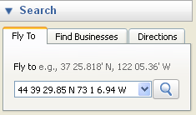
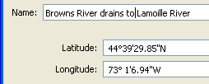

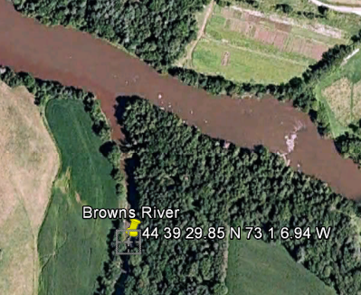
As you explore your way up the river (heading south and then east), see if you can identify the stream and channel features described in lecture. Zoom in and out as needed. As you identify features as part of the photointerpretation activity, you could pin a “Placemark” at each location you find and identify the pin by feature. To “pin” a site, click on the Placemark tool and then click on the location in Google Earth. A “New Placemark” window opens. Add a descriptive name of the stream feature and question number, for example, 1 - Point bar, and then click OK. Right click on the pin to Delete, Rename or view its Properties. When the Properties dialog is open, you can move the pin by left clicking on it with the mouse and dragging it to a new location, change the pin icon, or add URL links to descriptive sites or ground-based digital photos.
Each Placemark can be saved to My Places by choosing File/Save/Save My Places. Saved Placemarks will again be available the next time for that particular computer. Alternatively, right-click on a single Placemark and choose Save Place As. This will allow you to save the Placemark to your hard disk in a *.kmz formatted file which can then be emailed or shared via a web site and then opened on anyone’s Google Earth page by clicking on File/Open/ and then selecting the appropriate file.

- As you peruse the Browns River on Google Earth, identify (photointerpret) the following stream features:
    - stream crossings (road, bridge, RR)
    - tributary
    - straightened channels
    - meanders
    - meander oxbow
    - meander scars
    - point bar
    - cutbank
    - bank armor
    - agricultural ditches
    - bedrock
    - dam
    - covered bridge (near Westford)
    - old historic mill on the river (Jericho)

Now that you are a bit more familiar with the river and channel features of Browns River, answer the following questions based on your assessment of the imagery:

- Identify the left and right banks of Browns River.
- Can you see the thalwag in the imagery? If not, how do you know where it is in a meander?
- Sinuosity is a measure of how curvy the river is (defined as stream length/straight line length) and inversely reflects the power of the stream (e.g., less power = more sinuous). Based on the figure below, find areas in the river which represent low, moderate, and high sinuousity.
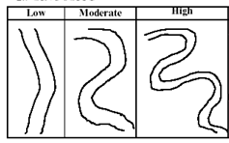

- Bank erosion is often greatest when the stream is incised, i.e. stream banks are vertical, and lowest when the bank heights are low. Find an example of a steep, high bank and a low bank.
- Would it be better to build a house on the inside or outside of a stream meander?
- Why does a point bar form only on the inside of a stream meander curve?
- Can you identify houses or buildings that appear to be in danger from lateral river migration?
- How can you date the age of depositional point bars?
- Using the “ruler” tool (under the Tools tab), select a meander with an oxbox and measure how far (report as meters per year) the stream has moved over time? Repeat this at at least one additional site along the river.
- Development that is located within 100 feet of a stream is defined as “encroachment”.
Can you find evidence of encroachment?
- Riparian buffers (particularly forested buffers) along the stream filter pollutants, provide shade to cool water temperatures, reduce bank erosion, and provide habitat, recreation, and natural beauty. Riparian buffers can be composed of trees, shrubs, and grasses. A buffer with trees is far less likely to erode than a grass covered buffer (shrubs fall between trees and grass). The worst case is when there is no riparian vegetation and the soil is bare (exposed), e.g., a cultivated field adjacent the stream. Examine riparian buffers along the Browns River and identify buffers composed of different vegetation types.
- Compare the width of riparian buffers around streams (US Natural Resources Conservation Service recommends a minimum 100 foot buffer). Locate a site where the buffers are adequate (>100 feet)? Locate a site where they are absent or too narrow? If buffers offer so many advantages, why might land owners resist in developing them?
- Now use the “History” tool to examine the movement of the river over time.
Check out the river at this location using these coordinates and the “Fly to” panel:
44°30'50.17"N 72°58'58.41"W
Zoom in as needed. A slider bar should appear below the History tool. Move the slider to view older imagery - compare 2004 and 2012 imagery. Note image spatial resolution and time of acquisition (leaf on vs. leaf off) dramatically affects photointerpretation.
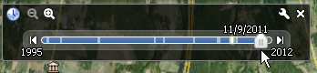
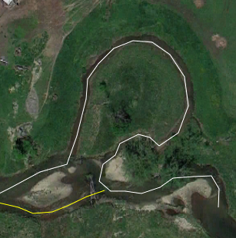
Use the Path tool to trace the center of the river in the most recent 2012 imagery and then examine that stream segment on the 2004 imagery – you might have to digitize the water centerline as two paths (shown in the figure as white and yellow lines). If needed, right-click on the Path and open its Properties dialog box to edit the path if needed, including adjusting boundary locations. Use the pointing finger icon, not the square cross-hairs icon to adjust the boundary. Note how the stream’s path has changed over time.
- Even the erosive power of water cannot erode bedrock except on geologic time frames. Identify sites where bedrock is visible at the surface.
- The channel bed material is classified as bedrock, boulder, cobble, coarse gravel, fine gravel, and sand or smaller). Try to differentiate the channel bed material on the imagery where possible. Which of the material size classes can you differentiate on the imagery?
Size Class | Millimeters | Inches | Relative Size
Bedrock | > 4096 | > 160 | Bigger than a VW bug
Boulder | 256 - 4096 | 10 - 160 | Basketball to VW bug
Cobble | 64 - 256 | 2.5 - 10 | Tennis ball to basketball
Coarse gravel | 16 - 64 | 0.6 – 2.5 | Marble to tennis ball
Fine gravel | 2 - 16 | 0.1 – 0.6 | BB to marble
Sand or smaller | < 2 | < 0.1 | Smaller than a BB

- Areas with shallow water depth, abundant point bars, unvegetated bars in the middle of the channel, debris jams, and where much of the channel bed is exposed are indicative of channel aggradation (deposition). Depositional features are found in areas with low, flat slopes or when the slope changes quickly from steep to flat. Find areas within the river channel that are dominated by aggradation.
- Besides erosion, deposition, planform change (lateral channel movement), channels also adjust by increasing in width or depth. As the banks collapse, the stream becomes wider and shallower. A wider and shallower channel does not have the same capacity to transport sediment so sediment builds up in the channel. Locate sites where the channel appears to be widening.

Prepared by Leslie A. Morrissey (UVM)

