Chasing Hurricane Andrew
A Google Earth Exploration

By Mike Burris, Faculty
Champlain Valley Union High School, Hinesburg, VT
mburris@cvuhs.org

Teacher Summary

The objective of this activity is to teach students how to use Google Earth while exploring hurricane dynamics, tracking, and reporting. Students will track Hurricane Andrew for a period of 6 days. They will plot the track of the hurricane on Google Earth and use Google Earth tools to make decisions about when and where to issue hurricane watches and warnings. Throughout the activity students will answer questions about the hurricane.

Upon completion of this activity, students should be able to use Google Earth to track a current tropical cyclone, make predictions about potential movement, and determine when and where hurricane watches and warnings should be issued.

Content for this activity comes from:

Ford, Brent A. "Chasing Hurricane Andrew." Project Earth Science: Meteorology. Arlington: National Science Teachers Association, 2001. Print.

Background

Hurricanes are the most destructive storms on Earth. They develop from tropical storms (cyclones) and are classified as hurricanes when their winds reach 74 mph. Hurricanes include a small, central region known as the eye, where winds are light an there are few clouds. Moving out from the eye, a narrow band of intense thunderstorms, heavy rains, and strong winds are encountered. This band is called the eye wall. Beyond the eye wall are strong but diminishing spirals of the same weather. Hurricanes are huge storms. Typically they are about 350 miles in diameter, and they usually last for a week or more.

Hurricanes contain tremendous amount of energy. They gather this energy from warm ocean waters in the tropics. As the warm, humid air rises, it cools and condenses, releasing heat (called latent heat). This warms the surrounding, making it lighter and causing it to rise farther. As the warm air rises, cooler air flows in to replace it, causing wind. This cooler air is warmed by the ocean, and the cycle continues. The heat from the warm ocean water is the fuel that hurricanes run on. For this reason, hurricanes diminish and die when they move inland or move into colder water.

In addition to high winds (gusts up to 192 mph) and torrential rains, hurricanes produce what is known as a storm surge. The circular winds, together with the low-pressure eye and high pressure outer regions of a hurricane, create a mound of water in the center of a hurricane. The storm surge causes considerable flooding and is responsible for most hurricane damage and deaths.

Weather satellites in orbit above the Earth can easily detect hurricanes. Satellite data, along with data from radar and aircraft, is used to follow developing hurricanes. Through tracking we can tell where a hurricane has been. We can also estimate where it will go in the near future. When it appears that a hurricane is moving toward land, the National Weather Service (NWS) issues hurricane watches and warnings. A hurricane watch means that hurricane conditions are likely in the watch area within 36 hours. A hurricane warning means that these conditions are likely within 24 hours. People living in low coastal areas that could be affected by a storm surge need to evacuate as soon as watches and warnings are issued.

In August 1992, Hurricane Andrew caused a tremendous amount of human suffering and billions of dollars in damage in the Bahamas, the southern tip of Florida, and parts of Louisiana. This hurricane was unusual because it struck the United States twice. After coming ashore in Florida, it passed over the Gulf of Mexico – regaining strength in the warm Gulf waters – then hit the coast of Louisiana. This activity contains the actual tracking data collected on Hurricane Andrew.

Procedure

- Included in this packet is the data set from Hurricane Andrew. It includes the following information:
  - Date/Time: Data was collected on Andrew every 6 hours beginning August 16 through August 28. Only a portion of data is presented here. Time is given in military time; for example, 1200 is 12:00 noon, and 1800 is 6:00 pm.

  - Position: This is the position of the eye of the hurricane by latitude and longitude. It is important to remember that the storm is much bigger than the eye about 65 miles in all directions.

  - Wind speed: Wind speed is given in miles per hour (mph).

- Plot the data for Hurricane Andrew on Google Earth.

  - Open Google Earth.
  - Select the “Placemark” tool.

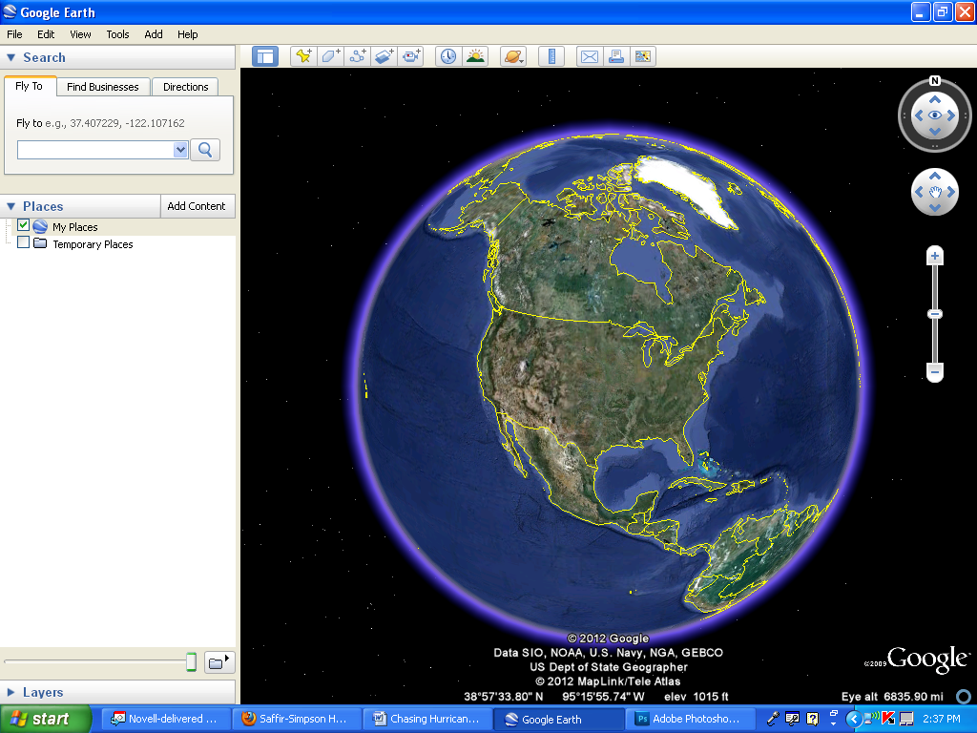

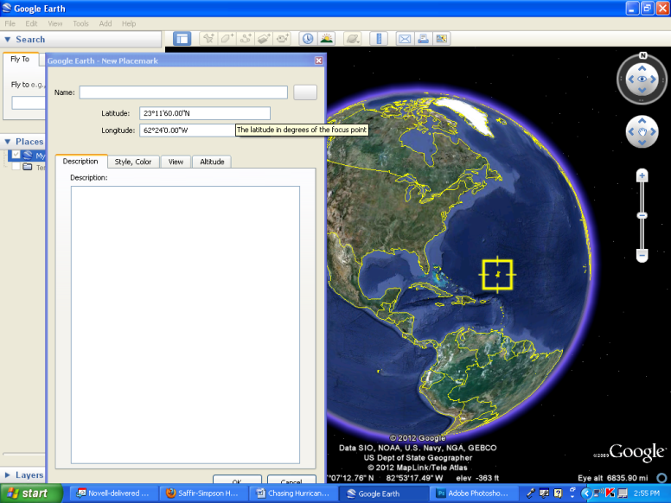
  - First, delete the “Untitled Placemark” from the name and leave it blank. Locate Aug 21/0000 on the first set of Hurricane Andrew data (see next page) and transfer the latitude and longitude coordinates to Google Earth. Google Earth will convert so don’t worry if the coordinates change when you enter them.

In the description box, record the date/time and wind speed.

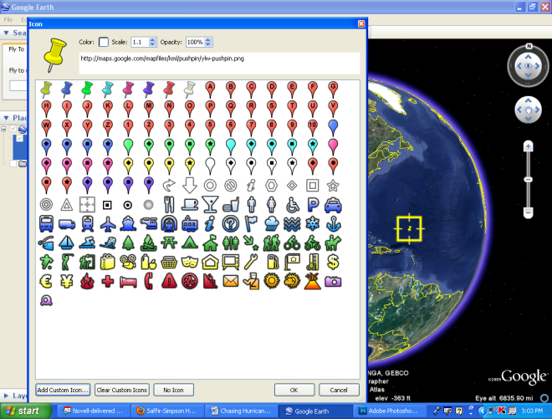
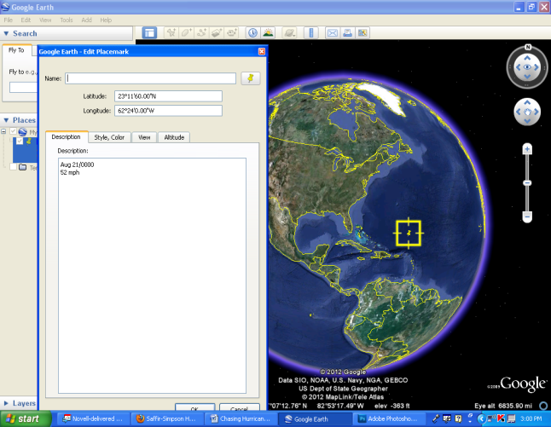
  - Select the icon button. At the bottom of the screen, select
“Add custom icon”

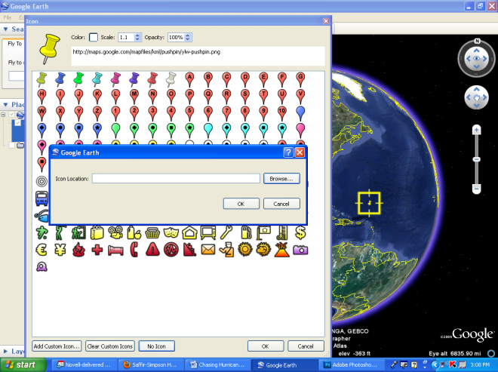
Also included in this packet are custom icons for different hurricane categories. Based on the current wind speed, choose the appropriate icon. Either cut and paste, or type the url address into the location box.
Click ok.
Note: To edit any placemark, right-click on the point in the Places menu and select “Properties.”

  - Continue this process for each point through Aug 23/0000. Make sure you select the correct icon based on the current wind speed.

Date/Time | Position |  | Wind Speed  (mph)
 | Lat. (°N) | Lon. (°W)
Aug 21/0000 | 23.2 | 62.4 | 52
0600 | 23.9 | 63.3 | 52
1200 | 24.4 | 64.2 | 58
1800 | 24.8 | 64.9 | 58
Aug22/0000 | 25.3 | 65.9 | 63
0600 | 25.6 | 67 | 69
1200 | 25.8 | 68.3 | 81
1800 | 25.7 | 69.7 | 92
Aug 23/0000 | 25.6 | 71.1 | 104

Use the ruler tool to figure out how far the hurricane moved from Aug 22/0000 to Aug23/0000.

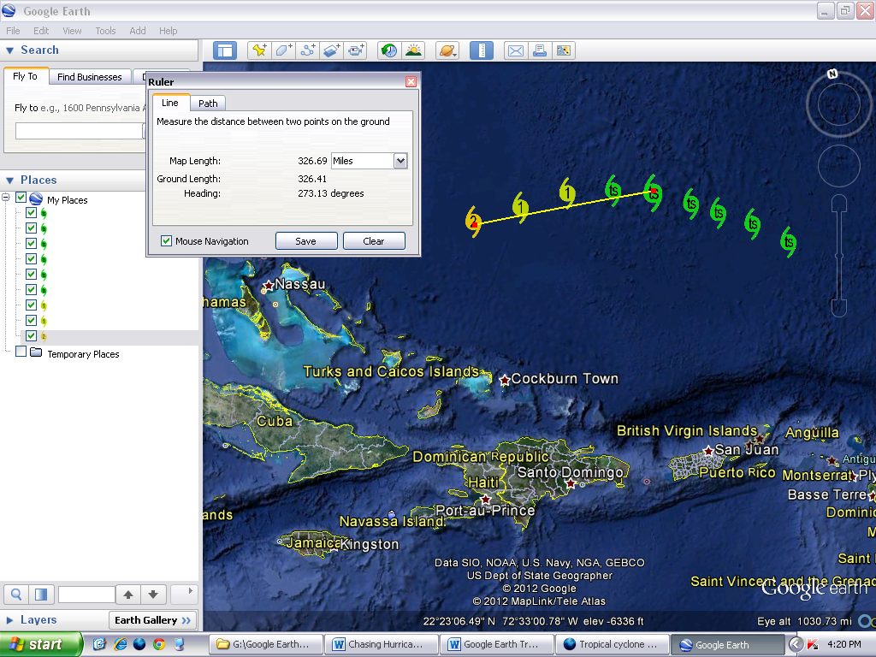
Select the ruler tool. Make sure it is set to miles. Place the marker on the first point. Left-click and release. Then move the marker tool to the second point and left click again.

Note: Make sure that all of your ‘placemarks’ are lining up under My Places and not under temporary places.

Question #1

Based on how far the hurricane moved in the last 24 hours and its direction so far, for which locations would you issue warnings or watches?

Continue to plot the movement of Hurricane Andrew for the next 24 hours.

Date/Time | Position |  | Wind Speed  (mph)
 | Lat. (°N) | Lon. (°W)
Aug 23/0600 | 25.5 | 72.5 | 121
1200 | 25.4 | 74.2 | 138
1800 | 25.4 | 75.8 | 155
Aug 24/0000 | 25.4 | 77.5 | 145

Question #2

Based on how far the hurricane moved in the last 24 hours and its direction so far, for which locations would you issue warnings or watches? Remember to use the ruler tool.

Continue to plot the movement of Hurricane Andrew for the next 24 hours.

Date/Time | Position |  | Wind Speed  (mph)
 | Lat. (°N) | Lon. (°W)
Aug 24/0600 | 25.4 | 79.3 | 138
1200 | 25.6 | 81.2 | 127
1800 | 25.8 | 83.1 | 132
Aug 25/0000 | 26.2 | 85 | 132
Question #3

Based on how far the hurricane moved in the last 24 hours and its direction so far, for which locations would you issue warnings or watches? Remember to use the ruler tool.

Continue to plot the movement of Hurricane Andrew for the next 24 hours.

Date/Time | Position |  | Wind Speed  (mph)
 | Lat. (°N) | Lon. (°W)
Aug 25/0600 | 26.6 | 86.7 | 132
1200 | 27.2 | 88.2 | 132
1800 | 27.8 | 89.6 | 139
Aug 26/0000 | 28.5 | 90.5 | 139

Question #4

Based on how far the hurricane moved in the last 24 hours and its direction so far, for which locations would you issue warnings or watches? Remember to use the ruler tool.

Continue to plot the movement of Hurricane Andrew for the next 24 hours.

Date/Time | Position |  | Wind Speed  (mph)
 | Lat. (°N) | Lon. (°W)
Aug 26/0600 | 29.2 | 91.3 | 132
1200 | 30.1 | 91.7 | 92
1800 | 30.9 | 91.6 | 58
Aug 27/0000 | 31.5 | 91.1 | 40

Question #5

Based on how far the hurricane moved in the last 24 hours and its direction so far, for which locations would you issue warnings or watches? Remember to use the ruler tool.

To save your file, right-click on “My Places” and select “Save Place As.” This is the only way you can save your file.
Questions and Conclusions

- Describe the movement/direction of the storm displayed on your map from beginning to end.

- Where did Andrew do the most damage before striking Florida?

- What happened to the direction of Andrew after it hit Louisiana?

- What happened to the wind speed in Andrew once it came aground in Louisiana? Why did this happen?

- Judging from the wind speed, when did Andrew become a hurricane and when was it downgraded to a tropical storm?

- In terms of damage done, why was it so devastating for Andrew to hit the southern part of Florida? Why might it have been less destructive if it had hit farther north; for instance, Georgia or South Carolina?

- Why is satellite technology so important in analyzing storm intensity, velocity and direction?

Appendix 1.

Tropical Cyclone Custom Icons for Google Earth

http://www.srh.noaa.gov/gis/kml/hurricanetrack/hurrimages/td.gif Tropical Depression
http://www.srh.noaa.gov/gis/kml/hurricanetrack/hurrimages/ts.gif Tropical Storm
http://www.srh.noaa.gov/gis/kml/hurricanetrack/hurrimages/h1.gif Category 1
http://www.srh.noaa.gov/gis/kml/hurricanetrack/hurrimages/h2.gif Category 2
http://www.srh.noaa.gov/gis/kml/hurricanetrack/hurrimages/h3.gif Category 3
http://www.srh.noaa.gov/gis/kml/hurricanetrack/hurrimages/h4.gif Category 4
http://www.srh.noaa.gov/gis/kml/hurricanetrack/hurrimages/h5.gif Category 5

Saffir-Simpson Scale

