Money and
the Federal Reserve System

Learning Objectives:

- Examine the role of money in the economy.

- Describe the structure of the Federal Reserve System.

- Describe the goals of Federal Reserve Monetary Policy.

- Explain the supervisory and regulatory authority of the Federal Reserve.

- Describe the services provided by the Federal Reserve to depository institutions.

What is Money?

What Are the Forms of Money?

Where Does It Come From?

Money Supply

Several different measures of money have been developed to accommodate the diversity of bank accounts and other payment mechanisms.

M1: cash and transactions accounts
- Currency in circulation
- Transactions-account balances (checking accounts, demand deposits, and other accounts that permit direct payment to a third party (by check or debit card)

M2: M1 plus savings accounts, etc.
- balances in savings accounts,
- money market mutual funds, and
- CD time deposits of less than $100,000

Creation of Money
Currency must be printed:
In the U.S., currency is printed by the Bureau of Engraving and Printing. Coins come from the U.S. mints in Philadelphia and Denver.

Deposit creation:

Transaction-account balances are a large portion of the money supply. Banks can create transaction-account balances by making loans. The money appears in the borrower’s account and the borrower is free to spend that money as with any cash deposit.

Factors Affecting Interest Rates

The supply of money saved is primarily the total money that is placed in demand deposit (checking) accounts, savings accounts, and money market mutual funds.

The demand for borrowed funds is all of the money that is demanded in our economy at a given price.

U.S. Government Securities

The U.S. Treasury manages the federal government’s debt in order to balance the flow of funds into and out of the Treasury.

When budget deficits occur, the Treasury sells short and long-term securities to finance the shortfall.

During times of budget surplus, the Treasury retires, or pays off, debt.

When the government needs to borrow, it competes with other sectors of the economy, driving up interest rates.

U. S. Treasury Bills, Notes, and Bonds

- T-bills (or treasury bills) are risk-free investments that mature in less than one year, typically in three or six months.
- T-notes are bonds that mature in ten years or less, typically ten-years, five-years and two-years.
- Federal bonds mature in periods that are greater than ten years and range up to thirty years.

Federal Reserve System

- The central bank of the United States.

- 12 Federal Reserve Banks located in major cities across the country.

- The Board of Governors – appointed by the President and confirmed by the U.S. Senate to serve 14-year terms. Two members are designated and confirmed to serve as Chairman and Vice Chairman for 4-year terms.

- The Federal Open Market Committee formulates monetary policy (7 members from the Board of Governors and 5 Reserve Bank presidents).

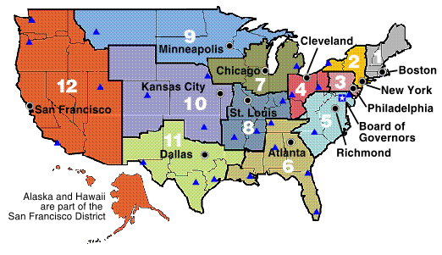
http://www.federalreserve.gov/

Federal Reserve

Monetary Policy

The Federal Reserve influences the economy through its effect on the quantity of reserves that banks use to make loans.

- The Fed’s tasks are to:

  - Support an adequate amount of money and credit for the needs of the economy

  - Avoid excesses that result in rising inflation

  - Avoid shortages that stifle economic growth and lead to rising unemployment

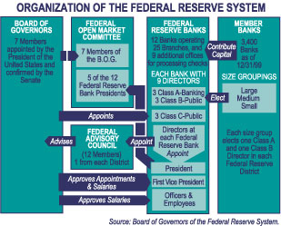
Federal Reserve Statistical Release H.15

The “H15” is the official source for index values for most Adjustable Rate Mortgages.

Table 1. Money Rates, as of April 12 and July 9, 2004, respectively.
Type of Rate | Definition | April 12, 2004 |  | July 8, 2004
Type of Rate | Definition | Rate (% per annum)
Discount | The charge on loans to depository institutions by the New Your Federal Reserve Bank | 2.00 | 2.25
Federal Funds | The rate banks charge each other for overnight loans in minimum amounts of $1 million | 1.01 | 1.26
T-bill, three months | The rate on government treasury bills sold at a discount of face value in units of $10,000 | 0.93 | 1.25
Prime | The interest rate that commercial banks charge their most creditworthy customers | 4.00 | 4.25

Source: Federal Reserve Statistical Release H.15 – April 12, 2004, and July 9, 2004

Discount Rate: the interest rate that banks pay to borrow reserves from Federal Reserve Banks
- Reserve Banks establish discount rate every two weeks.

Reserve Requirements: the percentages of deposits banks must hold in vault cash or at a Reserve Bank.
- The Board of Governors sets reserve requirements, but changes them only rarely.

The Fed Funds Rate is the target rate of the FOMC.
- The Fed buys government securities in the secondary market, increasing reserves in the private banking system.
- If private banks use these reserves to make loans, the supply of credit increases, and short-term interest rates fall.
- The Fed continues purchases until the Fed Funds rate reaches the target rate.
- To raise interest rates, the Fed sells government securities, reducing reserves in the banking system and decreasing the supply of credit.

Policy actions that add reserves back into the banking system:
- Stimulate growth in money supply, credit, and the economy
- Encourage lending at lower rates.
Policy actions that absorb reserves work in the opposite direction.
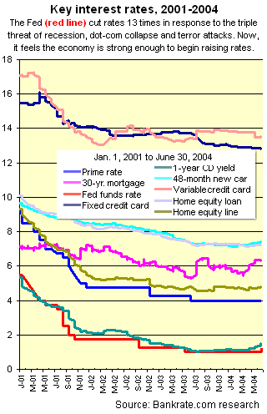
Monetary Policy (continued)

The Federal Reserve, especially under Chairman Alan Greenspan’s leadership, strives to eliminate inflation by holding money growth in check.

Price stability leads to:

- higher employment,
- stronger growth, and
- balance in international accounts.

The conventional wisdom holds that the Federal Reserve influences short-term rates much more than it influences long-term rates.

- Long-term rates are more susceptible to market forces.

- Not all rates move in lock step with the Fed, which influences short-term rates when it changes the fed funds rate. Mortgage rates, which are long-term debt, are more aligned to moves in the long-term bond market and are less affected by changes in Fed policy. Other products, such as credit cards, have built-in delays before they reflect Fed actions.

Federal Reserve

Supervisory and Regulatory Authority

- Field examinations and inspections of state-chartered banks, bank holding companies, and foreign bank offices.

Purpose of Bank Regulation:

- consumer protection

- systemic risk

- moral hazard from government guarantees

Federal Reserve
Depository Institution Services

Currency and Coin – Federal Reserve Banks distribute currency to depository institutions to meet public’s need for cash.

Check Processing – the Federal Reserve serves as a central check-clearing system.

Wire Transfers – The Federal Reserve Banks and about 7,800 depository institutions are linked electronically through a network that can transfer funds nationwide in a matter of minutes.

Automated Clearinghouses – Computerized facilities that allow for electronic exchange of payments (generally, recurring) among participating institutions.

Bankrate.com, accessed on July 13, 2004 at http://www.bankrate.com/gookeyword/news/fed/20010627e.asp

