SHOP GREEN
San Ignacio, Belize

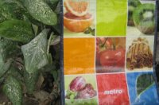

Applications of Sustainable Development
Galen University
Spring 2010

Report Compiled By:
Lisette Augilar, Caitlin Blouin, Ramon Carcarmo, Kathryn Debs, Winter Heath
TABLE OF CONTENTS

ACKNOWLEDGEMENTS..................................................................... p.3

INTRODUCTION................................................................................... p.4

BACKGROUND..................................................................................... p.4

PROBLEM STATEMENT....................................................................... p.5

METHODS.............................................................................................. p.6
1.) MICRO-GROUPS.................................................................. p.6
2.) SURVEYS.............................................................................. p.7
3.) SELLING BAGS.................................................................... p.7
4.) SOURCING BAGS................................................................ p.8

RESULTS................................................................................................ p.10

RECOMMENDATIONS......................................................................... p.13

WORKS CITED...................................................................................... p.14

APPENDICES.........................................................................................
A) PROJECT PROPOSAL.......................................................... p.15
B) LITERATURE REVIEW........................................................ p.19
C) ENGLISH SURVEY............................................................... p.28
D) SPANISH SURVEY................................................................ p.31
E) FLYER FOR MARKET.......................................................... p.34
F) HOW TO CREATE A COIN PURSE..................................... p.35
G) HOW TO SELL BAGS..................................................... ..... p.43
H) EDUCATIONAL DISPLAY................................................. p.54

Acknowledgments:
Shop Green would like to acknowledge our project partners Ms. Cynthia Reece and Dr. Colin Young from Galen University. They have been enthusiastic about this project since is was proposed and Dr. Young gave Shop Green sound advice throughout the semester about where to find a source for bags and recommendations about survey writing. Ms. Reece spread the word about our project and sold bags at her Rotary Club. We appreciate your support through out the semester and thank you very much.

We would also like to acknowledge our other project partner and professor Ms. Joni Miller. Without her idea, this project would not exist. Ms. Miller brought the initial 50 bags down from Canada which was a huge help. She also worked very closely with us when we hit some low points in the semester and got us back up again. We thank you very much

Shop Green would also like to acknowledge the student body of Galen University. You were very generous with donations and purchasing bags throughout the semester. You supported this project from day one and gave us valuable feedback from surveys so we could better understand what different demographics looked for in a reusable bag.

We would also like to acknowledge Sacred Heart Interact club members who responded enthusiastically to our project, and we only wish we had had more time to work together; however, we have high hopes for the sustainability of the project as the Sacred Heart and Caye Caulker Ocean Academy Interact Clubs continue promoting Shop Green.

Introduction:

The application of sustainable development in addressing real issues in any community requires three major operational criteria. These are the economic, social and environmental factors that are interrelated. One of the significant issues of concern is the management of solid waste in Belize. The increase in consumer supply and demand has stimulated innovative technology to invent synthetic materials such as plastics to satisfy our needs. It has been observed that shopping plastic bags has significantly increased in the Belizean domestic market which has become a nuisance and pollutant. Sustainable development is a significant pillar of Galen University which has stimulated the implementation of several projects that have addressed several economic, social and environmental issues. The Shop Green project was a project that was developed during the Application of Sustainable Development course. The project has four main objectives which were to reduce excessive disposable plastic bags, educate the public of the negative impact of plastic bags on the environment, raise funds to support environmental education programmes and develop a business plan that can be replicated. Therefore, the approach was to introduce a reusable bag that was attractive, strong and reusable. The main players of the project were students from Galen University, Sacred Heart Interact Club, Caye Caulker Ocean Academy. The Sustainable Development Committee of Galen University was also an important institutional support. Several meetings were held to organize logistics in the preparation of project activities. Some of the activities were selling of “Shop Green” bag, conduct surveys, data analysis, consultation with stakeholders and documentation of the project.

Organization Background
Project “Shop Green” was developed as an initiative at Galen University to be implemented during one semester. Sustainable Development has been one of the major pillars of Galen University therefore 5 students that were enrolled in the course of Application of Sustainable Development were engaged in the implementation of the project. The different strengths and special skills of each individual were the major tools used. The team was guided by qualified lecturers of the course.

Problem Statement:
Plastic bag pollution is a prevalent issue worldwide. As the Worldwatch Institute (n.d.) stated, “Plastic shopping bags are among the most ubiquitous consumer items on Earth. It’s hard to imagine life without them.” Produced in the trillions each year worldwide (W.I., n.d.), these icons of a throwaway culture can find their way into fragile ecosystems—particularly marine habitats—and threaten the health and safety of animals and even humans (Love Your Earth, n.d.). For this, Belize is no exception. Despite its small population of just over 300,000 (Central Intelligence Agency [CIA], 2010), Belize has its fair share of environmental problems—including plastic bag pollution.

As stated by 5 Gyres, “The short-term convenience of using and throwing away plastic products carries a very inconvenient long-term truth” (n.d.). This “inconvenient long-term truth” refers to the rate at which plastic bags degrade. Bags that are discarded and do not make it to the landfill can blow into natural environments and cause substantial damage. Once there, the rate at which plastics are able to breakdown can take up to 1,000 years in some cases (ReusableBags.com, n.d.).

Marine ecosystems are one of the natural environments negatively impacted by plastic bags. With 386 kilometers of coastline (CIA, 2010), Belize marine habitats are exposed to many of the negative effects of plastic bags. The Environmental Literacy Council noted that marine life is threatened by plastic bags because many animals mistake them for food—such as sea turtles which confuse plastic bags with jellyfish (2008). When ingested by animals, plastic bags can cause internal blockages, starvation, and even death (5 Gyres, n.d.).

Another issue associated with plastic bag waste is bioaccumulation, or the buildup of toxic substances in organisms in a food chain (U.S. Geological Survey, 2006). As plastics float in bodies of water, sunlight breaks them down into microscopic pieces. These fragments are then consumed by marine wildlife. Currently scientists are unsure of the direct effects of this, but some suggest that as the chemicals work their way up the food chain, they build higher and higher levels of toxicity and eventually make their way to human consumption (5 Gyres, n.d.). This could pose a potential threat to human health and safety.

Lastly, plastic bags can disrupt the visual nature of Belize’s unparalleled beauty. No one wants to see plastic bags on roadsides, in trees, or washed up on shores. This, along with the number of other problems linked with plastic shopping bags, is what Shop Green hopes to impact. Our project is looking to reduce the presence of these popular shopping companions in surrounding Belize communities and therefore diminishing the environmental and social impacts associated with them.

Methods:
- Micro-Groups
At the beginning of this project we decided, as a group, that we should work together to accomplish our goals. We decided what we were going to do and how to execute our plan for this project. As weeks passed, we figured out that this was not working for us, as a whole. We had a meeting and decided to break up the group and have individual members take on certain aspects of the project because we were not getting anything accomplished by moving as a large group.

Ramon Carcarmo was to find a source of reusable bags in Belize and to contact them. He went to the Belize Audubon Society because they were selling reusable bags. This did not work out because the source is from the United States and that was not what we were looking for. Our group also discussed contacting an upper-end grocery store in Belize to see where they sourced their bags from. This also ended up being a dead end.

As an alternative to just buying a bunch of reusable bags we thought it might be a good idea to have something that the students at Sacred Heart Interact Club could make. Lisette Aguilar is very talented and creative with design ideas so she made some alternative designs for the group to show to the kids. We also decided that if we did not have enough time with the kids at Sacred Heart, that it would be good to have a step-by-step manual of how to make the reusable bag. This is documented so the kids can make their own.

Surveys were a huge component to this project. Kate Debs took the initiative to compile all of the surveys collected and enter them in a data sheet to make graphs and breakdown the data needed to find a price point and to generally see if the community was interested in reusable bags.

Winter Heath compiled educational facts for the educational displays. We knew that we all could not make posters at the same time so Winter also created and designed the posters that were used at the market. These posters highlighted facts that showed how plastic bags were detrimental to the environment.

Caitlin Blouin created and designed the educational displays that will be used by Sacred Heart Interact Club and Ocean Academy Interact Club. These displays show pictures of how plastic bags have a negative impact on the environment along with facts. Caitlin made the flyer for the market along with compiling the literature review and report.

2.) Surveys
We needed a way to get feedback from the community in order to find out if this project would be successful or not. We compiled a survey in both English and Spanish to see what people thought about the idea of reusable bags and to get a price point. The surveys were written by our group and were given to Jeff Frank and Dr. Colin Young to make sure they were well written and not biased and to offer suggestions. The surveys were then dispersed to every member of the group and brought to many local businesses in San Ignacio along with friends and family members. Surveys were also conducted at Galen University so we could see how younger people would respond to the reusable bag.

Feedback from all the surveys was entered into a spreadsheet. From looking at the responses from people we were able to decide that the price point should be $10 a bag. We also saw that people were generally interested in purchasing a reusable bag and that there was a general consensus that there was a big problem in the community with plastic bags everywhere. Many people who filled out the survey eventually purchased a reusable bag from the group.

3.) Selling Bags
One of our goals we wanted to accomplish was to sell all of the bags that we had given to us by Joni Miller. We did this by setting up tables at Galen University and at the market on a Saturday morning. Both of these locations worked great for our group. We sold over 20 bags at the market in one morning.

At the market we set up a table with a banner that said ‘Shop Green’ and had two educational displays with facts about plastic bags. The displays also had many pictures of animals consuming plastic bags and of rivers littered with them. We used these displays to get people’s attention. We also had surveys there for people to fill out so we could see what a different demographic thought about reusable bags.

We also went around to local businesses such as Martha’s Inn and Torres’ Bakery because we went there for the survey and and every single person purchased a bag. People from our group also took bags home to friends and family to have them purchase. Lisette also took 15 bags to a women who wanted to sell them for us at her own business.

4.) Sourcing Bags
This was probably the most difficult part of the project. We were given 50 reusable bags from Canada that Joni Miller brought down with her. We wanted to find a sustainable source here in Belize, but soon found that impossible. We tried a few different routes but they all came to dead ends.

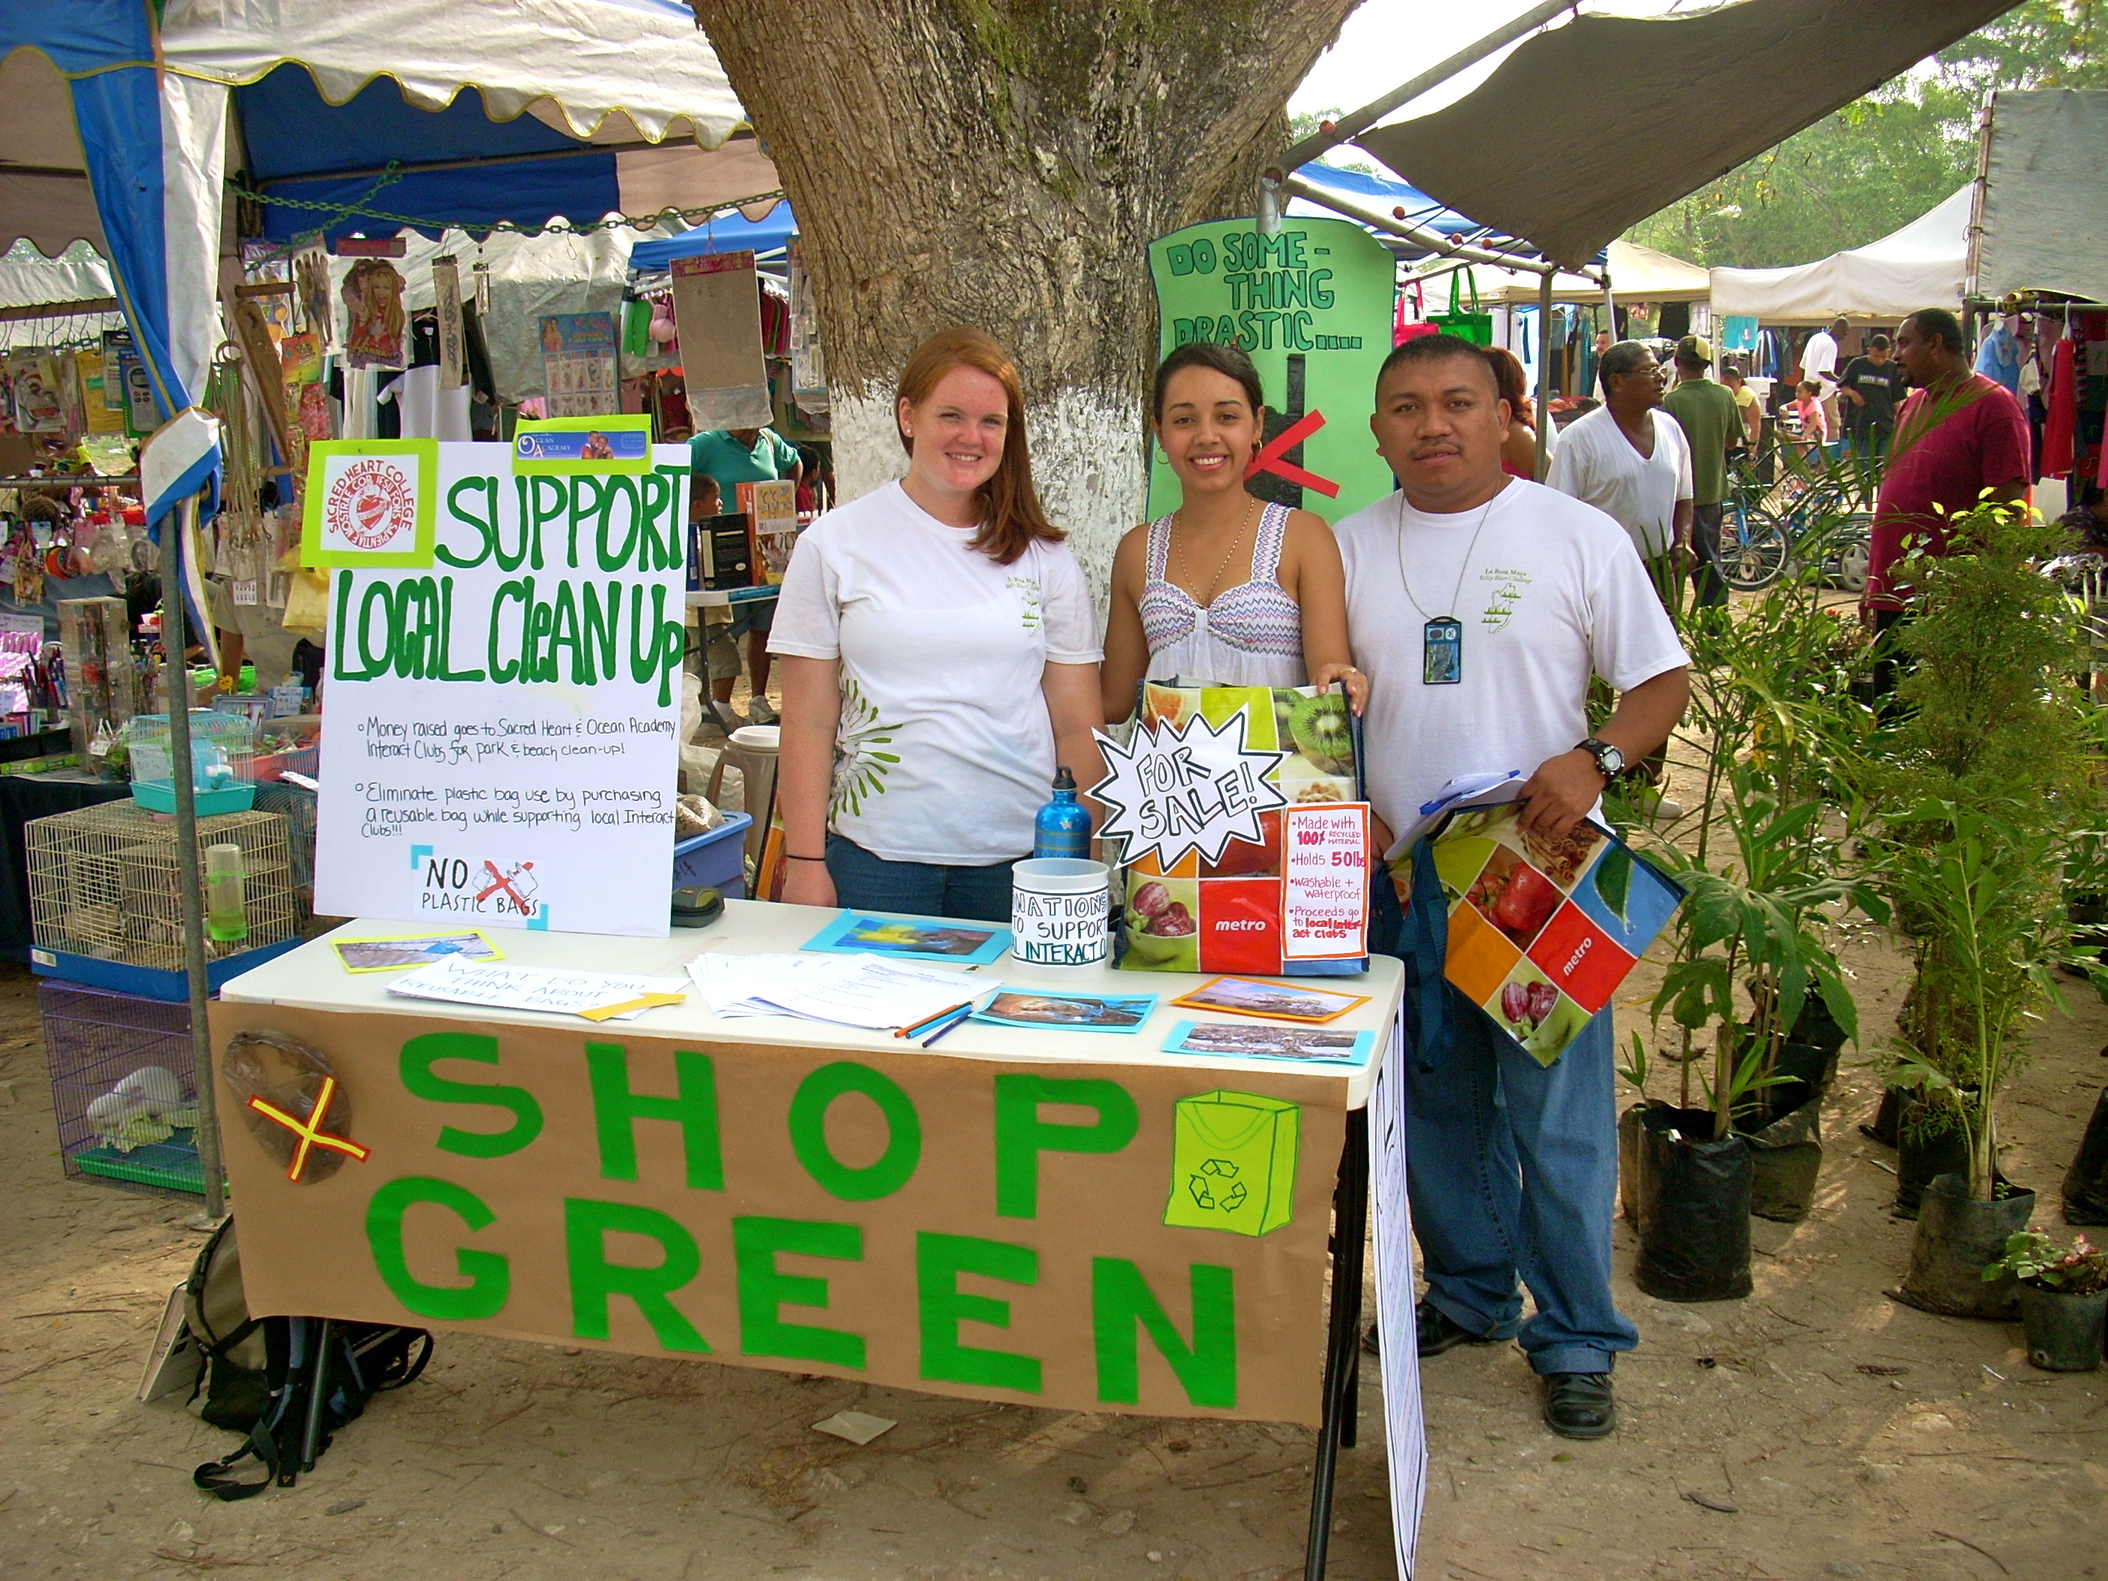
When we set up at our table at the market a man introduced himself as Mr. Lobos and started to talk about reusable bags. We soon learned that he made reusable bags out of cloth and old feed sacks. We loved this idea because it was a local and sustainable source that supported the local community. The bags were also very durable and were very stylish.

Results:

We distributed surveys in town, at Galen, and at the market. As of March 31, 2010, 63 had been completed. The survey questions can be consulted in Appendices p.25 (English) and p.28 (Spanish).

- Surveys
We found that most people shop at both grocery shops and markets. Only 5% said that they only shopped at markets. This may be beneficial in the future, when the project is looking for a point of sale. If they choose to sell bags in supermarkets, they will reach most of the population.

There was not a discernible trend in regards to the number of plastic bags that shoppers receive each week. However, an overwhelming 98% responded that they do reuse their plastic bags, mostly as garbage bags and to package or carry other items. Of the 2% that do not reuse them, throwing away and burning them were the most popular methods of disposal. Despite this, when asked if plastic bags are a problem, only 59% of respondents believe that they are.

The remaining answers ranged from somewhat to not at all. The most popular reason for plastic bags being a problem was that there are too many of them, closely followed by concerns for the environment and pollution, as well as them not being biodegradable. Only three people replied that they are harmful to animals and only two people replied that it was a problem because plastic bags are burned. This is concerning, considering the widespread use of burning as a means to get rid of garbage in Belize. Of the respondents who do not think plastic bags are a problem, the fact that they are reusable was the most popular answer. Unfortunately, a few people responded that they can be thrown away and burned, therefore they are not a problem.

94% of respondents indicated that they would be willing to purchase a reusable shopping bag. 90% said that they would be more willing to purchase a bag if they knew the proceeds were going to help an environmental cause and 10% said that they might be more willing. No one said that this would not affect his or her decision. When asked how much they would be willing to pay for a Shop Green reusable bag, almost half responded with $5-$7. About 20% responded with $7-$10, which is closer to our set price of $10.
We had some difficulties with the question about features people would prefer on a reusable bag. We listed seven features, including material, waterproof/washable, carrying capacity, design/style, compact, shoulder strap length, and durability, and asked respondents to list the importance of each one in a reusable bag with five being most important and one being least important. We were hoping to find out what qualities people like best and what we should look for when sourcing more bags. However, many people wrote five for every feature, which doesn't tell us anything. Also, a lot of them only ranked a few of the qualities. This made it hard for us to compare them to each other and figure out which were most important. However, while talking to people it became evident that material was one of the most important features and most people preferred cloth to plastic.
- Interact Club Participation
We were disappointed with our involvement with Sacred Heart Interact Club. We were not able to have an initial meeting with them until March 3,2010 due to stilted communication. Although the students expressed interest and seemed excited to become involved in our project, we had difficulty scheduling further meetings. Our next meeting was canceled and we were not able to plan another one, due to their two-week spring break. As an alternative to our original plan we have created a how-to guide for them to use when continuing the project. It includes instructions for sourcing bags, setting up and selling bags at the market, money handling, and advice based on our research. Caitlin designed an educational poster on the environmental effects of plastic bags for them to use when selling bags. Lissette also put together directions, including pictures, on how to make a bag out of cassette tapes. These bags will be a good way to attract attention to the project and create stylish recycled bags.
Since we could not carry out our original plan of including the Interact Club in creating educational posters and selling bags at the market, we decided to do this ourselves. Unfortunately, we did not get to do this until the end of March because we were waiting to meet with the students. Caitlin, Lissette, Winter, and Kate created posters displaying facts on plastic bags and explaining that the proceeds would benefit the environment. The funds generated from sales will be used for a beach cleanup on Caye Caulker and a park cleanup in Cayo. Ramon set up a spot at the market and we spent a Saturday morning talking with shoppers and selling bags. We sold bags to twenty people and many more expressed interest. Some were completely unaware of the harsh environmental impacts of plastic bags while others were already using reusable bags and excited to see that we are spreading the word. We felt that we had accomplished something just by connecting with the local people and getting the idea of reusable bags into their head.
Sourcing new bags has been the most difficult aspect of the project. We have sold forty of the fifty original bags and we want to have a source for new ones, preferably cloth, for the Interact clubs to sell. We looked into finding a source in Belize, but didn't have any luck. Ramon contacted the Belize Audubon Society, who started a similar project to sell bags. However, they got theirs in a one-time deal with a company from the United States. We also looked into finding bags in Guatemala, but were unable to locate a reliable source.
We finally found a sustainable source in San Ignacio. Ramon found Mr. Lobos at the market and started speaking to him about reusable bags and our project. Mr. Lobos explained that he used old feed bags with cloth and zippers to create bags. We decided this was a great idea and ordered 100 bags at $7.00 each.
We wish that we had had more time to work on this project, but we do feel we made a difference. Overall, we received a great response to the reusable bags. Despite some setbacks, we managed to spread the word about plastic bags and provide quite a few people with an alternative. This is just the beginning, though, and it is our hope that this project will continue to work for the environment in Belize.

Recommendations:
Shop green is a small project that is striving to educate the community of San Ignacio on the damages that are being caused to the environment by the constant usage of plastic bags. This project is being done along with the Sacred Heart College Interact Club and Interact Club of Ocean Academy in Caye Caulker. Our main goal is to keep the project sustainable. We recommend both clubs continue educating their communities on the importance of maintaining a plastic bag free environment. They can do this by organizing educational campaigns and visiting different schools to teach the children about the harm plastic bags are causing to the ocean creatures and wildlife. There are many creative ways of teaching children. For example, visually, children’s attention span is very short, and they will not pay attention to a long conversation as would a high school student. Children enjoy seeing pictures and playing games and even puppet shows and dramas can be done to carry out the message to them. As for the High School students, educational talk shows can be held along with power points of pictures and video clips that convey the message. They can also prepare sessions in which they can be taught to fuse plastic bags to make totes, purses, pencil cases, wallets, cosmetic bags, laptop cases and more. The internet offers so many creative things to make with fused plastic, it is fun, easy and creative and kids enjoy arts and crafts.
These clubs main audience to target is the community. We recommend that they design posters that can attract people and include educational messages. Knowledge is contagious therefore placing posters all over town can be a great way to call people’s attention; by doing so people will be aware of the harm being caused and probably they will contribute to the reduction of plastic bags.
Another recommendation is to target the local super stores and initiate agreements in which they can also contribute in the reduction of plastic bags. The clubs can get reusable bags from the sources that will be left by the “Shop Green” project and purchase them and resell to local stores so that customers can purchase them at a minimum cost. They can also involve the stores to sell plastic bags at a cost of $0.25. This will motivate customers to bring along their bags. The clubs can also involve the local stores to give a $0.05 fee for every bag brought back to the store and the club can collect the bags from them and create little bags purses and other fun stuff for sale and this will be a way to raise funds as well.
Shop Green advises the clubs to keep the project going and make it stronger and to do this they will need to arrange weekly meetings and brainstorm different ideas that can be used to continue educating the community. Knowledge is contagious and a change can be made if there are people who take the initiate to make the change.

Works Cited:
5 Gyres. (n.d.). What is the Problem. Retrieved April 7, 2010, from http://5gyres.org/what_is_the_problem/
Central Intelligence Agency. (2010). The World Factbook—Belize. Retrieved March 31, 2010, from, https://www.cia.gov/library/publications/the-world-factbook/geos/bh.html
The Environmental Literacy Council. (2008). Paper or Plastic? Retrieved April 7, 2010, from http://www.enviroliteracy.org/article.php/1268.html
Love Your Earth. (n.d.). Nasty Plastic Facts. Retrieved March 31, 2010, from, http://www.loveyourearth.org/Plastic_Bag_Facts.html
ReusableBags.com. (n.d.). The Numbers…Believe It or Not. Retrieved April 7, 2010, from http://www.reusablebags.com/facts.php?id=4
U.S. Geological Survey. (2006). Bioaccumulation. Retrieved April 7, 2010, from http://toxics.usgs.gov/definitions/bioaccumulation.html
Worldwatch Institute. (n.d.). Good Stuff? – Plastic Bags. Retrieved March 31, 2010 from, http://www.worldwatch.org/node/1499

Appendix A: Project Proposal
1.) Group Information: Shop Green
Name E-mail Phone Role in Group
Kathryn Debs kathryn.debs@gmail.com 625-0105 Secretary
Winter Heath wheath@uvm.edu 668-9707 Liason
Caitlin Blouin ceblouin@uvm.edu 668-9701 Co-Leader
Ramon Carcomo ramolive@yahoo.com 624-8459 Co-Leader
Lisette Aguilar Lizzy4u17@yahoo.com 623-9923 Secretary
2. Group Meeting Times: Wednesdays 2:30PM under palapa at Galen.
3. Project Description: Write a one-paragraph description of the project. What is the nature of the problem? Why is it a problem?
The purpose of “Shop Green” is to introduce a reusable shopping bag initiative to reduce plastic bag consumption in the San Ignacio area and instill lasting environmental values. Through various education techniques this project will look to inform the shopping public of the negative impacts of disposable plastic bags, an issue that is taking a toll on the local environment (e.g., pollution of air, land and water). Our group is also expected to develop a business plan that can be applied to other communities, such as Caye Caulker, and also generate funds to support environmental education in Sacred Heart Interact Club and Caye Caulker Ocean Academy Interact Club.
- Partner Information
Organization Contact Information
Shop Green Joni Miller (Caye Caulker Interact Club) miller_joni@hotmail.com 666-4375
Colin Young (Galen Sustainability Committee) cyoung@galen.edu.bz
Cynthia Reece (Sacred Heart Interact Club) creece@galen.edu.bz 668-0930
5. Project Timeline: Key Dates
Note: Group liason submits Weekly Project Summaries electronically to project advisor (either Jeff or Joni):
Feb 12, 19, 26; March 5, 12, 19, 26; April 2, 9, 16, 23
Date Activity How objectives will be met Person’s Responsible
2/12 Proposal Due -Select liaison Group
-Discuss project problem
-Brainstorm Budget

2/12 Partner Agreement -Meet with partner Group
Reflection #1 due -Identify needs Individual
Schedule meetings

2/26 Lit Review Due -Research web and other sources Each responsible for 1
-Divide responsibilities
-Write Report

3/5 Reflection #2 Due Individual

4/9 Reflection #3 Due Individual
Project Team Evaluations Group
First Draft of Final Report Group
Preliminary Powerpoint Group
4/16 Kate compiled powerpoint Individual
Ramon & Lissette gave estimates Individual
Lissette is trying to contact SHC Individual
Caitlin and Winter stopped by Angelus and Group
confirmed estimates
4/23 Lisette confimed meeting at SHC- Summed up project Group
50 bags to be made by Friday by Mr. Lobos Individual
Winter completed Instruction Manual Individual
Lissette completed Recycled Cassette Tape Manual Individual
Caitlin complied final report with edits Individual
Kate compiled final powerpoint Individual
Met on Wednesday with Joni to practice Group

- Proposed Budget
Identify anticipated expenses, including transportation, copying, purchases of materials and equipment, and possible contribution to project partner for continuation of project-related work.
Category of expense | Anticipated expense in $BZ | Justification | Running Total
Reimbursement | $100 | Joni's brother purchased reusable bags | $100
Supplies/Materials | $50 | Needed for educational displays, donation boxes, etc. | $150
Phone Credit | $0 | Will need to contact people for various resources (e.g., bag sourcing) | $0
Transportation | $0 | Unknown at this time if transportation costs will be needed | $200
Reusable Bags | $382.50 | Unknown at this time what cost of additional reusable bags will be | $382.50

Appendix B: Literature Review
Introduction
In the next few decades it has been projected that the world population will increase exponentially; this increase in population will increase the demand of food, energy, water, health care, sanitation, housing and others (World Resources Institute, 1994). Consumer demand has been one of the major driving forces that has accelerated the advances of technology and increased the substitution of traditional natural resources-based materials. One of these substitutions has been the invention of plastic bags made from petroleum. The distribution and usage of plastic bags have been popular among retailers as well as consumers. This is because the plastic bags are cheap, strong, lightweight, functional, as well as a hygienic.
In 2001 it was estimated that the United States consumed over 500 billion plastic bags while a trillion bags were used world wide(Roach, 2003). A significant quantity end up at mismanaged, open, dump sites, streets and other places in the environment. However, the Film and Bag Federation of the United States argue that plastic grocery bags consume 40 percent less energy, generate 80 percent less solid waste, produce 70 percent fewer atmospheric emissions, and release up to 94 percent fewer waterborne wastes when compared to paper grocery bags (Roach, 2003).
According to Pan American Health Organization (2003) the annual commercial/domestic solid waste produced in Belize was approximately over 112,000 tons. Medlin (2008) reported that 1.1 kg per capita of solid waste is produced daily in Belize and a total of 182 metric tons per year.
One of the most obvious impacts of plastic bags is the littering of landscape especially in communities with inefficient management capacity to deal with its waste. The rippling effects could be the propagation of diseases that eventually affects the communities. Open dump sites contribute to the problem when animals and the homeless explore the dump sites and litter the highways.
Plastic bags have had tremendous negative impacts in the marine environment because many marine animals such as turtles, whales, penguins and others ingest plastics believing it is food. So far there is no information on how many animals have died due to plastic pollution in the marine environment. Since plastic bags are non-biodegradable, authorities do not know long plastic bags will affect the environment, thus placing a burden unto the next generation of this world.
Another significant impact of plastic bags have had on many third world countries is the inhalation of toxic fumes coming out from burning of the bags. This has possibly caused the development of cancerous diseases and respiratory problems. Furthermore, the toxic fume also contributes to the deterioration of the atmosphere hence leading to Global warning.
It is the objective of this paper to provide a comprehensive report of the implementation of a project called “Shop Green”. The specific objectives were to introduce a recyclable shop bag to the San Ignacio/Santa Elena consumers as an alternative approach in reducing solid waste accumulation. The secondary specific objective was to generate funding that would be shared with its partners so as to sustain environmental advocacy programs.
Organization Background
Project “Shop Green” was developed as an initiative instituted at Galen University to be implemented during one semester. Sustainable Development has been one of the major pillars of Galen University. Students that enrolled in the course “Applications of Sustainable Development” were engaged in the implementation of the project. The different strengths and special skills of each individual were the major tools used. The team was guided by qualified lecturers of the course.
Creative Bag Solutions
The use and disposal of plastic bags have become a major problem worldwide and it is spreading rapidly. San Ignacio being such a small community it is overwhelmed with plastic bag garbage. Therefore, here are some clever solutions to get rid of excessive plastic bag usage and some tips on how to make good use of the existing ones.
The over usage of plastic bags in San Ignacio has derived from local Chinese stores where for every item purchased, they want to give you a plastic bag. We as the consumers must put a stop to this situation. Stores and businesses should encourage customers to bring their own bags; this will save the stores and businesses from spending money in purchasing so many bag as well (Green Business Consideration, 2008). Another possible solution can be to encourage all stores to charge a fee of $0.25 for a grocery bag; this will motivate people to bring along their own bags. Businesses and stores can also agree on offering a fee or $0.05 for each plastic grocery bag returned to the store (Manal, 2009).
Nevertheless, our major targets should be the companies that produce the bags. They need to be enlightened on the harm they are causing to the world. There are many scientists that are concerned with the environment and are finding solutions to replace the substance being used to make plastic bags. Scientists like Norbert Eisenreich, a senior researcher and deputy of directors at the Fraunhofer Institute for Chemical Technology (ICT) in Pfinztal, Germany, said his teams of scientists has come up with a substance that could replace plastic: Arboform -- basically, liquid wood.

It is derived from wood pulp-based lignin and can be mixed with a number of other materials to create a strong, non-toxic alternative to petroleum-based plastics (2009). This is a clever idea that can be used in Belize.
If you already have a collection of plastic bags here are some useful tips that can be used to recycle your plastic bags in an effective manner.
- You can fuse as many plastic bags as you can and make tote bags out of them and bring it along when you go grocery shopping.
- Use your plastic bags as your office or bathroom waste basket liner.
- Reuse your plastic grocery bags for the freezer. Purchase wax or parchment paper and wrap your meats or other food in the paper. Wash your plastic grocery bag, and then place the food in it. It will act as a barrier between your food and the burning freeze of the cold temperature. So it is recommended using the paper to keep it away from your frozen food.
- If you're traveling, consider placing your shoes in a plastic grocery bag before you put them in your suitcase (Manal, 2009).
These are all useful tips and solutions that can be used to reduce and eventually eliminate the drastic problem that plastic bags are causing to the wild life and the environment.

Effective Survey Writing and Analysis
Surveys are an excellent method of gaining information and learning public opinion on a specific issue. Although not full proof, they can provide insight that would be difficult to come by otherwise. There are many ways to construct a survey. In fact there are many correct ways to construct the same survey. With that in mind, many things should be considered that will affect survey writing, distribution, collection, and analysis. All of this depends on the information being collected and the population being surveyed. Two methods are often used, questionnaires and interviews. Questionnaires will be focused on, as they allow a larger number of people to be surveyed in a shorter period of time (Trochim 2006).

There are a few issues that should be considered before writing a survey. The first is the intended population. Literacy and language barriers are important because if people can’t read the survey, there will be no response. It may be necessary to provide the survey in more than one language or question the respondent in person. Think about the group being surveyed as well. It may not be possible to ensure they are a true representation of the population as a whole but the validity of the survey will increase if this is attempted. Question content is also important. Before the survey is written, a few things should be thought through, such as the complexity and length of the questions. This will depend both on the respondent and the subject of the survey. Administrative issues are a concern as well. How to distribute and collect the surveys will depend on cost and time availability (Trochim 2006).

Question content and wording are central to writing a survey. In order to keep the survey at a reasonable length, make sure each question contributes necessary information to the survey.
The questions should be specific enough to learn the desired information about the respondent but not so specific that you cannot gain a general view of his or her opinion. Also be sure that the questions are not biased or assume the viewpoints of those being surveyed. It will be hard to receive a truthful answer if the question forces the respondent to answer one way or another. For example, asking ‘What is wrong with plastic bags?’ implies that plastic bags are wrong. However ‘Are plastic bags a problem?’ gives the respondent a chance to form his or her own opinion (Trochim 2006).

The wording and terminology of the questions should be very clear. It should be evident to the respondent exactly what the question is asking. To avoid confusion, it may be helpful to structure the question with multiple choice answers or rankings based on their opinion. However, open-ended questions can be very useful when it is unclear how the respondent will answer. They will also decrease the chances of the respondent answering in a way they think is desired or expected. When considering question placement, it is usually best to begin with undemanding, descriptive questions. By easing into more sensitive or descriptive questions, the respondent is less likely to abandon the survey (Trochim 2006). It may also help to use a few different types of questions, such as multiple choice, matrix, or open ended. Variety will keep the respondents attention (Perez 2010).

Analysis of a survey involves three steps: data preparation, descriptive statistics, and inferential statistics. Data preparation involves logging and keeping track of the information (Trochim 2006). This may also include cleaning the data. If a particular question was skipped often or misunderstood by respondents, that should be taken into consideration and perhaps discarded. Otherwise, the results will be skewed (Bell 2008) Categorizing answers to open ended responses will make them easier to interpret. This can be done by choosing catagories that were often expressed and inserting each answer into the applicable category (Data 2001). Once this has been done, descriptive statistics are possible. These basically describe the information gathered in a simple format. Graphs and charts make the data easy to read and assess. Inferential statistics is used to make conclusions. Based on the data, the opinion of the population can be determined. This is the step that gives researchers essential information and allows them to put it to use (Trochim 2006).

Effective Environmental Education Displays
Displays are used in many different areas of discipline to convey a message or show research. Displays and posters are a very important way to communicate information to a reader according to the United States Environmental Protection Agency (2006). The EPA shows that there are different media that can be used to convey the information such as displays, booklets, pamphlets and inserts (EPA, 2006). Before deciding what type of media to use to convey the message, one must figure out who their target audience is going to be (EPA, 2006). Research needs to be conducted to figure out where people get their information from in order to reach them (EPA, 2006). When one figures out who their target audience is and how they get their information, then they can decide what kind of media to use in order to relay their message or information (EPA, 2006). The display also has to be designed correctly in order for the audience to understand what is being presented. People read from top to bottom and left to right, therefor the most important text must be on the top to grab the reader’s attention (Mandoli, 1999).

Usually a display is a piece of cardboard that is 90 x 60 cm (Hay & Thomas, 1999). Displays are used to show results of an experiment or to show facts (Hay & Thomas, 1999). When designing a display, it needs to capture the reader’s attention. There should be pictures and a design that intrigues the person (EPA, 2006). Writing should be kept to a minimum in order to keep the reader’s attention (EPA, 2006). But at the same time, the text that is there needs to be large enough to engage the reader (EPA, 2006). Displays should contain all the information needed so the reader does not need further explanation and is not confused about the subject being presented (EPA, 2006). It is never a good idea to have a large amount of open space in a display because that will disinterest the reader (EPA, 2006). According to Hay & Thomas (1999), one should be creating the display as they are finding information, not after everything is collected (Hay & Thomas, 1999). It is a good rule of thumb to have two to three days to gather all your information and photos before making the display so one can have adequate planning (Mandoli, 1999). After all the information is assembled, it should take someone around two days to complete the poster (Mandoli, 1999). Creating a display should not be rushed and needs to be planned out in advance so one has all the materials necessary (Mandoli, 1999).

According to Hay & Thomas (1999), there are 5 five main principles that every display must have in order to captivate the audience. The display must be attention getting and this can be attained by the layout, color and title (Hay & Thomas, 1999). The next principle it must contain is brevity; it should be straight forward and to the point (Hay & Thomas, 1999). The poster must also be coherent, there should be made so people do not have unanswered questions about the subject (Hay & Thomas, 1999). The poster must have direction so the audience does not get confused or disengaged (Hay & Thomas, 1999). It must also contain evidence to be credible to the reader (Hay & Thomas, 1999).

There are many aspects to a display that one must really think about before making. One has to consider font, color, photos, graphs, etc. in order to properly convey their message to an audience. Without proper planning, a display can be a waste of time and money because it will not capture the reader’s attention.

Belize Solutions for Plastic Bag Waste
As a developing country, Belize is faced with an assortment of different challenges. For example, funding for essential facilities such as an effective and sustainable waste management system can be limited. The Ministry of Foreign Affairs of Japan (MOFA) stated,

In Belize there are neither facilities for treating solid waste nor separative trash collection system and recycling system…. The problem of solid waste is not only an environmental problem in-land but also a source of sea pollution (2009).

Plastic bags make up a portion of this solid waste impacting Belize’s local communities and natural environments. One solution for reducing and managing the amount of solid waste present in Belize could be tackling the problem from a top-down approach—that is, at the government level. Encouraging the nation’s leaders to promote sustainable practices and behaviors by introducing new policies and regulations could have a major effect on solid waste issues, such as plastic bag pollution. One of Belize’s most influential industries the government could tap into is the tourism industry. Tourism is one of the largest industries in Belize along with garment production, food processing, oil, and construction (Central Intelligence Agency, 2010). Having tourism entrepreneurs and hoteliers take steps could have monumental effects. Also, encouraging other branches of the tourism industry, such as Ecotourism, could be a step in the right direction for stimulating positive waste management strategies. This could include training and educating employees and providing educational materials for tourists (such as consuming less non-renewable materials). All of these options are potential solutions to help Belize manage environmental issues such as plastic bag pollution, but these can be very costly and time-intensive.

A more feasible and plausible option for a small country like Belize is approaching the problem on a more local scale. Educating local communities, schools, businesses and other organizations can introduce the issue of plastic bag pollution in a more specific, face-to-face manner. Once individuals are aware of the problem they can then determine the best way to approach the issue. Some small businesses in Belize have already taken the initiative to make a difference in environmental issues the country faces. For example, Hickatee Cottages in Punta Gorda, Toledo District, Belize has established a system of reusing plastic bags and reducing their presence whenever possible; they have even connected with a local grocery store to employ a plastic bag recycling program (Hickatee Cottages, n.d.).

Positive environmental initiatives such as these are what Shop Green hopes to encourage. As a group, we are looking to instill lasting environmental values in local Belize communities that will continue to propagate long after the originating Shop Green members have left. The goals of Shop Green are to educate local Belize communities on the negative impacts of plastic bags; present alternative options, such as reusable shopping bags; and develop an effective business plan for selling reusable shopping bags that can be applied to and used by various organizations around Belize. Empowering Belizeans with the knowledge and the skills to continue this project is something Shop Green hopes to see for years to come.

Appendix C: Survey in English

Shop Green
“Shop Green” is a student group from Galen University studying reusable shopping bags in the Cayo District. All data will be used solely for the purpose of this project. Thank you for your time.
Age: Gender: Town/City:
Please Circle Your Response
- Where do you usually grocery shop?
  - Markets & food stands
  - Supermarkets (grocery shop; Chinese shops)
  - Both
  - Other: ____________
- How often do you go grocery shopping?
  - Everyday
  - 2-3 times a week
  - Once a week
- How many family members are you food shopping for?
  - 1-3
  - 3-7
  - 7-10
  - 10+
- On average, how many plastic bags do you receive a week when shopping?
  - 1-3
  - 3-7
  - 7-10
  - 10+
- Do you reuse plastic shopping bags?
  - Yes
  - No
  - Sometimes
- If so, how do you reuse them?
_______________________________________________________________________________________________________________________________________________
- If you do not reuse plastic shopping bags what do you do with them?
________________________________________________________________________________________________________________________________________________
- Are plastic bags a problem?
  - Yes
  - Somewhat
  - Not really
  - Not at all
- Please explain your answer to question #8:
________________________________________________________________________________________________________________________________________________
- Would you be willing to purchase and use a reusable shopping bag?
  - Yes
  - No
- How much would you be willing to pay for this Shop Green bag (see bag example)?
  - Less than $5
  - $5-$7
  - $7-$10
  - $10-$12
  - $12-$15
  - Other: _________
- On a scale of 1-5 what features would you prefer a reusable shopping bag to have? (1 being the least important feature and 5 being the most important)
___ Material (cloth or plastic)
___ Waterproof/washable
___High carrying capacity (e.g., can hold up to 50 lbs)
___ Attractive design/style
___Compact and can be easily folded up
___ Shoulder strap length (long vs. short)
___ Durability (long-lasting)
- How often would you use a reusable shopping bag during a week?
  - Everyday
  - 2-3 times a week
  - Once a week
- Would you be more willing to purchase a reusable shopping bag if the funds supported a local organization doing environmental work?
  - Yes
  - No
  - Maybe

Appendix D: Survey in Spanish
Edad:
Género:
Localidad:
Circule su respuesta
1) ¿Donde suele hacer usted sus compras de comestibles?
a. Mercado
b. supermercados
c. ambos
d. otros: ____________
2) ¿Con qué frecuencia va usted a hacer sus compras de comestibles?
a. Todos los días
b. 2 - 3 veces por semana
c. una vez a la semana
3) ¿Para cuantos miembros de la familia compra comestibles?
a. 1-3
b. 3-7
c. 7-10
d. 10 +
4) En promedio ¿Cuántas bolsas recibe al fin de cada semana de compras?
a. 1-3
b. 3-7
c. 7-10
d. 10 +
5) ¿Reutiliza usted las bolsas de plástico comerciales?
a. sí
b. no
6) Si así es ¿cómo las reutiliza?
a. las lleva a la tienda para poner sus comestibles.
b. para otros fines domésticos (por ejemplo, para bolsa de basura)
c. otros: ___________
7) ¿Ve usted bolsas plásticas de residuos como un problema en Belice?
a. sí
b. no
8) ¿Estaría dispuesto a comprar y utilizar una bolsa de compras reutilizable?
a. sí
b. no
9) ¿Cuánto estaría dispuesto a pagar por esta bolsa reutilizable?
a. $5 a $7
b. $7 a $10
c. $10 a $12
d. $12 a $15
e. otros: _________
10) En una escala de 1-5 ¿qué características preferiría usted en una bolsa de compras reutilizable? (el numero 1 siendo la característica menos importante y el numero 5 la más importante)
___ Material (tela o plástico)
___ Impermeables/lavable.
___Capacidad de carga fuerte (por ejemplo, una bolsa que aguante hasta 50 libras)
___ Atractivo diseño o estilo.
___solida pero que pueda ser fácilmente doblado
___ Con correa de hombro largo y corto
11) ¿Con qué frecuencia usaría una bolsa de compras reutilizable durante una semana?
a. Todos los días
b. 2 - 3 veces por semana
c. una vez a la semana
12) ¿Estaría más dispuesto a comprar una bolsa reutilizable si los fondos apoyaran a una organización local haciendo trabajo medioambiental?
a. sí
b. no
c. tal vez

Appendix E: Flyer for Marke
Shop Green
Come support
Sacred Heart and Ocean Academy
Interact Clubs

Come check out our table at the market on
Saturday, March 27
and purchase a reusable bag!

All proceeds go to the clubs for a
beach and a local park clean up!

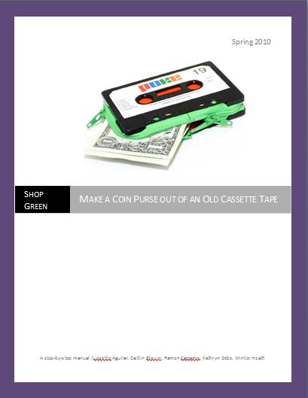

STEP 1: GATHER ALL MATERIALS NEEDED
- SCISSORS
- FOAM PAPER OR CLOTH
- GLUE GUN
- ZIPPER
- OLD CASSETTE
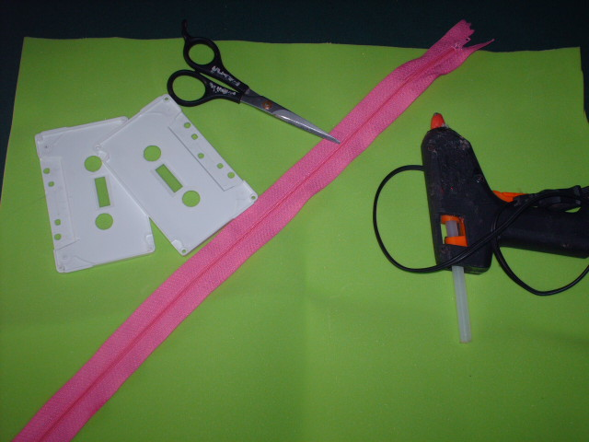

STEP 2: CUT PIECE OF FOAM/CLOTH USING THIS MEASUREMENT (7”*5”)
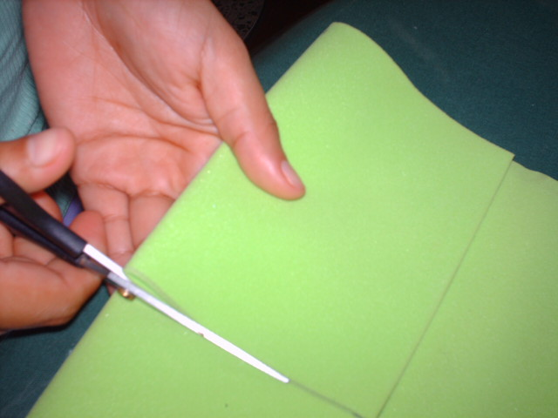

STEP 3: FOLD THE 7”*5” PIECE OF FOAM AND FOLD IN HALF.

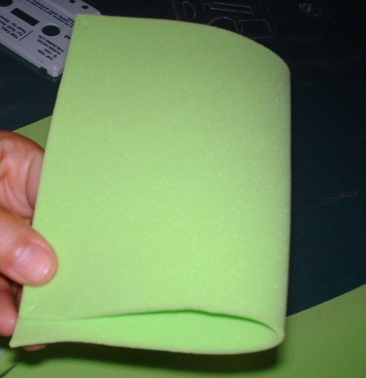

STEP 4: INCISE 2cm ON EACH CORNER

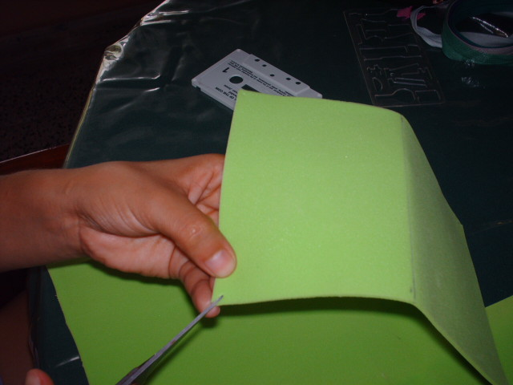

STEP 5: OVER LAP THE SLIT CORNERS AND GLUE TOGETHER

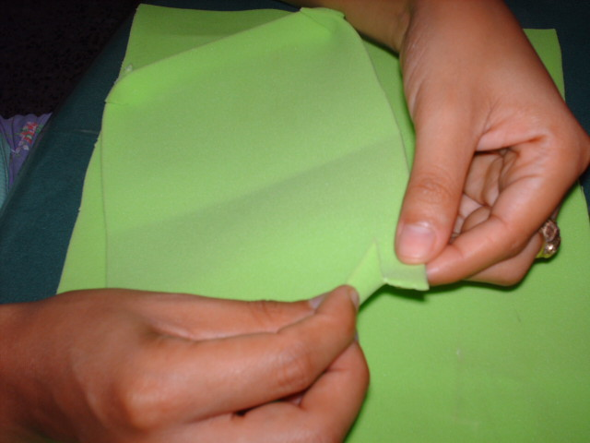

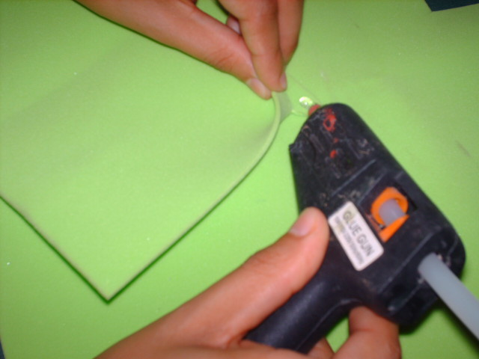

STEP 6: ON EACH SIDE LENGTH WAY, FOLD AND GLUE 1/2 INCH TO THE CENTER OF THE FOAM/CLOTH.
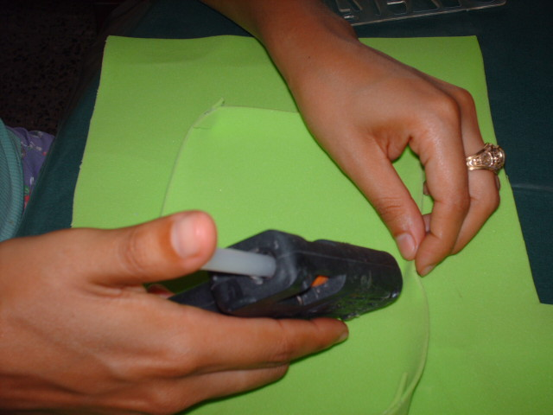

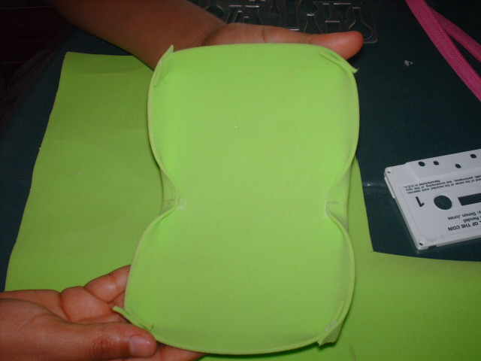

STEP 7: GLUE ZIPPER AROUND THE SIDE OF THE FOAM/CLOTH
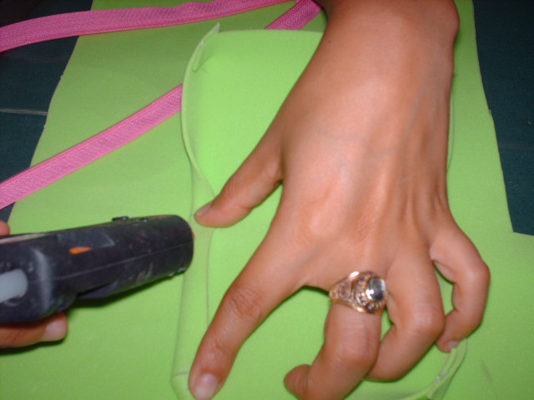

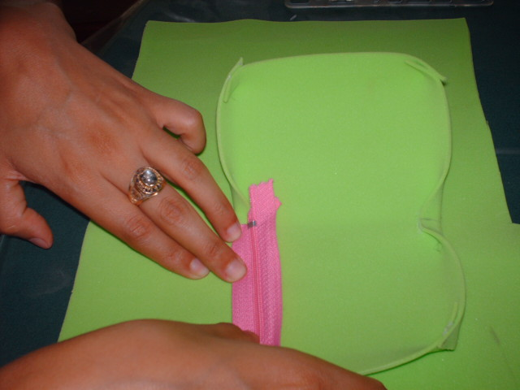

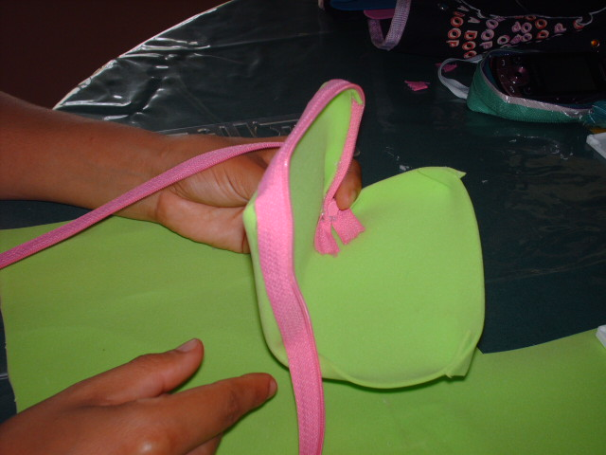

STEP 8: STICK TAPE ON EACH SIDE OF PURSE
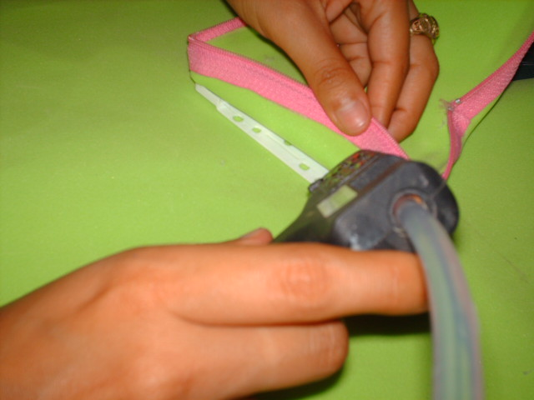

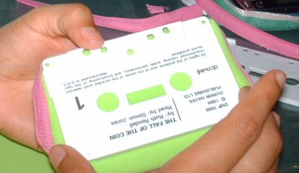

FINAL PRODUCT: 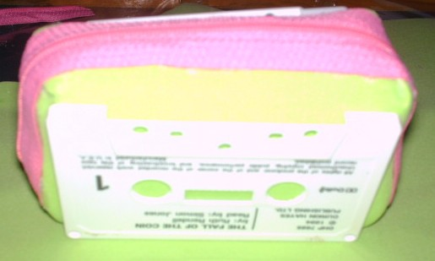

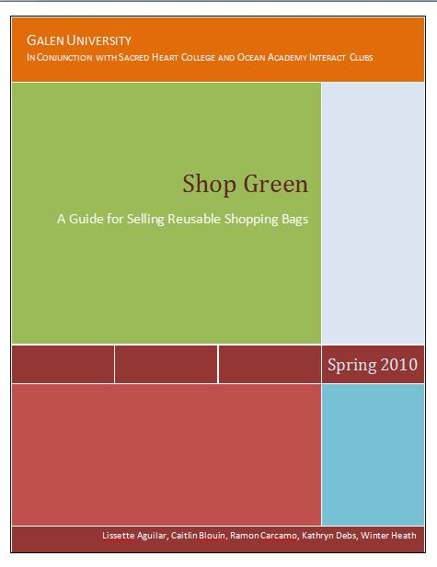

Table of Contents
Introduction.........................................................................................................3
Step by Step.........................................................................................................4
Confirm group roles and responsibilities...................................................4
Establish contact with bag source..............................................................5
Put name on it!..........................................................................................6
Organize a sales table date and time.........................................................6
Sell Bags!..................................................................................................7
Pictures of Shop Green in Action.........................................................................7
Fact Sheet...........................................................................................................8

Introduction
“Shop Green” is a project developed by students enrolled at Galen University. The goals of this initiative include the following: educate local Belize communities on the negative impacts of plastic shopping bags; present alternative options to the disposable bags, such as reusable shopping bags (below are images of the bags we sold); generate funds for local environmental clean-up efforts; and develop an effective business plan for selling reusable shopping bags that can be applied to and used by various local Interact Clubs.
During the course of one semester Shop Green worked to achieve these goals by accomplishing a number of tasks. One objective was to connect with the Interact Clubs of Sacred Heart College (SHC) in San Ignacio and Ocean Academy (OA) in Caye Caulker. By coordinating with these organizations, Shop Green hoped to instill lasting environmental values that will continue to propagate long after the originating Shop Green members have left. In order to see this through, our group has compiled a Shop Green Instruction Manual for the members of both Interact Clubs to utilize and therefore continue the project at their own will.
The founding members of Shop Green wish to leave the members of both Interact Clubs with the tools and knowledge to maintain this idea of reducing plastic shopping bag consumption as well as generate funds which can then be applied to future environmental projects. If nothing more than a general guideline, we hope you find this Instruction Manual helpful for your future environmental endeavors. Good luck!

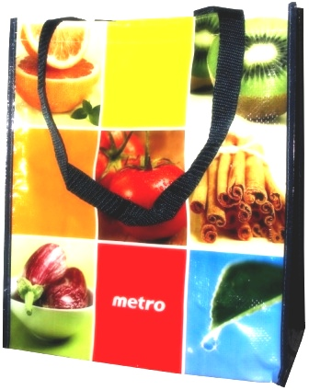
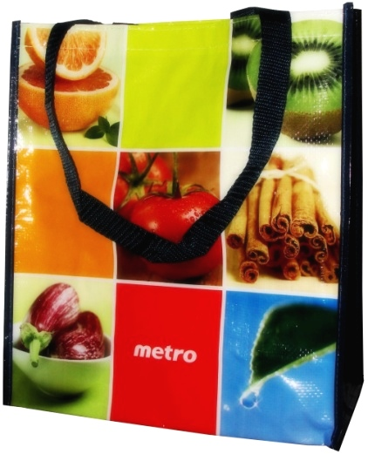
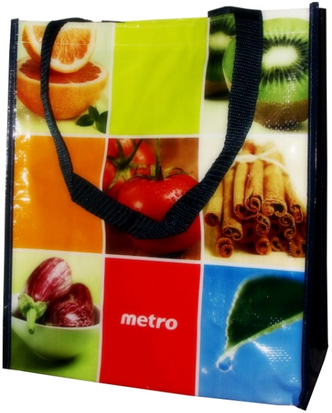

Step by Step
In order to make the project run smoothly, there are steps that must be taken to continue the Shop Green initiative. Our group has assembled a step-by-step process to help your Interact Club see the project through. These are general suggestions. Your group may discover another idea may work better in place of one of ours. Feel free to make adjustments as necessary. Enjoy!

 Confirm group roles and responsibilities
There are certain responsibilities that must be held by individuals in the group. Group roles may already be assigned in your Interact Club (such as treasurer); therefore it may be easy to assign these suggested responsibilities. We have identified the group roles we see best fit to accomplish the proposed tasks. These responsibilities may be rotated or shared amongst the group, but it may be better if some are not—it depends on what the Interact Club sees is best for the group. The suggested role responsibilities include:
Club Secretary: In addition to regular secretarial duties, this person is responsible for the educational display(s) intended for use at the sales table. The secretary must keep the display in a safe place until it is needed; he/she will then be responsible for bringing the display to the sales table.
Club Treasurer: This person is responsible for a number of different tasks. Our group has invested in 25 reusable shopping bags for each Interact Club to jump start your project. Each club is responsible for selling their own bags and investing their profits in their own environmental project.
After the initial 25 bags are sold, it would be beneficial for both clubs to bulk order reusable shopping bags together and split proceeds accordingly. In order to order more bags and efficiently divide the bag proceeds, the treasurer will need to establish and maintain contact with Ms. Joni Miller, the advisor of OA’s Interact Club. Ms. Miller will then coordinate with Ms. Cynthia Reece, advisor of SHC’s Interact Club, and Dr. Aird, the Principal of SHC, to manage the funds between the two clubs.
Ms. Miller’s contact information: miller_joni@hotmail.com 661-8878
Ms. Reece’s contact information: creece@galen.edu.bz 668-0930

Club Liaison: One individual must be responsible for maintaining contact with the producer of the club’s reusable shopping bags, Mr. Lobos. It’s imperative that only one person is designated for this role in order to reduce confusion and complications.
Mr. Lobos’ cell contact information: 661-7123
Media Liaison: One person should be responsible for managing the media for this project. When the group plans on having a bag sale, the Media Liaison will be in charge of creating and putting up posters around the community about the event. He or she will also be responsible for writing up short press releases for local newspapers about successful bag sale events and successful environmental clean-up projects that use the sale profits. The Media Liaison should forward any press releases to the Club Liaison to share with their partner Interact Club (OA and SHC).

 Establish contact with bag source
A local source for reusable shopping bags has been established with Mr. Lobos, a member of the San Ignacio community. Mr. Lobos has offered to create an initial supply of reusable shopping bags for both Interact Clubs. Twenty-five bags will be provided for both clubs. Ms. Reece will hold the bags for SHC and Ms. Miller for OA.
It is important for the liaison of each Interact Club to maintain contact with Mr. Lobos if they intend to continue purchasing reusable shopping bags to sell. It’s encouraged that contact is established early in order to introduce the group to Mr. Lobos and maintain a good relationship with him. Students may find an easier or more feasible source for the reusable shopping bags. If this is the case, please inform Mr. Lobos of any change.

Our group has left behind a “how-to” for making reusable shopping bags out of recycled materials hoping to inspire students to create their own reusable bags. It’s also a great opportunity to sell bags that are personal to the club.

 Put a name on it!
“Shop Green” is the temporary name that was assigned to the project when it first started. We encourage each club to come up with a new, exciting name that may better pertain to their group/environmental mission. It may be a good idea to contact Mr. Lobos about possibly sewing the new name or logo into the reusable shopping bags as well.

❍ Organize a sales table date and time
In order to have a successful bag sale each club must set up a sales date and time. After two tabling experiences, our group has a few suggestions:
- At least two students should be present (no more than five)
- In one case we found it very helpful to have at least one person present that can speak Spanish
- Make sure the time and location of the sale is favorable to selling bags. It’s better to pick a time where there will be a lot of people present (e.g., during a lunch period)
- Set a goal for your group. How many times does your club hope to set-up a sales table in a month? How about a school semester?

■ Sell bags!
So, group roles have been assigned, the group has contacted the bag source, the project has a great new name, and a sales date and location have been arranged. Now it’s time to sell bags! Here’s what you should have on the day of the sale:
- Collect the educational displays from the group secretary
- Bring at least 10 bags, if not all, to the sale
- Make sure to have at least $10 in change to give to customers
- Bring the Fact Sheet (see below)
- Sell bags for somewhere between $15 and $20 in order to make a profit
- It’s also a good idea to not have chairs at the table. You’re more likely to draw people’s attention if you are standing and interacting with the crowd
- Bring a camera! The Interact Club partners (OA and SHC) would love to have pictures of students selling bags. The Media Liaison should be responsible for e-mailing the photos to both advisors.

Pictures of Shop Green in action
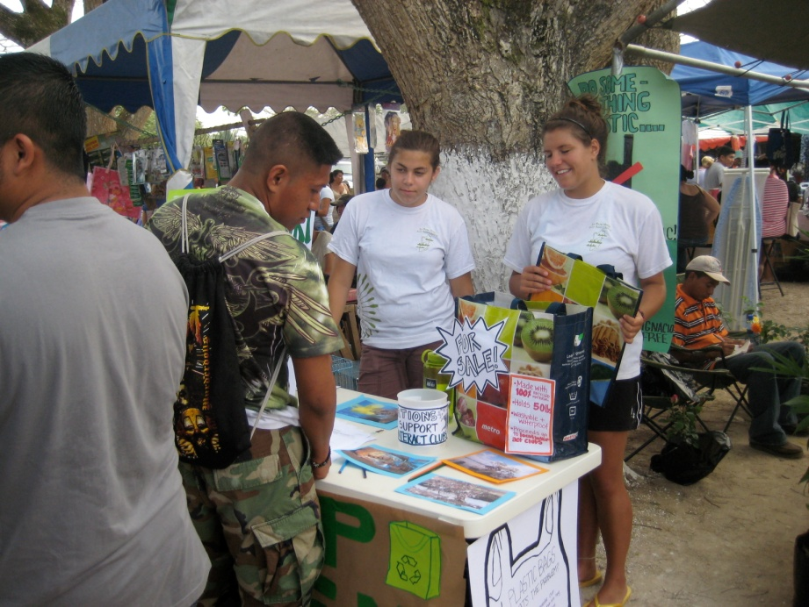
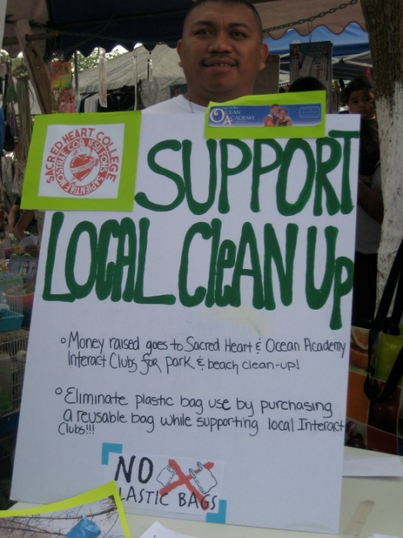
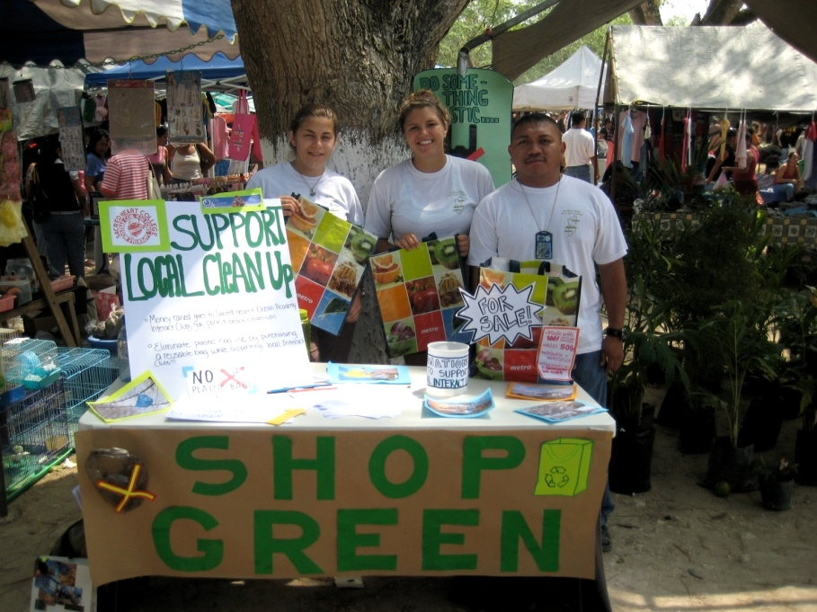

Fact Sheet
While selling the bags, or at any point, people will have questions about the Shop Green project. To make sure each club is prepared our decided to provide a Fact Sheet that has some quick bullet points explaining the background and mission of the project.
- What is Shop Green?
Shop Green is a project started by students enrolled in Galen University’s class called Applications of Sustainable Development. The goals of the project are to reduce the use of plastic shopping bags in the community by introducing reusable shopping bags and raising awareness of the harmful effects of plastic bags. Shop Green also helps local Interact Clubs raise money for environmental clean-up projects.
- How did your club get involved?
Another goal of the project was to connect with the local community. The students at Galen coordinated with the Interact Clubs of Sacred Heart College and Ocean Academy to help introduce the concept into the community as well as work with the students to create an environmental initiative that can be continued by the students for years to come.
- How does the project help raise money for the clubs?
In addition to the almost 50 reusable shopping bags sold by the originating group members of Shop Green, students will also sell reusable shopping bags on their own. Money made from the sales will be split 50/50 between both clubs.
- What are the environmental clean-up projects the clubs are raising money for?
Money made by Sacred Heart College’s Interact Club will be put toward a local park clean-up. Ocean Academy will use their funds for a mangrove clean-up project.
- Where are the reusable shopping bags from?
A couple from San Ignacio make each reusable shopping bag out of new and old materials. The bags are made from old grain sacks and lined with cloth. Their thick straps and lining make the bags very durable. In addition to supporting the local economy, the bags are also sustainable because they come from a local source instead of being sourced from another country or international manufacturer.
- Why are plastic shopping bags bad?
Plastic bags can greatly impact the environment and to human health. Bags find their way into natural environments from flying off of trucks, blowing out of landfills, or simply being left on the side of the street. From there the plastic bags can wreak havoc on delicate ecosystems such as marine habitats. In many cases, animals mistake plastic bags for food. For example, turtles mistake plastic bags floating in the water for jellyfish, their main source of food. Once the turtles ingest the bag, their airway can become clogged and they can choke to death.
Also, if plastic bags end up in a landfill, they are often burned. This process releases harmful chemicals into the air which is then breathed in by humans causing irritation and discomfort.
Reusable shopping bags are a positive alternative to plastic bags because they last longer, are just as convenient, in many cases hold more groceries and help reduce unnecessary consumption and waste.

