Applications of Sustainable Development

April 9, 2010

Group Members:
Deborah Cal
Raymond Edwards
Margaret Fitzgerald
Travis Gervais
Margaret Stone
Elida Tuyud

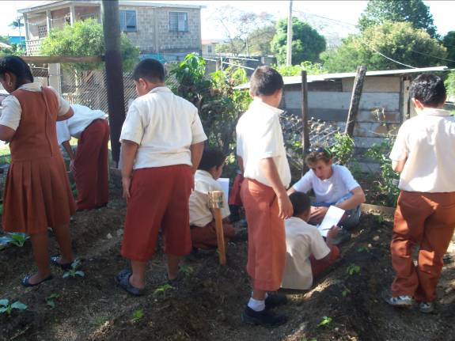

Table of Contents
________________________________________________

Acknowledgments………………………………………………………………………….3

Introduction………………………………………………………………………………....4

Methods………………………………………………………………………………………..6
- Preparation…………………………………………………………………….6
- Garden work…………………………………………………………………..9
- The Garden journal…………………………………………………………12
- Meetings and time into put into project…………………………….13
- Garden jobs……………………………………………………………………14

Results and Findings………………………………………………………………………14

Recommendations…………………………………………………………………………16

Appendices
Lesson Plans:
- Health and fitness………………………………………………………19
- Circulatory System……………………………………………………..20
- Environmental problems and 3 R’s………………………………21
- Ecosystems and the food chain…………………………………….22
- Ecosystem protection………………………………………………….23
Bingo Card…………………………………………………………………………..24
Journal Page………………………………………………………………………..25
Weekly progress summary…………………………………………..………..28
Literature review……………………………………………..…………………..35
Expense Report……………………………………………………………………45
References…………………………………………………………………………..46

Acknowledgments

The completion of the Community Garden’s project at Faith Nazarene Primary school would not have been possible without the dedicated help and support which we received from the following people:
Joni Miller, our group’s project advisor, played an integral part in our project. She helped in facilitating our initial meeting with the principal of Faith Nazarene. She was always willing to give us feedback and suggestion, from the perspective of a teacher, in regards to our lesson plans. She helped us, in the classroom, to execute our lessons in a way that was fun, educational, and engaging for our students.
Mr. Rodolfo Urbina, the president of the Faith Nazarene Parent Teacher Association, was willing to donate his time to assist in the construction of the garden. He was essential in expanding the garden beds, putting up the fence, and turning the soil.
Mr. Velasquez the head Standard III teacher at Faith Nazarene, was always willing to assist in the classroom, by providing us with the materials we needed and keeping the students attentive and focused. He was also very helpful when it came to lesson planning by reviewing with us what material he wanted us to cover in each week’s lesson.
Mr. Brandon, a Standard III teacher at Faith Nazarene, was always in the classroom or out in the garden with his students making sure everything was running smoothly. He was always willing to offer helpful suggestions to our group on how we could make our lessons more effective and tailor them to the personal needs of his students.
Edgar Tuyud, an employee at Central Farm, was critical in the design of the garden at Faith Nazarene. With his experience in agriculture he was able to give us insight on how to create a successful garden, given the climate and soil quality of Belize. He also provided us with essential materials such as seeds and seedlings, and the mesh netting we used for shading the garden.
The Belmopan 4-H club provided our group with donations of organic fertilizer and seedlings. They were interested in seeing us succeed in bringing a community garden project to Faith Nazarene and getting the students their involved in it.
Lavern Flowers, the Principal at Faith Nazarene Primary School, was very supportive of our project. She made arrangements with the Standard III teachers and helped us in scheduling times when we would come in every week to teach a lesson on gardening, health, fitness, and the environment.
Edmond Loague, a parent of a student at Faith Nazarene as well as a member of the Parent Teacher Association, dedicated a lot of his time and labor. He turned up all the soil which allowed us to expand our beds, giving us more growing space. He also installed all of the posts used for the fencing.

Introduction

Food security is a common problem in developing countries, Belize included. In this country, there is a rising disconnect between who eats the food and where the food comes from. Many of the indigenous communities in Mesoamerica, including the Maya, the Garifuna have traditionally lived off the land for since before Common Era. However, the onset of the 18th and 19th centuries marked a shift in among the landowners in British Honduras (today Belize) away from subsistence agriculture (Naturalight Productions Ltd., 2010). Those who owned the land were more interested in developing the timber industry, most specifically the mahogany trade, than they were in agriculture. Following the emancipation of slaves in 1838, those newly freed people were indirectly discouraged from owning land by the institution of a land use fee by the British government. Instead of owning land on which to farm, the native people of British Honduras, as well as those brought over by the British to serve as free labor, were in encouraged to work on the mahogany gangs by the owners of logging companies. Coupled with the past suppression of agriculture and the relatively high poverty rate
Another impact that development has brought is the westernized schooling system. The educational system was primarily controlled by religious denominations, following Belize’s gain of independence on September 21, 1981 (Rustheiser, 1992). The most prevalent denomination influencing the Belizean educational system is the Jesuits. Their rituals and educational values have made their way from the United States to Belize influencing even the pre-existing British Anglican and Methodist secondary schools which were already established. The beliefs of such religious sects do not emphasize the importance of agriculture nearly as much as many of the indigenous cultures of Belize do. For example the Maya people were the first in Mesoamerica to develop the agricultural practices of terracing and raised fields. In fact Maize played a central role in the Maya religion, which believed that humans were created from the crop (Awe 2010) The Maya people would pass on the importance of Maize and agriculture, but now as the country develops and the shift is being made towards a more U.S. and British educational system the emphasis on the importance of agriculture is being lost. Now there are only a few educational institutions in Belize, Tumil Kin being one of them, which emphasize the importance of indigenous practices of agriculture in their curriculum.
The benefits of teaching this practice to children are great. They can learn so many things from growing a garden, from simple things like colors and counting, to identifying plant species, to more complex things like the interaction between garden plants and animals and composting. It is a very hands-on way of learning which kids love and helps them retain information easier.
One of the biggest benefits of teaching gardening to children in Belize is addressing food security issues. By teaching the same practices and ideas that were cultivated by their ancestors, the indigenous knowledge can be preserved. This same knowledge that fed their ancestors can be used to help improve food security by encouraging home gardens and less dependence on mass producers of food for wellbeing.
This garden project aimed to begin to address these needs of Belize through the children of Faith Nazarene Primary School in San Ignacio. Through classroom lessons and hands on gardening, we want to teach the children of standard 3 some basic gardening techniques, as well as intangible skills like responsibility, critical thinking and the power of observation.

Methods

Preparation
The initial meeting with the project partners proved to be successful in determining their support towards the project. The persons that attended the meeting were the group members, Ms. Joni Miller, and the vice- principal of Faith Nazarene School (FNS). Everybody involved in the project signed the project agreement; which essentially laid out what actions we were planning on taking to accomplish our goal and the steps the school would take to assist us. The classes of Standard III (STD III) were the ones to be involved in the project. Faith Nazarene has two STD III classes and both classes were involved in the project. It was quite a challenge to figure out the scheduling of the classes because of the schedule of the group members. The schedule for the classes was discussed and a time was set for the classes. The days we taught at FNS were Mondays and Wednesdays. Mr. Brandon’s class was scheduled to on Mondays; the class time was to be from 1:00 to 2:30 and the gardening time was to be from 2:30 to 3:30. For Mr. Robelvi’s class we were in the classroom from 10:30 to 11:30 in the morning and gardening time was from 2:30 to 3:30. The classes that the group members taught were the HFLE (Health Family Life Education) and the Science class.
Once the scheduling was set the topic for the week’s class was given to the group by Mr. Robelvi who is the head of STD III at FNS. A book was provided by Mr. Brandon to serve as a guide for the lesson plans. The lesson plans were prepared and a power point presentation was made for each of the lessons. The same presentation was used for both classes. The lesson plans were prepared weekly when the group met. Potential activities related to the week’s lesson were brainstormed and then planned by our group. These activities allowed the students to get involved and actively participate in the lesson. They also served to reinforce the material that was covered in that week’s lesson. The students were divided up into groups comprised of about six students each. The purpose of the groups was to get the students interacting with each other; thereby reinforcing the concept of team work. Dividing the class into smaller groups also allowed us to better manage the class; instead of the 3 to 4 of us, the instructors, in the class at one time having to answer the questions of 36 students, we only had to worry about assisting 6 groups with any difficulty they were having. When it came time to garden we split the class up in to only two groups. Some students went to the garden while others did different activities. Some of the activities involved making “please keep out” signs for the garden, labels for the plants, and decoration of their “Garden Observation Journals”. The segmentation of students between classroom and garden made it so that when the students were in the garden they were all able to be doing something productive; either watering the plants, weeding the beds, or writing in their “Garden Observation Journals”.
The group came up with a list of tools that would be needed to work on the garden. The list was submitted to the instructors. Two shovels, a hammer, and nails were gotten to work on the garden. These were the only tools that were really necessary to begin the garden. Other materials such as poster boards, markers, tape, and crayons were used for the lessons and classroom activities.
The first weeks of the project were quite challenging because the group was unfamiliar with the way to go about doing lesson plans and what methods to use. A lot brainstorming was done and information was gathered to come up with lesson plans. One of the challenges was to teach the class the lessons while having the project deal with nutrition. One of the goals was to teach the students to be healthier. The only lesson that dealt with being healthy was when the lesson was on fitness. After the first two weeks the planning ran smoother and the group got more comfortable in doing the lesson plans. We began to get a better understanding of the kinds of teaching methods that were effective for the group of students we had, which enabled us to develop more engaging reinforcement activities.
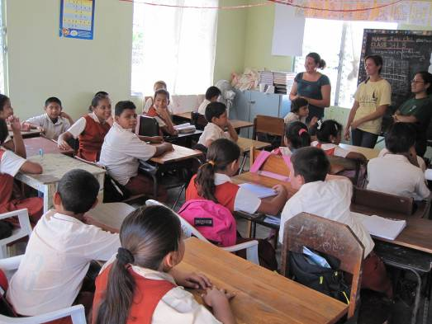
Our First Class

Garden Work
One of the main things we discussed at our first meeting was the fact that our service-learning project was a delicate one. It was very intricate as we were to deal with both children and plants both of whom require special care. We eagerly began our first challenge as a group, which was to investigate what types of vegetables and fruits grew well in this climate, the space they required and how long they would take to germinate. Based on our findings and the space we had to work with, we agreed that we were going to plant four basic vegetables: tomatoes, sweet pepper, lettuce, and cilantro.
We asked Mr. Edgar Tuyud, who is employed by central farm, to come and look at our garden and make some suggestions as to how we could proceed with the space and location of the garden. During this time we also met with Mr. Edmund Loague, a parent, who works closely with the PTA president, Mr. Rodolfo Urbina. We asked him if he would be willing to assist us with some of the labor required in constructing the garden. Fortunately, they were both excited and willing to assist us in any way possible.
After hearing suggestions we came up with a basic plan for the direction of the garden. We were going to make six beds with the help of the children; we were then going to plant, put up a fence and lastly we aimed to construct a shade cover for the garden so reduce the risk of desiccation from prolonged exposure to the sun. Slower but surely we were able to accomplish these goals throughout the course of the semester.
Making the beds was one of the first steps towards getting the garden ready. Students and group members actively worked to clear the space of any garbage, lumber and rocks that were in the area. With the use of some common tools such as shovels and picks we made raised beds for the pants and broke the lumpy soil into small crumbs more suitable for planting. It was here that we realized that the soil we were working with was not conducive for the cultivation of a garden. We decided that we would fill sacks of black soil, which has more organic nutrients, from Galen’s construction site and use it enrich our soils.
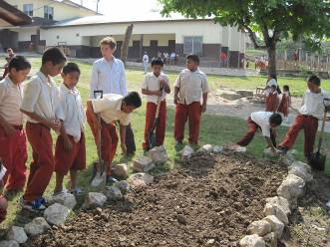
Creating the Beds

Upon completion of the garden beds, our next objective was to obtain seedlings that were already at least a few weeks old and could be easily transplanted by the students. In our first attempt at getting seedlings, we got a few lettuce plants and some cilantro seeds but nothing else. To our benefit we found out that 4-H organization assists with projects like this. We contacted the 4-H organization located in Belmopan and explained to them what are project was trying to accomplish. Fortunately they decided to assist us by donating some tomato and pepper seedlings for our garden. The week that followed, both Standard III classes proceeded to planting their vegetable plants and also watering them.

The next major task was the fencing of the garden. Mr. Loague assisted us with the burying of posts, which were provided by the school. Before we were actually able to put the fencing up, we had to purchase lumber. The lubber was needed to connect together the vertical posts, which would enable us to fence of the garden area. In order to know how much wood we had to purchase we had to measure the area and get an estimate to the project coordinator for approval. We all participated in constructing the fence around the garden area, leaving a door as the main entrance open.
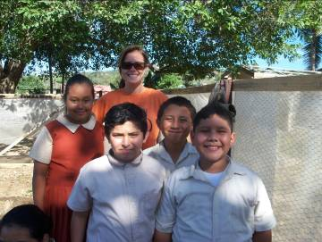
Margaret and Students in front of new fence

Every week we tried to bring in a few bags of fertile black soil to mix into the garden to enrich it. Recently, we went to a chicken farm and purchased some chicken manure that we mixed with black dirt and spread it all over the garden beds. This was an organic way of adding nutrients to the soil to achieve a better crop.

We recently completed a huge part of our work at the garden site, which was the adding of the shade cloth. We began by anchoring ¾ inch PVC pipes from the ends to the posts around the fence to form arches. Once the four arches were sturdy enough we proceeded to measuring and cutting the shade cloth that was going to be used to cover the top of the garden. We laid the three lengths flat on the ground with overlapping ends and stitched them together with fishing line to form a long sheet. Together we held the corners of the shade cloth and slid it gently over the PVC arches. It was now exactly how we wanted it. It fit just perfect so we started securing it to the frame from all angles. We are all so very happy with our garden and the fact that all the plants seem to be doing well and the will do even better now that they have some shade from the scourging heat.

The Garden Journal

Gardening is a fun activity that the students at Faith Nazarene have gotten to actively participate in and they enjoy it a lot. As part of the learning process the group decided that the students should each have their own journals. Hence, each student received a small booklet that had the first set of questions as a sample of what the rest should look like. The students began by first decorating the cover of their journal. We then explained to them that they were to take the journals to the gardening site, make observations and enter them into their garden journals (see page 25)
For the first few weeks students were only able to answer a few questions because the plants were too young to show flowers and fruits. In any case, this activity has taught the students to take a closer look (observe) for chances in growth.
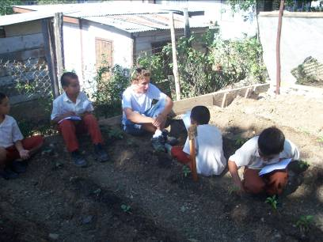
Recording in Journals at the Garden

Meetings and time put into project
Meetings with our group occurred twice a week and would last around an hour each. At the beginning of the week we came up with a lesson plan and then would meet half way through the week to discuss how class went and work on the progress of the garden. At the beginning of the project we were meeting for about four hours a week in order to start form lesson plans, a plan for the garden and other in class assignments due.
As a group, we have put a lot of time and effort into this project. We have spent a lot of time gathering and making material to use in class as well as time on our own working on the garden. Classroom time equaled four hours a week, and about an hour of preparation went into each of those classes a week. That means including meeting time, class time and preparation we have spent around eight hours working on this project weekly.
Over spring break, we knew we had to all assign times for us to water the garden since the children were out of school. Not only did we make a chart saying who was going to water when but we also used this time to make some improvements on the garden.

Garden Jobs
In order to ensure that the children were doing their part in the garden we developed a job system. The children were broken up into six groups and each group had a different day they were responsible for the garden. We had the watering group, which had to water the garden in the morning and in the evening and the management group, which had to weed, clean, and make sure kids weren’t entering the garden. Our goal for the job poster was to put some of the work on the kids. It was important to us to hand over as many responsibilities as possible and this is one of the ways we accomplished this. The majority of the kids really have enjoyed working in the garden, while others have needed to be pushed more. Having groups made the kids push each other to do their part as well because kids self-regulated each other.

Findings and Results

As a group, we have taught several classes emphasizing on the importance of gardening and taking care of the environment. Being in the classroom and in the garden with the children has enabled us focus on subjects that we felt as a group was important. We are leaving Faith Nazarene with a new garden that they will needed to be cared for and eventually harvested. We have found while doing this project that nutrition is truly an issue with these students. The “snack bar” at the school offer unhealthy snacks and few healthy ones. In the future, it would be helpful if there was more time allowed to put emphasize on the nutrition section. It is also important for children to understand the importance of keeping the earth clean, how everything is interconnected, understanding the ecosystems, the importance of exercise and how the body works, and basic gardening skills, all of which we have covered within our class.
Doing this project we have learned what techniques did and didn’t work. What did work was doing lesson plans like our recycling one. In this class we were able to give a good lesson while making the students engaged. A situation that didn’t work well is our test giving. We gave them a quiz that proved to be unsuccessful. The test may have been a little too complex and needed to be read out loud when administrated. Even though the students overall performed poorly on the quiz we are still confident that our lessons were successful.
In the garden we had some things that worked while others failed. We found that working with the children in the garden to be a very rewarding experience. While in the garden the students were interested and were retained information that we told them. The level of enthusiasm varied between student but for the majority they were all eager to play a part in making the garden. The journal was a great way for students to stop and really observe the progress of the plants. They were able to think about what the garden needed and what improvements needed to be done. We learned that due to the weather and children going to school and playing around the garden that some things didn’t work. When we put some mesh up around the garden it was ruined quickly from the children poking holes in it.
Through this project we have learned the process of administrating a garden for students. We have become more comfortable in a classroom as well as improved our communication skills. Working with the principle, teachers and PTA president we have gained connection that have been very beneficial to the building of the garden and the maintenance of the garden for the future. We plan on handing over the project to the PTA president to take care of the garden over the summer and there is talk about who will be covering gardening in the fall. We hope that through our connections with the teachers and students are hard work won’t disappear.

Recommendations

One of the sources of our success for the project was the knowledge passed on to us by the group that pioneered this project in the spring of 2009. Their failures and successes were valuable building blocks on which we continued what they had begun. One of the most valuable tips that got passed onto our group and we would like to recommend to the next years group is to start from seedlings. This is for two reasons. First, the plants have no chance of bearing fruits by the end of the 6 week project if they are started from seed. Second, the students need to see quick progress in order to have confidence in their growing skills. Beginning from seedlings will provide this.
A major part of our project was supposed to be about nutrition. After we met with our project partners for the first time, we realized that this goal was not going to work for this year. As a result, we taught instead science and health, fitness, life education. We taught them as a part of the regular curriculum and added in information about nutrition as often as possible. This resulted in our group feeling spread too thin, because we were teaching topics in the classroom, and still teaching in he garden, and the two were not connected. As a recommendation for the future of this project, we would suggest the project partner can work together with the group that allows gardening and nutrition to be the primary focus of the lessons. Fitting this into the curriculum could be a hard task, and therefor fit for the future service learning group to accomplish.
On that note, we have another recommendation for the education next year. This is designing a curriculum at the beginning of the project to outline what is agreed upon to be taught for each lesson for the 6 weeks. This has many benefits. First, it ensures that the project partner and the group are on the same page. This creates clear expectations and a reference to measure the groups achievements against. Also it gives the group the knowledge of what lesson they will teach it week. This opens up the option of having a pretest and a posttest, so the level of retention can be assessed.
There is a few things that our group really excelled in that we would like to share with the following group.The first is having really good communication with our partners and our advisor. If there was any question with the meeting time, what we were expected to teach, or feedback, we would get in contact with the related party immediately. This open line of communication played a huge part in our success. Second, and related to good communication, is the importance of building trust and respect with your project partner. As with elementary schools in the United States, Belizean primary schools are complicated and busy places. It is easy to become more of a burden on the teachers than an aide. We worked really hard to show the administration and teachers at Faith Nazarene that we were there to be an asset to them and to fulfill their goals for the project. Once mutual respect has achieved, the project goes much easier. Respect and reliability are foundations of relationships in Belize. Following these guild lines will not only help one group reach success, but ensure the sustainability of the project for many years to come.

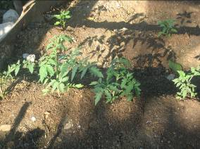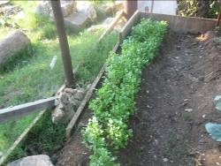
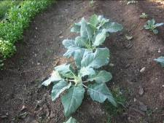 Plant developments
Our garden, completed!
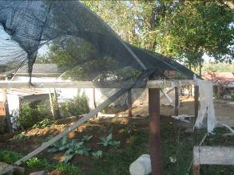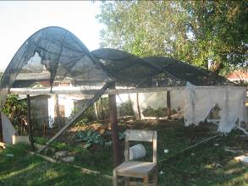

Appendices

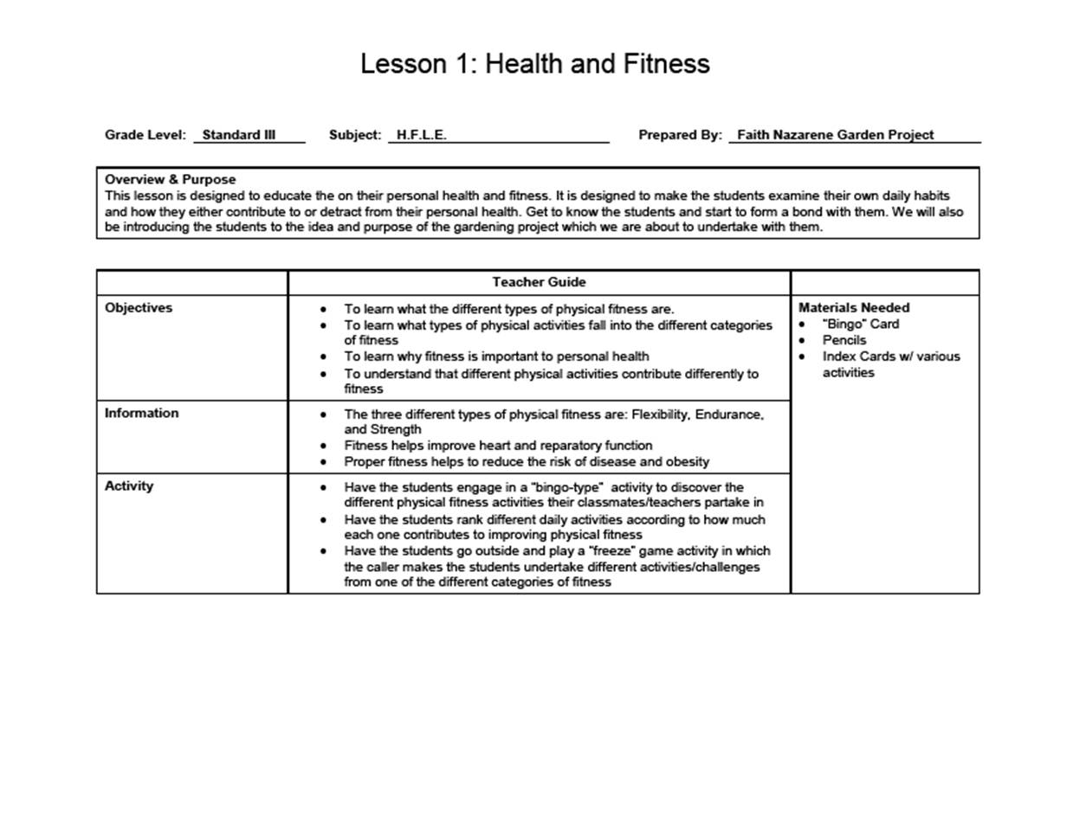

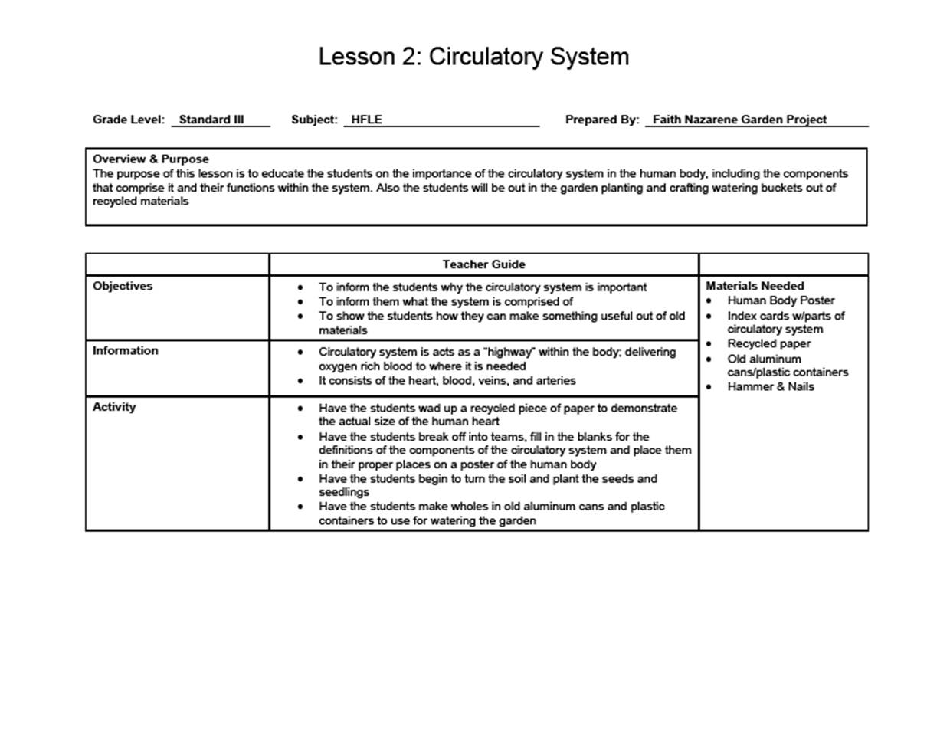

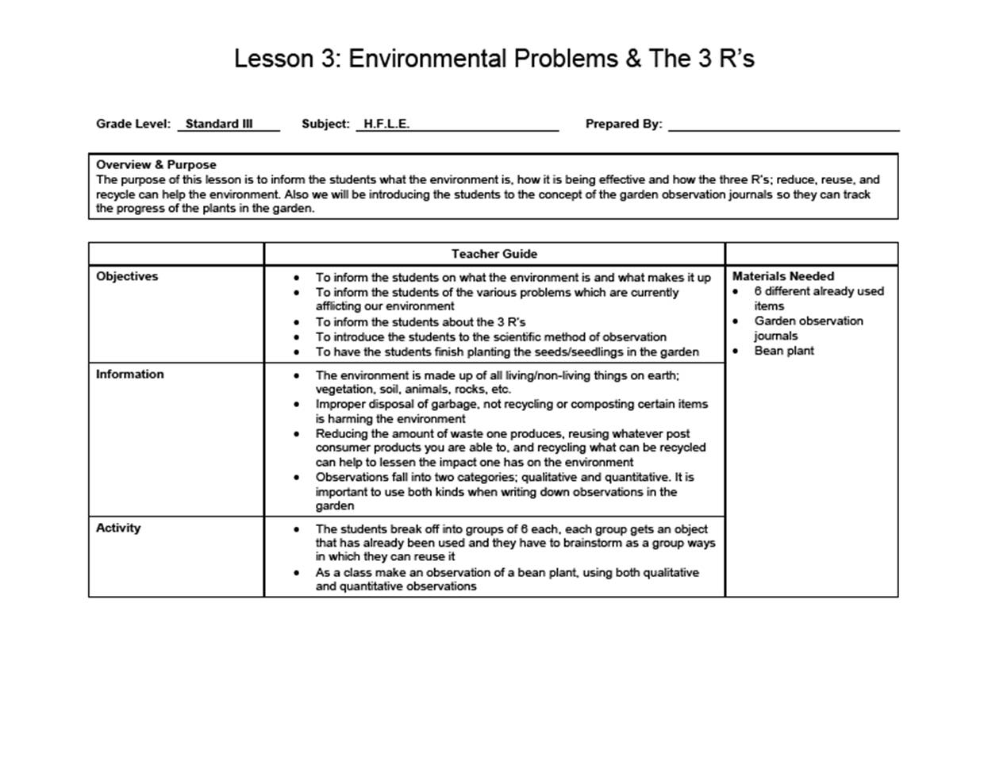

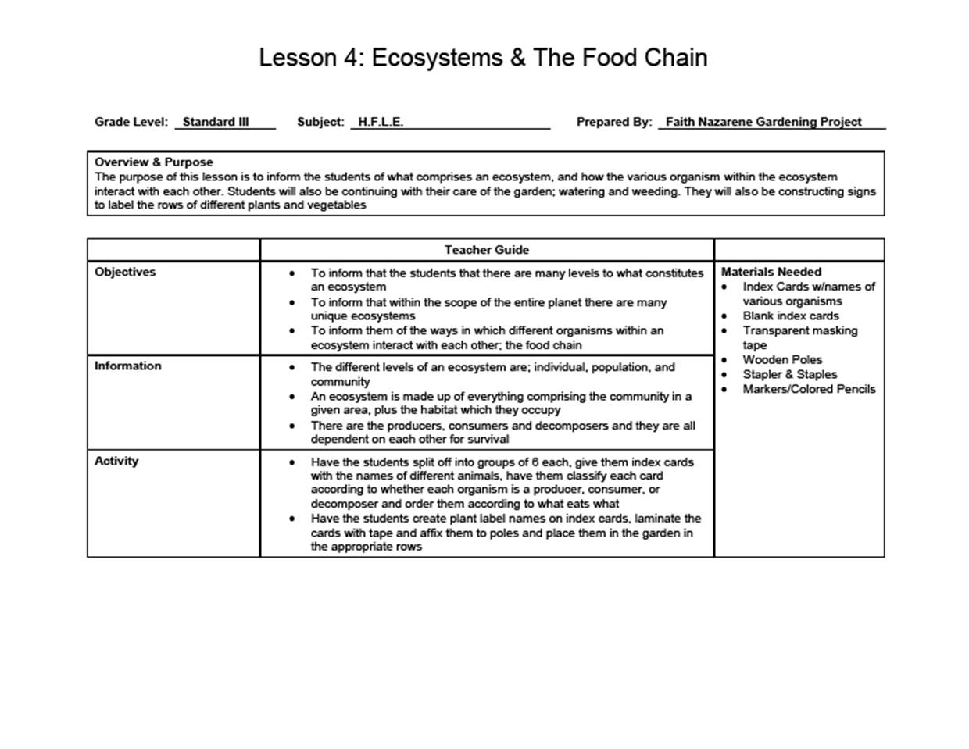

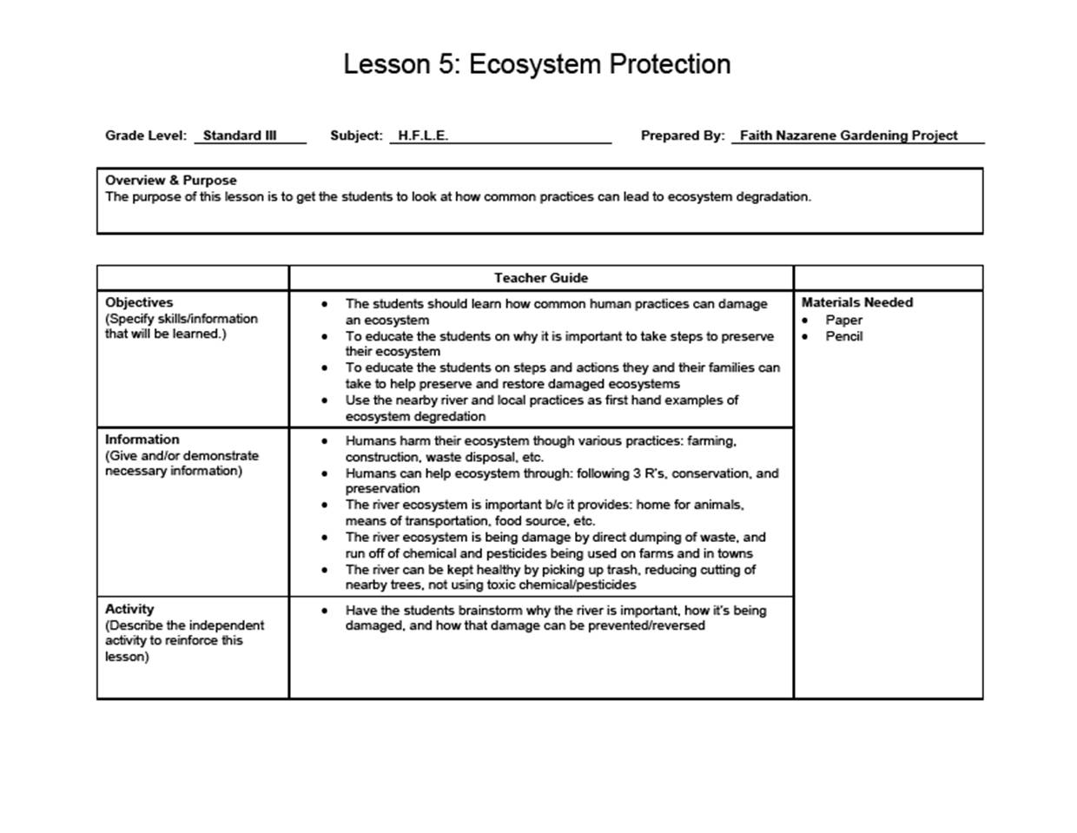

Bingo Board

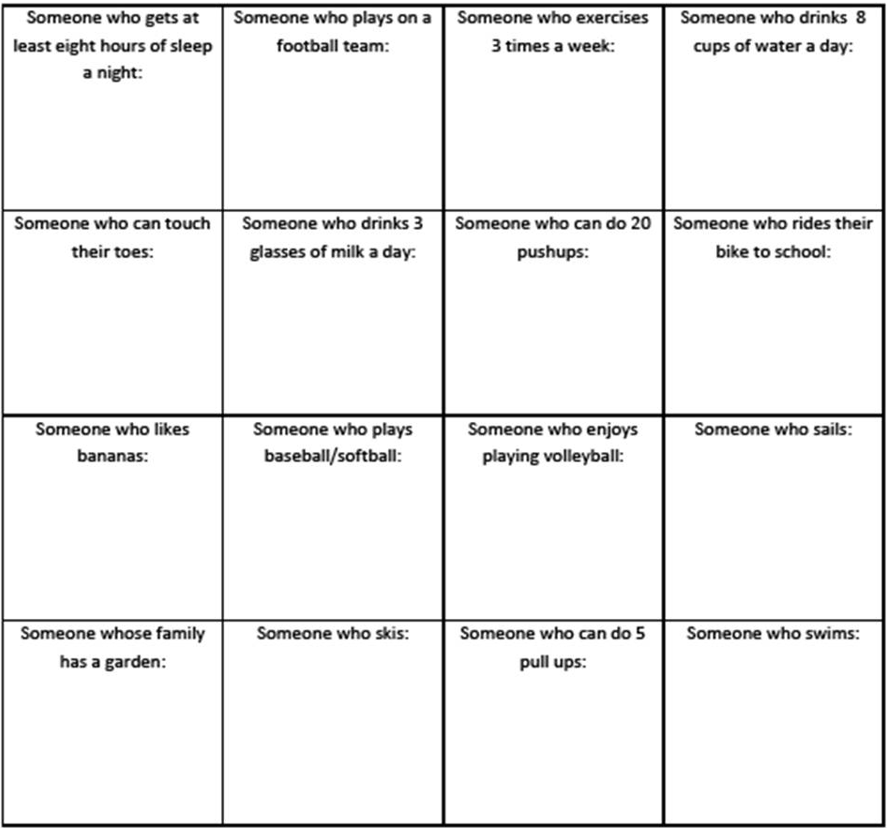

Journal Page
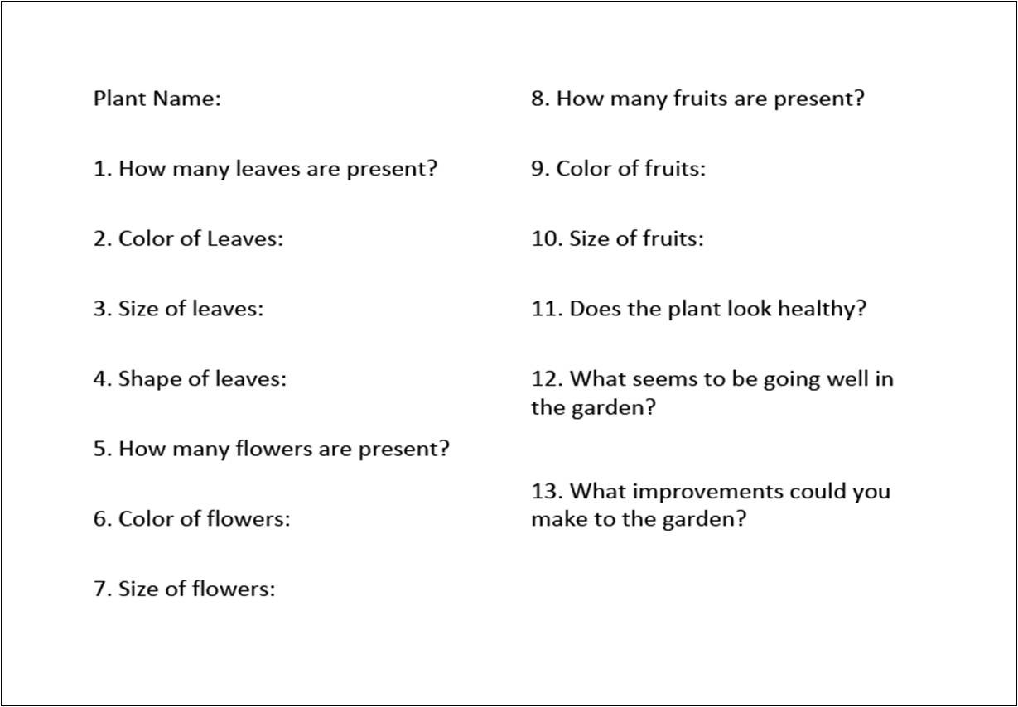

Final Quiz

Fill-in the Blanks
Fill in the blanks with the correct word from the box. 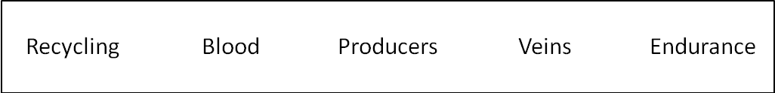
- ______________ carries oxygen and nutrients though the body.
- ______________ is how long you can do an activity for.
- Blood uses______________ and arteries to travel through the body.
- Filling up an empty water bottle with water and making watering cans out of old cans are both examples of ______________.
- ______________ take in energy from the sun in order to make food.

True and False
Say whether the following is true or false:

- In the food chain the producers eat the consumers.
- The environment is made up of all the living and non-living things on earth
- An ecosystem is made up of individuals, populations, and communalities
- The liver pumps blood throughout the body

Multiple Choice
Circle the correct answer for each question:
- What is not part of the 3 R’s?
  - Reduce
  - Reuse
  - Remain
  - Recycle

- What is not a type of fitness?
  - Strength
  - Arteries
  - Endurance
  - Flexibility

- How can we help the environment?
  - Burn Trash
  - Dump chemicals into the river
  - Cut down lots of trees
  - Recycle

Weekly Progress Summary

Week of | Progress towards the goals (i.e., who did what?) | Goals for next week | Stumbling blocks/Problems
Feb. 12 | Travis contacted Ms. Flowers and established a meeting. We established group roles and weekly meeting times. We discussed what goals and expectations for the project. And we brainstormed possible means for accomplishing them. We also distributed among group members plants to research; look up germination period, plot space require, climate, etc. | Meet with Ms. Flowers and find out what results/goals/expectations the school community wishes to see from the project. We hope to establish a more detailed outline of the potential shape our project will take. | We were unsure of what resources where at our disposal for this project, this created some difficulty with estimating a budget.
Feb. 19 | We met with the vice principle of Faith Nazarene and filled out the contract  We met as a group and planned out our first lesson  We met with Joni and she gave us suggestions on how to improve our lesson plan  We established a date when Elida’s brother is going to look at the gardening space and give some suggestions as to how to proceed  We met with Mr. Robelvi to discuss what curriculum he wanted us to cover in class  We met with the president of the PTA at Faith Nazarene who offered help with the construction of the gardening plot | Teach each of the standard 3 classes for a 2 hour lesson  Get soil/manure to garden  Begin germinating seeds  Build fence around garden to keep pests out  Purchase the equipment we will need to accomplish this project | Not knowing what resources we had available to us at the school, in terms of tools and equipment  Trying to find a suitable time to meet w/Mr. Robelvi to discuss the curriculum  Trying to come up with a lesson plan that was age appropriate/educational/engaging all at the same time
Feb. 26 | We taught 2 hour lessons in each of the Standard 3 classes  We purchased shovels, seeds, hammer and most of the materials we will need  We collected two bags of soil from Galen which we brought to Faith Nazarene to serve as the top soil to the garden plot  We begun creating a border to the garden so pests will not get in  We received feedback from the teachers on how to better structure our lesson plans | Have the students create their own garden journals to make observations in  Have the students begin planting the seeds/seedlings and caring for the garden  Complete the fencing as well as the shading for the garden  Teach a lesson about scientific method and making observations  Teach a lesson about the circulatory system | We now have two different amounts of time to teach for, so editing the master lesson plan to allot for the shorter class is a challenge  Figuring out the most effective way to get the students all equally invested in taking care of the garden on the days which we are not present
March 5 | We began planting the seeds/seedling in the Garden with the students  We taught a lesson on the circulatory system and heart health  We were able to introduce the Garden Observation Journals to Mr. Brandon’s class and had them do a practice observation but we were unable to introduce it to Mr. Robelvi’s class because Wednesday was a half day | Measure out the perimeter of the Garden to figure out how much lumber will be needed  Introduce the Garden Observation Journal to Mr. Robelvi’s class  Come up with a system to distribute the responsibilities of caring for the Garden | We are often times not kept abreast of half days or events that the school has which disrupts our teaching schedule
March 12 | We met with a group of 5 students from UVM and their professor, Dr. Berlin. We showed them the garden and they observed us in the classroom. Dr. Berlin, mentioned a man from Vermont might be willing to come down to Belize and work on forging a partnership between Faith Nazarene and a local farm if we are able to lay some of the ground work for him.  We taught Mr. Robelvi’s class a lesson on Environmental protection, but were not able to teach Mr. Brandon’s class b/c Monday was a holiday  We purchased the lumber that we needed to complete the fencing off of the Garden  We introduced the class to the “Garden Job” chart and explained the different responsibilities | We are in the process of trying to coordinate something with the 4-H organization in Belmopan  We are talking with Dr. Berlin and trying to contact Doug to see what we would have to coordinate between Fait | Some of the subject matter that the teachers are asking us to cover isn’t relevant to the theme of our project
March 19 | We spent an extra half hour in Mr. Brandon’s class catching up on the lesson we missed last Monday  Wednesday was a half day which we were not informed of so we had to condense gardening and the weeks lesson into one hour  We taught Mr. Robelvi’s class and Mr. Brandon’s class a lesson on the ecosystem and we did an activity with the students based on the food chain  We worked on putting up the PVC pipe for the shade netting | Elida is working on getting the 4-H group to come to one of our lesson’s; hopefully they’ll be able to make it Monday or Wednesday  We want to give the students a test or some kind of assessment covering all the lessons we’ve taught them  We have to figure out how the garden is going to be maintained during the two weeks the students are away on break | Getting the students to complete their assigned tasks for garden  maintenance  Staying informed of the school schedule is difficult; this week we asked Mr. Robelvi to call the liaison in the event that there is a half day or other event that would impact our teaching period
March 26 | On Monday Mr. Brandon’s Standard III students were taking an examination, so we were not able to teach them, we arranged to go in on Thursday for half an hour to do Garden Observations with the students  We taught a lesson to Mr. Robelvi’s class on how the students can take action in their community to help preserve the environment  We brought the students outside to work on garden observations of the plants  We were able to get a key from the caretaker at Faith Nazarene so that we could go in to water during the two week break | We are going to give the students an quiz on the material  we’ve covered with them so far  We are going to work on improving the fencing of the garden; the netting has already started to rip  During these next couple of weeks that we don’t have to teach we are going to work on getting our final project | Mr. Robelvi is not going to be teaching after the break; we now have to coordinate with another teacher on lesson plans for the remaining two weeks we need to teach
April 2 | This week because the students were not in school we worked primarily on our final project  We searched for more articles so that we could expand our lit review  Elida talked to her brother about getting more netting so that we could put the shade covering up  We went to the garden in the late afternoons to water and weed while the students are away  We collected more chicken poop for fertilizer | We need to divide up responsibilities for the final project  We need to either buy more netting if Elida’s brother is unable to get us some, and then we need to put that netting up  We need to continue to weed/water the garden while the students are away on vacation  We need to get more soil from Galen to mix with the fertilizer | Only having one copy of the first draft has a lit review has been making it difficult for everyone to know exactly what they need to correct/improve upon  We’re sharing the responsibility of watering/weeding the garden and it has been difficult to handing off the key between us @ Martha’s and the Belizeans. We still need to figure out how to hand it off before we leave for Guatemala for Easter
April 9 | We prepared a short final examination based on our semester’s lessons for the Standard III students  We finally got some netting, and we put up the PVC pipe as well as shade covering  We continued to water and weed the garden while the kids were away  We got soil from Galen which we mixed with the fertilizer and added to the garden | We need to collect and read the students garden observation journals next week  We need to talk to both standard III teachers, Ms. Flowers and Mr. Urbina to figure out how the garden is going to be cared for after we leave | Trying to equally distribute responsibilities for the final presentation and project has been difficult because there is rarely a time when we’re all available to meet as a group  Compiling our lit review was a challenge because the group member who had the hard copy w/correction did not come back to Cayo until the Wednesday afternoon before the final copy was due
April 16 | We assigned tasks for the final project and power point presentation  We taught our final lesson to Mr. Brandon’s class  We collected the Garden Observation Journals from both classes  We gave the students a quiz of all the material we covered throughout the course of the semester | We need to look at both the Garden Observation Journals and the quizzes and write something up about them in our results & findings section  We have to plan out what we are going to do for a last day celebration with the class  We need to talk to Mr. Urbina and Ms. Flowers about what’s going to happen to the garden after we leave | Trying to figure out how the garden is going to be managed after we leave  Getting used to the new classroom dynamic now that Mr. Robelvi is no longer standard III  Administering a test when the class last reviewed the material before the start of vacation
April 23 | We had a final celebration with the students on Wednesday, where we made healthy snacks for them  We talked to Mr. Urbina, and the PTA will look over the garden after we leave  We rehearsed our power point in front of both Jared and Joni, got feedback and made necessary correction  We sent an e-mail out to Doug Davis about the Farm-School Program | Continue communication with Doug Davis about starting up a program  Continue communication with 4-H to try and have them help with the garden after we leave | Trying to get the power point out to all of the group members with unreliable internet  Trying to coordinate times when we could all sit down and rehearse the power point

Literature Review

A school garden is an important way in which students learn about the importance of eating healthy, while also implementing some ways in achieving it. School gardens have been implemented throughout Belize in order to promote better nutrition and educate the children on healthy eating. One of the biggest challenges that our group faces is that the garden may fail after handing it over to the school. However by looking at the recommendations from last year’s group and discussing solutions to this challenge, we hope that the project continues. The literature review will further help us in achieving our goals at Faith Nazarene and better educating the children about the importance of nutrition and eating healthy. The garden and nutrition project we are working on can be play a major role in encouraging these primary school kids to eat healthier. Several articles are examined in this literature review, which are associated with the project we are working on. They are going to be a critical part in completing the project for this course successfully.

Nutrition in Belize
In 1996, there was a census conducted on the height of primary school children ages 6 to 9. This study was the first for Belize and its results were quite astonishing. It revealed that 15.4% of the children showed growth retardation (too short for their age) and the majority came from the Toledo, Cayo, Corozal and Stann Creek Districts. The CEO in the Ministry of Heath, Dr. Allen attributes the retardation in growth to environmental factors that can easily be manipulated by personal and community action (Ramos, 2009).
The article is relevant to our service-learning project in that we designed our lessons around the theme “nutrition” and we tried to reinforce the importance of healthy eating by making a vegetable gardening. Our work is simply a step taken to address the problem of poor nutrition among our children. According to the article, the second census done in May 2009 will be able to give us a better idea of the magnitude and severity of the growth retardation problem but the source of information could not be consulted. These results will be used as a guide for drafting decisions based on the national, district and village data collected. If Dr. Beer is right about growth rate being highly dependent on the diet, health, environment and socioeconomic factors of the child then we are on right track.
As the team prepared and patiently waited for the school bell to ring, we witnessed how the children ran around playing games as they snacked on what we commonly call “junk food”. They ate chips, biscuits, sweets and ideals during their break. If one child was observed consuming some sort of fruit it was a lot because it was rare to observe a kid eating healthy. This makes our task even harder because we need to tackle the problem from the source and the source may be the cafeteria. The lessons we teach have to be supplemented by the practices within the school compound such as the diet and how this influences the health of the children. A small garden cared for by the children at the school will be beneficial to them and to the cafeteria.
Dr. Beer in the article suggested that the data collected could be very useful for designing and evaluating policies, for the redistribution of resources, intervention, and indicating whether responsible agencies have been successful in reducing growth retardation (Ramos, 2009). A primary school like Faith Nazarene would be an ideal institution to participate in the survey. Once a group of urban and rural schools participate we can compare the results and make some concrete recommendations. It is already recommended that studies like these be done every five years but we cannot be sure that they will. Within the Faith Nazarene school the administration could also take a stand in ensuring that healthy snacks are sold at the school cafeteria and that the curriculum includes weekly physical activities.
Teachers play an important role in the responsibility they have in reporting growth retardation as they keep record and track of the children in their classroom. This can be done not only by the teacher but also by parents who spend a lot more time with the children. From a survey and activity we did in class with the students we realized that most of them have an idea of the benefits of healthy eating and are able to recognize the healthy and unhealthy foods. What we don’t know is if they can afford it. We need to take a close look at what is the diet of children in Belize between the ages of 6 to 9 to understand the issue at hand better. Because the stunted growth is also affected by the child’s health, fitness must also be included in addressing the problem.
Due to the gap between studies (1996-2009), it would have been good to mention the interventions have been taken during that time. The article makes absolutely no mention of what can be done about this issue. School projects such as the Gardening project can be implemented at primary schools throughout the country and they are definitely a great recommendation. The emphasis should be in incorporating what is taught under the health and nutrition curriculum to a practical activity that children can engage into. They would not only enjoy it but they would be learning at the same time. The question right now is what are the results?

Garden Design
The main goal of this service learning project is to develop a sustainable garden at Faith Nazarene Primary School and educate the children about the importance of nutrition and health science. The above article was studied and some interesting points about great garden design were discovered in it. In order to give credibility to this article, it is important to say that it was written by a garden design expert and the host of On Garden Architecture. One point that is mentioned is that in order to have a beautiful garden it is important to have a great design outline. Tips are also given to ensure the planning of a garden and how to keep it looking fabulous all year long. This is important in order to maintain our garden looking good throughout the year. Ten very important tips are given to create and maintain a healthy garden throughout the year. These tips are very important and can aid us with our garden. They provide essential information in starting a garden and how to make it always look good. One of the main goals of this project is developing a garden and the article provides things such as tips, recommendations and suggestions on how to accomplish this. One of the major problems with this article is that the recommendations given need to be adjusted for the Belizean context. The article is written more for an American style garden and there are some differences between Belize and the United States. The article is still a great piece of work in helping people get an idea on how to go about creating great garden designs. The article points out an important thing, it is important to locate a water source to water the plants. This is very important because water is essential for plants to survive.
The website is for School Garden Project of Lane County. It is a well-established program that has a lot of information on having a school garden project. The website provides information on its program, as well as, information that people who want to have their own garden projects can use. Some of the things available are cost lists, plant choices and a planting chart, maintenance costs, etc. All of this is really useful for our project. The only problem with it is that the information is geared towards use in Oregon, USA, and other northern locations. The way it is organized and presented is a great example for us to replicate; however the costs and vegetables discussed do not apply for projects in Belize.
This website is all about teaching kindergarten to 4th graders about gardening. It is full of all kinds of resources that can be used in our garden project. One benefit of using this resource is that the editors of this information have a lot of experience with this topic. Therefore, any ideas that we have, chances they have already tried it and have a revised idea that works better. Some of the topics covered on this website that are relevant to this project are journaling, teaching composting, nutrition in the garden, and indoor activities. Information on each topic is divided by grade, so there is something useful for every age in standard 3.
This article is based primarily on nutrition programs in elementary schools in California. It has a number of different in-school nutrition programs in the article. For each program, the article discusses it and evaluates its effectiveness at improving the students’ healthy eating choices. The most relevant part of the article to this project is the section on gardens and diet. It evaluates a program in a California school that has both nutrition lessons and an accompanying garden. One great idea that is presented in the article is sending home newsletters to the parents after each lesson to help the whole family to get involved and further the child's learning. This is something that could be done in our project easily but we were unable to implement this strategy. It would be a great way to bring some of the knowledge to the parents of what the project is teaching and how they can help their student learn more. In this article it is concluded that this type of project has the potential to be effective in positively changing the food preferences of the children involved. This means that if our project follows some of the same guidelines, it has the proven potential to be successful.

Education

Goal: To give an educational experience for the children that is useful and informational as well as fun. In order to do so we need to examine ways to improve our own teaching abilities as well as tools we can use to motivate the children.
The article had several emphasis on what needs to be done in order for a teacher to be successful. A person needs to be passionate about what they are teaching as well as excited. It talks about holding students accountable and making sure they follow through, this is important to the development of the students. So, one way we are going to hold them accountable is by making sure they water the garden. The article emphasizes having high expectations. For us it is important to set expectations that are doable for kids in Standard 3. The group needs to provide out of the box techniques for teaching and new learning techniques these students haven’t experienced yet. Using the garden and giving them a job and hands on situation is a new way we are trying to reach the children. Making it seem like their jobs is very important is important according to the article. Also, Incentives are a good thing, but need to be small.
Trying to give individual attention to the students and being sympathetic when help is needed is an important tool to use when working with younger students. Due to class size, it is important to understand when a student just wants attention versus when they really want help and guidance. The ability to recognize mistakes and learn from them is important for the teacher as well as the student. The author reminds the reader to not take anything too seriously; if a mistake happens or something doesn’t work out it’s okay.
In order for things to be done in the garden it is important that students take part of the responsibility. Not only because there is a lot of work but because by giving them jobs, it passes the responsibility back to them. This article suggests that you have the students choose what jobs they would like to perform. If more time was given, having students choose between watering the garden, or managing the garden may have been a good idea in order to put more emphasizes on the job assignments. You have to give the children certain tasks although it is unable to trust that they will complete them. This has been a problem in our garden because it is hard to trust that they will actually water the garden. The article thinks that it is important that when a teacher is about to give jobs to students that you build up anticipation by telling them about it a few days before actually introducing it. This idea is a good one because then the students are thinking about it beforehand.
As the article says, “classroom jobs are a wonderful way to teach responsibility and build a sense of classroom community.” Hopefully by giving garden jobs we are accomplishing both of these things.
Nutrition and Fitness

The article reviewed talked about the perceptions of nutrition and fitness that students, teachers and parents have. The article can give some sense of what preconceived notions the Standard 3 students have regarding food, nutrition and fitness. Because a large sections of our project focuses on healthy lifestyle choices with respect to food and fitness it is useful to understand where the students are coming from in terms of their prior knowledge. This will give us an idea as to how we should tailor our lesson plans so the students get the most out of them. The article discussed using focus groups of American students in sixth seventh and eighth grade. It is likely that what we encounter in the classroom will not mirror the result of the survey conducted in the article because of cultural differences between America and Belize and the age difference of the students; we will be working with standard three kids. The article talked about students having rough ideas as to what constitutes a healthy food. When asked most kids replied with fruits and vegetables as being healthy foods, however most did not mention lean proteins or whole grains (Power et al., 2010, p. 15). Therefore in our nutrition lesson plan we will have to emphasize the importance of a balanced diet and that fruits/vegetables are not the only healthy foods available. When discussing fitness the article mentions that kids recognize and participate in sports and other enjoyable as forms of physical activity but few consciously exercise (Power et al., 2010, p. 16) this means that we will have to focus our fitness activities on games and really fun and interactive activities. We also want activities to be inclusive and easy for everyone to participate in regardless of prior skill. This is because in the article the survey found that a barrier preventing most kids from participating in physical activities is they are self conscious about their skill level or the perceived “coolness” of the activity. The article confirms that our students, like the students in the study are likely to have a prior understanding:

“These results confirm that early adolescents understand the role of lifestyle factors in health. Consistent with previous focus group studies,15–18 early adolescents understood the relationship among eating, activity, sleep, and health, although they appeared more motivated by the short-term than long-term consequences of these behaviors—weight control, energy level, and sports performance versus long-term health.” (Power et al., 2010, p. 17)

This means that we are probably not going to be starting from scratch; the kids have a prior understanding of the subject material and it is ultimately up to our group to make sure that the information that they have is correct, as well as fill in any gaps which may exist.
Gardening with young kids posses a tremendous number of obstacles, regarding attention span, limited understanding of science and biology, and behavior management. The article “An Elementary School Garden Project offered a number of possible solutions to the aforementioned problems. The article was specifically about starting up an elementary school garden, though mostly anecdotal as opposed to scientific observation. The article was useful because it runs parallel to what we are attempting to do at Faith Nazarene. There are a lot of strategies and activities discussed in the article that we were already implementing in the classroom, prior to reading about them in the article. There were also new ideas and activities which our group had not thought of, which now after reading about, we will consider implementing. The article discusses having to deal with the problem of keeping 45 kids occupied and behaved; we face a similar problem with the 72 students involved our project. The article say that to ensure the students were all kept “profitably occupied” (Elzey, 1944, p.117 ) was by dividing them up into groups. This is certainly something we can do with our class in order to ensure that the each get a turn to interact with the plants in the garden while not have the other standing by idly. The article offers up activities that are both educational and engaging for the young students. One such activity was a demonstration of how different soil types (e.g. sand, soil, humus) differ in their ability to retain air and water (Elzey, 1944, p.116). The article also discussed having the class select the garden plot based on the amount of sunlight a place gets (Elzey, 1944, p. 117) we are unable to do this because the garden plot had already been started prior to our arrival. However, we can still demonstrate the importance of sunlight to the students through an experiment in which we expose seedlings to varying amounts of sunlight and observing how their growth patterns differ. The important information which this article provides our group is that our gardening project has to be interactive and engaging as possible in order to ensure that it has the greatest educational benefit to the students.
One question that came up amongst our group at the start of the Faith Nazarene Garden Project was: Are these kids going to be old enough to grasp the concepts we are trying to teach? The article “School Gardens in Ireland 1902-24” helps in addressing the question of school gardens and age appropriateness. The article discusses how gardening can be introduced to students in elementary school to teach as Sir Horace Plunket, vice president of DATI said: “elementary notions of science and a training of the faculty of observation through illustrations of scientific teaching drawn from physical surroundings of rural life” (Forrest & Ingram, 2003, p. 81) The article then goes on to say a garden has the ability to be of use for higher education; in Ireland gardens were set up as teaching grounds to educate people on the practice of successful gardening and also empowering them to pass on the knowledge (Forrest & Ingram, 2003, p.85). The implication of this is that as a group we should not concern ourselves with whether or not the students are too old or too young to garden. The article demonstrates that school gardens have educational value regardless, of the age or education level of the pupils. What matters is that the lessons are tailored to fit the level of the students. One thing that this article stressed was the passing down of knowledge. When discussing the benefits of a school garden Forrest and Ingram said: “school gardens educated older pupils in the technical skills of gardening, leading to food production and, to some extent, nature study.” (Forrest & Ingram, 2003, p.80) This has tremendous implications for the sustainability of our project. The aspect of the project that the UVM group from last year had trouble with was keeping the garden going after they left. According to the article our aim in this project should not be teaching the students how to garden; our aim should be to educate the students how to teach their peers and younger about gardening. If we teach not only the information, but also how to re-teach that information to others, then we can ensure that this project is sustained and kept going by being past down from one grade to the next. (Forrest & Ingram, 2003) (Elzey, 1944),

Conclusion
Doing the literature review has served the purpose of looking at what experts have to say about the many areas related to the service project our group is working on. It allows for us to look at their views and from there we can implement the relevant concepts that can be related to out gardening and nutrition project at Faith Nazarene. Some of the challenges the group faces can also be addressed by looking at what other people have to say about it or how similar challenges have been solved. It has been a great opportunity for the group to work on a project like this and the willing power of everyone has certainly allowed for this project to flow smoothly throughout. The project has come a long way from the beginning and as it closes to an end the results of much hard work are becoming clearer.

Budget
Category of expense | Anticipated expense in $BZ | Justification | Running Total
2 Shovels | $30 | We need these to help us turn the soil in the garden | $30
3 PVC Pipes | $36 | We need these to create the frame for our shade cover for the garden | $66
Lumber | $40.30 | We need this to help construct the frame for our fencing | $106.30
School Supplies from Angelus Press: Markers, Tape, Paper, Posterboard | $28 | We need these for our class room lessons, for making posters and signs with the students | $134.30

References
Awe, J. (2010). Maya Archaeology and Architecture [Power Point Presentations]. Retrieved from Galen University.

Elzey, L. (1944). An Elementary School Garden Project. The American Biology Teacher, 115-118.

Forrest, M. & Ingram, V. (2003). School Gardens in Ireland 1901-24. Garden History, 80-94.
Gannys Gardening School. Retrieved April 9, 2010. Website: http://www.grannysgardenschool.com/503-0-00-Journal.html

Haig Seferian (2010). 10 Easy Steps to a Great Garden Design. Retrieved on February
25, 2010 from
http://www.hgtv.ca/gardening/articledetails.aspx?ContentId=755&cat=2&by=6

Lewis, Beth (December, 25, 2008). 6 Traits of Successful Teachers. Retrieved February 25, 2010, from about.com website: http://k6educators.about.com/b/2008/12/25/6-traits-of-successful-teachers.htm

Lewis, Beth. Teaching Responsibility with Job Applications and More. Retrieved April 1, 2010, from about.com website: http://k6educators.about.com/od/classroommanagement/a/Classroom_Jobs.htm

Morris, Jennifer. (September- October 2000). School-based gardens can teach students healthier eating habits. California. Retrieved April 9, 2010. Website: http://californiaagriculture.ucanr.org/landingpage.cfm?article=ca.v054n05p40&fu lltext=yes

Naturalight Productions Ltd. (2010). The Suppression of Agriculture. Retrieved April 2010, from A History of Belize: http:// www.belizenet.com/history/chap8.html

Power, T., Bindler, R., Goetz, S. & Daratha, K. (2010). Obesity Prevention in Early Adolescence: Student, Parent, and Teacher Views. Journal of School Health, 9-13.

Science Daily, (2009). Leaf Vegetable. Retrieved February 25, 2010 from http://www.sciencedaily.com/articles/l/leaf_vegetable.htm

Ramos, A., 2009. Are our children too short for their age? Amandala Online. Retrieved
on February 29, 2009 from http://www.Amandala.com.bz/newadmin/preview.php
?id=8532
Rustheiser, C. C. (1992). Education. Washington, D.C.: Library of Congress Federal Research Division.

School Garden Project of Lane County. (2010). Retrieved April 9, 2010. Website: http://www.efn.org/~sgp/html/howto.html

