Economics 172
Homework 8 Due Wed. May 4

Review Questions
Chapter 10 10.6, 10.9, 10.11, 10.26

Ch 11 11.2, 11.5, 11.6, 11.21, 11.25

Chapter 10
10.6 Airline fares were above the competitive level because costs were elevated above the competitive level as the airlines engaged in non price competition. The airlines did not earn any economic profits. The CAB allowed them to raise prices in response to their higher costs.

10.9. a. A reduction in maximum fares cabs could charge would reduce the price of a medallion. It would be like a price ceiling below the equilibrium price so there would be a shortage.
b. This would increase the demand for taxis (subways and busses are substitutes) so the price of a tax trip would increase and the price of a medallion would also rise.
c. This would also increase the demand for taxis.
d. Same as c.
e. The price of medallions would fall but taxi fares would not change until entry was allowed.

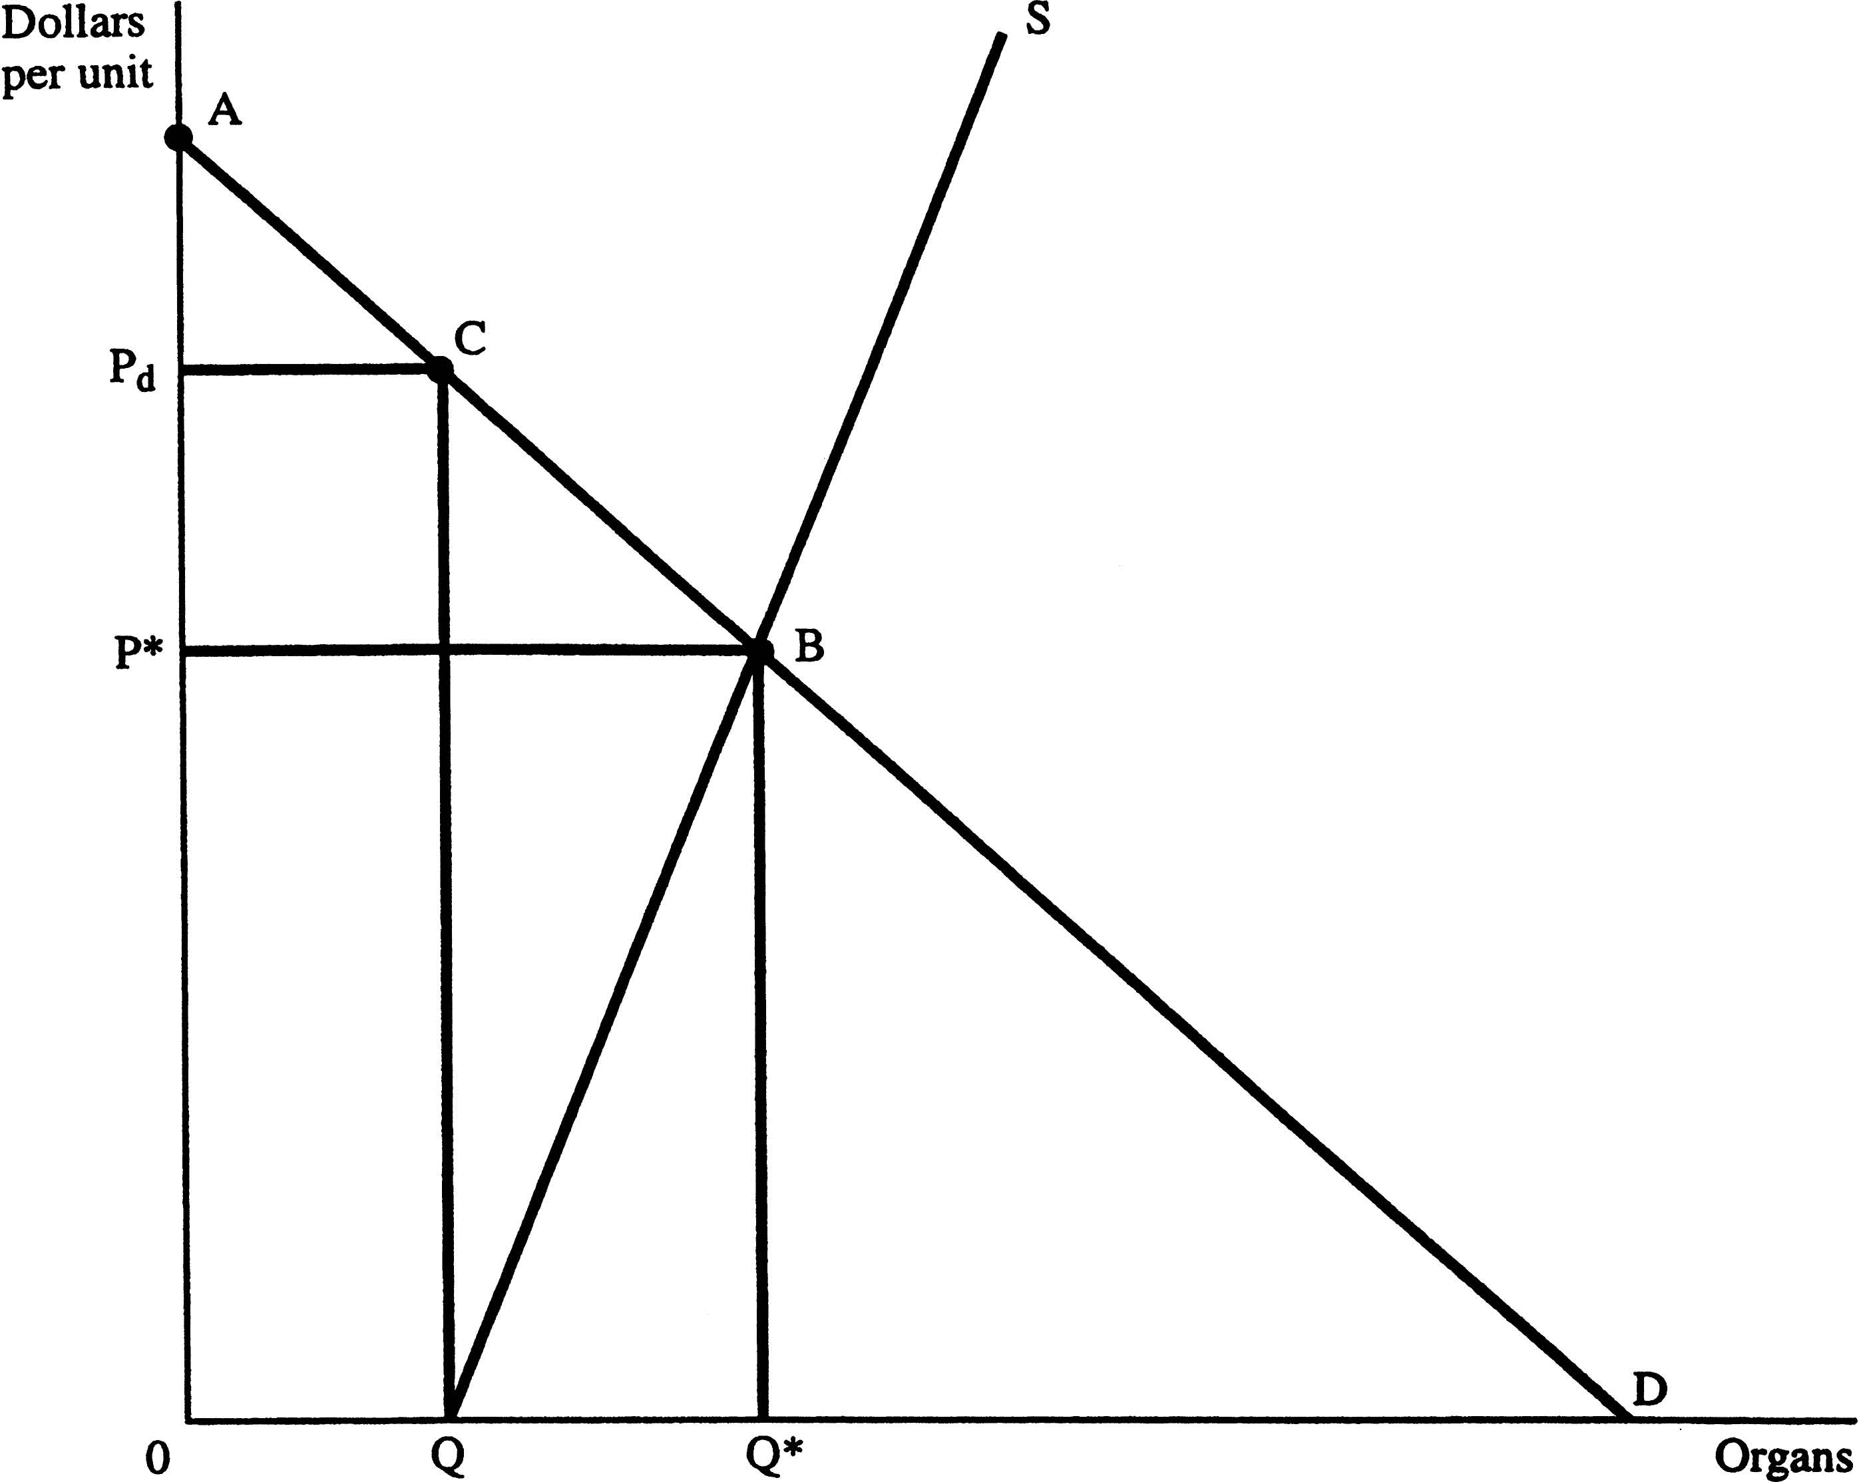
10.11. Under the current system, the quantity supplied of organs is Q and the price is 0. Note that there is a shortage of the amount from Q to where the demand curve hits the x axis. Buyers pay nothing for the organ itself (although they do pay for all the medical services required for the transplant). Total surplus is ACQO.

Under unrestricted markets, the quantity would be Q* and price would be P*. The total surplus at this equilibrium would be ABQO. Under the current system, the surplus is ACQO, which is less by the area of triangle CBQ.

10.26 In the short and long run, the number of hours worked by the average licensed doctor will increase, the profits made by licensed doctors will increase, and the prevailing prices charged will rise.

Ch 11

11.2 We would clearly be better off with an AIDS vaccine than without one.

11.5 If P = 2MC how to find elasticity of demand e?

MR = P (1-1/e) Solving for e:
MR/P = 1-(1/e)

MR/P – 1 = 1/e

e = [1/(MR/P)-1]

e = [1/(MR-P)]/P

e = P/(MR-P)

A monopolist prices where MR = MC so e = P/(MC-P) and we know that P =2MC so

E = 2MC/(MC – 2MC) = 2MC/-1MC = -2

The elasticity of demand is -2.

11.6 If the ski resort charged a lower price and increased output, it would not be maximizing profits. If they lowered lift ticket prices, they would have to lower them for everyone, not just the skiers who would only ski at the lower price.

11.21. ATC is minimized and is $50 per unit. MR = $60. If ATC is minimized then MC must equal min ATC so MC = $50. Since MR>MC, it is not maximizing profits and it should increase output.

11.25 If the City Council waits 10 years and price ends up equaling average cost, the good citizens of Berkeley have missed out on 10 years worth of any consumer surplus at all from buying cable TV, even if they are paying a monopolistic prices and the cable TV company is earning economic profits.

