There were 2 different exams, but the questions were the same. Those of you who had the second exam will have to look for the question in a different sequence below.

Economics 11 Name: __________________
Spring 2005 Exam 1

. If labor in Mexico is less productive than labor in the United States in all areas of production,
a. neither nation can benefit from trade.
b. Mexico can benefit from trade but the United States cannot.
c. Mexico will not have a comparative advantage in any good.
d. both nations can benefit from trade.

A country ALWAYS has a comparative advantage in something, which means that it will always benefit from trade, as will the nation it trades with. So d.
. Approximately what percentage of the world’s economies experience scarcity?
a. 25%
b. 50%
c. 75%
d. 100%

Every nation experiences scarcity. There is not enough of everything to satisfy everyone’s wants. So d.
. Henry decides to spend two hours playing golf rather than working at his job which pays $8 per hour. Henry’s tradeoff is
a. the $16 he could have earned working for two hours.
b. nothing, because he enjoys playing golf more than working.
c. the increase in skill he obtains from playing golf for those two hours.
d. nothing, because he spent $16 for green fees to play golf.

If he spends 2 hours playing golf, he gives up the opportunity to earn $16 (d). The opportunity cost is the cost of the next best alternative.
. What would happen to the equilibrium price and quantity of peanut butter if the price of peanuts went up, the price of jelly (a complementary good) fell, fewer firms decided to produce peanut butter, and health officials announced that eating peanut butter was good for you?
a. Price will fall and the effect on quantity is ambiguous.
b. Price will rise and the effect on quantity is ambiguous.
c. Quantity will fall and the effect on price is ambiguous.
d. The effect on both price and quantity is ambiguous.

There’s a lot going on here. Peanuts are an input into the production of peanut butter, so a decrease in the price of peanuts will shift the supply curve of peanut butter to the left (decrease). If fewer firms produce peanut butter, supply decreases. An decrease in the price of a complementary good will increase the demand for peanut butter (shift right). If there are positive health effects from peating peanut butter, the demand will increase. The net result is that the price will be higher, but quantity may be higher or lower (b)
. A donut shop sells fresh baked donuts from 5 a.m. until 3 p.m. every day but Sunday. The cost of making and selling a dozen glazed donuts is $1.00. Since this shop does not sell day-old donuts the next day, what should the manager do if he still has 10 dozen left at 2:30 p.m.?
a. lower the price of the remaining donuts even if the price falls below $1.00
b. lower the price of the remaining donuts as long as it’s more than $1.00
c. Lower the price on all donuts so they will all be sold earlier in the day
d. throw them away and produce 10 fewer dozen tomorrow

The cost of making the donuts are a sunk cost once they are produced. If you threw them out, you would get no revenue from them, regardless of what you decide to do tomorrow. If you lower the price, even below $1.00 you will still get some revenue from them, which is more than $0. So a.
. In the former Soviet Union, producers were paid for meeting output targets, not for selling products. Under those circumstances, what were the economic incentives for producers?
a. to produce good quality products so that society benefits from the resources used
b. to conserve on costs, so as to maintain efficiency in the economy
c. to produce enough to meet the output target, without regard for quality or cost
d. to produce those products that society desires most

The economic incentives are to meet production targets (c). That’s why Soviet goods were of such low quality.

. One component necessary for markets to work is
a. government control of market prices.
b. a benevolent society.
c. property rights.
d. abundant resources.

Government control of prices doesn’t make markets work. And abundant resources don’t either. In fact, scarcity is caused by scarce resources, which makes markets a necessity for efficient allocation. Property rights are key: letting people own resources and do what is best for them with those resources.
. Price ceilings and price floors
a. are desirable because they make markets more efficient as well as equitable.
b. cause surpluses and shortages to persist since price cannot adjust to the market equilibrium price.
c. can be enacted to restore a market to equilibrium.
d. are imposed because they can make the poor in the economy better off without causing adverse effects.
They are put in place to make things more equitable, not more efficient. They do cause surpluses and shortages (b). They prevent markets from getting to equilibrium. And they do have adverse effects.
. In the United States, incomes per family have historically grown about 2% per year. At this rate incomes will double every
a. 10 years.
b. 25 years.
c. 35 years.
d. 50 years.
The rule of 72 says 72/growth rate = years to double. 72/2 = 36, so c is correct.
. In the nation of Dictatorland, farmers traditionally feed grain to their livestock. Central planners, however, decided to increase the price of grain to make grain farmers happy and to reduce the price of bread made from that grain to make city dwellers happy. Now the price of bread is lower than the price of grain. We might now expect
a. farmers to continue to feed grain to their livestock.
b. farmers to start feeding bread to their livestock.
c. city dwellers to start buying grain to make bread to eat.
d. city dwellers to start buying grain to make bread to sell.

This actually occurred in Poland when it was controlled by the communists. Since grain was more expensive than bread as a feedstock, farmers bought bread and fed it to their cows. Pretty inefficient, but a good example of how people respond to incentives.
. If, at the current price, there is a shortage of a good,
a. sellers are producing more than buyers wish to buy.
b. the market must be in equilibrium.
c. the price is below the equilibrium price.
d. quantity demanded equals quantity supplied.
Draw a supply and demand diagram. If there is a shortage, quantity demanded is greater than quantity supplied, which must mean the price is below the equilibrium price.
. Factors of production are
a. used to produce goods and services.
b. owned by firms.
c. abundant in most economies.
d. scarce only in poor countries.
A is correct. They are resources used to produce goods and services. They are owned by people and are scarce everywhere. That is why firms have to pay to use them.
. If an economy that produces two goods is producing efficiently
a. there is no way to produce more of one good without producing less of the other.
b. it is possible to produce more of both goods.
c. it is possible to produce more of one good without producing less of the other.
d. it is not possible to produce more of one good at any cost.
By definition, producing efficiently means you can’t produce more of one good without giving up another good. The economy is on its production possibility frontier. So a.
. When quantity demanded has increased at every price, it might be because
a. the number of buyers in the market has decreased.
b. income has increased and this good is an inferior good.
c. the consumer prefers another good more than this good.
d. the price of a substitute good has increased.
This means that the demand curve has shifted to the right. That will occur because of d
. An early frost in the vineyards of Napa Valley would cause
a. an increase in the demand for wine, increasing price.
b. an increase in the supply of wine, decreasing price.
c. a decrease in the demand for wine, decreasing price.
d. a decrease in the supply of wine, increasing price
An early frost would effect supply, not demand. Producers would be able to produce less wine at any price, so d.

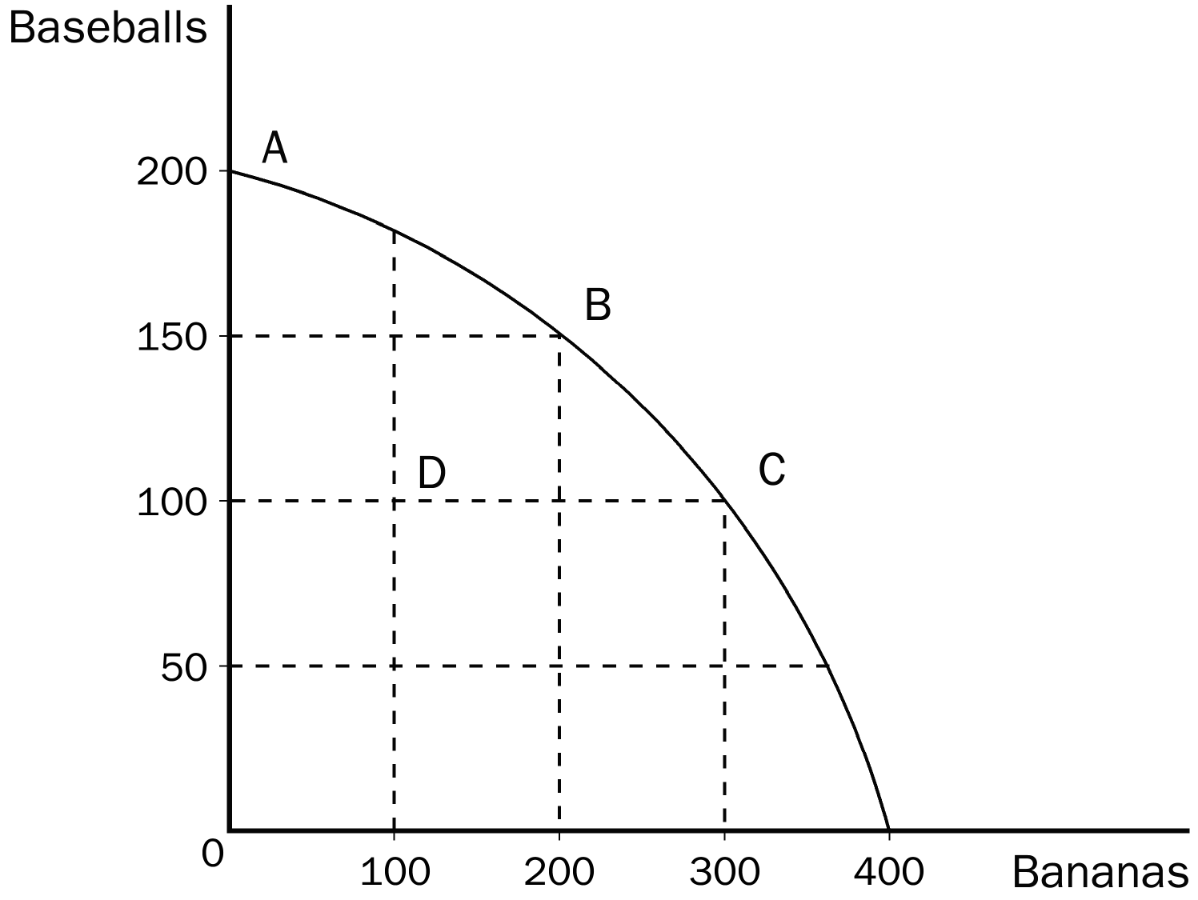
. In the production possibilities frontier shown, what is the opportunity cost to society of the movement from point A to point C?
a. 50 baseballs
b. 100 baseballs
c. 100 bananas
d. 300 bananas
Moving from A to C means you have 300 more bananas. You give up 100 baseballs to get there. So b.

. The prices of shares of stock that trade in stock markets
a. are determined by demand and supply
b. are only allowed to fluctuate between government established price floors and price ceilings.
c. are set on a daily basis by the corporation that issued those shares.
d. can be predicted with a large degree of certainty over the near term future.
Demand and supply determine price, so a. If you could predict the prices with a large degree of certainty, you would be rich, and you’d win the Stock Market Game competition we are having.
. In the housing market, rent controls cause quantity supplied to
a. fall and quantity demanded to fall.
b. fall and quantity demanded to rise.
c. rise and quantity demanded to fall.
d. rise and quantity demanded to rise.
Rent controls keep rents below equilibrium. The quantity supplied will fall and quantity demanded will be higher than at equilibrium.
. Which of the following would NOT be considered a factor of production?
a. labor
b. land
c. capital
d. money
Money is not a factor of production.
. An advance in production technology will
a. increase a firm’s costs.
b. allow firms to raise the price of their product.
c. shift the supply curve to the right.
d. Both a and b are correct.
Improvements in technology reduce a firm’s costs and allow it to reduce prices. The supply curve shifts to the right, so c.

. Suppose you make jewelry. If the price of gold falls, we would expect you to
a. be willing and able to produce less jewelry than before at each possible price.
b. be willing and able to produce more jewelry than before at each possible price.
c. face a greater demand for your jewelry.
d. face a weaker demand for your jewelry.
In the jewelry market, a decrease in the price of gold means jewelers can produce more jewelry than before at any price, so b.
. In the 1970s, long lines at gas stations in the United States were primarily a result of the fact that
a. OPEC raised the price of crude oil in world markets.
b. U.S. gasoline producers raised the price of gasoline.
c. the U.S. government imposed a price ceiling on gasoline.
d. Americans typically commute long distances.

If the answer was a, then anytime a producer raised its price, there would be long lines. And if b, then we would see lines whenever prices went up. The reason we had long lines was because of c.
For the following question(s), use the accompanying table.

Labor Hours needed to make one unit of: | Amount produced in 160 hours:

 | Quilts | Dresses | Quilts | Dresses
Helen | 40 | 10 | 4 | 16
Carolyn | 80 | 16 | 2 | 10

. According to the table, the opportunity cost of 1 quilt for Helen is
a. 2 dresses.
b. 3 dresses.
c. 4 dresses.
d. 5 dresses.
Helen can make 4 quilts in the time it takes her to make 16 dresses, so the cost of making one quilt is 4 dresses.

. According to the table, the opportunity cost of 1 dress for Carolyn is
a. 5 quilts.
b. 1 quilt.
c. 1/5 quilt.
d. 4 quilts.
Carolyn can make 10 dresses in the time it takes her to make 2 quilts, so the cost of making 1 dress is 2/10 of a quilt, or c.
. According to the table, Helen has a comparative advantage in
a. quilts and Carolyn has an absolute advantage in neither good.
b. dresses and Carolyn has an absolute advantage in quilts.
c. quilts and Carolyn has an absolute advantage in dresses.
d. dresses and Carolyn has an absolute advantage in both goods.
Helen can make both dresses and quilts in less time than it takes Carolyn, so she has an absolute advantage in both. Helen is twice as productive as Carolyn in the production of quilts, but only 1.6 times as productive in the production of dresses, so Helen is much better at producing quilts, which is where she has a comparative advantage. So a.
. According to the table, Helen has an absolute advantage in
a. dresses and Carolyn has an absolute advantage in quilts.
b. quilts and Carolyn has an absolute advantage in dresses.
c. neither good and Carolyn has an absolute advantage in both goods.
d. both goods and Carolyn has an absolute advantage in neither good.
Based on the logic in 25, d.
. According to the table, Helen and Carolyn both could benefit by Helen specializing in
a. dresses and Carolyn specializing in quilts.
b. neither good and Carolyn specializing in both goods.
c. quilts and Carolyn specializing in dresses.
d. both goods and Carolyn specializing in neither good.
Helen specializes in quilts, where she has a comparative advantage, and Carolyn has a comparative advantage in dresses, so she specializes in that. C.
. Although lawmakers legislated a fifty-fifty division in the payment of the FICA (Social Security) tax
a. the same outcome would occur if the entire tax had been levied on only the worker or only on the firm.
b. the employer now is required by law to pay a larger percentage of the tax.
c. the employee now is required by law to pay a larger percentage of the tax.
d. employers are no longer required by law to pay their portion of the tax.
Tax incidence theory tells us that where the statutory incidence is placed is irrelevant. Economics dictates who pays taxes, not governments. So a.
. A good is considered scarce in a society when
a. more output of the good is possible.
b. everyone in that society cannot have all they want of the good.
c. the government restricts production of the good.
d. only the richest people in the economy can buy all they want of the good.
B is the definition of scarcity.
. An increase in the price of oranges would lead to
a. an increased supply of oranges.
b. a reduction in the prices of inputs used in orange production.
c. an increased demand for oranges.
d. a movement up the supply curve for oranges.
An increase in the price of oranges is a movement up the supply curve, d. An increased supply of oranges will cause the price to fall.
. Belarus has a comparative advantage in the production of linen, but Russia has an absolute advantage in the production of linen. If these two countries decide to trade
a. Belarus should export linen to Russia.
b. Russia should export linen to Belarus.
c. For these two countries, trading linen would be a “stand-off” so they should trade another product.
d. Without additional information about Russia, this question cannot be answered.
If Belarus has a comparative advantage in linen, that is what it should export. By definition, Russia will have a comparative advantage in something else.
. Suppose roses are currently selling for $40.00 per dozen. The equilibrium price of roses is $30.00 per dozen. We would expect a
a. shortage to exist and the market price of roses to increase.
b. shortage to exist and the market price of roses to decrease.
c. surplus to exist and the market price of roses to increase.
d. surplus to exist and the market price of roses to decrease.
If the actual price is above the equilibrium price, there will be a surplus and prices will fall. D.
. Rationing by long lines is
a. inefficient, because it wastes buyers’ time.
b. efficient, because those who are willing to wait the longest get the goods.
c. the only way scarce goods can be rationed.
d. only necessary if price ceilings are not binding.
A is the answer. It is inefficient to force everyone to wait in line no matter what their opportunity cost is. A cardiac surgeon’s time is much better spent performing operations than waiting in line. So is a teacher’s time and just about anyone else’s.
. A minimum wage imposed above a market’s equilibrium wage will result in the quantity
a. supplied of labor being greater than the quantity demanded of labor and unemployment will occur.
b. demanded of labor being greater than the quantity supplied of labor and unemployment will occur.
c. supplied of labor being greater than the quantity demanded of labor and a shortage of workers will occur.
d. demanded of labor being greater than the quantity supplied of labor and a shortage of workers will occur.
A minimum wage above equilibrium means quantity supplied is more than quantity demanded. A. workers can’t find work.
. You have responsibility for economic policy in the country of Freedonia. Recently the neighboring country of Sylvania has cut off all exports of oranges to Freedonia. Harpo, who is one of your advisors, suggests that you should impose a binding price ceiling in order to avoid a shortage of oranges. Chico, another one of your advisors, argues that without a binding price floor, a shortage will certainly develop. Zeppo, a third advisor, says that the best way to avoid a shortage of oranges is to take no action at all. Which of your three advisors is most likely to have studied economics?
a. Harpo
b. Chico
c. Zeppo
d. none of them

If there are fewer oranges you should let prices rise to let the market allocate them. If there is a price ceiling, people who want oranges at the low price won’t be able to get them. If there is a binding price floor, there will be a surplus of oranges. Zeppo took economics.

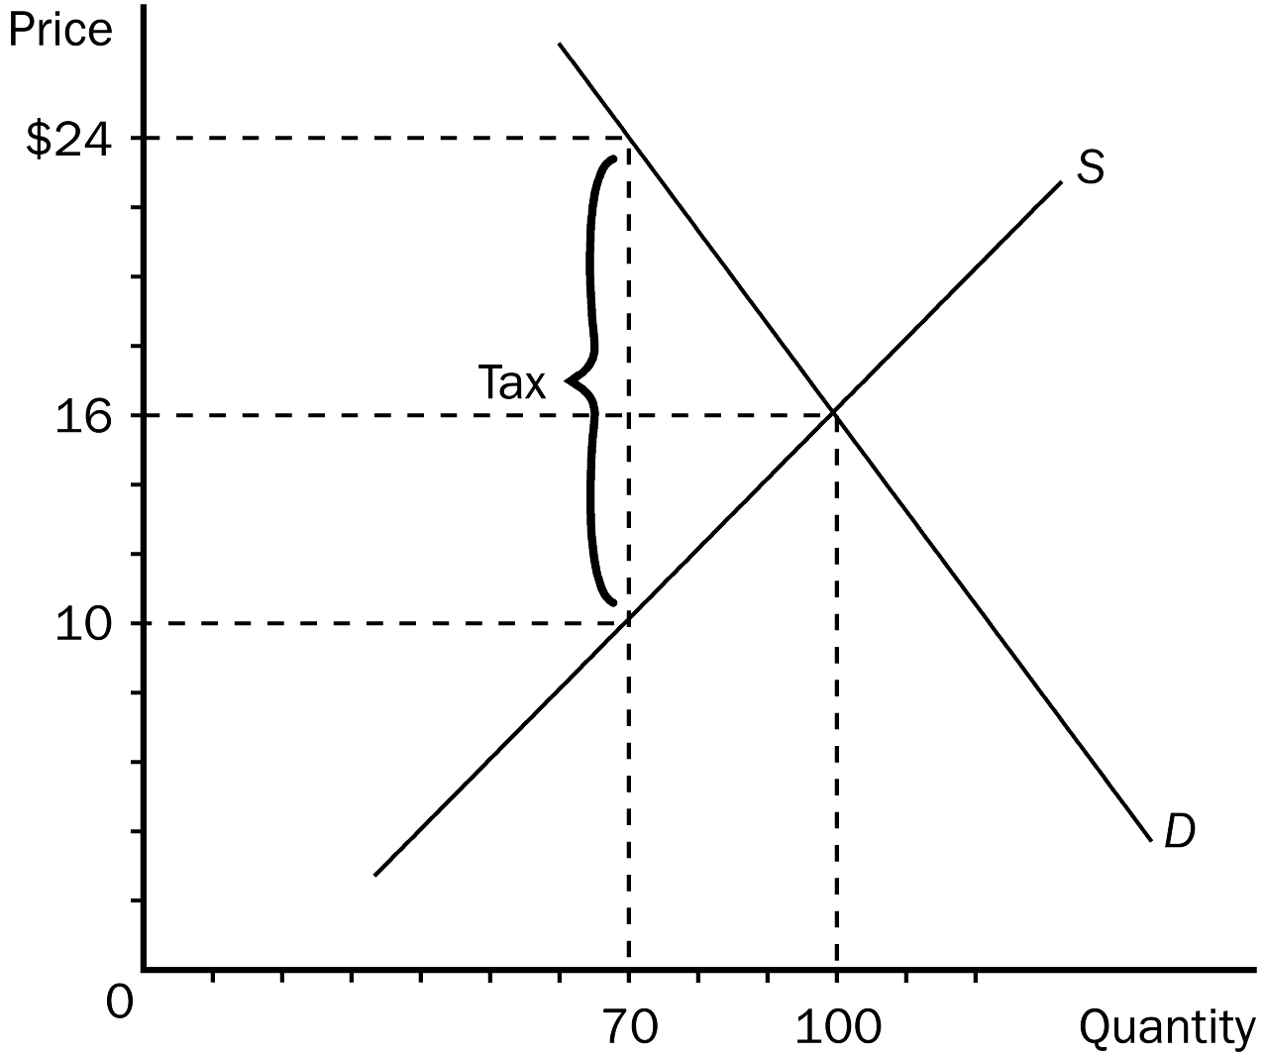
. In the graph shown, the price that will be paid by buyers after a tax is imposed is
a. $24.
b. $16.
c. $10.
d. $8.
Buyers will pay $24.
. In the graph shown, the price sellers receive after the tax is
a. $24.
b. $14.
c. $10.
d. $8.
Sellers will receive $10
. In the graph shown, the per unit burden of the tax on buyers (that is, how much of the tax buyers pay) is
a. $16.
b. $14.
c. $8.
d. $6.
Buyers pay $24 and before the tax they paid $16, so they pay $8 of the tax.

. The earned income tax credit is an example of
a. supply and demand.
b. a policy designed to increase efficiency.
c. a wage subsidy.
d. a price control.
C , it is a wage subsidy. It doesn’t increase efficiency. It is put in place for equity reasons.

. When Lenin said that the government should control the commanding heights of the economy, he was saying that
a. markets, with government regulation, would determine what the economy would produce.
b. the government should control all aspects of the economy.
c. the government should control only the key industries in the economy.
d. the government should control industries such as airlines and high altitude mines that would enable government bureaucrats to more easily see what was going on in the economy.

Lenin meant the key industries in the economy. C.

