Economics 11 Name: __________________
Spring 2005 Exam 1

. If labor in Mexico is less productive than labor in the United States in all areas of production,
a. neither nation can benefit from trade.
b. Mexico can benefit from trade but the United States cannot.
c. Mexico will not have a comparative advantage in any good.
d. both nations can benefit from trade.
. Approximately what percentage of the world’s economies experience scarcity?
a. 25%
b. 50%
c. 75%
d. 100%
. Henry decides to spend two hours playing golf rather than working at his job which pays $8 per hour. Henry’s tradeoff is
a. the $16 he could have earned working for two hours.
b. nothing, because he enjoys playing golf more than working.
c. the increase in skill he obtains from playing golf for those two hours.
d. nothing, because he spent $16 for green fees to play golf.
. What would happen to the equilibrium price and quantity of peanut butter if the price of peanuts went up, the price of jelly (a complementary good) fell, fewer firms decided to produce peanut butter, and health officials announced that eating peanut butter was good for you?
a. Price will fall and the effect on quantity is ambiguous.
b. Price will rise and the effect on quantity is ambiguous.
c. Quantity will fall and the effect on price is ambiguous.
d. The effect on both price and quantity is ambiguous.
. A donut shop sells fresh baked donuts from 5 a.m. until 3 p.m. every day but Sunday. The cost of making and selling a dozen glazed donuts is $1.00. Since this shop does not sell day-old donuts the next day, what should the manager do if he still has 10 dozen left at 2:30 p.m.?
a. lower the price of the remaining donuts even if the price falls below $1.00
b. lower the price of the remaining donuts as long as it’s more than $1.00
c. Lower the price on all donuts so they will all be sold earlier in the day
d. throw them away and produce 10 fewer dozen tomorrow
. In the former Soviet Union, producers were paid for meeting output targets, not for selling products. Under those circumstances, what were the economic incentives for producers?
a. to produce good quality products so that society benefits from the resources used
b. to conserve on costs, so as to maintain efficiency in the economy
c. to produce enough to meet the output target, without regard for quality or cost
d. to produce those products that society desires most
. One component necessary for markets to work is
a. government control of market prices.
b. a benevolent society.
c. property rights.
d. abundant resources.
. Price ceilings and price floors
a. are desirable because they make markets more efficient as well as equitable.
b. cause surpluses and shortages to persist since price cannot adjust to the market equilibrium price.
c. can be enacted to restore a market to equilibrium.
d. are imposed because they can make the poor in the economy better off without causing adverse effects.
. In the United States, incomes per family have historically grown about 2% per year. At this rate incomes will double every
a. 10 years.
b. 25 years.
c. 35 years.
d. 50 years.
. In the nation of Dictatorland, farmers traditionally feed grain to their livestock. Central planners, however, decided to increase the price of grain to make grain farmers happy and to reduce the price of bread made from that grain to make city dwellers happy. Now the price of bread is lower than the price of grain. We might now expect
a. farmers to continue to feed grain to their livestock.
b. farmers to start feeding bread to their livestock.
c. city dwellers to start buying grain to make bread to eat.
d. city dwellers to start buying grain to make bread to sell.
. If, at the current price, there is a shortage of a good,
a. sellers are producing more than buyers wish to buy.
b. the market must be in equilibrium.
c. the price is below the equilibrium price.
d. quantity demanded equals quantity supplied.
. Factors of production are
a. used to produce goods and services.
b. owned by firms.
c. abundant in most economies.
d. scarce only in poor countries.
. If an economy that produces two goods is producing efficiently
a. there is no way to produce more of one good without producing less of the other.
b. it is possible to produce more of both goods.
c. it is possible to produce more of one good without producing less of the other.
d. it is not possible to produce more of one good at any cost.
. When quantity demanded has increased at every price, it might be because
a. the number of buyers in the market has decreased.
b. income has increased and this good is an inferior good.
c. the consumer prefers another good more than this good.
d. the price of a substitute good has increased.
. An early frost in the vineyards of Napa Valley would cause
a. an increase in the demand for wine, increasing price.
b. an increase in the supply of wine, decreasing price.
c. a decrease in the demand for wine, decreasing price.
d. a decrease in the supply of wine, increasing price
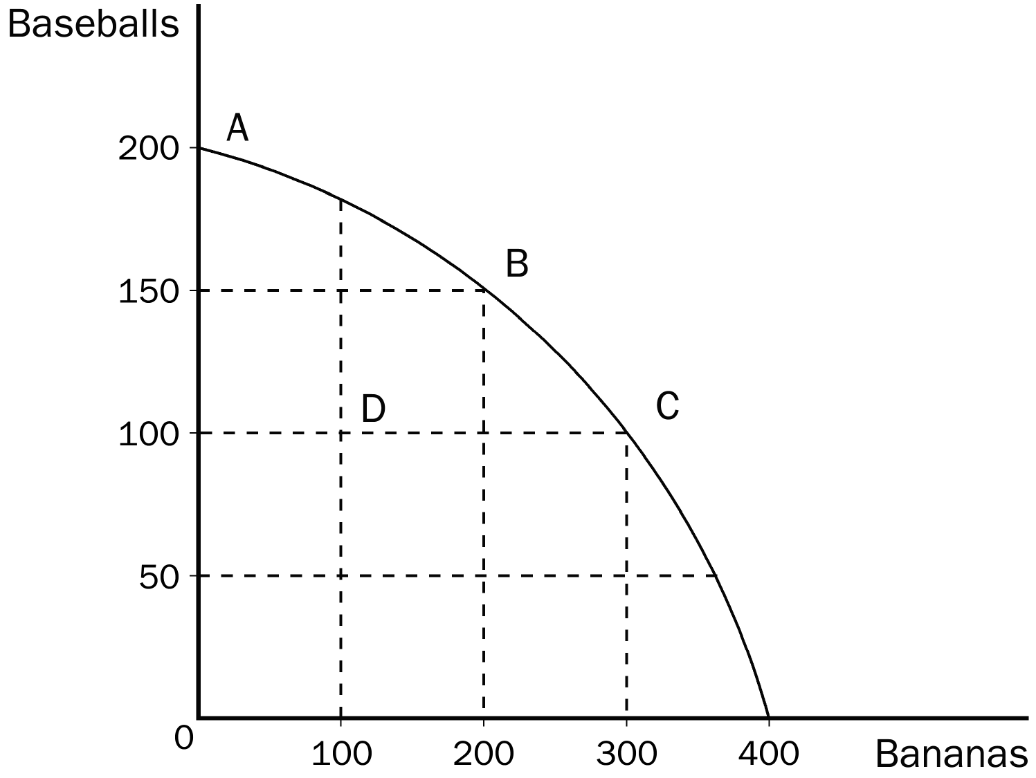
. In the production possibilities frontier shown, what is the opportunity cost to society of the movement from point A to point C?
a. 50 baseballs
b. 100 baseballs
c. 100 bananas
d. 300 bananas

. The prices of shares of stock that trade in stock markets
a. are determined by demand and supply
b. are only allowed to fluctuate between government established price floors and price ceilings.
c. are set on a daily basis by the corporation that issued those shares.
d. can be predicted with a large degree of certainty over the near term future.
. In the housing market, rent controls cause quantity supplied to
a. fall and quantity demanded to fall.
b. fall and quantity demanded to rise.
c. rise and quantity demanded to fall.
d. rise and quantity demanded to rise.
. Which of the following would NOT be considered a factor of production?
a. labor
b. land
c. capital
d. money
. An advance in production technology will
a. increase a firm’s costs.
b. allow firms to raise the price of their product.
c. shift the supply curve to the right.
d. Both a and b are correct.
. Suppose you make jewelry. If the price of gold falls, we would expect you to
a. be willing and able to produce less jewelry than before at each possible price.
b. be willing and able to produce more jewelry than before at each possible price.
c. face a greater demand for your jewelry.
d. face a weaker demand for your jewelry.
. In the 1970s, long lines at gas stations in the United States were primarily a result of the fact that
a. OPEC raised the price of crude oil in world markets.
b. U.S. gasoline producers raised the price of gasoline.
c. the U.S. government imposed a price ceiling on gasoline.
d. Americans typically commute long distances.
For the following question(s), use the accompanying table.

Labor Hours needed to make one unit of: | Amount produced in 160 hours:

 | Quilts | Dresses | Quilts | Dresses
Helen | 40 | 10 | 4 | 16
Carolyn | 80 | 16 | 2 | 10

. According to the table, the opportunity cost of 1 quilt for Helen is
a. 2 dresses.
b. 3 dresses.
c. 4 dresses.
d. 5 dresses.
. According to the table, the opportunity cost of 1 dress for Carolyn is
a. 5 quilts.
b. 1 quilt.
c. 1/5 quilt.
d. 4 quilts.
. According to the table, Helen has a comparative advantage in
a. quilts and Carolyn has an absolute advantage in neither good.
b. dresses and Carolyn has an absolute advantage in quilts.
c. quilts and Carolyn has an absolute advantage in dresses.
d. dresses and Carolyn has an absolute advantage in both goods.
. According to the table, Helen has an absolute advantage in
a. dresses and Carolyn has an absolute advantage in quilts.
b. quilts and Carolyn has an absolute advantage in dresses.
c. neither good and Carolyn has an absolute advantage in both goods.
d. both goods and Carolyn has an absolute advantage in neither good.
. According to the table, Helen and Carolyn both could benefit by Helen specializing in
a. dresses and Carolyn specializing in quilts.
b. neither good and Carolyn specializing in both goods.
c. quilts and Carolyn specializing in dresses.
d. both goods and Carolyn specializing in neither good.

. Although lawmakers legislated a fifty-fifty division in the payment of the FICA (Social Security) tax
a. the same outcome would occur if the entire tax had been levied on only the worker or only on the firm.
b. the employer now is required by law to pay a larger percentage of the tax.
c. the employee now is required by law to pay a larger percentage of the tax.
d. employers are no longer required by law to pay their portion of the tax.

. A good is considered scarce in a society when
a. more output of the good is possible.
b. everyone in that society cannot have all they want of the good.
c. the government restricts production of the good.
d. only the richest people in the economy can buy all they want of the good.
. An increase in the price of oranges would lead to
a. an increased supply of oranges.
b. a reduction in the prices of inputs used in orange production.
c. an increased demand for oranges.
d. a movement up the supply curve for oranges.
. Belarus has a comparative advantage in the production of linen, but Russia has an absolute advantage in the production of linen. If these two countries decide to trade
a. Belarus should export linen to Russia.
b. Russia should export linen to Belarus.
c. For these two countries, trading linen would be a “stand-off” so they should trade another product.
d. Without additional information about Russia, this question cannot be answered.
. Suppose roses are currently selling for $40.00 per dozen. The equilibrium price of roses is $30.00 per dozen. We would expect a
a. shortage to exist and the market price of roses to increase.
b. shortage to exist and the market price of roses to decrease.
c. surplus to exist and the market price of roses to increase.
d. surplus to exist and the market price of roses to decrease.
. Rationing by long lines is
a. inefficient, because it wastes buyers’ time.
b. efficient, because those who are willing to wait the longest get the goods.
c. the only way scarce goods can be rationed.
d. only necessary if price ceilings are not binding.
. A minimum wage imposed above a market’s equilibrium wage will result in the quantity
a. supplied of labor being greater than the quantity demanded of labor and unemployment will occur.
b. demanded of labor being greater than the quantity supplied of labor and unemployment will occur.
c. supplied of labor being greater than the quantity demanded of labor and a shortage of workers will occur.
d. demanded of labor being greater than the quantity supplied of labor and a shortage of workers will occur.
. You have responsibility for economic policy in the country of Freedonia. Recently the neighboring country of Sylvania has cut off all exports of oranges to Freedonia. Harpo, who is one of your advisors, suggests that you should impose a binding price ceiling in order to avoid a shortage of oranges. Chico, another one of your advisors, argues that without a binding price floor, a shortage will certainly develop. Zeppo, a third advisor, says that the best way to avoid a shortage of oranges is to take no action at all. Which of your three advisors is most likely to have studied economics?
a. Harpo
b. Chico
c. Zeppo
d. none of them

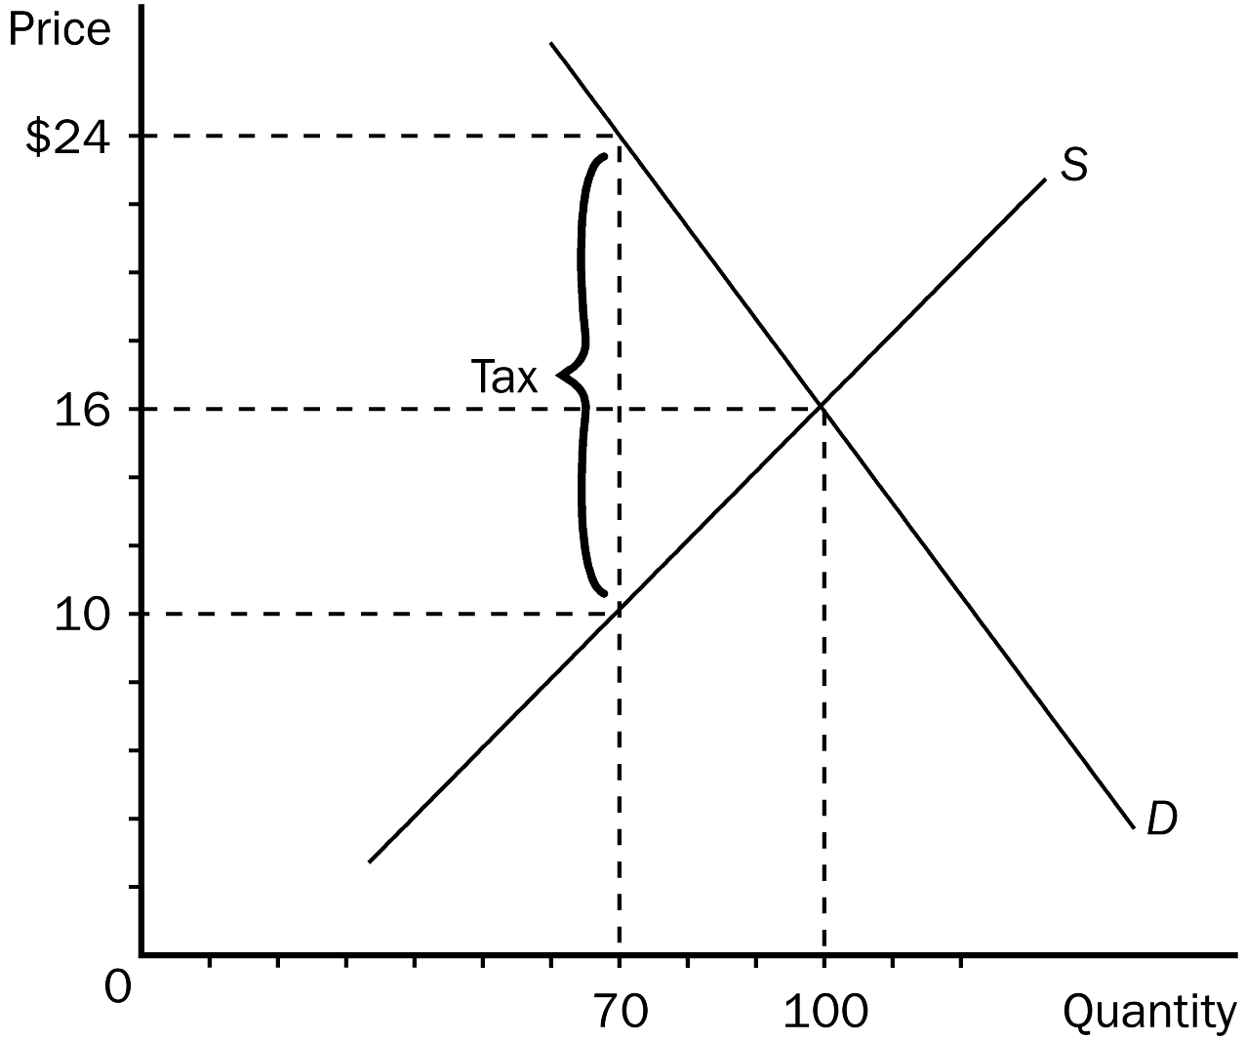
. In the graph shown, the price that will be paid by buyers after a tax is imposed is
a. $24.
b. $16.
c. $10.
d. $8.
. In the graph shown, the price sellers receive after the tax is
a. $24.
b. $14.
c. $10.
d. $8.
. In the graph shown, the per unit burden of the tax on buyers (that is, how much of the tax buyers pay) is
a. $16.
b. $14.
c. $8.
d. $6.

. The earned income tax credit is an example of
a. supply and demand.
b. a policy designed to increase efficiency.
c. a wage subsidy.
d. a price control.

. When Lenin said that the government should control the commanding heights of the economy, he was saying that
a. markets, with government regulation, would determine what the economy would produce.
b. the government should control all aspects of the economy.
c. the government should control only the key industries in the economy.
d. the government should control industries such as airlines and high altitude mines that would enable government bureaucrats to more easily see what was going on in the economy.

